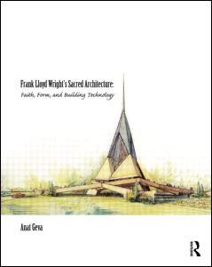
Frank Lloyd Wright’s Sacred Architecture
Faith, Form and Building Technology
By Anat Geva

A comprehensive study of the sacred buildings built and designed by Frank Lloyd Wright, this book offers scholarly discussion with analytical drawings and photographs. These projects represent different periods of Wright’s career (from 1886 to 1958), new building technologies, and application of his design concepts as demonstrated in his sacred architecture. This unique contribution will be useful to all those interested in Wright’s architecture and theory as well as in sacred architecture.

Table of Contents:
Introduction Part 1: Faith, Form and Building Technology: A Conceptual Model of Sacred Architecture Part 2: Faith 1. Nature 2. Democracy and Freedom 3. The Whole as the Equilibrium of its Parts Part 3: Form 4. Nature 5. Democracy and Freedom 6. The Whole as the Equilibrium of its Parts 7. Sacred Path/Plan 8. Sacred Verticality Part 4. Building Technology 9. Nature 10. Democracy and Freedom 11. The Whole as the Equilibrium of its Parts 12. Light 13. Acoustics 14. Thermal Comfort Part 5. Conclusion
Forthcoming: Sept. 2011 | 288 pages | Hardback: 978-0-415-49684-1| $70 $55

Redeem your discount online with code: ERJ78 at Routledge.com.

