moving design V: The Art of PLAY
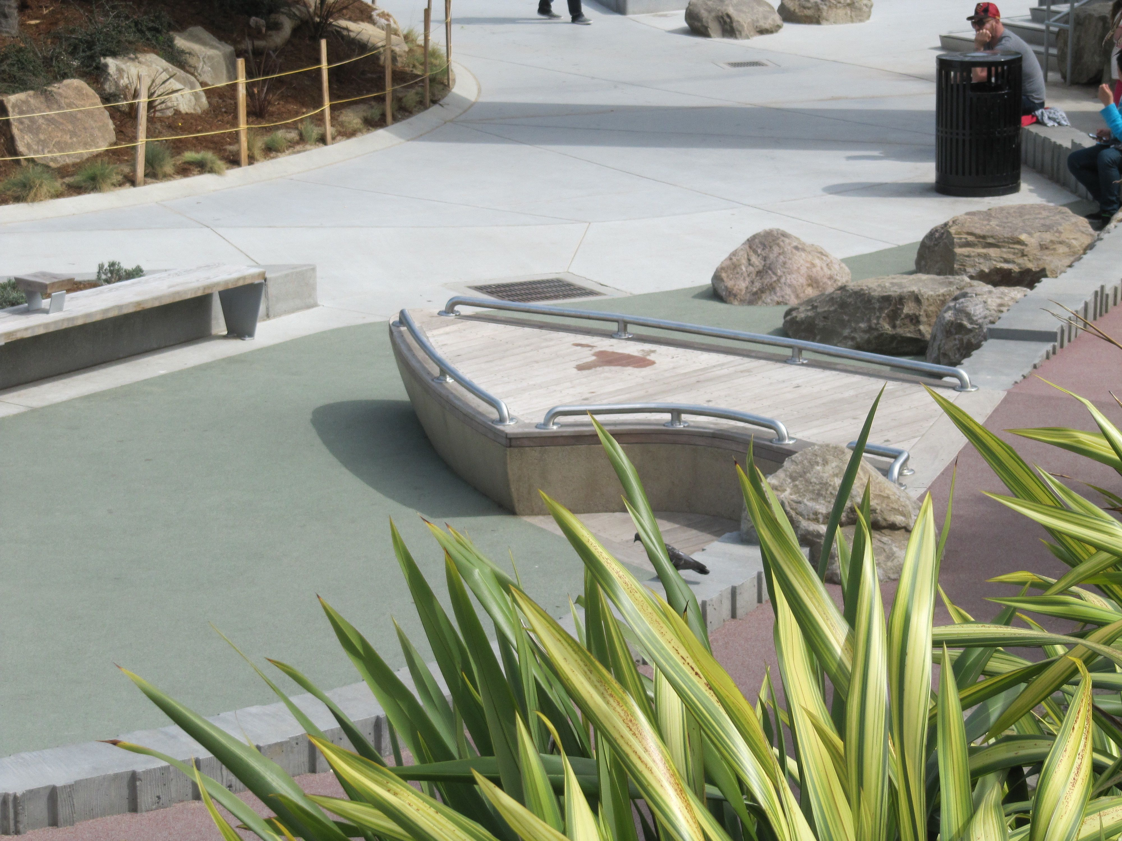
21st Century Learning Environments blur the boundary between fun, play, wonder and information access. Melding examples from the past and present, this webinar looks at playgrounds as valued cultural activity centers and unique destinations that challenge children’s curiosity. Contrasting commodification of play with cultural specificity of place and architect/artist collaborations, we will look at changing perceptions of play and playgrounds from the 1950’s to the present that concentrate on the importance of the art of play. Examples will be shared that present play destinations as cultural play scapes.

LEARNING OBJECTIVES
1 Understand Playground Perspectives from the 1950’s
Place Based Directed, Supported, Independent Learning
Collaboration with Diverse Approaches
Communal and Social Place Making
Immersion in Outdoor Experiences
2 Examine Changing Historical Precedents of Playgrounds
Loss of Site Specificity (content and context) to Commercialized Sameness
3 Discuss Play + Play Experiences That Create Cultural Value of Place
Sequence of Entry and Approach
School, Museum and Environmental Outdoor Environments
4 Learn Relationships Between Play, Play Equipment and Place
Author and Host
Susan G. Solomon, Curatorial Resources & Research

Linda Keane, AIA, CAE Alternative Learning Environments Chair, STUDIO 1032 ARCHITECTURE and ENVIRONMENTAL Design,
Professor, The School of the Art Institute of Chicago; Director, NEXT.cc

SUSAN G. SOLOMON
Susan G. Solomon is an art historian with a Ph.D. from the University of Pennsylvania (1997). Her concentration on twentieth-century architecture led to authoring of two books on Kahn. The Graham Foundation for Advanced Studies in the Fine Arts supported publication of Louis I. Kahn's Trenton Jewish Community Center (Princeton Architectural Press, 2000) and the Lucius N. Littauer Foundation helped fund Louis I. Kahn's Jewish Architecture: Mikveh Israel and the Midcentury American Synagogue (Brandeis University Press, 2009). Inspired by the collaboration between Kahn and sculptor Isamu Noguchi on the Adele R. Levy Playground (unbuilt, New York City, 1961-65), she wrote American Playgrounds: Revitalizing Community Space (University Press of New England, 2005). The Graham Foundation generously aided publication. Solomon has extensive experience as curator, writer,and speaker. She heads her own research firm, Curatorial Resources & Research in Princeton, New Jersey. http://www.curatorialresources.com/

Linda Keane, AIA, NCARB works on green initiatives along the Chicago Milwaukee corridor. A leader in design education, Keane is Professor of Architecture and Environmental Design at the School of the Art Institute of Chicago where she directed the City of Chicago Green Roof Website and led initiation of a third accredited Master of Architecture program in Chicago. With Mark Keane, partner in STUDIO 1032, she created animated films about architecture awarded a PBS Emmy. Their National Endowment for the Arts and Graham Foundation Grant supported Architecture An Interactive Introduction (McGraw Hill) was the first CD and Book created by architects introducing the art and science of architecture and allied fields to the general public. The Keanes are co -creators of the eco web of NEXT.cc a Union of International Architects, NEA and United States Green Building Council honored media program on sustainable environmental and cultural practices.
John R. Dale, FAIA, LEED AP is a Principal at Harley Ellis Devereaux in Los Angeles, John Dale has been involved in the master planning, programming and design of public and private projects for almost 30 years. He has created high performance pre-school through secondary school environments. By defining small learning communities which boost student achievement, promote sustainability, and galvanize community involvement, he has established widely recognized models of regional and national significance. John has also been a leader in promoting green schools. Building on evidence-based research, he has put in practice the theory that students are healthier and learn more effectively in well-ventilated, acoustically balanced, naturally lit spaces with strong connections to the outdoors—all features of energy-conserving, sustainable design.
John R. Dale, FAIA, LEED AP, CAE Webinar Chair and Harley Ellis Devereaux
Email: jrdale@hedev.com and harleyellisdevereaux.com

GoToWebinar Registration:
https://www3.gotomeeting.com/register/273052398

