AIA San Antonio COTE

In late 2017, the AIA San Antonio Committee on the Environment (COTE) hosted a lecture on happiness by Harry Wallace, a professor of psychology at a local university. The question posed, “How can happiness be achieved through architecture?” brought in a sizable audience and explored the connection between the quality of an architectural space and its effects on objective and subjective human well-being. Towards the end of the lecture, Professor Wallace asked, “Are architects happy?” He posited that while architecture is an educated and respected profession, the traits of being detail oriented (or even borderline OCD, his personal experience with architect friends) might decrease happiness in the long term. By the end of the evening, though, Wallace changed his mind on this answer. The group sitting before him was fully engaged in the topic, while snacking on hand crafted appetizers and drinking good wine. The discussion that followed the lecture lasted well over an hour and by 10:30 we had to ask people to continue chatting elsewhere so we could lock up the AIA.

AIA San Antonio is a small chapter with a small COTE we have some 10 consistent members, but through a combination of scrappy tactics and innovative programming we’ve built AIA San Antonio COTE into a leading voice on sustainability for our region. Over the years, we’ve honed our process and our current formula for running a successful local COTE comes down to three major principles: Great topics, great graphics, and great food. When we host a COTE event, attendees know that they’ll be receiving all three and this brand has kept our committee going strong.

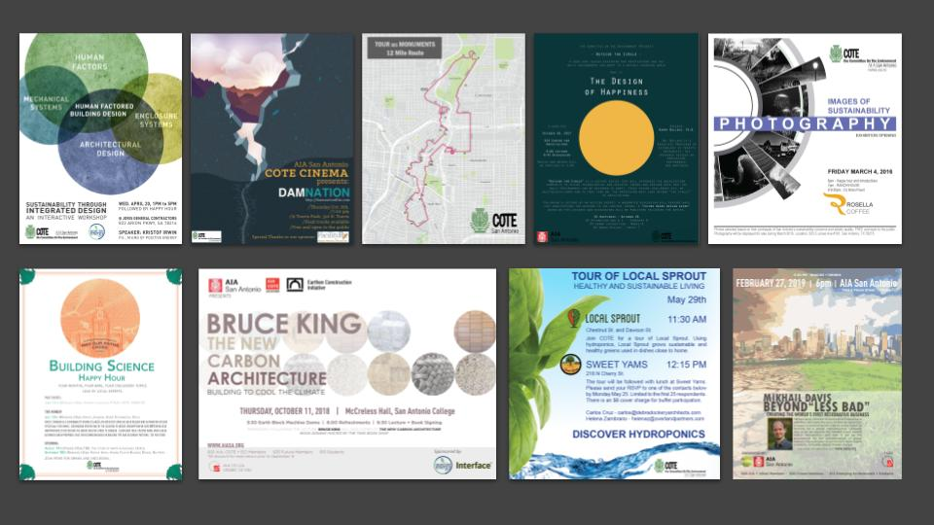

Great Programs
COTE SA has a dual mission, “To educate the architecture community on issues of building science and high performance design and to increase the public’s awareness of health, comfort, and happiness in the built environment.” To achieve these two priorities, COTE SA holds many different types of events from bike tours, to factory visits, to our annual art exhibition, “Images of sustainability”, but our bread and butter is providing thought provoking lectures, on timely topic, delivered by nationally renowned experts.

- Choose presentation topics that are relevant, interesting, and deep. Use COTE programming as a venue for satisfying your own curiosity. If there’s a topic that the members really want to know more about, chances are that the community is interested as well.
- Let presenters know to skip background information and dive deep into the content. Even for events geared towards the community at large (as opposed to just architects), the attendees show up for substance, not background.
- Don’t allow product sales pitches or canned courses. Any presentation that has significant education value will be granted at CEU by the AIA.
- Bring in the experts. We look for nationally recognized experts to lecture for AIA San Antonio COTE, but it's essential to keep travel expenses low. Airline miles from the AIA’s credit card covers airline tickets and our guests are typically hosted in the homes or back houses of our members. Member hosts are provided with some groceries so that our guests can prepare breakfast and lunch for themselves. To ensure that the visit to our city is as useful and enjoyable as possible, we typically create an itinerary, including touring offices or river boat rides and we always treat our guest to great local meal following the talk.

Great Food
Our COTE is known for our food. Every event, no matter how small, includes a buffet. A spread for a typical evening lecture might include fresh vegetables, hummus, guacamole, mixed nuts, salsa, crackers, a variety of cheese and jams, olives and other marinated vegetables, berries, stuffed dates, and of course, beverages, including an adult beverage offering. People are hungry at 6:00 when we hold evening lectures and knowing that quality, healthy food will be available might be enough to encourage those on the edge to show up. On a deeper level, sharing food is how we connect as humans and going beyond the expectations lets attendees know that we value the effort they are making to be there. Therefore, we strive for COTE lectures to be less like college classes and more like dinner parties.

- Take care of the attendees. We want COTE event attendees to feel welcome to know that we appreciate the effort they took to attend. Food is an inexpensive and effective way of conveying this message.
- Provide variety and quality. All food at COTE SA events is healthy, organic, vegetarian, diverse, and delicious. It's important for the food to match the mission and values of the committee and we accomplish this by keeping to organic, plant based options that comply with a wide range of dietary restrictions. All food is purchased from the grocery store which keeps costs down and saves signicantingly on packaging. Members often arrive at events a little early to chop vegetables, arrange cheese boards, and stuff dates.
- Choose food that aligns with the topic. Food should be seen as integral to the event and if it can tie directly to the topic, the experience of both will benefit. Our “made in San Antonio” manufacturing tours featured local beer and uniquely San Antonio treats and our happiness series included dark chocolate and other foods that boost serotonin.
- Aim for zero waste. Aligning food with COTE’s mission and values needs to extend beyond food and include packaging as well. Beverages are served in glassware and china and flatware and provided for most events. For larger events, where washing dishes would be too onerous for the staff, we use compostable serveware.
- COTE San Antonio’s operating budget is made up from a combination of a few annual sponsors and fees for attending continuing education events. Since we do all of our catering ourselves from the grocery store, we have been able to save a significant amount of money over delivery from a restaurant. This allows us to simultaneously keep event costs down and provide great food for our attendees. We don't host typical lunch and learn product presentations, but when we do have a speaker who offers to provide lunch, we ask for a cash contribution instead to take care of the food ourselves.

Great Graphics
The last key to the recipe is branding our committee with quality graphics. This mostly applies to the flyers that we produce to advertise our lectures and events. While the committee chairs work to bring in the speakers, and the AIA staff go above and beyond in providing great food, The members take on the responsibility of creating event flyers. Members who volunteer to create flyers often go all out, knowing that their flyer will be part of a series of well known COTE event flyers that stretches back years. Eye catching graphics is what separates COTE SA events from all others and is a key part of the brand that keeps our members engaged and our message resonant.

