A 21st Century Police Headquarters Rises Out of the Heart of Darkness
Jake: Welcome, everyone to this session in the Law Enforcement Track. I’m Jake Davis. I’m with DLR Group, and I’m also the Track Chair for the Law Enforcement Track for this year’s conference. With me, I have my dear friends and former colleagues Brian Meade and Larry Hlavacek from Dewberry architects.
We’re going to talk a little bit about a project that we all had some piece or part in, Brian and Larry more than myself, certainly. As we’ve thought about this, I tried to put this into a certain context. I think that all projects are beset with a certain set of difficulties, and I think that as we’ve heard the stories that have permeated out through this conference about new ways of doing things and new constructs for getting through things, I think it’s interesting to look back and look at the way that we maybe did some things more traditionally but actually in alternative ways that turned very difficult situations around.
With that, obviously, we have the compliance stuff. We’re going to give you a learning unit for AIA in the process.
I’m going to start out with a little bit of a quote. I’ve used this title that this was a 21st century police station that rose out of the heart of darkness, out of a really challenging and difficult time, so I’m going to start with a quote from actually the Joseph Conrad book “The Heart of Darkness.”
The quote is: “A mighty big river that you could see on the map resembling an immense snake uncoiled, with its head in the sea, its body at rest curving afar over a vast country and its tail lost in the depths of the land.”
I think that that speaks to the challenges that go into seeing your client’s vision through, navigating a very difficult economic and political landscape, and then finding a path through some alternative delivery in order to make that happen. As we talk about this, we want to talk about how trying circumstances can be overcome through collaboration, and that’s true with any kind of project.
In terms of the learning objectives for this, we want to talk about:
- Fast track,
- How to prioritize elements in your project, whatever your project happens to be. This project was a police project where there were elements of the building – in particular, a garage and a firing range – that were considered critical success factors that if they had not appeared in the project, the project would have been abject failure in one sense.
- How to conquer budgets that a set by others that really have very little relevance to what you’re being asked to do – set by political officials, potentially,
- The collaboration between architect and contractor – that actual trust, the empathy that you form for one another in the process. Those things are important and they permeate all of these delivery methods that we look at.
With that, I’ll hand this off to Brian.
Brian: As Jake said, we want to use this one project as a case study to tell a story here about a seven-year – almost eight-year – history now with one specific client. We wanted to start off today’s presentation just quickly going through a timeline to get you up to speed with what we went through.
We started back in 2004, where the client Hanover Park, which is a western suburb about 45 minutes west of Chicago, had hired us to perform a needs assessment study. Again, this was a relationship between a client and an architect. There was no contractor or any third party on board right now.
The first study specifically asked for looking at a renovation and addition potential for an existing police station – so it was more of a top-down kind of approach.
This is the original site, this kind of trapezoid here, which was the eastern gateway into the village of Hanover Park, between the metro line to the south and a pretty busy thoroughfare, Lake Street route 20, to the north there.
Jake: A U.S. Highway.
Brian: That’s right. The initial study was more of a limited approach where we were looking at the existing building, which was both village hall and police functions. We were asked to look at a study while trying to maintain parking for public, for police staff, for village staff. How could we do a limited addition and renovation?
The result of that study was about 20,000 square foot addition here in blue, and that was a budgeted $5 million project. That was early 2005. Then things went quiet for a while. Then a couple of years later, fast forward to the beginning of 2008 – and this is just a really brief synopsis of what went down.
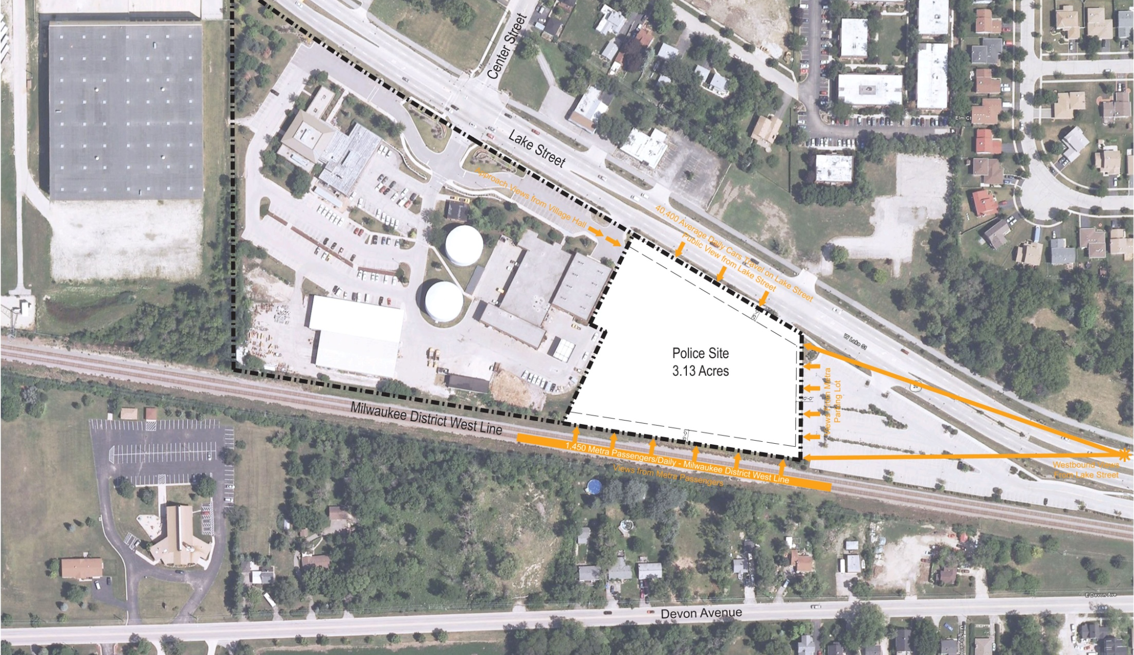
The village was still interested in pursuing this, and some land was becoming available just east of the municipal campus. This campus is basically their municipal heart with public works, police, and village functions. You have the metro line parking here in the brown. This was a great opportunity to purchase an adjacent property and expand their campus even more and potentially have more space for police.
Study number two, in the beginning of 2008, asked us to look at a bottom-up approach where we really we’re going to go back and look at the true needs, looking out at least 20 to 25 years, knowing that now they had a three-acre site that would allow for more building, better adjacencies flow, better separation between public and staff parking. That was this site here between the metro parking and the village campus.
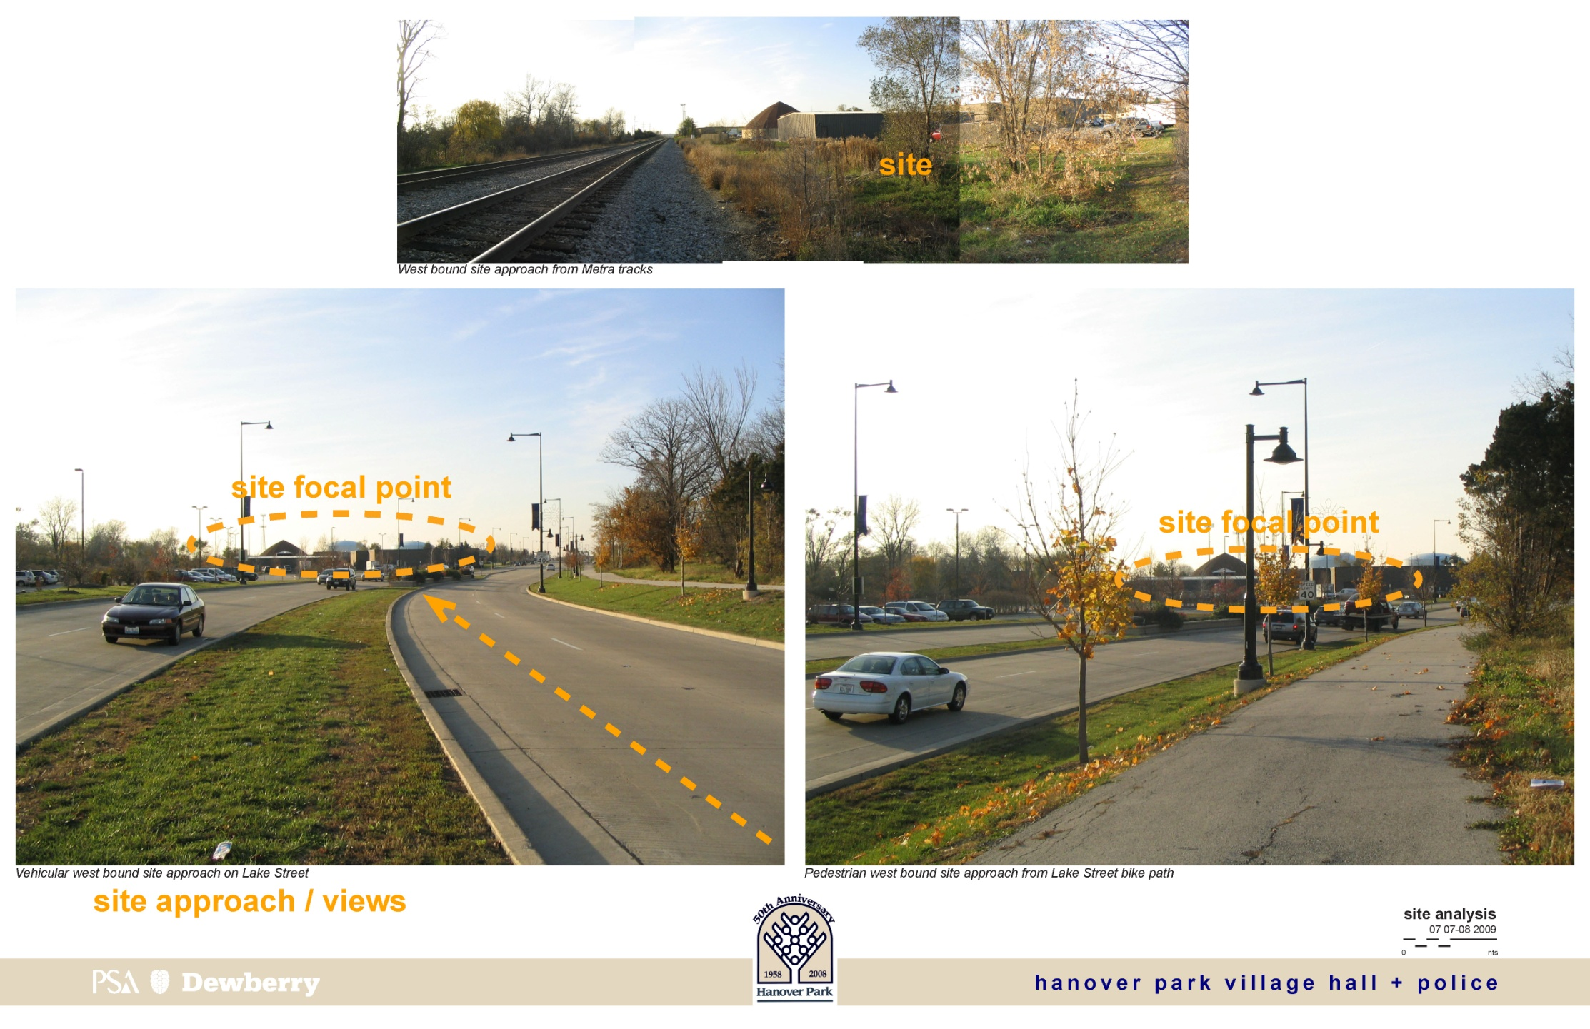
Just some images from that part of the study. Obviously, it was really a great prominent corner – the northeast corner as you bend around the Lake Street.
As that study progressed – it was definitely over a year’s study, back and forth – one of the results of that initial study was a 52,000 square foot structure. We have now gone from the 20,000 square-foot addition to 16,000 original, where study number one was saying, “Maybe we need 36,000 square feet.” Now, with study number two, we’re up to 52,000 square feet and a $15 million construction budget.
Again, this was still early 2008. The times were still very good, the economy didn’t start to go south yet. This is where we were at that moment in time.
Jake: To quickly review, not that this is new territory for anyone, but in the fall of 2008, things went sour. I think it’s interesting for those of us who really has spent a lot of our careers in the municipal world, what we began to see was that there was this lag period of time that took place where when the general economy went bad in the fall of ’08 and the beginning of ’09, it really took another 12 to 18 months in a way for the recession and the triple hit that municipalities took from reduced state and federal funding, from property tax decreasing –foreclosures and so forth – from sales tax erosion because of failed retail and so forth.
What then begins to happen is that you have a project that has been growing in terms of its goals, in terms of its dream, and now is hit with this reality that is this going to happen? Is there political will left for this project to happen? Or, is this project going to completely die on the vine?
Brian: Things got a little panicky. Early 2009, as we were trying to finish this study, Hanover Park… Again, we were alone in this – client and architect. We didn’t have a teaming arrangement with a contractor or a Design/Build relationship.
Again, after hearing so many of the conversations in the last day and a half, we were out there on a limb. We do have some in-house cost estimating, but we were really trying to respond to their fears and concerns. Early 2009, as we were trying to complete the study, all of a sudden they were saying, “Gosh, 52,000 square feet, $15 million. We’re not sure we can afford that, so can you already start to look at cost reductions in the study?”
This was just one table from our study where here we were as architect and partner quickly trying to look at do we reduce the basement that was in the study? Do we get rid of the EOC, the firing range? All of these things that we all naturally attend to. We were just trying to quickly apply unit cost to them with the best of our ability and just show that there are ways to still move forward with the client and at maybe a smaller amount.
They pondered that. Months went by. Late 2009, the economy is still pretty bad, but then conversations started happening with a local contractor, Leopardo Construction. As everyone was realizing, construction costs were going down. It was very competitive and everyone started to think, “Well, maybe this is the best time to build,” because of those conditions.
As we were trying to finish the study then they started adding back and saying, “If this is the prime time to consider building, why don’t we start to look at some add alternate ideas?”
The village of Hanover Park never had a very strong sustainability goal, but at this point, they were encouraged, because they saw some of our other LEED silver projects, to say, “What would be the added cost to be sustainable and go at least LEED silver?” So we started to look at that. “What would be some of the goals to have enclosed parking?”
One of the communities, Streamwood, just north of Hanover Park had just recently, two years ago, completed a new police department with a brand new shining indoor 25-car garage. They were completely enamored with that, and that became a really big wish list. It started on a wish list, and as you’ll hear in our story, became a must-have.
We quickly looked at indoor options anywhere from just three cars, at $150,000, all the way up to a 30-car indoor garage that was going to be over a million dollars. This started to end our study in late 2009, as they saw it as a chance to really maybe move forward at this time with the project.
Quickly, we wrapped it up in the beginning of 2010. They finally pulled the trigger to go forward. In February, we are brought on board, and then in March, shortly thereafter, Leopardo Construction was brought down as construction manager at risk. As you can see, we started the project in earnest, and then as we go on – and Larry will discuss more – we’ll talk about how Leopardo’s influence as really collaborative team member really helped us steer the path for this successful project.
Jake: I also want to point out that in this period of time – Larry, correct me on this if I’m wrong about the timing of it – the village board assigned, essentially, a construction number to the project.
Larry: That is correct. What was happening within the village is they were trying to figure out what their financing was going to be. They realized that property tax revenue, which is one of their main sources of income, was unpredictable at best, so they were really trying to figure out how much money they could bond and allocate for this project safely. One of the things that they looked at was what areas of this building were somewhat expendable?
The Hanover Park police department had operated without a covered garage for decades. They didn’t have one before, so they considered that an expendable feature. The firing range was another expendable feature, as they had an aging firing range already in place in the village hall that could at some future date be renovated, and there are multiple problems with the firing range.
Those were the conversations going on with village at that time. They were really trying to figure out how much money they were going to have available on a really unpredictable economy.
Jake: Also, trying to deal with the political hit from advancing the idea of capital funding at that time when people were losing their homes.
Larry: That’s true. There were also staff reductions that were going on with the village, so they were trying to tighten up their budgets and everything. You had two different conversations. You had politicians on the one side who were coming up for a re-election soon and were trying to do what the people wanted. Then you had the other people who were saying, “This is an economic advantage that we can take advantage of and try and move the project forward and perhaps get it done for a cheaper price.”
For decades, we’ve operated under a traditional Design-Bid-Build construction and design methodology, and really there is inherently a big problem with that method. You can see that represented here with the big wall.
On one half of it, you have the design group. The design group works independently at the beginning of the project and they really focused on the scope of the project and the quality of the project. That project goes out to bid, and at that point, the contractor is brought into the project, just looking at the budget and the schedule.
Those two things, more than likely, aren’t on alignment, and that’s a problem. It pushes the project delays way beyond what you normally would expect it to. It causes you to have to take things out of the project, which is painful to owners.
What we wanted to do is look at integrated CM team approach on this project. This team approach balances those forces. It brings the construction manager into the project early on, where they can offer their input throughout the entire design process, so that you’re focusing on scope, budget, quality, and schedule all at the same time through every phase of the project.
In that way, by balancing all those forces, you end up with fewer conflicts, you meet the owner’s expectations, and you end up reducing the amount of surprises that you’re going to have later on in the project.
Jake: The other thing that it does for you is it makes you a lot more agile, and that ended up being a really crucial factor in the mix here. We’ll get into a little about why agility was important to take advantage of a really rapidly de-escalating marketplace.
Larry: Information is king, and the more people you have to offer you information throughout the project, it can only help you out.
CM at-risk, the traditional model of it, the owner has a contract with the architect. The owner has a contract with the construction manager at-risk and brings him in for pre-construction services during the design project.
There is a loose link between the architect and the construction manager. It’s not contractual, but it is acknowledged as being part of the team so that relationship is there, just not contractually.
What this does with the construction manager is it brings them in and they give you a guaranteed maximum price (GMP), so the owner knows what they’re getting in advance of getting bids. They can lock in that price, and that price has built-in contingencies to allow for things that haven’t been designed or haven’t been developed by the point that you’re locking in that price.
That just allows you to really offer up the shared savings potential, an added incentive to a construction manager, and that will allow the construction manager to really work diligently throughout the process to save money in the hopes that they will get a return on that, as well.
This value/cost curve is one of the main advantages of the CMR involvement early on in the project. What you’re seeing here is of the degree of change in green. That’s the area in this chart that you want to maximize your ability to change things without adding cost.
As time goes on, you can see the cost to making changes – the red line that swoops up. As you go through planning, design, and construction, the cost of those changes are going to ramp up rather quickly.
You will notice the ability to make changes don’t really cost a lot in the beginning. That’s when you have the flexibility to choose the correct systems and make those changes. But as you move on through the project, to try and make those changes starts costing more and more and more. Having that CM input early on – for the selection of structural systems, MEP systems, and electrical systems – is key to making a correct selection as you move forward.
The roadmap to success:
- Create and monitor a comprehensive project schedule.
These are all things that a construction manager would be doing throughout the entire project.
- Preparing an early logistics plan.
Really a lot of this is risk management. We’re looking at different things you’re going to do through your project and by examining them early on, you can make better decisions that, again, are going to reduce costs, reduce your schedule.
- Assist with MEP systems.
- Identify and manage scope creep.
- Cost and value design management.
These are just a few of the other things that they do.
This next slide was really critical, and this was a slide that Leopardo Construction brought to the owner and discussed with them early on the project. It was really an understanding of the project cost.
Too many times, you will get through your design and you’ll have to do a value engineering exercise, and what it everybody focus on? We’re going to take the high-end finishes in your building, and we’re going to reduce those, because that’s the least painful. You’re not losing square footage or anything. Unfortunately, those are the things that you see and you touch and you deal with every day and those are the things that the clients really hate to lose.
As you can see from this chart, the finishes, specialties, roofing, sealants are a small part of the budget. Really, almost 75% of the budget is made up of these top five systems: the structural systems and shell; the carpentry, dry wall, and acoustics; electrics; site conditions; and HVAC.
If you can concentrate early on in your project on these systems to create the most economical, efficient, low-maintenance systems for the owners and get the most out of your money and have those affect your designs decisions as you go forward, you’re going to capitalize the amount of money that will be available for things like the finishes later on in the project.
This is a diagram of one of those exercises. When we were talking with the CM during our design phase, we were talking about the building shell – how can we limit the amount of building shell or we can use a lower-cost building shell for a portion of the building.
What you’re seeing here in the red line is the backside of the building and the parking garage that really is out of the public view. We identified that as a high-target area to look at reductions in the cost of the building shell, which ultimately led us to using a precast concrete panel wall system for those areas.
You’ll see in the next slide that we’re able to do some interesting design things with those.
Jake: I’m just going to make a quick comment about this. Some of the things we heard in past presentations is about the innovation that can happen early when you have a truly collaborative environment. For me, as project designer on this, it was a really great lesson in building trust with a contractor, with another part of the team.
You start the project, and I saw it as a building with hardly any backs or back of the building. You have a very civic public face to the north, and then you have thousands of commuters on the line to Chicago who are on the south as well as the south entry. I saw it as really trying to give civic presence on both sides.
Early in our first meeting, as Larry said, the contractor was there with hard numbers, saying, “You know what? We can do a precast system with a custom add mix where you don’t have to worry about painting it, you still get durability, for $23 a square foot.”
Once I started to see how beautiful that mix could be, what kind of reveals we could be, it really opened up my trust level to say, “Okay. That can still be a really great finish.” And as Larry said, maybe 75% of this building could start to get that more economical system and really leave the brick, the contextual material that will blend in with the rest of the campus, on that north part.
Jake: Not to mention the fact that there were square foot elements of the building that were still on the table, still on the chopping block, essentially, so part of making those decisions was really buying the liberty to free up those components for the project.
Brian: That’s absolutely right. One of the quotes we have later in the presentation was the public works director as well as the chief of police were both clear throughout their early process that they wanted to make sure that firing range and the garage became a must-have at almost any cost. They said, “If you give us a concrete box, as long as we get those program items, we’ll be happy.”
It was always this fine dance about really trying to give them program but obviously give them more than just a concrete box.
Jake: A windowless, heartless box.
Brian: That’s right. We did some nice add mixture, some reveals. We even were able to cast in some key phrases at different parts of the building.
Larry: Schedule challenges: one of the things that we definitely wanted to do with the construction manager was to identify some long-lead items on this project. Again, this was a function of risk management.
Looking at the structural steel and the precast, the emergency generator, finding out how long it was going to take to procure those items so that we could look at when we were going to be bidding those, when the most advantageous time of the year was going to be to bid those, so that we could start developing that overall schedule. And if there was a problem with the precast not being able to be delivered in a certain time period where it’s critical for us, that have might have led us to looking at an alternative solution.
Those were some of the reasons we looked at those things: the type of generator, the size of the generator, when those things could be delivered, would that meet our schedule?
Jake: And to try to avoid things like winter conditions, which are an issue in the Chicago area.
Larry: Correct. In fact, that was one of the discussions. As we were approaching the beginning of the construction of this project, we looked at it and said, “If we had any kind of delays on this project we could start creeping into winter conditions.”
You have no idea in Chicago whether you’re going to get your first snowstorm in October or whether it’s going to be January, so when you start getting in that range, you have to plan for that. That was one of the factors that led us to using precast in that decision. That was a system that could be delivered with snow on the ground and still put in place if need be.
Looking at some of the things that were essential to the procurement. Some of these are fairly clear and straightforward. Obviously, you need to have good clean documents. The better the documents are for this type of delivery method, the better your numbers are going to be, the fewer change orders that there are going to be.
The construction manager wrote detailed scopes. It was really critical for them to do that. It really took a lot of the questions out of this throughout the entire process. Defining the phasing and logistics, getting the right sub-contractors to bid, having a construction manager who has all those existing relationships is essential to making sure that you get the right teams working on your project.
They are the ones who work with these contractors on a day-to-day basis on other projects, and they know which contractors are doing well, which ones aren’t, which ones have the available manpower, which ones are struggling. If you don’t have that input, you’re kind of flying blind when you’re going to be selecting some these subs.
Jake: This was also a time when a lot of subcontractors were frankly going out of business, and dealing with a rapidly eroding and changing subcontractor pool, you didn’t know who is going to bid at a given time. That starts to lead to a strategy of being more real-time with your information as it comes along.
Larry: One of the things that actually happened during this planning with the construction manager was, instead of bidding us all out at one time, we saw a particular softening in the market that was happening on some other projects that they have been working on. That was really making it an opportunity for us to get into some key areas of this building and get them bid out to take advantage of that softening in the market.
Some of those were the structural package, the site improvements, the architectural shell, and the generator. When we identify that those things were coming in really low on a lot of projects and that market was really hitting a low – I think it was almost 18% lower than what people were typically bidding out at that point in time – we looked at how we could take advantage of it. That’s when we developed a multiple bid package strategy.
Again, this whole method with the construction manager team allowed us that flexibility. They brought in that knowledge to us, we looked at it, we decided as a team how we could take advantage of it, and because we had the flexibility, we were able to change our focus. Instead of one package, we shifted to seven packages, accelerating these three first critical ones to take advantage of that marketplace.
Brian: To add to the trust factor, some of these images represented some of the deduct alternates that were in bid package three. Leopardo was a really good trusted partner by that point and said, “If you really want to get this civic façade with all of these brick as real bed-depth brick and not just a veneer then let’s go with that as the base bid.” We had a couple of deduct alternatives where we would go to either a thin brick veneer or then no brick at all and just precast. That was a thing that we did there.
Likewise, when it got to the actual volume and massing, the base bid was for the full 27-car garage here on the left, and we had done previous exercises about what would be the savings if you just reduced it to a car port and then maybe just a screened in parking lot with no enclosure? So number three end up becoming a deduct alternate in that bid package three.
Larry: The strategy that you just saw on that slide and the ones we used for this last bid package, instead of doing add alternates, we actually shifted everything to deduct alternates. We knew that the prices were coming in really good and we want to take advantage of that for the biggest scope of work possible.
By shifting that strategy a little bit, to go from add alternates to deduct alternates, we were able to take advantage of the full cost savings on a much larger scope that actually allowed us to get almost everything in the project that we wanted to get into it and include the garage and firing range, which were critical for the owner to get.
Brian: Here at the end, you can see, as Larry said, some specific examples: exterior sunshades on the south elevation were a deduct alternate as well as the lobby floor. We started with the most civic finishes of trying to get terrazzo for both the first floor and second floor public lobbies, but there were some concerns that we wouldn’t get it by the time we got to package six, so porcelain tile was a deduct alternate.
As Larry said, as more and more of the project got bought out – as we heard from previous presentations, as well – the risk gets reduced, the client gets more confident, and so they were able to make sure that the bidding came out successful in getting those.
Jake: When talking about alternative delivery, we’re also talking about a very compressed design schedule, not only in overlapping design and construction schedule but in fact what really would have been maybe a six-month process compressed into what amounts to about a three-and-a-half month process.
Larry: Of course, everything doesn’t always go the way you expect it. As we got the bids and we were getting ready to construct the garage, we had taken geotechnical samples throughout the entire property. Of course, in between every one of those samples that we had was about ten feet of organic fill. We had a huge area that we needed to dig out right where the garage was supposed to be built.
This is a perfect example of how the risk management paid off at this point in time. We had already discussed what would happen if the project had been delayed and gone into winter conditions. We took that into account when we were developing the exterior structural system.
By using the precast and the steel superstructure, we knew that we would be able to build even if we ended up getting into snow a little bit. Excavating all this dirt took about $100,000 out of our contingency, which was well within our contingency, but it also put us about a month behind schedule at this point.
Then snowmaggedon hit. This dumped about four feet of snow into our building. Fortunately, because of that good risk management, it only slowed us down for about two days when we cleared the snow out and then we are back on schedule again. It wasn’t a huge item. It didn’t affect any of the construction that was actually going on except for the short term to clear the snow so that the contractors could actually get into the site.
Brian: We just went through the whole process of starting the construction. These slides deal with more of the end result, about some of the planning principles, about the actual design, the finishes.
In some of the planning too, as we talked about earlier, if you have a certain budget and you have the certain programming goals… I think Leopardo was a great partner and always pushing us and challenging us. We always trying to think about flexibility and how many spaces do dual function.
In the planning, we really try to push that to an extreme. Does every conference room need to be dedicated for certain department, or can you really start having shared spaces in different parts of the building?
Jake: But aside from pushing us, I think that there was a cooperative element. We’ve heard from a number of the other groups the idea of people sitting at the same table. I think it’s more than just sitting at the same table. It’s actually having some of the same empathy and the same goals, the same ideas in mind.
As architects, we tend to lament the idea that our contractor friends are busy grabbing architects and taking control of the BIM model and doing all of these other things. There are some real concerns there.
But the flipside of that, the positive side of that is that a lot of the folks that we’re sitting across the table from are us. There is sincerity, in a sense, for the fact that we have the same goals in mind. We want to see the quality in the job. There is a shared sense of that. That was the case here, and the results actually speak to that.
Brian: This slide is just a graphic for site circulation. As many of you know, the best practice is keeping nice, controlled, separated police and public circulation.
The solid is vehicle and the dash just pedestrians. Two ways in and out for all the police vehicles to both sides of the site, and then all the red for public for both pedestrian and vehicle is kept to the north.
With the best practices, a public citizen coming in can actually come into three locations of the building. You can come into the main lobby at the northeast main entry for both code enforcement and the radio room for common information request. Separated to the left part of the building is the bond out door here by booking and holding. Then a special property and juvenile door is tucked in this corner, as well. So really clear separation.
Jake: We should also probably mention that this site is only about three-and-a-half acres and had to accomplish not only this 63,000 square foot building, but the parking that goes with it and stormwater detention on site, dealing with the railroad easement on one side of the property.
We’re making these points, but hitting some of these best practices and creating some degree of security standoff and some separation was challenging, and so these were all overlaying challenges on the whole economic story that went with this, the whole scope story that went with it, as well.
Brian: To that point, a month after both of us came on board for the full implementation, we had an integrated design shred [? 34:27] with all the key stakeholders. One of the things that came of it is this funny hammer-shape plan that truly is a result of form follows function. As Jake said, the site was so constraining, this angle aligned with the west property line, this was parallel to the south, and it really was an exercise of also trying to minimize the amount of exterior shell.
We had started with one of our parties [? 34:49] in the design shred [? 34:50] where there was more of a boomerang V-shape that really gave a strong, more urban edge to the north and then this edge to the south. Obviously, the V-shaped just created a lot more perimeter skin, which added cost, and actually in the end wasn’t maybe as efficient with some of the adjacencies. With a really strong teaming arrangement, there were a lot of great things that came out of it.
Jake: It would have created the separation to the public parking from the building and keeping cars away and so forth. Some of the things that we shoot for in the design of these types of facilities were accommodated by altering that and they happen to meet with the financial goals, as well.
Brian: That’s right. The last thing about this slide is the stormwater management and the little success story there just added to the savings of the project. We had started thinking about civic lawns, big flat areas, and doing a lot of underground storm containment, and started to price some of that. Obviously, it’s quite expensive and the pricing to do that under the staff parking lot was pretty high.
With the civil engineer on board early on, he said, “You guys are already fitting this in like a tight puzzle, so what if we try to get surface stormwater detention in three areas? Turn the front lawn into a rain garden. Make it an amenity. Really utilize this southeast corner of the site and the southwest corner.”
Long story short, in the end, we were able to have zero underground more-expensive detention and make an amenity out of it.
Larry: By pushing that detention towards the front of the building, it created a natural barrier, too – a defensive barrier from vehicles – so if vehicles were trying to approach the building, they would get hung up on the detention wall, basically.
Brian: Just quickly on this slide again. One of our best practices is limit the access for the public. Let them come as little into the building as they can unsecured. These orange colors: first floor, limited access, public lobby, rest rooms, community room that can accommodate 50. Then on the second floor, with allowed access, they can go directly up an elevator and then be at the front entry door to the administrative suite, the social services suite, and the investigation suite. So very, very limited public access right there.
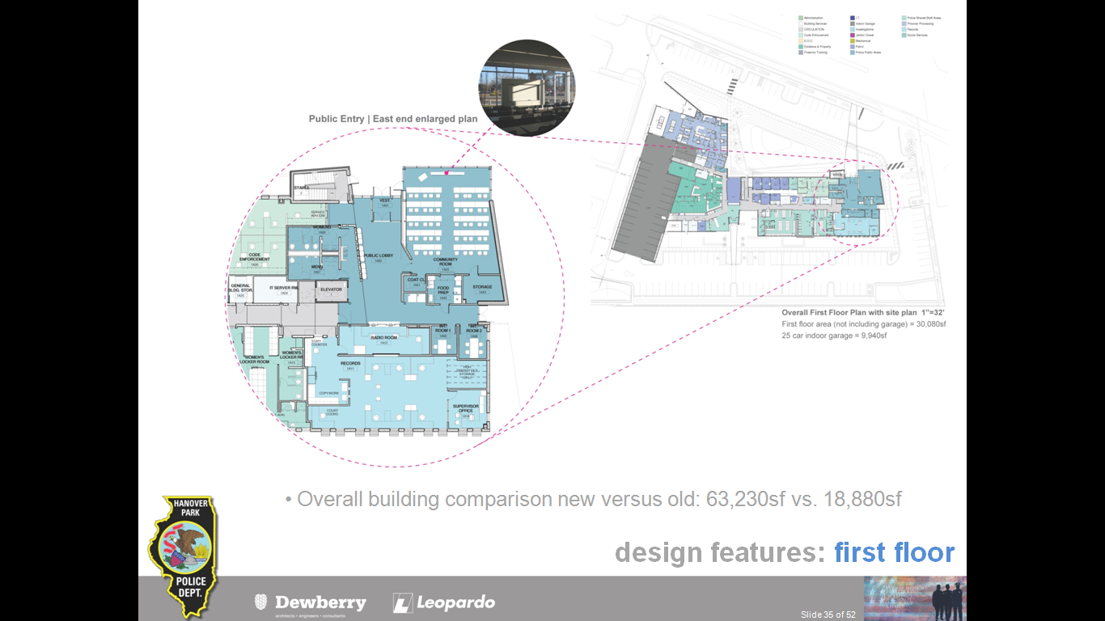
This graphic is just a blow up of that. Here’s the first floor. This is the blow-up area with, again, the public entry, the community room, storage, food prep, access. This was a unique community where they have a very active code enforcement department, and so rather than having a horrible way-finding where the public has to always go to the radio room or ask people where do they go to make a complaint or to pay a fine, it was very important to have code enforcement as very visible public window right there off the public lobby.
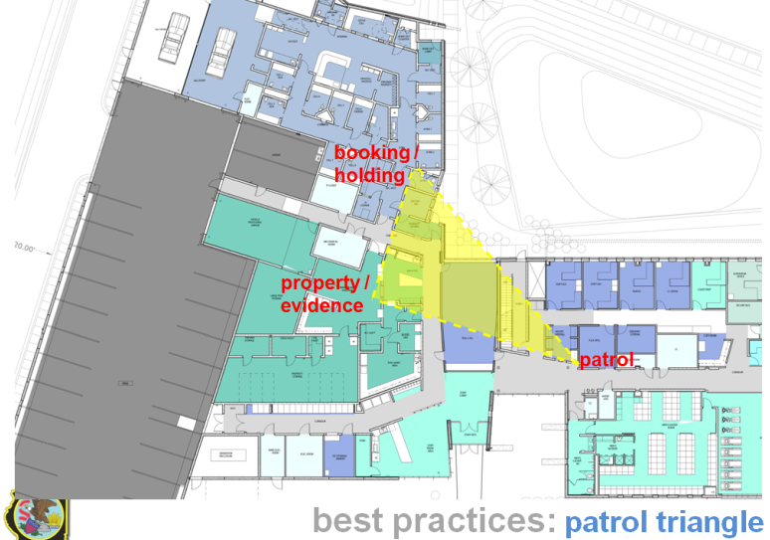
Just using this to round out the rest of the first floor plan, code enforcement patrol is right here in the middle. As you’ll see in another blow up, staff entry is right in the heart of the building for patrol, fitness, locker rooms.
Property and evidence are right here against the vehicle-processing bay in the garage. Then even though it seems like you wouldn’t want booking and holding on the front of a building because of its lack of windows, obviously, because of the need for the bond out door and the location of public parking, it just nicely ended up there from a functional standpoint.
Patrol triangle is another best practice: when staff come in, having a very efficient minimal effort of circulation to get to some of the busiest areas while you’re on your shift – from report writing here to bagging and tagging and processing evidence to then booking and holding department. Very close to the front entry for staff here on the south. That was a key goal, and having the symbolic roll call room right on axis with that staff entry was pretty important.
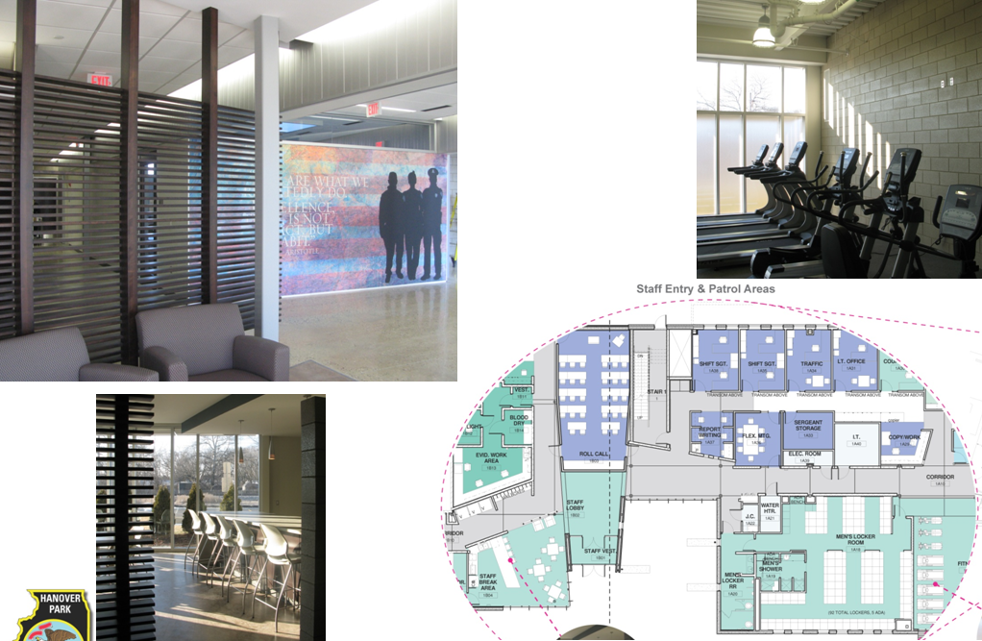
This is just a blow up of that cultural heart, if you will, of the police department. This image here is the axial terminus of the staff lobby, so we had a nice mural commissioned with a nice Aristotle quote that was to inspire all the staff every day when they come in for shift.
The break area: in programming, it’s always interesting to hear their feedback and their comments and the trends. They definitely wanted to get away from their more sterile area and go to more of a Starbucks café type environment – so having different types of seating arrangements from lounge chairs to bar stools, bringing some wood and cork flooring into that space. To this day, a year and a half later, it has become one of the favorite staff amenities of the building. They have a really nice fitness room now that has lots of natural light coming in from the south, which was a popular feature.
In terms of the second floor of the building, the way it’s stacked out is only about 13,000 square feet of the overall 62,000 square foot building. It is primarily investigations, administration, social services, and then a bunch of mechanical and support spaces.
As I said before, in design development, all of our square footages and scope are always being challenged and pushed down. We started to make conference rooms be off this main street corridor, so if they mostly lived in the investigations department, they could also have easy access to the main corridor, and anyone in social service, admin, and patrol staff could come up and reserve that on occasion.
That was a really good thing as the team was pushing us early on to really challenge ourselves there in making a corridor more than a corridor. The end of this corridor turned into the staff break area. When we started with the program, it was a true staff break room with a door, with its own sitting area, and again, that started to just flow into a more open commons area. It’s at the end of the hallway with some tables, chairs, wonderful glass looking to the south. Just really trying to be efficient with the square footage that you have.
The basement is just under 10,000 square feet and that is under the two-story bar. A five-lane firing range is the majority of it, with its mechanical and backup and support. Then there is a EOC/training room that is at the east end of that.
Again, just by the arrangement of the stacking diagram, even though they started the building saying this wants to be staff-only access, because it’s right next to the vertical elevator, it’s very easy now for outside agencies to come in and get let in down there. Even if they had an overflow of public event, they could let the public down there and it’s still very, very limited. You have the controlled doors pretty immediately after you get out of the elevator, so pretty good functional stuff.
Finally then, going into material context: we talked earlier about whenever you’re next to an existing campus – even though it was from the ’70s – they still wanted to have some continuity there. Looking at the existing brick from this campus was definitely a direction from the client to reintroduce some of that brick on our new building. The existing brick was this orangey red modular brick, but we obviously started to push things a little bit and said, “Could we work it in the budget” – since we were working so closely with our construction manager – “to look at Norman?”
We started to look at Norman brick. Then through just a stroke of luck with the Norman not being able to be shipped on time, they had some ambassador brick laying around. So we actually got this wonderful 16 inch very linear, almost peristyle, ambassador brick on the project. That was a bonus surprise.
The importance of mockups: I think this was talked about in some previous sessions. Even if it was Design-Bid-Build, you can always spec in mockups. But whether you go Design-Build or construction manager at-risk, having that discussion much earlier in the conversation where they can also help you sell it to the client and say, “We really should do these kind of mockups to reduce the risks,” so we know ahead of time what is this brick texture going to look like.
This was an industry thing to add texture to the building. The client was pretty confident from our renderings early on, but when we did this mockup at the beginning of construction, it just totally sold them on that.
The same with the block, with durability. Again, we’ve heard this in past presentations: how do you protect at least that first four feet wainscot of corridor? We wanted to do it in all block, but there was a concern from the client: “Is that going to be too cold? Is it going to be too institutional looking? Can’t you add striping or all sorts of different colors?”
We wanted to do it very minimal, very sophisticated, so we did a mockup showing them that we could just use a ground face block and an occasional textured block, a split face block, and add some really sophisticated, elegant interest in that. The mockup really helped them sell that.
Between the block and the polished concrete floor and some skylights on the second floor, it really added what we were hoping to go for as a durable timeless finish for this. To date, they couldn’t be happier with the easy maintenance of that floor and the walls.
This is one of the conference rooms that are accessible on the second floor that’s easy to get to, and then this is the break area at the back.
Sunshades and screening. The theme last year was poetic pragmatism. In design, you think about in this trying time, how can we keep pushing design but make it more functional and really convince not only ourselves but the client that it’s worth keeping?
Obviously, sunshades on the south and vertical fins – in this case, on the north – were really helping from a screening standpoint. We really were able to sell the client not only from a design standpoint adding a rich texture with these 11-inch fins but because it faced north on the very busy Lake Street, anyone driving by at 40 or 50 miles an hour, this is really what you saw. You just saw the louver of fins. You couldn’t see directly inside of it unless you are walking past. They bought into that premise, and it was a really nice add to the project design.
Just some finished images of the project. This is definitely the civic face that we were able to achieve, more than just the concrete box that the original expectations were hoping for. It’s the very transparent community room right there on the northwest corner, the two-story lobby here at the main entry, and then the investigations department, which has its very open ribbon window on the top and then patrol on the bottom.
Then as you get towards the west part of building, it is your property return juvenile area. We’re able to keep that really nice brick at least for the first 12 foot datum, and then you have the precast finish, the more economical system poking above that.
Some views at the front. Here’s that rain garden, a depressed area, that, as Larry mentioned, not only saved us money from that standpoint but it becomes a natural standoff barrier for that, as well.
Again, it was a puzzle. We would have loved to have had a better standoff distance, but it was such a tight urban site that it did get pretty tight. But we have the bollards here right at the public entry to help give them a little bit of that barrier protection.
This is the view from the northwest corner. This is your bond out area with water celebrating the idea of water coming down and dumping into this stormwater area. This is the bond out area, and this is a screen with sally port.
Just a couple of more shots. The precast concrete: as you saw on the other slide, it was a project of two material stories. You had the contextual story to the north with the brick, you had a lot of these precast with the interesting reveal pattern on the south, and then the administrative suite which cantilevers dramatically out towards the entry to the community to the east there.
You have the fitness room, which has a lot of light there, and then staff entry is right in the middle back there. At night, the staff entry is very inviting. You have a staff patio here at the entry. Roll call is behind the behind the mural. You have the café break area. Then report writing and that upper break area on the second floor as well at the staff entry.
Public entry: in bid package six, we were able to keep the terrazzo. It just really helped to convey that civic image as well as some of those features. We all try and get into our civic buildings. Having a custom cast badge that’s in the floor was a really nice feature.
Finally, as was mentioned before, we were just happy. Even though there are all of those very nice glamour shots, the most important thing at the end of the day for the client was that they got their firing range and garage. That was one of the critical success factors from the beginning. We think with the Leopardo Construction as our construction manager at-risk that they were very valuable in making that happen.
Jake: The integrated approach being the best approach in a way that the process of fast-tracking the project, the collaboration, the ability to conquer some real roadblocks in the way – a budget that was set that had no real bearing on reality.
In a way, I think the project was somewhat bailed out by a marketplace, but I think that this integrated team helped to really harness the opportunities that were out in the marketplace and to help also subvert the risk a little bit for this owner and make them feel better about the fact that they were spending money – the situation was really being taken care of.
With that, I think we’ll open it up for questions.
Participant: What was the total cost to the end?
Larry: The total construction cost was just under $16 million. It was $15.938 million.
Jake: There actually was some contingency return?
Larry: There was. That was the total cost after a lot of the things had been added into the project at the end. They had extra budget left so there were some things – like some extra window blinds, window coverings, and some extra furniture – that the owner wanted, so they took those out of the remaining budget, worked up towards the $16 million mark.
Participant: Did the contractor earn [49:46–49:50 inaudible]?
Larry: I actually don’t know the exact amount that the contractor got in shared savings.
Jake: It was a stepped arrangement, the way that they worked it out, that they got something like 30% of the first $50,000 of savings or something like that, and there was a cap – and I think it capped out at maybe $100,000 in total shared savings.
Participant: What kind of bid covers did you guys did there? I know the market was really in tough shape, but I guess, at the beginning, you still got a lot of people, and then as we’ve gone through the five years, a lot of firms have gone out of business. Were you still getting a lot of bidders on those packages?
Larry: It varied from package to package. The precast was a great example. We knew that we were going to be really tight on that, just because there aren’t a lot of precast plants that were operating at that time, and one of the plants was operating at capacity. We knew that going into it, so we knew we were going to have two people bidding that. That was the minimum that we went to.
Other than that, we were pretty fortunate, and I think we had usually on average somewhere between five to eight bidders on about every package.
Participant: Who did that precast?
Larry: It was Dukane. We had brought Ducane in early on in the process. They offered design assistance and everything. They helped us with the economy of the precast package as well as the detailing and size of the panels so that we could minimize the amount of cost in that, as well.
Participant: How long did it take the construct?
Larry: It was a 14-month process.
Jake: That included the snowmaggedon and the soils and everything else. It finished pretty much right on time.
Larry: We actually finished two weeks beyond our original schedule date, and those were both due to two weeks of severe weather. Is anybody from the Chicago area? Does anybody remember that? That was the storm where everybody was stuck on Lakeshore Drive.
Jake: People were sleeping in their cars. It wasn’t pretty.
Thank you for attending.

