Moving Design IV: Outdoor Learning Environments
Linda: Thank you for taking time out of your busy day to really look in detail at the Green Schoolyard Movement. We’re very honored and pleased to have with us Sharon Gamson Danks, who is an environmental planner and founding member of Bay Tree Design, Inc., in Berkeley, California. She runs a woman-owned landscape architecture planning firm that has been collaborating with clients to develop lively outdoor spaces, including ecological schoolyards. We will tell you more about Sharon, and she will tell you more about herself.
Roy Diblik, who was to join us today, has just come back from a whirlwind set of workshops on the East coast and has come down with laryngitis, so he cannot join us today. We will talk briefly about his no-maintenance approach to planting community gardens.
Let’s begin. Everything that one can learn inside can be learned outside. In the twenty-first century, we are looking at incorporating nature-related understandings and a return to associating how the things that people do – the way we teach and learn – are directly connected with the outdoor environment.
The Green School Movement has really infiltrated the type of environmental education that is running through the renovation of our existing and the building of our new schools. We also know that green school means a green curriculum, and it means coming outside on the school campus and changing and transforming learning opportunities there.
Roy Diblik is an outdoor educator and garden designer and worked on the Lurie Flower Garden in Chicago and recently finished the Shedd Aquarium. He writes about how plants need to planted together in a community that supports and sustains each other.
Our main guest today is Sharon Gamson Danks, who has been doing research on schoolyard projects in North America, Europe, Great Britain, and Japan over the last ten years. This has helped her develop design guidelines and best practices for green schoolyards. She has written her first book, “Asphalt to Ecosystems,” which is available. It's really informative, and has even more images and case studies that she’s going to share with us today. We’re very pleased to have her.
Welcome, Sharon. Let’s get started.
Sharon: Thank you so much for inviting me to join you today. It’s an honor to be here with all of you. Thank you for the introduction.
I am speaking to you today as an environmental planner. I have a background in landscape architecture and city planning, and had first asked the question about this topic when I was in graduate school 15 years ago looking at how cities could be designed so that they take fewer resources to run, and how do you involve ecological systems thinking from the city perspective in the design. To me, it involves citizens understanding ecological systems. Where does that come in? For me, that comes in at schools.
I started looking at school grounds from an ecological perspective. This slide captures that in some ways. What I’d like to be able to do is see ecological systems on school grounds as educational tools. They can be small tools, like the small wind turbine on the left, that demonstrate production and function of an ecological system. Or they can be large tools like the very large wind turbine on the right, which allow to the school to have a positive impact on the ecology of their place.
I was drawn to this topic from an ecological systems thinking perspective, and over the last twelve years, I’ve done research visiting nine countries and going to about 250 school grounds to get an idea of what schools are doing to bring these ideas to the children. As a parent in the last twelve years, I’ve also become more interested in the way children experience cities from a play perspective and from a perspective of how they wander through their neighborhood.
This slide here is from an article written by David Derbyshire in 2007. It shows a family in England whose children at eight years old had different ranges they could roam in the same geographic space. The largest bubble there is the great grandfather, and the progressively smaller circles represent their children over four generations, with the current eight year old only allowed to go to the end of the block.
To me, this loss of children’s domain – children's shrinking domain – is really a profound thing that we as a society should address in many ways. On school grounds it says that if children are no longer able to go off on their own and have an adventure outside of school, then it’s the school’s responsibility to put that sense of adventure, challenge, curiosity, and mystery into the grounds. What we often give them instead is a blank slate of evenly manicured lawn, or flat asphalts, or a play structure with particular ways of playing the “right” way. There’s no sense of exploration there.
This slide includes things along those lines that allow children to both understand local ecological systems and their place and do so in a way that promotes inquiry and exploration.
Linda: Building on what Sharon has shared with us on the map of England, is a map from our own country. The top slide is just a graphic that really says that almost 50% of our students are bussed, so they go from their home to the bus to the interior of the school with maybe only 20 minutes to play on an asphalt playground.
If we look at the other 50% who are not bussed, we find that almost half of those people are also driven to school and picked up by their parents. If we also look at the amount of unstructured time per week a child is allowed free time outside, it’s less than 15 minutes.
Sharon: The first example I’d like to show you today is one from San Francisco. This is not a project I was involved in, but it's one that I admire and one that has sparked a movement to transform school grounds in San Francisco. This is the Tule Elk Park Child Development Center as it looked in 1991 and the same view of that same place ten years later. You can see in the background that there are buildings that are starting to disappear behind the trees.
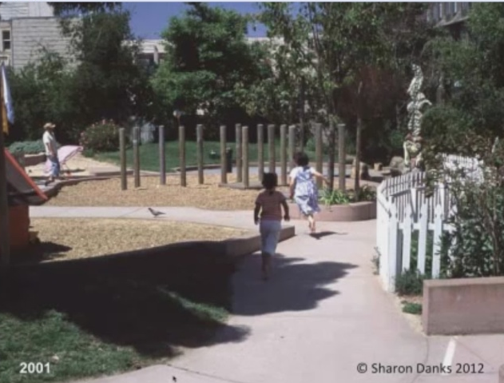
The same shot here is in 2007 where the buildings have fully disappeared. You can imagine that the children playing and learning in this yard have a completely different experience of the world around them than the kids in the first picture.
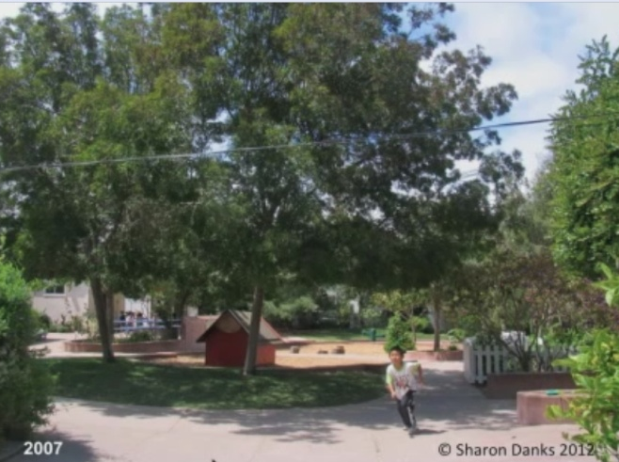
This also brings up research by Wendy Titman who talks about the hidden curriculum of school grounds and what children pick up from their environment about the value adults place on them and their environments. This says to children, “We care about you.” The other environment doesn’t say that. So, really, children see schoolyards like this as an expression of care.
In having the opportunity to visit schoolyards around the world and talk to people in different places, I have drawn from that research and experience six themes that I see recurring in school grounds. To me, the schoolyard projects that are the strongest are the ones that have all of these six things present on the same site. I’m going to talk about one case study that has them all in one place, and then I’ll go through each of the six as the structure of this presentation to tell you more about what each of those pieces entail.
The first example is taken from the Coombes School, which is in England. This is a remarkable project that has been continuously developed over a 40-year period. It’s a site where something new is added every year, and more likely, every semester. The entire school is involved in making those changes. The single head teacher, Susan Humphries, spearheaded much of the project's development, and subsequent head teachers, principals, have taken it on. Really, it involves taking the entire curriculum outside and weaving the components of play and learning together.
What you’re looking at here is a tree that the children are playing under that was planted by children many years ago. Hanging in the branches of the tree are wooden spoons that were carved in front of the children from wood taken from their site. The children have turned them into art projects, and it’s one of many rotating displays that are on the school grounds that show off the children’s own handiwork.
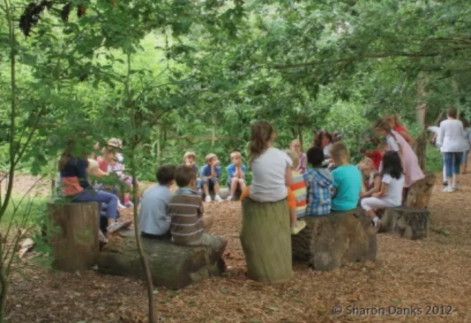
Here is a scene where the kids are sitting in a forest clearing in a forest planted by children many years ago, on logs of those trees planted by children. They like to have every child plant at least one tree before they leave the school. This is only about a two-acre site, so you can imagine that, with hundreds of children planting a tree before they leave, they would have a lot of trees. So the other piece of that policy is to make sure you cut them down. It teaches sustainable forestry, and it also gives them plenty of materials to use in their lessons.
They have three different ponds on-site. This school was a preschool for most of its history. When I was there, I asked Sue Humphries about the safety and liability issues surrounding having the ponds on-site, and she said, “Well, England is an island. There’s water all around us. We have rivers. We have ponds. We need our children to understand safety at the water’s edge, so, of course, we have ponds because it’s our responsibility to teach those things in a context that’s manageable.” I think that’s a really enlightening perspective and a very reasonable one. Most of our cities and towns also have some water in their midst.
Here’s an example of what you get when you put that rich ecological system near children. They have, among other things, some farm animals and ducks on-site. Here’s a photograph of the excitement that ensues when the ducks make their short migration from one part of the schoolyard to play in the pond. They celebrate everything that they do on the schoolyard, so to celebrate the ducks coming from their enclosure to the pond that day, the kids drew artwork on the pavement.
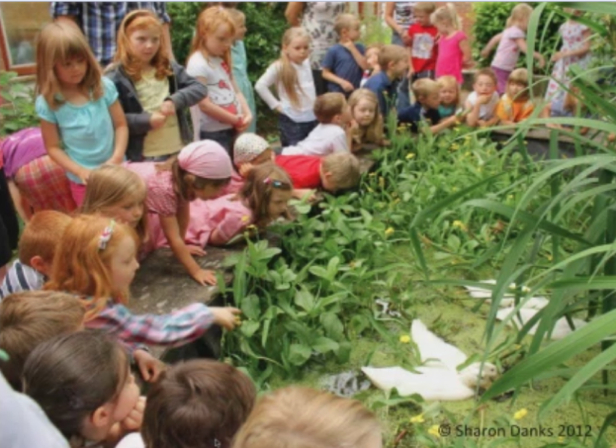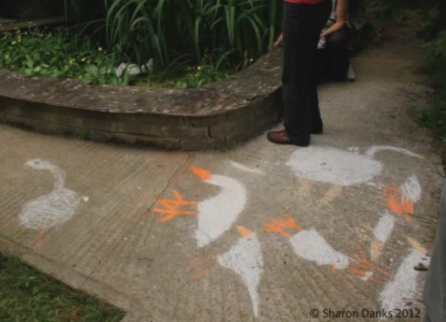
There are many things that they put outside for recess for their children. As I said, the school was a preschool, and now I believe it’s preschool through fifth grade. They have age-appropriate play. In this case, the younger kids do finger painting on a chalkboard with bubbly water.
They also allow water play with some simple storm gutters and buckets. And really, when you think about it, this is about understanding gravity and fluid dynamics – really complicated concepts made relevant for preschoolers.
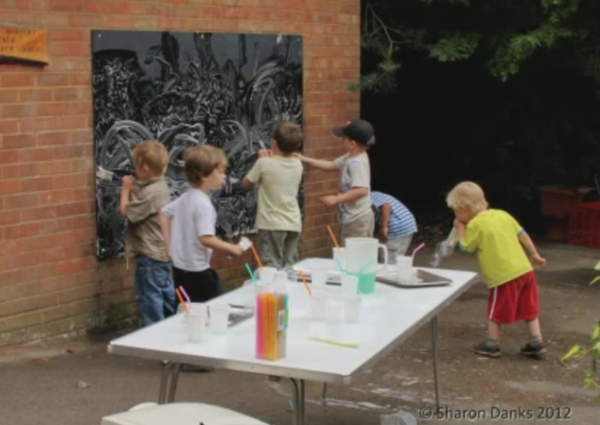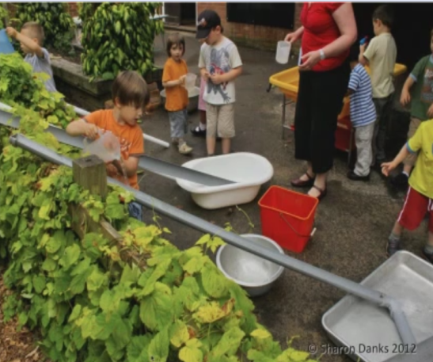
There is a lot of joy in playing with water, and the best part is making puddles and then being allowed to play in the puddles and getting a bit dirty. That requires, of course, having some extra shoes, pants, and shirts for those who get very dirty all the time. But they find that it’s a manageable thing.
In keeping with the project-based learning methodology that they have, here is part of a temporary exhibit on how things are made and what they’re made from. In their schoolyard, they have many different kinds of trees. In the foreground, there are some willow trees hung with baskets and chairs and furniture made from willow. Elsewhere, out of sight of this picture, they have a walnut tree with a headboard hanging from it, and oak tree with a chair, and a pine tree with a doorframe so that children can make the connection between the source of the material and the products that come from it.
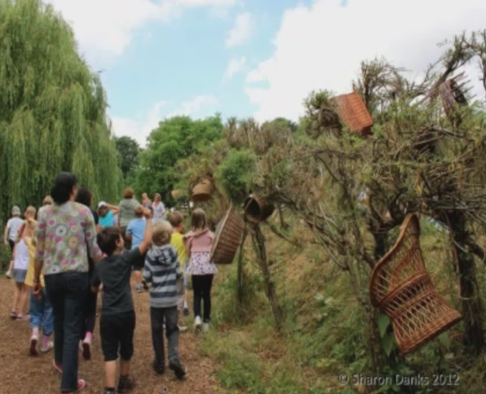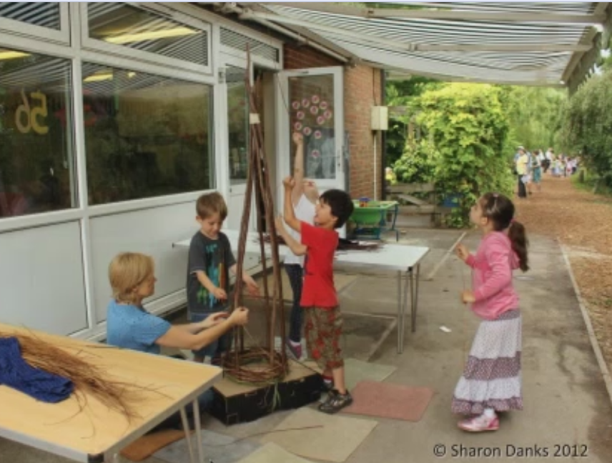
They learn about something and then they put it into practice themselves. They become the experts on this by trying it. Here, children are making a willow garden ornament for their edible garden with wood cut from their site.
On-site they also have the most fabulous geology trail I’ve ever seen. This map shows where all of the rocks on their school yard come from. There is a little bit written up about what type of rock it is and what the history is – where that piece of rock might have come from. It might have come from the port to build and old port stone. It might be a millstone. It might be a particular type of granite from Cornwall. This is about the geology trail that is spread throughout the school.
Here’s an example of one of those fabulous installations. This one is called Coombeshenge because, for them, Stonehenge is a local place. This is their idea of an outdoor classroom and a playhouse with local relevance and cultural connection.
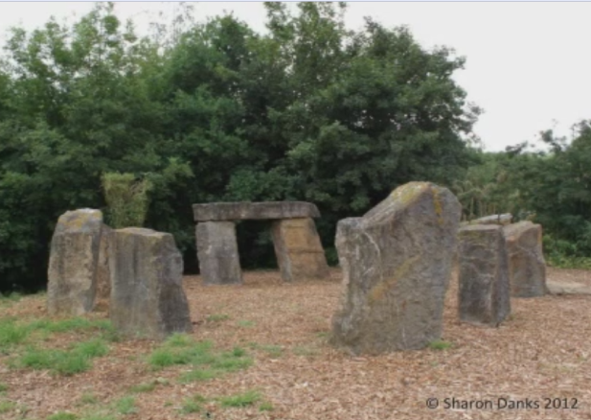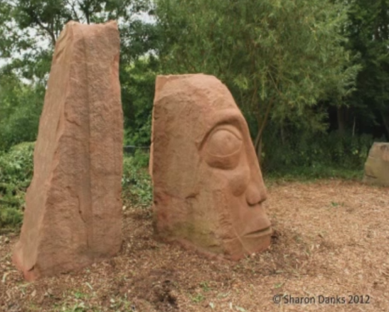
Here’s another piece of artwork that’s part of the geology trail. For this one, they had the artist come to the school site. This face was not carved offsite; it was carved onsite in front of the children for as many weeks as it took for the artist to actually do it. I think the classes came out formally to watch, and they also just had him working there so children could understand how things are made.
Linda: Thank you. The Coombes School was so beautiful and inspiration and motivational for all of us who are working with school groups. How do we make that transition from the way teaching has been done inside to really connect all of those subjects – the common core state standard subjects – in and out through nature?
Sharon: After showing you Coombes, I just want to underscore that that project did not come about overnight. It’s a process of adding something incrementally over the years. So don’t get discouraged if that looks large, comprehensive, and challenging. It’s quite possible to do a little at a time. All the rest of these examples I’ll be showing you are projects that did things a little bit at a time, as well.
From this point forward, this is a mix and match of different examples from different schools. This slide here is about hands-on curriculum and how putting things out on the grounds allows schools to teach what they’re already teaching outside in a way that the kids can touch.
For example, the picture on the top right is of a garden teacher teaching about the parts of the plant and then letting children eat parts of the plants – in this case, a radish for roots, or fruits like oranges.
It’s important to have a place to sit, structurally, in these schoolyards. It’s great if you can have one location that’s some sort of an amphitheater that seats multiple classes, or even the whole school if there’s space; and then other spaces that seat a single class, and smaller spaces for break-up groups to work in small groups of one to four.
As some of the examples of what teachers can do outside, here are some slides of science studies. The first is wind studies using balloons. The second is geology. On the top right is a human sundial, where the child’s shadow casts the time on the ground. You can do wildlife studies, decomposition studies, and many other things.
Measurement is a very easy component to weave into the architecture or design of the paving or the painted patterns.
Reading language studies could involve having a place to sit and read to a child or posting quotes that resonate with the school’s values. Using signage to convey languages taught at the school is also popular.
Outdoors is very conducive to messy art lessons, and it could be something like this more formal stone carving studio at a high school, or simple things like just having a place to sit and paint; and also places to install children’s artwork, whether it’s a ceramic tile or painted wood so that some of the children’s hands show in the site design.
Ecological systems can be realized in many different ways on-site. The first example here is one wildlife habitats. For almost every school, especially in urban or rural areas, you can invite pollinators to the schoolyard by planting things that they’re attracted to. The case in the middle there with the mural is a school in Canada where the plants were dormant but the school still wanted you to feel like that was the butterfly garden, so they have this fabulous mural in the background.
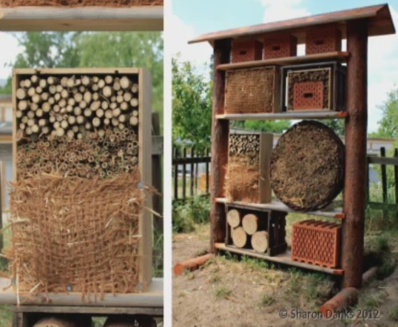
Feeders and other types of wildlife attracting things are good as well as having signage that explains the wildlife that’s coming. In some cases, it’s the wildlife that’s already there and you just need to point it out so that the children and adults will look at it.
This is something called an insect hotel that is at a schoolyard in Berlin. This one is designed to invite cavity-nesting insects to take up residence right next to the edible garden. It’s done in a beautiful way.

Wildlife habitats look different wherever you are and should reflect the local ecology. Here’s an example from an urban school in Chicago where they have a prairie habitat and had an artist make a few pieces to put in. That that takes a little bit of the wildness of the prairie and makes it intentional for the community.
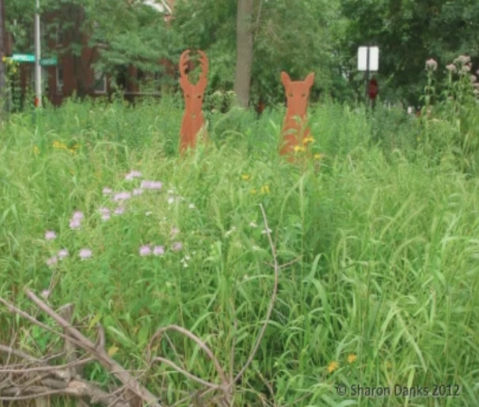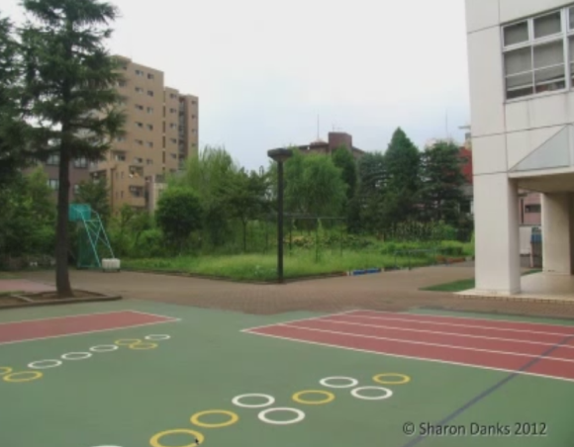
This is an example of a schoolyard in urban-dense Tokyo. In this school, about one-third of the site is covered by the building, about one-third is paved, and about one-third is unpaved. That unpaved area in the back is a pretty extensive edible garden and wildlife habitat with a recirculating pond system.
The pond system looks like this when you walk into the center. It’s really quite an amazing oasis in the midst of dense Tokyo. You can imagine that the children’s experiences here are radically different than they would be walking down the street.
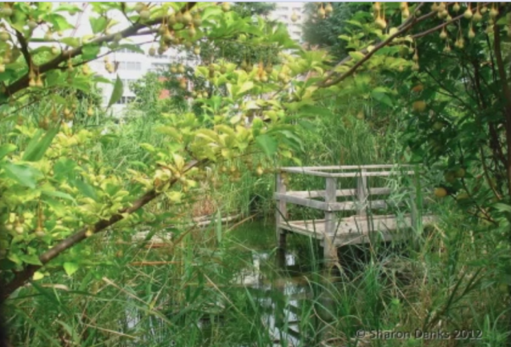
Linda: We’re trying to point out that the schoolyard habitat can actually take all the learning that happens inside throughout the years – from preschool, to middle school, to high school. There are many opportunities, and Sharon has wonderful examples coming up about performing arts, fine arts, math, history, and geography. Even when the teachers are not trained as environmental educators, they can actually bring what they’ve been trained to do outside to a schoolyard habitat.
Sharon showed us some wildlife habitats, and probably one of the most pressing needs in the outdoor classroom is to provide a place for what was really there from nature before we came and cleared the land and built our schools.
The types of things that need to be considered are – just like for us – the food, the water, shelter, and safe places. These can exist parallel to and on the fringe of – and begin to build that interaction between children and the outdoors and the life that is outdoors.
Sharon: Another ecological system that I think is really important to represent well and visibly on school grounds are water systems because a lot of children don’t really understand where the rain goes when it hits the roof and the path it travels in their local watershed. There are many ways to make that visible for children.
This example from a school in Taiwan is one where the train from the rooftop is captured in cisterns. The principle is pointing out the pipe signage that’s labeling rainwater. They have enough cisterns at this school to capture enough rainwater to flush all the toilets at the school, so that's what the rainwater's used for in this case.
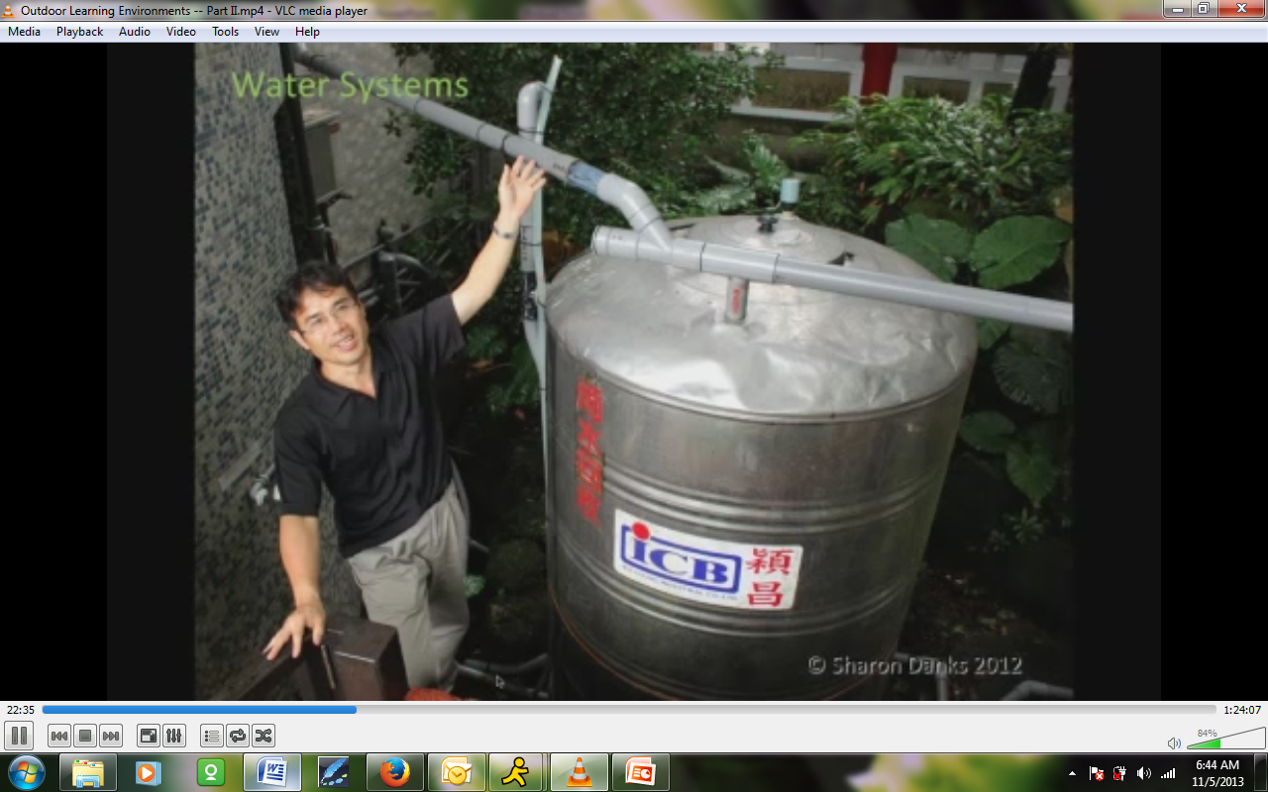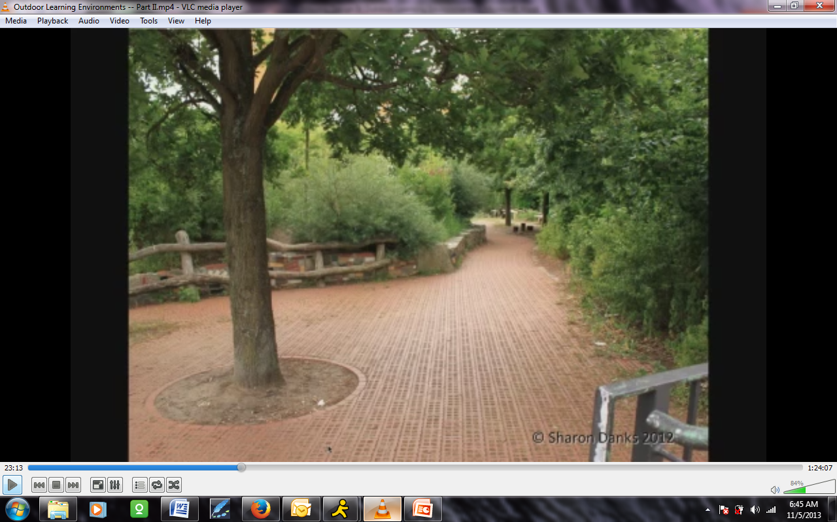
This is a schoolyard in urban Berlin, which was, many years ago, a typical schoolyard paved edge to edge. But there are policies in Berlin now that require schools and other public places, I believe, to keep all their rainwater on-site. The majority of the schools have taken up all or almost all their asphalt and have replaced it with permeable paving that allows the rainwater to soak in. It keeps their watershed healthier, and also creates an absolutely fantastic place for children to play.
When I walked through this yard on the tour I was on, I asked about how the teachers supervised the children because, in the United States, a lot of teachers like to be able to see the kids the whole time they’re playing. They said, “Yeah, we started out that way, too. But these plants were small when we put them in and they’ve grown up slowly, and that's allowed their policies to adapt.”
In the meantime, they found that children began to solve their own problems. They stationed the teachers where the children can find them, and they only bring the serious problems to the teachers. They learn conflict resolution on their own, which is a positive thing. This is a really interesting water example that has led to a social example as well.
Here is a slide where the principal of a school in Taiwan is illustrating what fun her water play pump is in her schoolyard. Not only is this a fabulous piece from a play perspective, but in the inset slide there, you can see that they have a number of outdoor hand washing stations in their schoolyard. The kids come in from playing outside and they wash their hands before they go in.
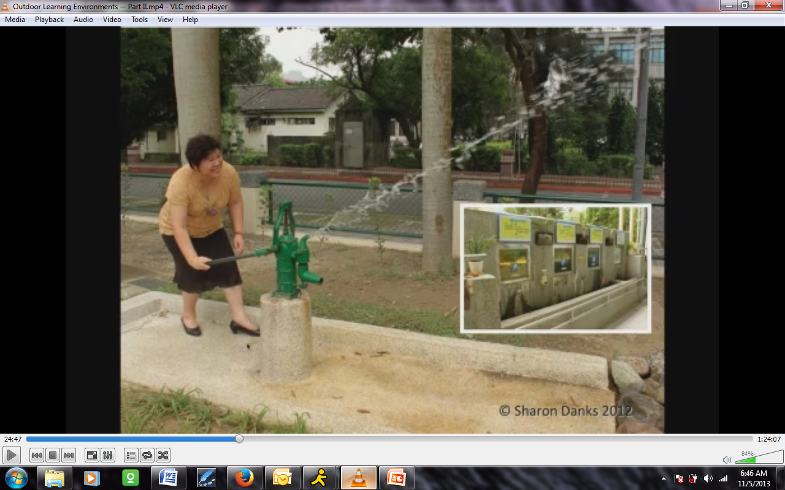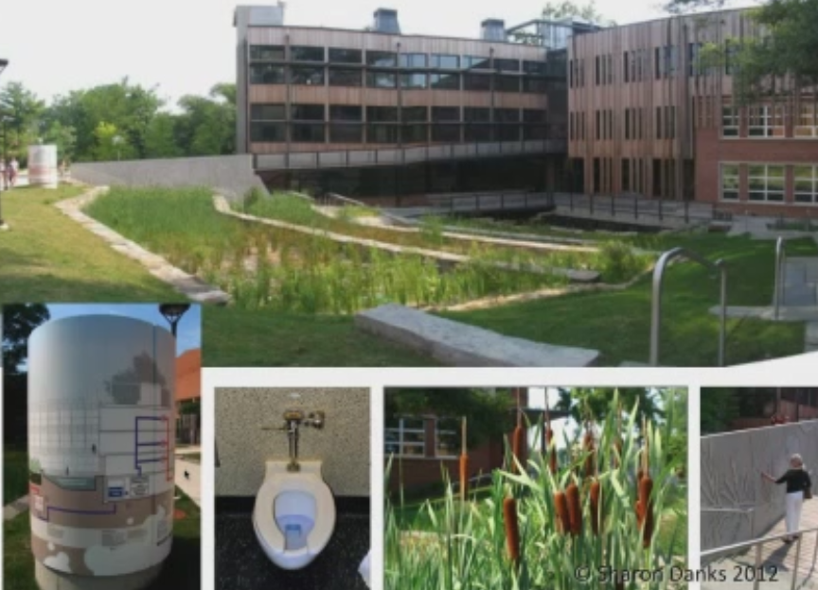
And along the top of that outdoor hand washing station are four tanks of water that is a gray water filtration system. They have signage above that explains. It’s an interpretive display for the gray water system. Then the water goes through an additional filter. After that, it goes into this play pump. So their gray water is part of their water play system at this school.
This is a picture of Sidwell Friends School in Washington, DC. There are many remarkable things about this school’s design, which is a LEED Platinum school. One of the most remarkable is that, at their front entrance is a black water treatment wetland. The school’s toilets flush into a system that goes into the basement through different purification filters, and then comes out into that cylindrical display on the bottom left which is covered with a fabulous interpretative display that explains the water’s path.
That’s a filtering system, and you can see it in the top picture in the background on the left. The water then goes down three tiers of wetlands through plant filters before it’s used again to flush the toilets. It’s a remarkable thing to have as your entry piece. It’s beautiful and welcoming.
Linda: With this idea of taking water which is this invisible thing that we use every day on a daily base and making it more available to students, we know that all of these first-hand experiences are actually the best experiences and build the deepest memory. But we do know that there is book learning that goes along with this, and to support both the teachers who may not know these and the students on their own. The Earth Day Educator’s Network and other non-profits have organized curriculum that is accessible for teachers to help connect water to every element of their teaching.
Along with water, if we really look at the transformational nexus that should inform our education, there’s the water-food-energy nexus. How we use energy and where it comes from, both in the natural systems and in our artificial systems, is really integral to changing the way we do things.
Sharon has some great example.
Sharon: Here’s a school in Berkeley, California, that has a small demonstration-sized solar panel that's connected to the pond. The children can come up to the panel at recess or during class time and turn it. That’s what turns the water on and off in the pond. The sun wasn’t really shining so much in this picture, but there’s a jet of water that comes out of the central rock as the fountain when the sun shines on that.
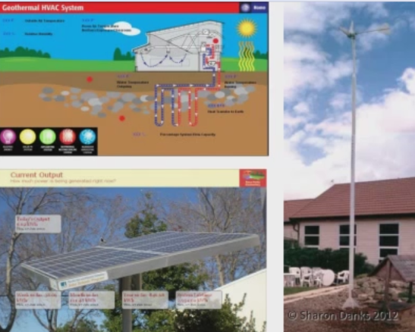
I see children bringing their parents over to explain that all of the time. A simple cheap investment like the small solar panel there is often a better educational tool than the extensive ones on the roof that they can’t see.
It’s also key to have interpretive displays, particularly for hidden systems like a geothermal system or a larger solar installation that is less interactive. It’s key to understand how they work and how much energy they’re saving.
The wind power is just another example of a different type of renewable energy.
In addition to energy production, schools can conserve energy. This is a slide from Kyoto, Japan with a very lightweight trellis system that they call green curtains hung over the side of this environmental ecology center for children. It changes the experience of the room, as you can see in the picture on the bottom right. Looking out, it hides the parking lot. It produces food, and it also shields the building from excess sun just in the summer. The plants die back and it’s open in the winter.
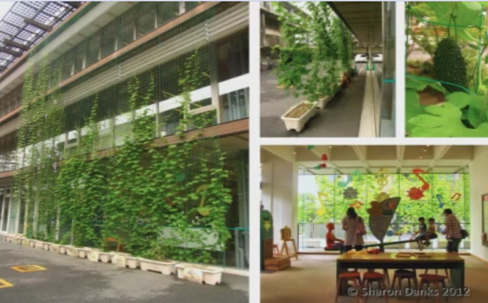
In our typical schoolyards, children also are touching a lot of man-made materials all day – plastics, composite desktops, and metal. It’s nice to be able to reinforce connection to the natural world through using natural materials on the school grounds, whether it’s something like logs or rock in different types. These are places in California on the left and in Norway on the right.
Earth itself can be used as a building material. Some schools, like the one on the top left, have made things out of cob – which is like adobe but made out of one-piece adobe – build by the community. For that little greenhouse, you can use rammed earth or wattle and daub to teach ancient building techniques as well as creating things from a few resources.
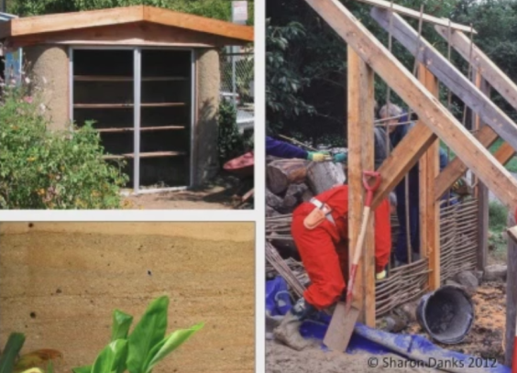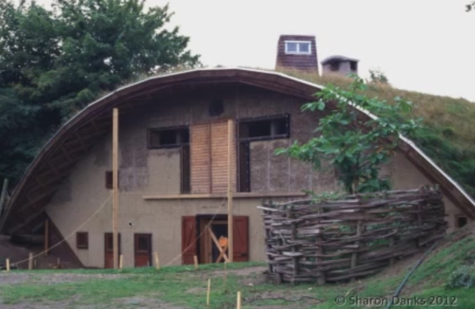
This remarkable building is the Permaculture After School Center in the city of Lund, Sweden for the public school system. It probably would have gotten the LEED Platinum stamp, but this was built about 15 years before that system was created. One of the most remarkable things is that it was physically built by middle school students as their after-school program under the direction of an architect as their after-school leader. This is the barn for the Permaculture After School Center. The side out of the picture has wind turbines and other things, but the building itself was built out of light clay infill and a wood structure and uses recycles materials throughout.
Salvaging building materials is also important to include, whether it’s wood or concrete or they have special significance like those millstones. You can use ceramics to make murals. There are other things that go beyond just mere recycling that shows children how material can be re-used in a beautiful way.
A sense of place is what you’re creating when you put all of these things together. It’s also something lacking from most standard playgrounds, which are just asphalt, grass, and a play structure from a catalogue. We’re trying to create variety, uniqueness, and sense of place. Part of that is natural context.
This school has a watershed model for their own school permanently installed in the schoolyard with a bit of vertical exaggeration on the hill so that, when the teacher pours water down, children can see how their watershed works.
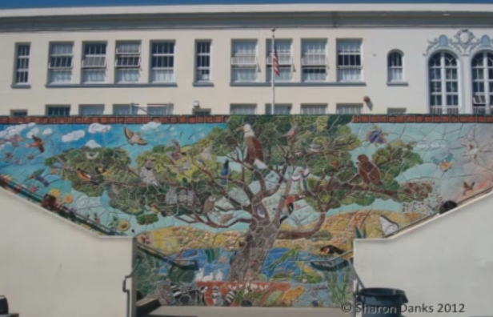
This is an example of the ecology of San Francisco being captured in a mural that was a collaboration between a local artist and the students. It captures all of the pieces of the ecosystems in their own environment.
Place-making is also about cultural context. In this slide, we see a teacher at a school in Taiwan who is explaining the local tradition of making indigo dye. What they have on-site are indigo plants and a way of processing them and teaching that traditional local craft to the children as a piece of their local culture.
Geographic context includes your place in the world from a geography perspective, so that may mean making maps of the world or maps of your country, your state, your city, or interpretive displays that show important landmarks and compass directions somewhere in the schoolyard.
Again, in regards to making the schoolyard memorable, this is a piece of art done by a basket weaver, but it’s also tree guards around the three trees growing in this picture inside those baskets. The idea is that, unlike the metal systems, these baskets are designed to fall apart over time. They were installed with the belief that they would fall apart at about the same rate when the tree would no longer need protection.
John: We have a question from Deborah Young. She writes, “I’m curious to know about the design of the features to meet the needs of all students, as this is what I consult on with schools in my area. For instance, making sure that the features and exhibits can be accessed by students with mobility, sensory, or cognitive limitations.”
I know, Sharon, that you have some things to show about that, but would you like to respond?
Sharon: There are a couple of slides coming up soon that speak to that. I do think that it’s important to put accessible pathways through these playgrounds, and every key feature should be on that pathway system so they can be enjoyed by everyone. As we’ll see in the play section, that accessibility is also a question of having size-appropriate play environments and learning environments for children of different ages, as well.
John: Thank you. This whole session is being recorded and will be available on YouTube. We weren’t able to provide a complete handout of this slide presentation due to the agreements with the publishers of Sharon’s recent book, but you will be able to get access through YouTube.
Sharon: There may, in fact, be a handout which is not quite available yet, but hopefully soon. Moving along with play and addressing the question about equal access from the sense of size and skill of the students at a school, a lot of places around the world have looked to something like basketball where, in the traditional set up, you have one court where just a few kids can play on that takes up a whole lot of space. It’s typically dominated by the kids who are the fastest and the strongest, which sometimes lends itself to bullying.
What these schools have done to combat that is to arrange the basketball hoops at all different heights, which lets kids who are not quite as good at basketball yet try their hand at an appropriately-sized hoop, or, if they’re younger, to gain that skill. It also lets more kids be active more of the time. You can have more games going. Here are a couple of different formats where that works.
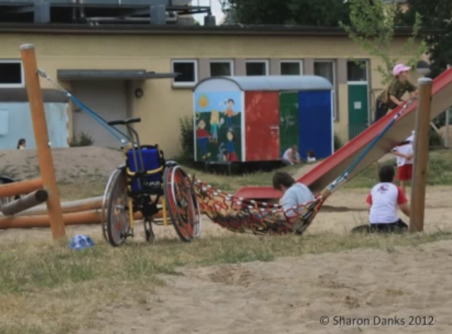
This slide also speaks to accessibility, but from a different perspective than our American perspective with our particular regulations. This one is a school in Berlin that is a special needs school. It has a large number of students who are in wheelchairs. They took the approach of asking the students what they wanted in their schoolyard. They wanted to off-road across the sand and the grass to play with their own abilities on things that they could reach.
Here you see a child who’s gone across the grass and the sand on his own and put himself in the hammock so he could play there. In the background, what they do with these slides is make them double way so that a caregiver can take a child down a fast, exhilarating, exciting slide sitting next to them, instead of dumbing down the experience and putting it on a small height. I’m sure that there are many ways to approach this, but this one is just a unique perspective I thought we should look at.
Throughout Scandinavia, this is a standard play structure for swings. What you can see here are six children swinging at a time facing one another so they can actually talk and have a conversation and play a game together. This is part of the social play theme that you find in Germany and Scandinavia where research shows that children learn more, play better, and have a better understandings of their bodies and social negotiation skills when they have to talk to one another and say, “I’m going to go this way first, and then you’re going to go second.”
The swings are also designed so that they can’t all be jumped off of at the same time. You see that there are different configurations so there’s a chance for negotiation, but not too much chance of hitting one another.
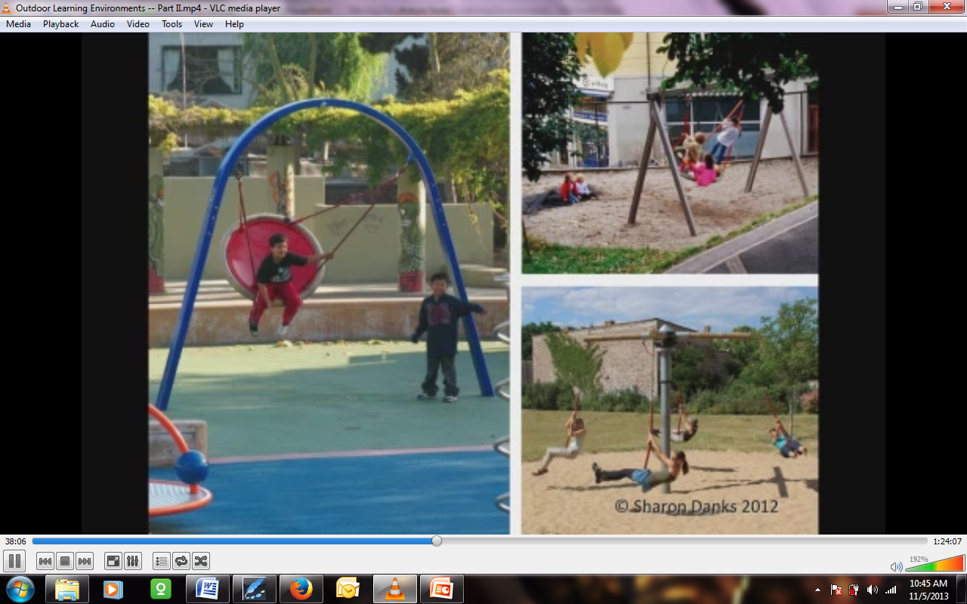
Here are some examples of other types of social play. On the left is an arch swing that is commercially available in the United States. You can see it used in Sweden on the top right there. Multiple children can play on it at once – big kids, small kids, and parents with an infant. It often takes more than one child to push it, so it’s a social experience to play on it. And there's another swinging social example below.
Very often, when you have a schoolyard that’s entirely asphalt or lawn and a child can see from one side all the way to the other side and see every corner, there’s no reason to travel to the other side of the schoolyard because you already know what’s there. But if you make pathways and things that make the schoolyard just a little bit more mysterious, then you find that children will follow those paths, run through them, and get a lot of exercise on their own. Research actually shows that environments that invite this kind of active play have children who get far more exercise than they do when they’re playing sports.
The idea is not to eliminate sports space, but to balance it with environments like this. Here’s a pathway calling to be run down.
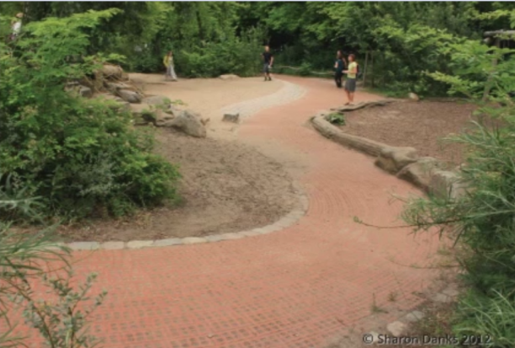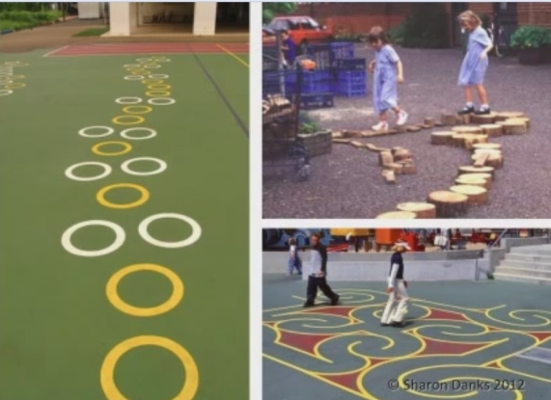
Those types of experiences can also be created with paint and by giving children moveable materials that allow children to make their own path. Those are just log rounds.
Here’s an example from Sweden. Again, in Sweden, Norway, Denmark, and Germany, a lot of trees, when they’re taken down in the neighborhood, have their small branches taken off and the trees are given to schools as play equipment. This is starting to become popular in the San Francisco bay area. Generally, the logs I’ve seen in the U.S. are more on the order of the left part of this slide, rather than the right. But it's the idea is that natural features liked downed trees can be imaginative play as well as active play pieces.
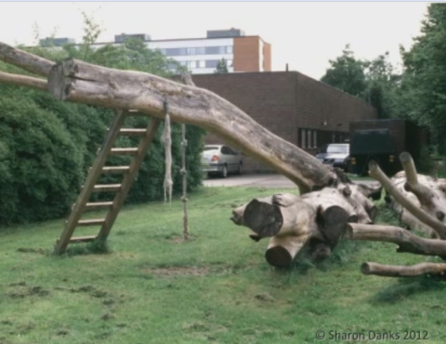
Here are some examples of embankment slides built for children in Norway. The advantage here is that you get an exhilarating fast ride with a very safe experience. If you fall off the slide, you’re just on the hill. On the right is an example from a middle school in Norway. They have playgrounds for middle school kids, and their equipment is just larger.
This is another school in Norway where the children asked the designer to build them a mountain. He gathered up 400 boulders from a fjord nearby and had them installed by crane. They’re gigantic rocks. They were mapped by a geology graduate student, so the school uses them as a geology curriculum. But most of the time, the kids play on it. They climb up to the top of that. They go down the little house on the top through an area where they can rappel down inside the pipe and then run out a tunnel. And in the winter, they sled down this hill.
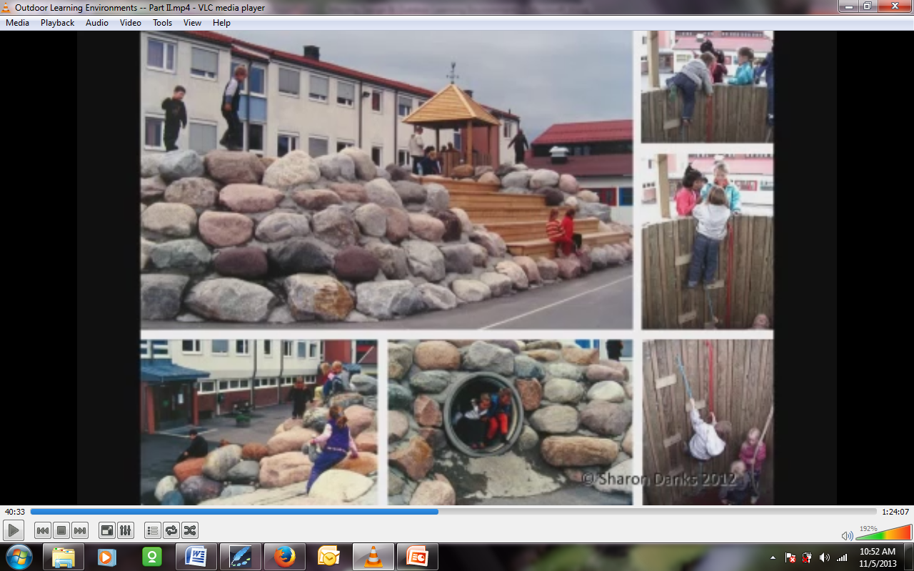
When I walked with the principal and the designer, I asked them if they had a lot of injuries on this because I didn’t see any safety surfacing and the children were climbing on rocks. He said, “Oh, no. Actually, our injury rate has gone way down since we’ve installed this because the children aren’t bored and children know how to climb.” I just thought that was a very refreshing perspective. I don’t recommend not having the play surfacing, but it is an example of treating children as if they are competent. That’s often followed by the fact that they are.
Everything you put in the playground will be played on. Here’s a seating circle, for example, being used for creative play games. Providing opportunities for creative, imaginative play to occur is an important aspect missing from most of our standard schoolyards.
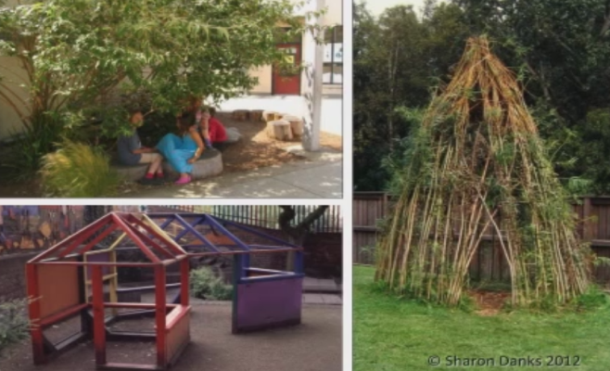
Some things we can add quite easily are playhouses of all different types. Those could be living playhouses or bushes carved out to allow children to make forts underneath them. They can be transparent playhouses for younger children.
Having manipulatable materials – loose parts – for kids to play with is very key. At a school in Berlin, their storm water run-off system goes into that boulder channel, but the top of the channel is also a play feature with a water pump with municipal water.
As we watched, 20 children came together and were collaborating on a project on their own with no direct adult supervision. This type of arrangement allows for that type of collaboration. Again, that type of collaborative project is also something that discourages bullying because kids are engaged and following the most creative leaders of their group.
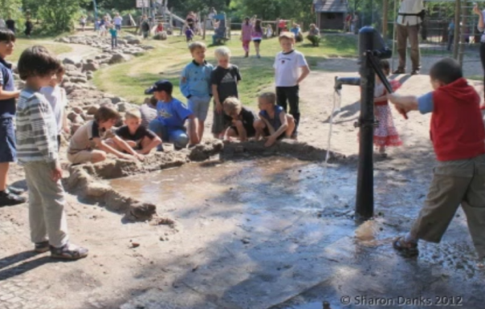
Here’s an example of a school using natural materials like paint, grinding up petals, leaves, and mud.
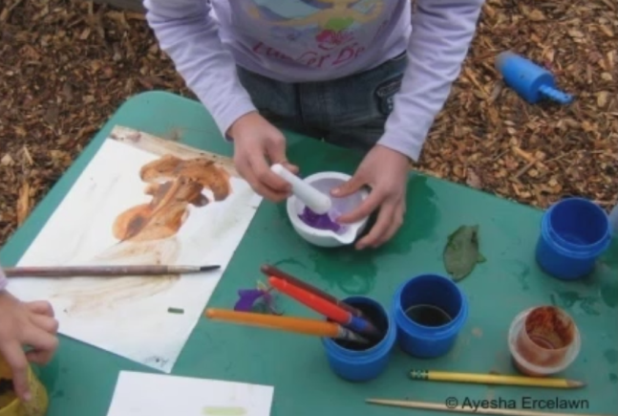
Linda: This unstructured play that Sharon is talking about is going to be a really formidable motivator in transforming our school yards. Research shows us that unstructured playtime does several things for a child. She mentioned social skills, teamwork, and environmental sensitivity. These moments of unstructured play are often ignored by today’s society, and certainly by today’s educational system. But research is showing us that they’re actually really critical for innovation and creative thinking.
Sharon: Now I want to move on to the topic of where this topic of green schoolyards intersects health. Here you see an example of shade and microclimate variety being something you can introduce into school grounds with street cloth or by creating structures that children can go into to have a choice of whether they’re hot or cold that day, and to protect them from UV.
It’s also important that these school grounds follow organic management practices and don’t put anything poisonous into their schoolyards in terms of chemicals and that they avoid the use of toxic materials. Here are some pressure-treated lumber and tires, which are not things that we recommend for schoolyards. In fact, they’re on the list of what is not allowed on San Francisco school grounds. Everything in those environments should be safe for kids to touch.
Here’s an example from a nutrition perspective of promoting health through providing nutrition using a school garden. The kids in this picture are harvesting amaranth seed, which is not only nutritious, but beautiful.
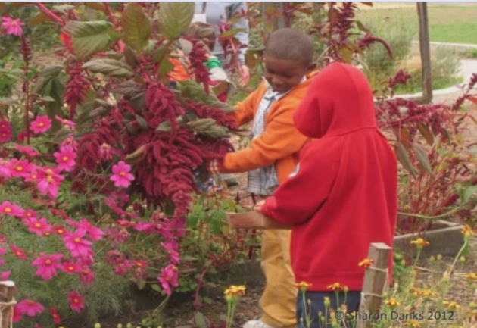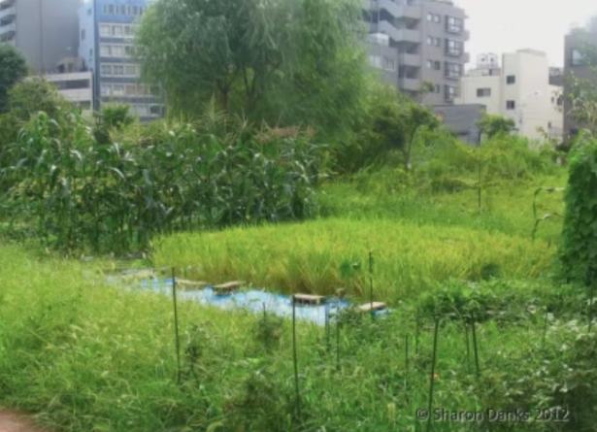
This is an example from the school in Tokyo that I showed you earlier. It’s a close-up of their rice paddy garden. Again, it’s both a cultural example and an edible garden. They have some corn growing there, and other herbs, to promote health.
In addition to those teaching gardens I was just showing, this is an example of what I call a nibbling garden. This one is not a garden that is directed by the garden teacher, but it is something that’s open to the kids at recess so they can come in and pick the raspberries when they’re ready, eat the edible flowers when they ready, pick sorrel (which tastes like lemon) when they’d like to, and incorporate those materials into their games. It also allows them to be much more aware of seasonal change because they are waiting for those things to get ready and are happy where they are.
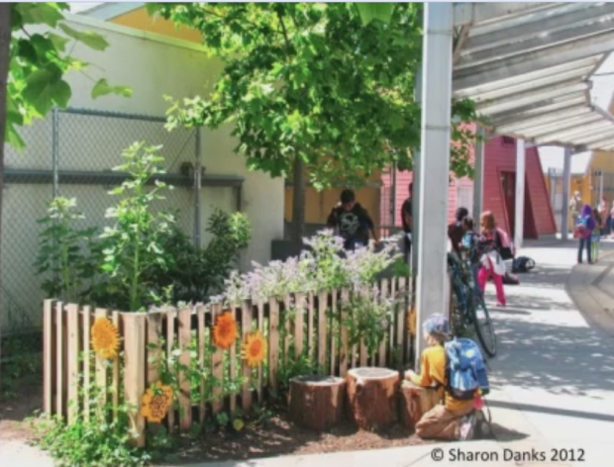
Some schools are branching out and including farm animals on their school grounds in different ways. There are lots of chickens in our schools here in the bay area. Some are also starting to put beehives in for the honey production and pollination they provide.
When you have that food growing on the schoolyard, it’s great to be able to cook it with the children. Here at a school in Berkeley, the garden educator has just picked a beet and washed it off. She’s cooking it in the pot for the kids so that they can try what they grew in their own schoolyard. That’s just a very simple camping stove being used as a low-budget way of cooking with children.
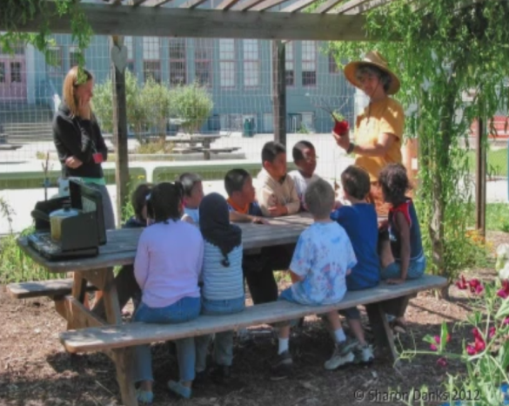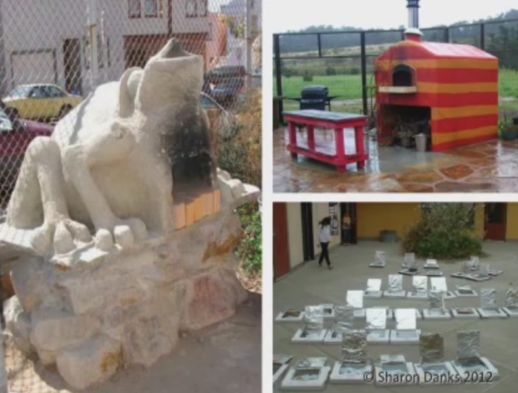
As some more complex examples, we have an earth oven in the shape of a frog that was built by middle school kids with the help of their teacher at one school in San Francisco. In Sonoma, here’s another school that has another type of oven made out of concrete. On the bottom, there are some simple pizza box/solar box cookers at a school in Berkeley, California.
In addition to growing good and cooking it on-site, sometimes schools will volunteer to be the host site for a community-supported agriculture box. A local farm is producing that food. Families pay for it and sign up and pick up the food so that the children can take the nutrition education they learned in the garden and bring that idea home with them to their families.
Linda: Here we’re looking at the third part of the water-energy-food nexus, and really seeing so many ways that different subjects can be incorporated into outside activities with the students, weaving in the systems thinking – not just of a water cycle in a science class, but in life cycle ecologies where everything that we learn is learning how to have a relationship with the environment and with each other.
The North American Association for Environmental Education has established standards is 2007. These standards actually introduce twenty-first century critical thinking skills looking at science – the earth as a physical system, the living environment, social studies, humans and their society, and then finally, environment and the society. Skills for analyzing and investigating environmental issues are key to all of our children, as well as decision-making and citizenship skills that come from those environmental issue investigations.
The goal is this personal and civic responsibility as the main focus for education. If only one-third of our population here in the United States goes to college, it’s really critical that our children are given these understandings.
Sharon: This slide brings up the idea of life-long health. For me, that means things like skills development and common sense. Too often we in the United States let our fear of liability start to harm our students because we’re no longer exposing them to things that are important aspects of child development and skills that we want them to have as adults.
That would include things like knowing local plants. In this example, kids at the Coombes School are making a nutritious soup out of stinging nettles, which are found growing throughout their site. The kids have learned where the plants are and they avoid them. They use them as a cooking resource.
It’s also found in tool safety and teaching children to use tools safely. That includes garden tools or other types of construction tools.
It also extends to water safety and teaching about being safe at the water’s edge, around a body of water that’s a manageable size and depth.
It’s also about teaching of fire safety by having small-scale fires on-site from which children can learn and experience and understand.
It’s also about giving children a chance to develop balance skills so that they will not be so clumsy as adults. They will have skill in navigating their own environment and not trip over every crack in the sidewalk.
In Berlin, the insurance companies have taken on this idea of beneficial risk – the idea that putting some risk in the children’s environment is actually a very positive thing. They have a policy that translates roughly to: you learn to fall by falling. Because they insure the entire city of Berlin for the whole age range of that population, they’re tired of insuring adults with no balance. So they are investing in children learning balance and learning their own limits through allowing them to have more risky play on their schoolyard. They believe that’s a very positive, beneficial experience for children that pays off as lifetime health.
Here’s an example from a German schoolyard where the kids have carved their own climbing wall. It’s also a retaining wall in this schoolyard. What they use it for is this: the children are encouraged to leap off of the wall and they have a wonderful time. The slide in the background is also designed with this in mind. The stairs up to it are not even; they are all at different angles and different heights. The idea is that you learn to look down.
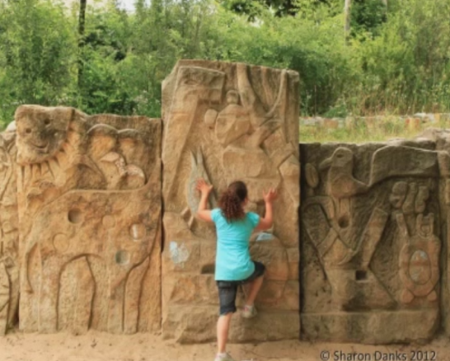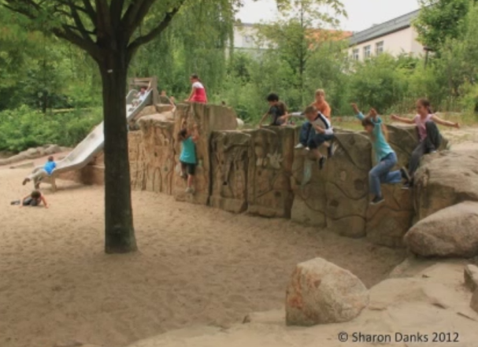
This teaches you to look at your environment and not expect every surface to be smooth and trip-free. They purposely introduce as many trip hazards, as we would call them, as possible because that is a positive environmental skill that pays off in lifetime health as adults who don’t trip on cracks in sidewalks.
What you also gain from giving children these types of environments is the sense of accomplishment that comes from learning a new skill and climbing up high and feeling like you’ve done something.
Here’s an example on the right of a preschooler in Japan being able to climb up high. You can tell from that smile just how happy she is.
These projects don’t happen in a vacuum. They don’t happen with only one person involved. They are the result of community involvement, generally with some guidance from the design community. But also it’s really about catalyzing that community and having them come together to produce a green schoolyard.
Our firm promotes this type of participatory design. We often start with an urban schoolyard that might look like this – a typical urban schoolyard in the San Francisco area – and brainstorm with the community to find out what the teachers are already teaching that they would like to take outside. This is not about adding to their plate, but providing them with resources. What would the parents like to see on the schoolyard? What are the goals for the school community? We do this in a way that speaks to all of the languages that are present at this school if possible.
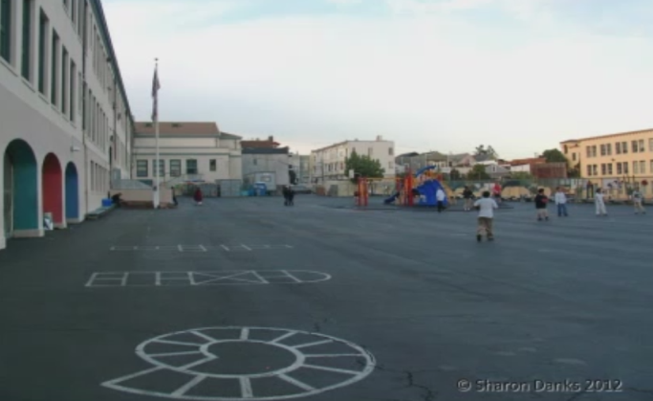
Linda: There are so many tools for designers to use with teachers. There's a tool kit used by William Caudill of Caudill, Rowlett, and Scott where they brainstorm goals, statements of vision, facts, information and constraints, and come up with concepts and design ideas. It’s really quick to get input and all kinds of unexpected ideas from the community.
Sharon: It also involves taking the school out on a tour of their own site to look for underutilized space and observe more closely how it’s used now.
Linda: This connection between a community and a reinvigorated wildlife habitat and between a twentieth century and what could be a twenty-first century education – this collaborative process – engages a community and develops a buy-in and a stewardship of what is developed.
Sharon: The next phase in the design process is a design workshop with adults and children where they take the ideas they thought about and find a place for them on the site. That does build ownership, and it also expresses the ideas more clearly. Here’s the children’s vision of what they’d like on their schoolyard.
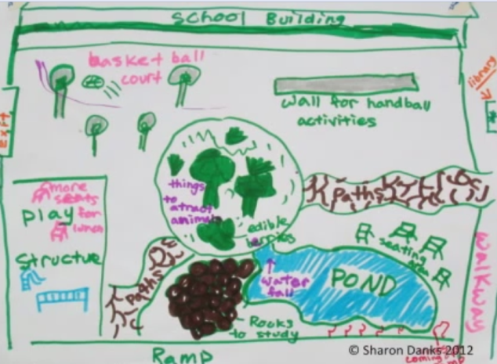
Ultimately, the designer’s role is to pull all those ideas together and come back to the school with a master plan that says, “This is what I hear you saying you would like.” The school debates that and then agrees on it and comes to consensus on it. Then it prioritizes what they would like to do. It might be a ten-year plan you’re setting forth and they decide which one is the first phase that they’ll tackle now, and then they’ll put this into construction in an iterative process.
Here’s an example that shows you a single portion of a schoolyard developing over time. In this case, the site started out looking like this, and then the school community came together and redesigned it. The school district first got a grant for a solar panel.
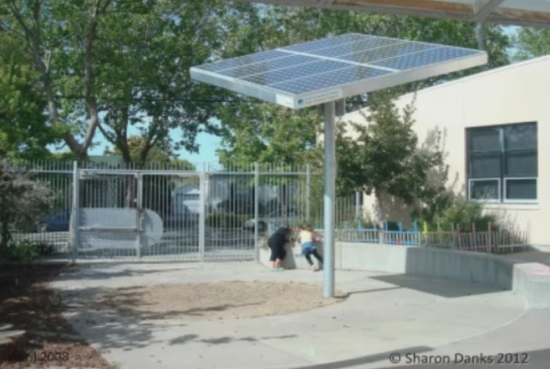
We knew we wanted to take out some of the asphalt. In this case, the school district said, “We’re going to skip the plans. We’d like you to just draw on the pavement the parts that you’d like us to take out and we’ll have a contractor bid on the line.” It doesn’t always go this way. It’s usually more construction drawing-oriented, but this was very efficient. The professionals did the concrete removal, which is always advisable.
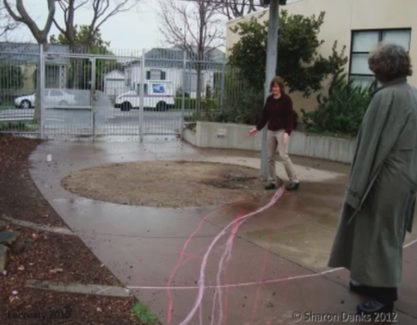
So the concrete came out. The contractors finished their work. The school community put in the soil and the wood chips, keeping the cost down. They were very happy with their progress.
Then the students participated in figuring out where the pond would go in that new nature area. On a community workday, the community put the pond in. Mostly parents, mixed with teachers and the principal, dug the pond and put all the solar equipment together. Communities have a lot of professionals within them who have great skills.
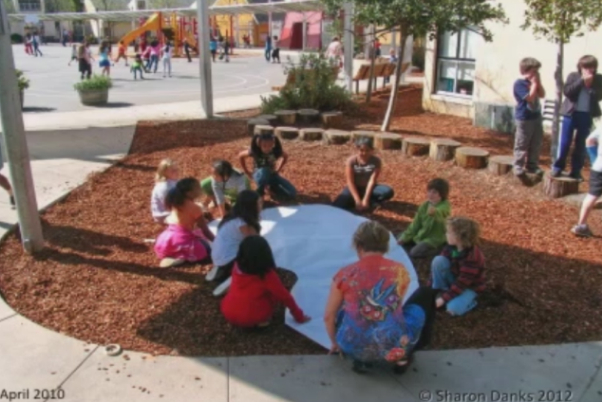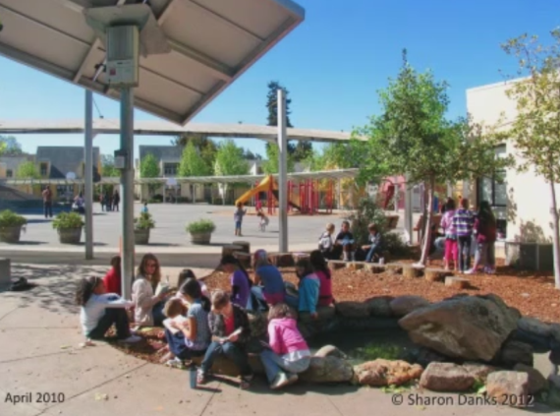
This is what the finished pond looks like. As you can see, it’s right on the edge of the schoolyard. It’s part of recess time, and it’s also a great place for adults to read with children and have other small group outdoor activities.
In the end, another key piece is community stewardship. These projects don’t come about in a vacuum and they need everyone involved in building ownership throughout their construction so that they will also step forward to give a hand in keeping it up because we, as a society, have not really given our facilities departments much money to work with. If we, as communities, want our schoolyards to be different, we need to step forward and work together to take care of these shared spaces, thinking of maintenance as stewardship. That can take the form of community workdays.
We should also remember to celebrate our community accomplishments. In the end, remember that the overall goal is the happiness and sense of well-being of the children who inhabit these schoolyards.
In closing, I just want to leave with you a few rules of thumb, which for me are: dream big but start small. So have a master plan and then implement it over time in manageable phases that the school can learn to maintain on their own.
Never finish this process. The schools that finish their green schoolyard work are the ones that have their garden projects die. Because the community changes every year as the children graduate, you need to keep every class of students engaged. That means building something every semester or every year in perpetuity. This is not a one-stop process like building a park.
Involve everyone in the design process, the construction, and the stewardship. And plan ahead for how you’re going to take care of the schoolyard.
The last slides, in closing, are from a transformation of a schoolyard in San Francisco that our firm played a role in the vision process for. There’s the before site, and then the site when it was newly constructed. The wheelchair ramp is the main path of this. Here’s the site a little bit later when it’s starting to grow in. Here you can see what that looks like from above.
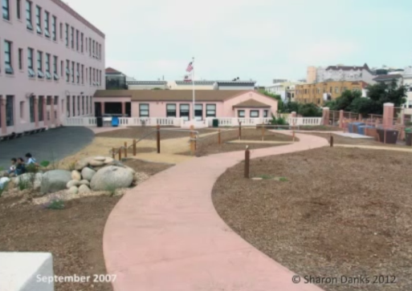
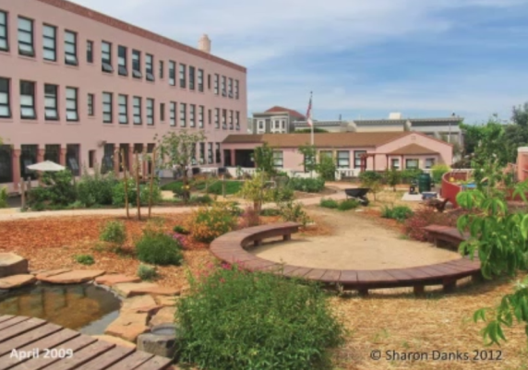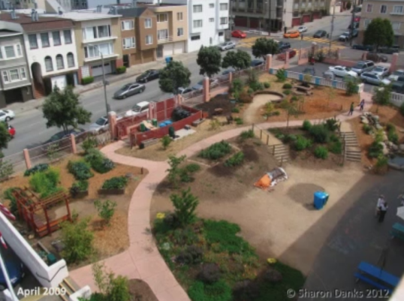
If you’ve enjoyed these pictures, there are 500 photographs in “Asphalt to Ecosystems” that echo these ideas with full explanation. I also want to invite you to join the International School Grounds Alliance, which is a network of non-profit organizations around the world supporting this movement. There’s more information about that at www.GreenSchoolyards.org.
Thank you.
Linda: That was excellent, and I know there will be lots of questions. The International School Grounds Alliance is an amazing group of people who put all kinds of relevant issues to all of us. I know there was a great discussion about risk and unstructured play, and it’s ongoing.
I know you have organized other conferences, but you have one coming up in Canada in a few months. Would you like to talk about that?
Sharon: Sure, thank you. The International School Grounds Alliance has a LinkedIn group under the name “International School Grounds Alliance Public Forum,” where a lot of these types of discussions are going on. There are a lot of design professionals and school ground practitioners from around the world who are continuing to discuss these issues and work together to come up with ways to help this movement grow and move forward.
We did hold a conference that I directed in September of 2011 that helped to found this organization. Every two years, there will be another conference in a different place around the world, and the one coming up is September 23-25th of 2103 in Toronto, hosted by our partner organization, Evergreen. The information is available on www.GreenSchoolyards.org.
Linda: I think that’s so important, Sharon. Your research and your embracing of ideas internationally is very critical for our country to see and share in because it’s transformative in how we think about our school days for our children.
I just want to thank you very much for taking the time today and really inspiring us. Let's see if there are any questions.
John: I will give you the first set of questions as a cluster because I think they’re related to each other. The first one is from Shawn. His question is, “What are the barriers to implementing these types of projects in the U.S.? Are there legal issues?”
I’ll tack a couple of other questions onto that. Rick Wilson asks, “I would like to integrate natural climbing designs with low, soft plant material. Have you ever seen acceptable U.S. fall zone material that can be a growing soil for plant material, or any way to achieve that?”
The final question I’m linking to this from Raymond Kelly is: “In these European schools, how is liability for injury handled, both for the school system and the designer?”
I think these all are somewhat related and I think you’ve talked a bit about it, but would please elaborate?
Sharon: Those are definitely complex questions. I’d say that they vast majority of what I was showing in the slides, with very few exceptions, is completely possible within our existing legal framework.
Right now, for example, San Francisco’s unified school district has one of the most exciting programs in the country to develop green schoolyards, and they are fully embracing these ideas. There are many schools – I’m not sure exactly how many have been built so far – but our firm was involved in master planning 29 green schoolyards with the whole school communities in their city over the last five years. I believe that there are probably between 40-60 projects underway. They have ponds, rocks, boulders, logs, and other things like that going in among the plants.
If you look at the playground safety codes, the falls and heights are the same. It just depends on what you’re putting in. It doesn’t have to be from a catalogue. The convenience of buying those things is that they’ve figured out that fall zone, but if you work with a certified playground safety inspector, they can tell you what the proper heights are for the natural materials as well.
I think the very few things that are a bit more complex are things like tree climbing and ponds over a certain depth. I think in San Francisco they use 18 inches as a measure of what they allow. Each city, each school district, and probably each state architect comes up with their own thoughts of how to interpret the codes because some of the codes are specifics to be followed exactly as they’re written, but others are guidelines. There are some judgment calls that allow for flexibility.
I think there’s also a movement underway in the United States to look at our codes because a lot of them are designed to prevent short-term minor accidents, but what they do is cause long-term health problems like obesity and diabetes. A skinned knee is not really a health hazard; it’s a learning experience. Part of what we need to do as a society – but we can’t do it as individuals, but we could do as a group, as a group or a movement – is to look at where our regulations make sense and where they truly protect us, and where, instead, they have started to constrain our health in a long-term way.
We need to respond to that as a profession and as a movement, and take a more critical look at it because when you look only within the U.S. context, it all seems pretty logical. But when you go outside of that context and you see that children in Scandinavia aren’t getting injured and that none of the kids in those pictures are overweight, you'll see that there are many health benefits that outweigh the short-term smaller risks. So maybe it’s time for us to reevaluate what we do here.
John: Thanks. Here’s a question from Suzie Harrington: “It looks like more of the photos show grades up to six and fewer from seven up. If accurate, is this indicative that the schools in which ecological schoolyards tend to be installed are the ages that tend to use them? Are there any other comments on age-related differences in design and use in such schoolyards?”
Sharon: I think that a greater number probably are at the preschool through sixth grade level, but there are certainly really exciting projects happening at middle schools and high schools. I think my pictures probably skew younger since those are the schools I have spent more time at. The middle and high school projects are very exciting in that they tend to give kids even a more central role in designing and building things, as you can see from that middle school after-school center in Sweden, for example.
I went to a school in the Chicago area where the high school students were brewing biodiesel in their science lab and had taken out the courtyard landscaping in one area and made an endangered turtle habitat area to nurse back to health some turtles that were injured. So I think that the high school and middle school programs are more student-directed than they are designed by outsiders. But we need more of them.
Linda: Right. I think that, in this movement, we are going to see it start earlier with the smaller children. Often, their playgrounds are smaller – like we learned in the last webinar from Eric Nelson. We do need to have these types of experiences for middle school, high school, and even adults. Right now, they often exist in a bussed field trip to a nature center or a nature preserve, and we need to bring that thinking and those notions back to our local communities.
John: Maybe the best example of multi-generational environments are the healing gardens that have been developed in some of our large hospital complexes.
Scott Faulk says, “My wife and I had started a school garden at the elementary school where she teaches. How do we get more information from you? Do you have any suggestions on how to change insurance in the United States, as has been achieved in Berlin?”
Sharon: As far as the garden organizations, I think that there are a lot of different groups online if you were to Google that. They give specific horticultural advice for your own region. There are so many curriculums out there online. There are some aggregators of that information, like the California School Garden Network, which has websites that have those resources from many different places put into one site.
In regards to the second question, it’s definitely complicated. I think that we start to invite them into these discussions. They’ve been left out and on the responding end, and I think that one pro-active move is to bring them in as partners. In Berlin, it’s being led by the insurance company because the insurance company looked at their bottom line and said, “Adults are costing us a lot of money. How do we prevent all those injuries and health problems?”
They came up with this as a solution, and I think what we’re trying to do with the International School Grounds Alliance is just that: bringing that knowledge from other places here to start to model some of our systems on theirs. But they're also homegrown solutions, too [1:10:53 ?].
John: Roderick Wilson is saying, “What I hear from your talk is that there needs to be an aspect of the movement that takes on policy by getting a major insurer to offer broader, less-expensive coverage for 'risky schoolyards' and tort reform.” This is a question that's come up by a few people. How do we expand on policy to make these kinds of environments more likely to get through and approved?
Sharon: Those are the kinds of questions that we're going to be tackling at the conference in Toronto. Specifically, one of the angles of the working group of the International School Grounds Alliance is trying to wrap our minds around how we do that here. I think it’s something we haven’t fully solved yet, but we’re starting to explore it. If that idea interests you, I encourage you to enjoy the discussion about the benefits of risky play on the International School Ground Alliance’s LinkedIn forum.
John: Pragnia [?] was asking about your view on a one-school campus for K-12 versus age-appropriate campuses spread across neighborhoods in a small town setup.
Sharon: I’m not an educator, so I don’t know, from that perspective, what I would recommend or not, but I do think that we do need more multi-age play environments. Those often look like our regional parks. They are places that engage people of all ages, and I think we can definitely benefit by having multi-age/multi-generational outdoor spaces. We should really look at our school grounds as public space and how do we use this public space to its full effect for the community?
Linda: As an educator and an architect, I would agree completely with that. We need not single-use playgrounds, but rather multi-age playgrounds where a grandparent can actually sit and enjoy company with another grandparent while their little children play.
In our next webinar with Susan Solomon, we’ll be looking at the research on cultivating community space. So often now, our playgrounds are single-age or age groups to the detriment of any interaction from any other groups. So I think, just like with city zoning, we’re going to be looking at mixed-use increasing.
Sharon: I would go as far as to say that in some cases in our cities where we have schoolyards that are paved from edge to edge, that we really have abandoned public space in our midst. It’s not the fault of the school districts, who have had their budgets shrink and their facilities departments shrink; it’s us as society. This is really a paradigm shift in the way that we view our public space. We need to reclaim it as a space that belongs to our community, and we must do that in a hand-on way, guided by a design sense that brings it together as a space. Most of all, it’s about making these places that serve multiple services for our communities as much as possible.
John: Here's a more specific question. “What provisions are there for those groups of students who have allergies to plants and weeds? I have seen school kids who have special requirements in terms of breathing and so on.”
Sharon: There are organizations that have specific lists of plants available that do have less pollen. In general, though, I think with most of these plants, when planning for a school community of, say, 500 children, we try to balance everyone’s needs and be respectful of those issues while also encouraging the health of the natural environment, which does naturally include pollen and other allergens.
John: Here are a few questions about the broader benefits. Peter Newton asks about the economic impact of these projects to surrounding neighborhoods, both in terms of school achievements, crime reduction, community pride, and property values. Distressed neighborhoods tend to be most in need of these projects. Have there been studies on the impact of this?
Then Kenneth Bennis asks, “Are these play areas shown open and available to communities for use after school hours? Are they seen as community assets, or are they only used during school hours of operation?”
Sharon: I think there have been studies – I can’t point to any in particular offhand – which, at least anecdotally, look at how community pride is definitely fostered by creating beautiful places in a neighborhood and how more eyes on the street and more presence in the schoolyard helps to bolster safety in the neighborhood.
Linda: I do know that there are studies – I know that Terry Guen, a landscape architect in Chicago, but there are others – that show that the poorest areas in most urban areas are the areas with the least trees. So this notion of the denaturing of an urban area gives power to this movement to bring that nature back to the school grounds.
I think there are school grounds are closed – school gardens. There are community gardens that closed at a certain time. This is common practice across the world where the concierge or the gardener goes home at night and it is locked. Next week, I think we’ll be talking more with Susan, who has studied this, to see what kind of percentage of those should be open, and what percentage should be closed at certain hours for the safety of the community.
Sharon: I would also add that, in our area, we have schools that are not neighborhood schools; they’re districts that have selective choice where parents pick the public school they would like their children to go to. The ones that have developed their grounds become the most desirable in the district. They are enrollment can change from low to high, and that makes the other schools in the district jealous, so then they change their grounds as well. So we do see a fair amount of that happening, at least anecdotally.
I think, in our region, there is also the balance between the school districts who have tried to keep at least a percentage of their schools open after hours as community resources. They are used on the weekends quite a bit. The ones that are locked don’t necessarily find themselves with less vandalism because people still come in after hours or on the weekends. If you lock them, the only people who come in are the ones who are okay with breaking the rules, seeing as they hop the fence to get in. If you open the gate, you have a wider variety of who's there, and rules tend, anecdotally at least, to be followed more and there’s less vandalism.
Although I should say that whenever you put something new in, the first couple of weeks or months that it’s in is probably the time it gets hit by the most vandalism and by the most tripping or other minor problems. There's an adjustment period when you switch that you should expect.
Linda: That’s good to know. Schools still like to seek the blue ribbon schools for being districts that get the highest percentage of their children to go onto college. So we’re now seeing a suite of schools starting to seek out green ribbon schools, which basically means that they’re introducing environmental practices into their curriculum and onto their school grounds. So I do think it does change as parents’, mobile families, are looking to live in a place where there is a good school system. As the environmental understandings become more and more part of the public voice, these families will be seeking schools that have this healthier approach to full systems thinking and integration of healthier times during the school day with more time spent outside.
John: I want to end with one question which was raised by Peter Rockwell, and I think some of his concerns were echoed in some questions by Ann Ellis. Let me use Peter’s words: “How would the mysterious or hidden aspects of a play area reconcile with the current paranoia about Columbine or Sandy Hook’s situations?
Sharon: I think that you can create mystery and adventure while still allowing for adult supervision. There were some pictures, for example, of the fort under the bushes where the adults can fully see the children, but the children have enough plants around them to feel a sense of enclosure. They feel they have enough privacy to make a game up in that location, but the adults can still observe them.
In a more built-up schoolyards, like the one in Berlin, you could either take the approach of stationing teachers on one place for children to come to with problems, or those supervisors could wander those yards if they wanted to and get a view of everyone.
I think that the issues like what happened at those schools are complex and societal, and they are not things you can fully address with the site design. If you go too far in addressing it with site design, you allow those people to win. You change the experience for hundreds of students based on a very small chance of something happening, and the ability to prevent it is difficult. I think that’s a wider question that needs more contemplation, also, from a societal perspective on a number of issues.
Linda: Sharon, I just want to thank you again. Your research is phenomenal, as is your pervasiveness in connecting with so many different groups. Actually achieving these gardens in our own country is really admirable and gives us all a standard to live up to. Thank you very much for taking the time to spend with us today.
Sharon: Thank you so much for having me here. I really enjoyed it.
John: Can you tell people where they can acquire your new book?
Sharon: “Asphalt to Ecosystems: Design Ideas for Schoolyard Transformation” is the name of the book, and it’s available in most bookstores. You can order it at any bookstore. It’s also available online from the publisher if you go the website www.AshphaltToEcosystems.org. I would recommend getting it from the publisher. There’s also a link to it on our company website, www.BayTreeDesign.com.
John: Thank you so much.

