From: AIA Small Firm Exchange (sfx@aia.org)
Subject line: Call for Small Firm Volunteers

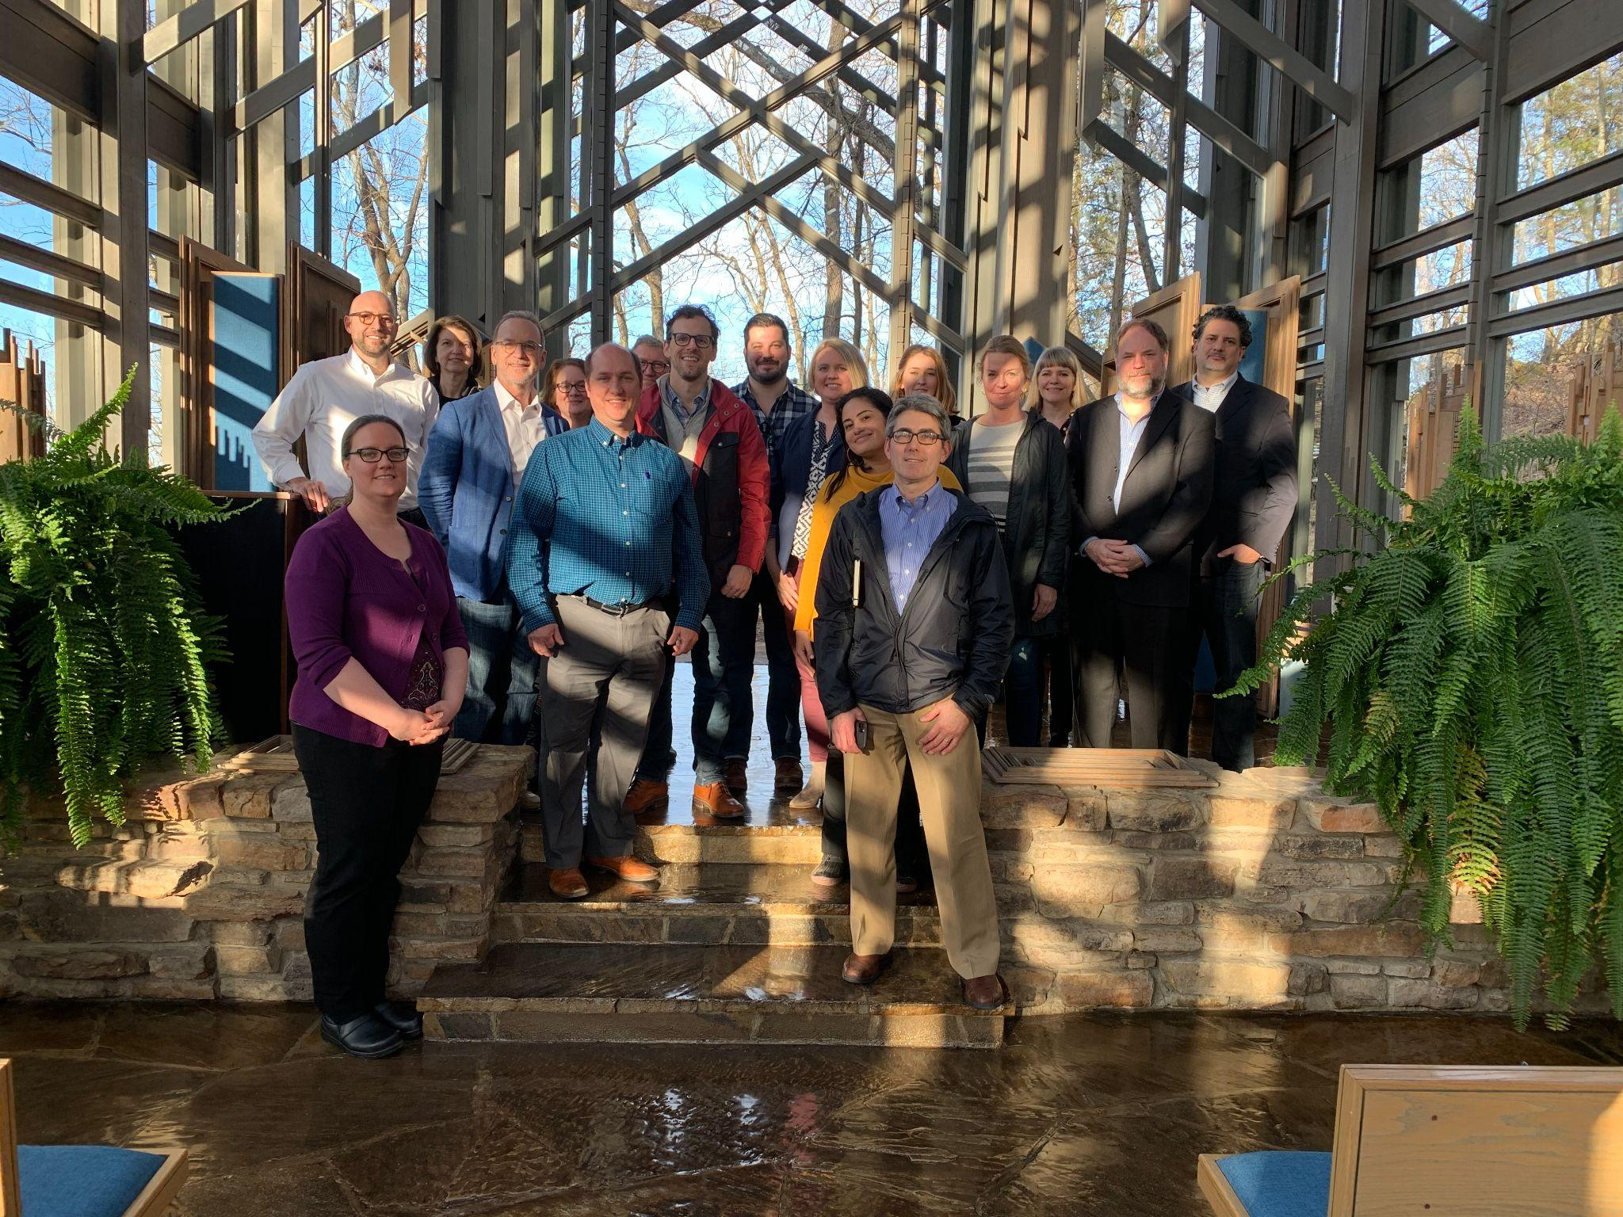

Small Firm Exchange board meeting, March 1-4, 2020. RIP Michael Lejong, AIA, our 2020 chair and host at Thorncrown Chapel (designed by E. Fay Jones) outside of Eureka Springs, Arkansas.

Get Involved: Become a leader with the AIA Small Firm Exchange

Help us increase the influence of small firms within the AIA by volunteering directly for the Small Firm Exchange or as a small firm owner on one of many AIA National Committees.

Submission closes at 5pm ET on Monday, November 8, 2021. Nominees will be notified by December 15, 2021.

[Become a volunteer]

More from SFx

Become an SFx Board Member or State Representative

The Small Firm Exchange’s annual call for board members is extended to November 8. We are looking for volunteers who want to be a catalyst for change and make a positive impact on the architecture profession. The SFx board is a great opportunity to network with peers, share resources, and advocate for small firms on a national platform. Interested? Apply now >

Given the dissolution of AIA regions, we are also developing a network of state representatives to serve as liaisons —delivering small firm resources to your state and local chapters and sharing your state’s small firm concerns with the national organization. Are you a connector? Apply today >

AIA National Committees

Are you an enterprising member with a passion for the future of the profession? Are you interested in building your expertise, networking skills, and learning from others? Volunteering on a national committee may be just the experience for you.

National committees are a great way to stretch your leadership, and to connect the work of members and others to the AIA Strategic Plan. Apply by November 8.

View volunteer opportunities >

Around the AIA

Small firms and the Framework for Design Excellence
By Nate Kipnis, FAIA

Being a small firm practitioner, it can seem like projects may not matter ‘in the big picture’ and that their impact won’t make a difference. Projects might be smaller and budgets more limiting, but every project matters.

Read more >

How the AIA's New Custom Residential Agreements Help Custom Home Architects and Contractors
By Marika Snider, Ph.D., AIA, Principal Architect, Snider Architecture, LLC, Michael Bell, FAIA, Esq., President, Bell Architecture APC and Leonard Kady, FAIA, Principal, Leonard Kady Architecture and Design

The new AIA Custom Residential Documents streamline the contractual process for architects by tailoring them for the distinctive requirements of the custom residential construction market. These are the first documents published by the AIA specifically developed for use in custom residential design.

Learn more >

Connect with SFx

Visit our website >

Follow us on social
Facebook >
Instagram >
Twitter >

