From: AIA Small Firm Exchange (sfx@aia.org)
Subject line: Small firm resources

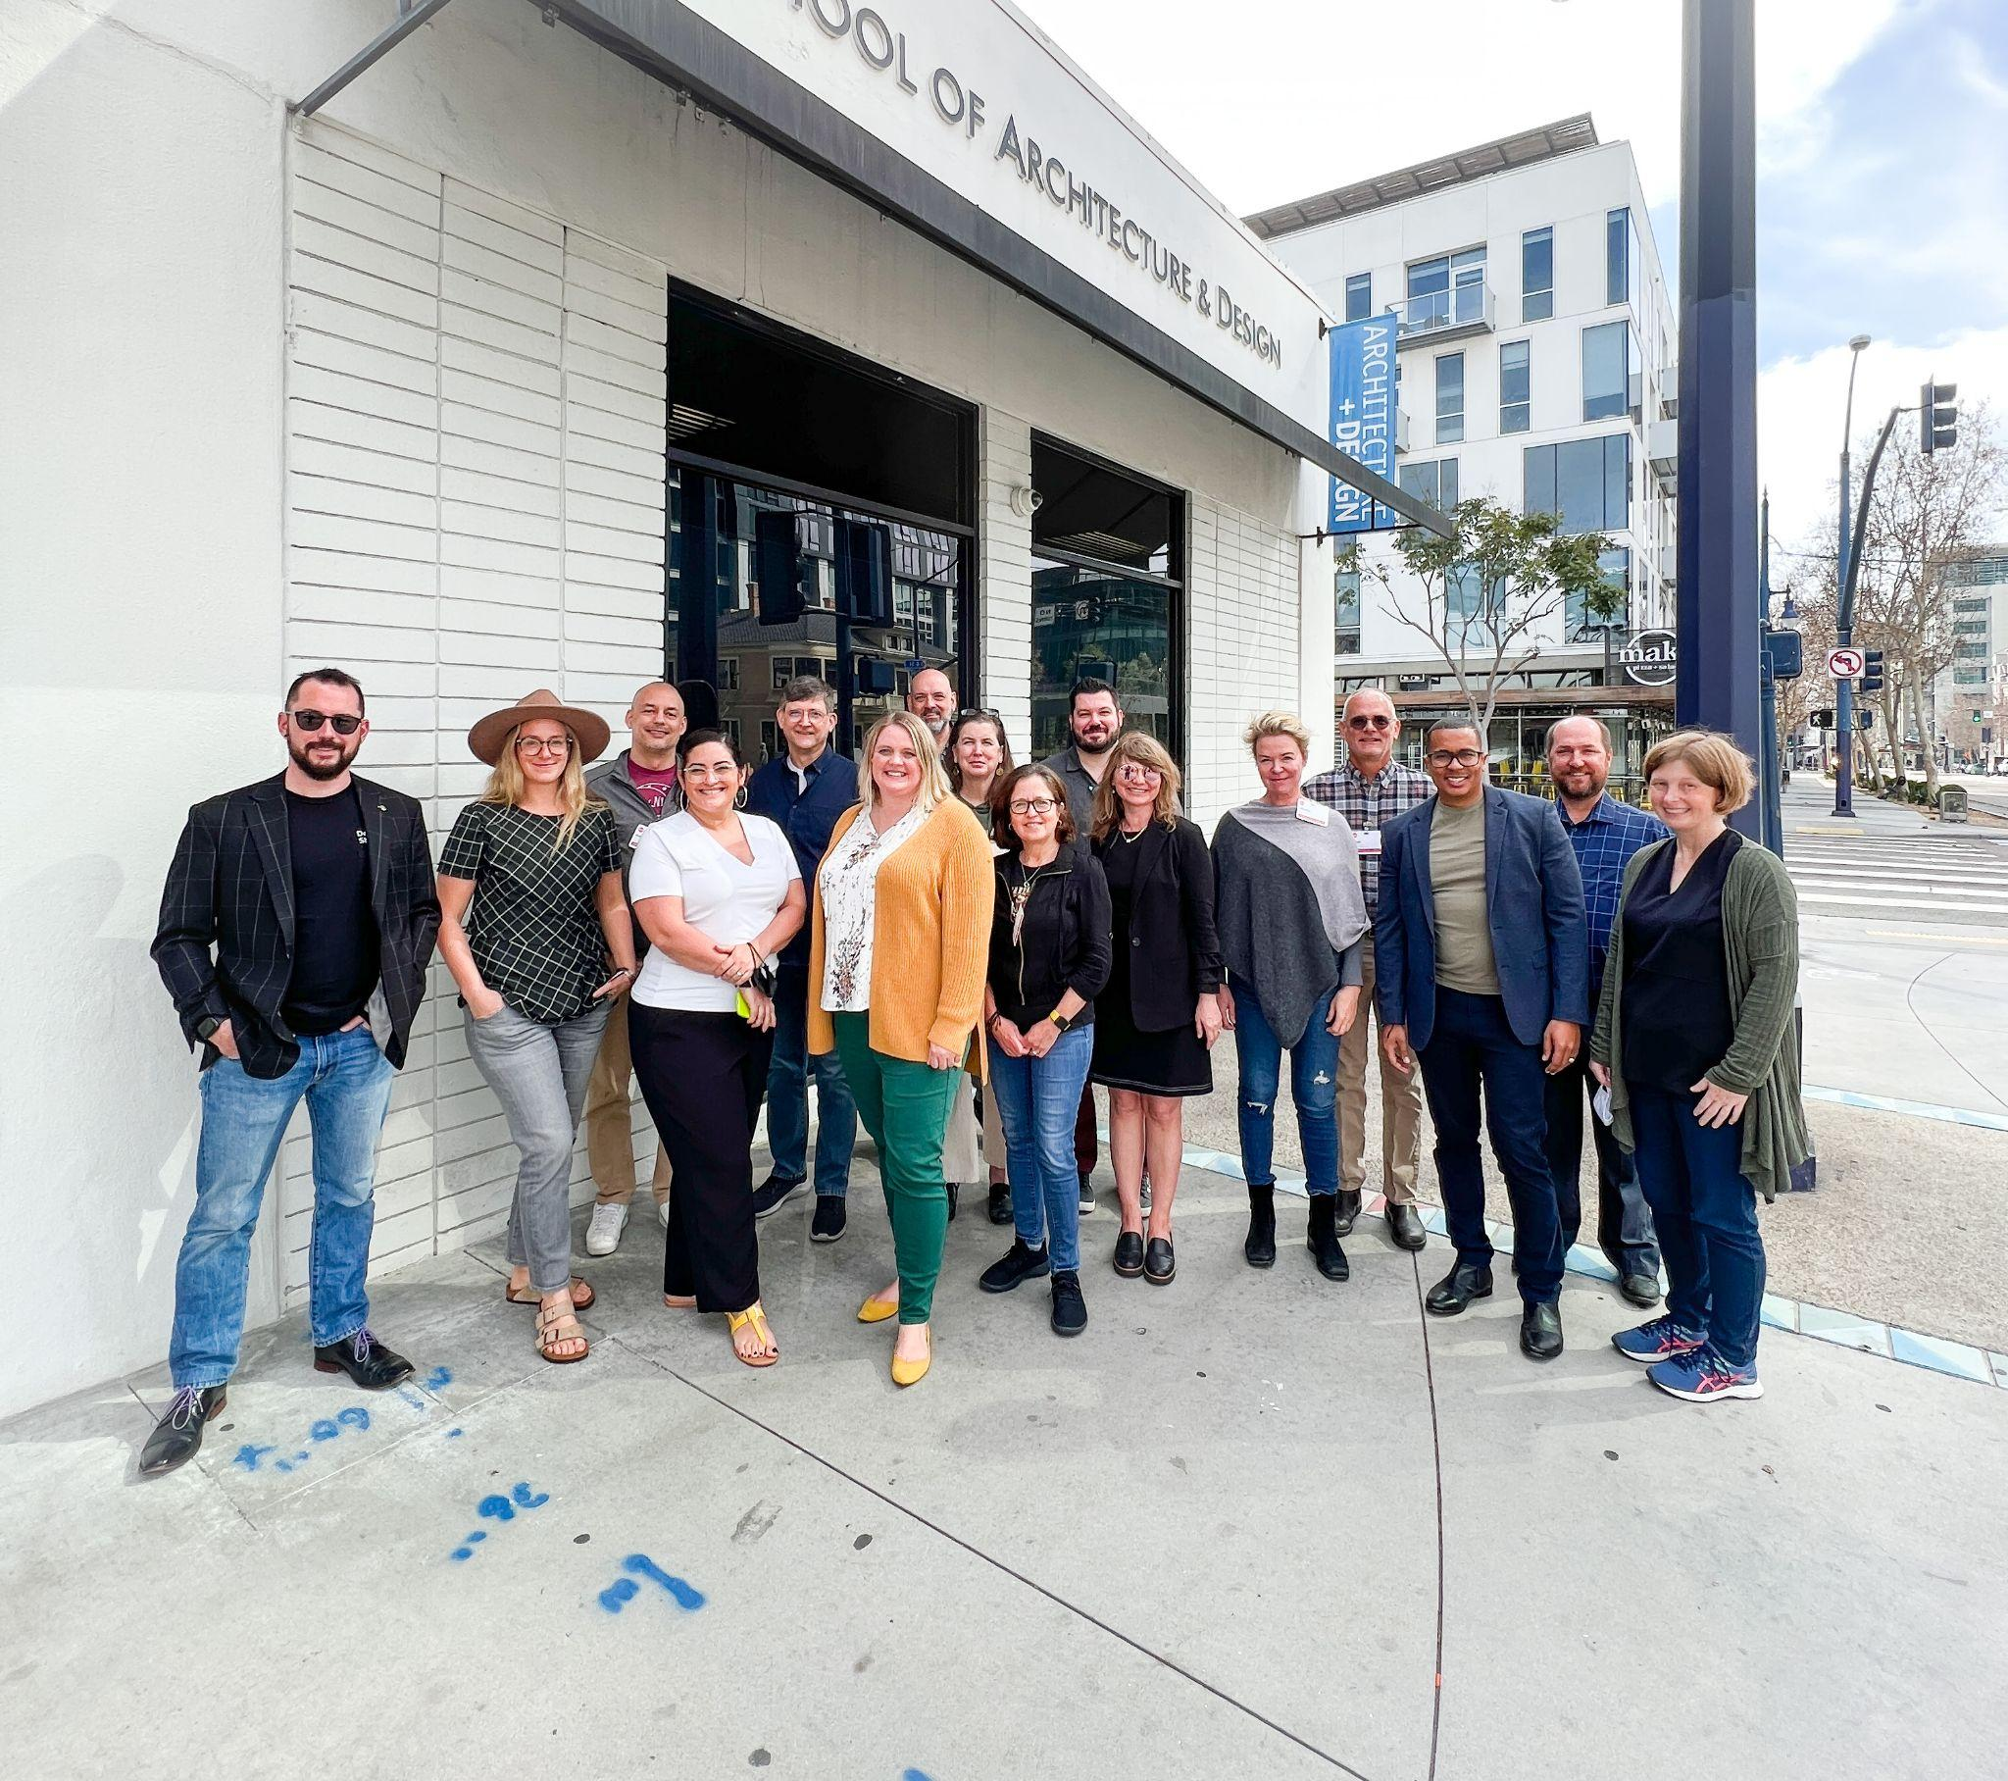
Board members gather at the NewSchool of Architecture and Design in San Diego. Photo: Kathleen McCormick

SFx 2022: advocate, share, and inform
By Bruce Fallon, AIA, 2022 SFx Chair

It’s just been a few weeks since we returned from the 2022 Small Firm Exchange (SFx) Annual Board Meeting held in San Diego, California and I couldn’t be more excited about the future and the work of the SFx board for this year.

Learn about the new network of state representatives, work planned for 2022, access small firm-focused resources on social media, and tell us what you need as a small firm leader.

Read the letter >

More from SFx

My Startup Firm Story: The Outpost Studio
By Dana Ellis, AIA
Are you thinking about starting a small firm? Learn how Dana got started in 2021 with free resources from the AIA.
Read her story and access those resources >

The small firm guide to A’22
By the SFx Conference Workgroup
A'22 has small firm events and educational opportunities for you and your staff. See the full list of curated activities and register by April 13 to save.
View the guide >

Around the AIA

AIA Trust: Small Firm Claims Study
Download the latest Small Firm Claims Study indicates that most claims made against small firms derive from either delays and extras or property damage and offers case study examples—with tips on how to avoid these claims. (The latest data is from 2019 due to a lag in having claims resolved before reporting.)

Download the study >

AIA KnowledgeNet: Discussions on Practice

See member discussions on issues of interest to small firms including: Cloud Based Data Storage vs. Traditional Server; Online Client Payment Options, and Firm Hiring.

Post a message to the discussion forum >

2022 Update on the Economy
Free | 4 LUs
Join AIA Chief Economist Kermit Baker, Hon. AIA, and AIA President Dan Hart, FAIA, for quarterly discussions of the industry's latest economic data and what firms are reporting. We’ll focus on recent developments in AIA’s Architecture Billings Index (ABI), key trends in our economy, and strategic issues that architecture firms are dealing with, such as developing and maintaining a workforce.
You can enroll in all four webinars with one click and earn 4 AIA LUs. Can’t make it during the live event? View the on-demand recording later.
Register now >

Call for Submissions: 2022 Small Project Design Knowledge Community Grant Program

The purpose of this grant is to provide financial support for non-profits working with architects on community-based projects. Learn more >

Project Delivery Symposium 2022: Delivering the Future
Now on-demand
Hosted by AIA’s Project Delivery Knowledge Community, during this symposium owners, architects, engineers, and constructors will join to discuss the latest strategies for driving successful project outcomes including best practices, allocating risk, and employing software and data tools to close gaps between concept development, design, construction, and fabrication. Learn more >

Connect with SFx

Visit our website >

Follow us on social
Facebook >
Instagram >
Twitter >

