From: AIA Small Firm Exchange (sfx@aia.org)
Subject line: Small Firms Rising

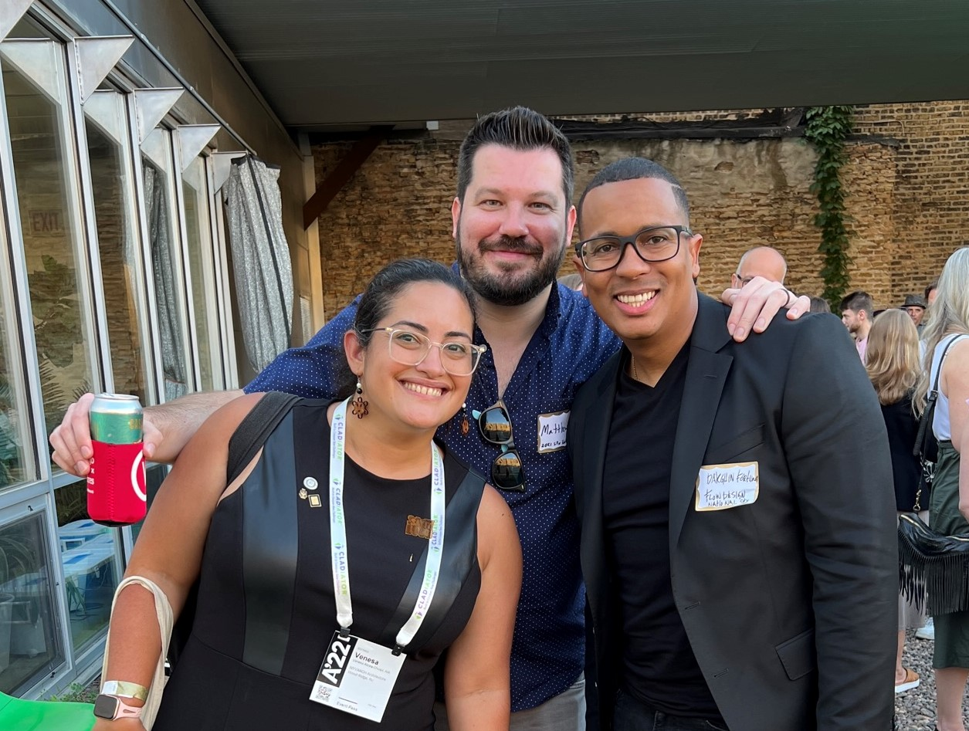
Current SFx board members Matt, Venesa, and Darguin hangin out at the A’22 SFx party hosted by Urban Lab.

Flex your leadership skills with the AIA Small Firm Exchange
Help us increase the influence of small firms within the AIA by volunteering directly for the national Small Firm Exchange as your state’s representative.
We are looking for volunteers who want to be a catalyst for change and make a positive impact on the architecture profession. SFx provides lots of opportunities to network with peers, share resources, and advocate for small firms on a national platform. We are entering year two of our network of state representatives. Those reps serve as liaisons —delivering small firm resources to your state and local chapters and sharing your state’s small firm concerns with the national organization. Are you a connector?
Read the full position description >
Apply by October 1 >

More from SFx

Applying for AIA Fellowship as a Small Firm practitioner
By Janet Bloomberg, FAIA (Class of 2020)
As a small firm practitioner, it may seem difficult – many believe that Fellowship is more attainable for architects who work for large firms. However, I would say that those who own or work for small firms have some distinct advantages that they may not be aware of.
Read why >
What to expect applying to the AIA College of Fellows
By AIA Honors and Awards staff

Get insights gathered over the years supporting the program, the jury, and providing feedback to unsuccessful candidates. Let’s debunk the most common myths, learn from the most common advice, the common mistakes, and the copious number of resources available to you on this endeavor.

Get the details >

My Conference Story: Flow Design @ A'22
By Darguin Fortuna, AIA

In 2019 we first attended the national AIA conference in Las Vegas. Much of what we are, belief and embody was born out of such experience. Knowing our place (The one we are making), within the bigger picture, industry and ecosystem is indeed fulfilling to say the least. A'22 was no exception.

Learn why Flow went in 2022 >

A’23 Peer Reviewer Opportunity
We need diverse voices and emerging professionals to help select small firm content for A’23 and tell us which proposals speak to your needs. (Peer reviewers do not have to attend the conference. So, this opportunity could be ideal for parents of young children or busy professionals that want to dip a toe in the water of national engagement.)

- Apply by September 15th
- Review 20-ish proposals between Oct 10–30, 2022
- Get 15% discount on A'23 registration
Apply in 5 minutes >
Go all-in and submit a presentation proposal >

Around the AIA

How small firms can create energy-efficient building designs
Small firms face many challenges due to the lack of resources and information. The Definitions for Building Performance establish a common vocabulary to assist in designing and constructing low to zero carbon buildings and beyond. This glossary aims to provide precise terms to develop more efficient and accurate communication among all parties (building owners, architects, consultants, engineers, contractors, and manufacturers). We have also identified terms that we think should be avoided.
Access the tool now >

Small Firms on AIA 2030 Commitment Directory

More than 1000 firms with offices across the country and the world are committed to designing for energy efficiency and carbon neutrality by 2030. Did you know that you can explore the list of participating firms in your state and sort by firm size, how long they’ve been part of the 2030 Commitment, or how many years they have submitted portfolio data to actively track progress.
Search the directory to find a local mentor firm >

AIA KnowledgeNet: Discussions on Practice

See member discussions on issues of interest to small firms including: Cloud Based Data Storage vs. Traditional Server; Online Client Payment Options, and Firm Hiring.

2022 Update on the Economy
Free | 4 LUs
Join AIA Chief Economist Kermit Baker, Hon. AIA, and AIA President Dan Hart, FAIA, for quarterly discussions of the industry's latest economic data and what firms are reporting. We’ll focus on recent developments in AIA’s Architecture Billings Index (ABI), key trends in our economy, and strategic issues that architecture firms are dealing with, such as developing and maintaining a workforce.
You can enroll in all four webinars with one click and earn 4 AIA LUs. Can’t make it during the live event? View the on-demand recording later.
Register now >

Connect with SFx

Visit our website >

Follow us on social
Facebook >
Instagram >
Twitter >

