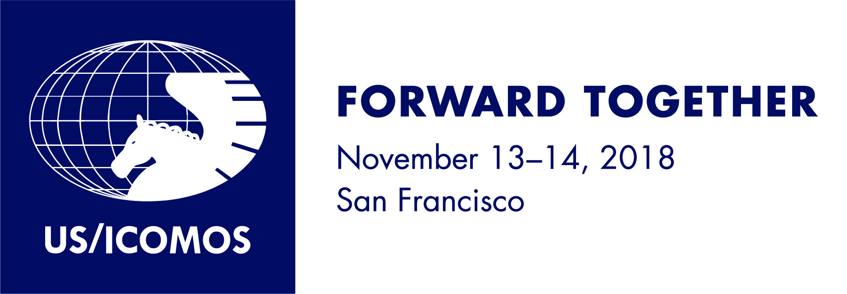

Join thought leaders from around the globe in advancing the conservation connections between cultural and natural heritage. Forward Together: A Culture-Nature Journey Towards More Effective Conservation in a Changing World builds on the recognition among US and international professionals that integration of cultural and natural heritage conservation and stewardship across professional boundaries and disciplines is essential to improving conservation outcomes.

WHY ATTEND?
- Share the latest international theory, practices and techniques with a broad audience of conservation practitioners;
- Explore the power of intangible heritage and the diversity of associative values people hold for special places;
- Address the urgency and impact of climate change on heritage places and explore opportunities to build resilience;
- Consider the evolution of Western and non-Western perspectives on nature and culture;
- Reflect on the status of the first 40 years of US World Heritage inscriptions and the future of US participation in the World Heritage Program;
- Meet a network of international colleagues from a range of disciplines and perspectives.

REGISTER
To register, follow this link and be sure to choose either Forward Together and PastForward, or just Forward Together. Please contact director@usicomos.org with any questions.

Preliminary Schedule

Tuesday, November 13: Concurrent Breakout Sessions Arranged by Theme

- Adopting a landscape approach for the conservation of cultural and natural resources -- from urban to rural places.
- Stewardship of biocultural landscapes in the 21st century: Forging community-based approaches
- Strategies for managing multiple values of large landscapes and transboundary sites
- Adapting the tools of heritage conservation to meet the challenges of large landscapes

- Recognizing intangible heritage and diverse perspectives as integral to conservation strategies.
- Intangible heritage as a driver of cultural landscape management and holistic conservation
- Stewardship of biocultural landscapes in the 21st century: the role of traditional knowledge and practices
- Taking a landscape approach to integrating nature and culture

- Building resilience, adaptation and sustainability for urban and rural landscapes.
- Harnessing traditional knowledge to meet the challenge of climate change
- Building resilience through a deeper understanding of culture and nature
- Linking resilience, sustainable heritage and community livelihoods

- Considering the past and future of the World Heritage List from the perspective of the U.S.
- World Heritage: Recent developments and new opportunities
- World Heritage Sites: looking through a nature/culture lens

Wednesday, November 14

The focus of the second day will be working sessions and round-table format discussions. We are planning a series of focused, interactive sessions, including:
- A Tale of Two Cities: Annapolis and St. Augustine, Balancing Preservation and Community Values in an Era of Rising Seas
- Identifying and Implementing Conservation of Key Biodiversity Areas While Integrating Local and Indigenous Knowledge and Cultural Values
- Linking Nature and Culture through Capacity Building: Lessons Learned and Challenges Ahead
- Reflection on Day 1 and discussion of key elements in a San Francisco declaration.

Please join us! Follow this link to register and choose either Forward Together and PastForward, or just Forward Together.

Please contact director@usicomos.org with any questions. We appreciate your interest and support.

