Introduction to BOMA Measurements
Mary: AIA Interior Architecture Knowledge Community Presentation, Introduction to BOMA Measurements. My name is Mary Burke, FAIA, and I am your moderator.
Today's presentation is copyright 2012, The American Institute of Architects.
The AIA Knowledge is a registered provider with the AIA Continuing Education System. Today's presentation is worth 1.5 Continuing Education Hours for licensed architects, and 1.5 Elective Supplemental Experience Hours for interns enrolled in the Intern Development Program, IPD.
The rules established by the Building Owners and Managers Association, BOMA, are the recognized national industry standard for measurement of space. During today's course, you'll gain insight into these important professional tools and understand how to measure a building, which is a sensitive topic to many professionals.
Among other outcomes, it can be used to [?] learn how to use BOMA's Method A and Method B to measure a building's area and the pros and cons of each. Joining me today are presenters Andrew Patapoff, AIA, and Erik Hodgetts, AIA.
Andrew Patapoff, AIA, has been a licensed architect for 35 years, so he has been over 40 years in the profession. He's a Senior Associate at IA Interior Architects. For the last 12 years, his work has been focused exclusively on interior renovations for corporate clients, many of whom rely on BOMA calculations to establish lease terms for their spaces.
Andrew has given numerous seminars to IA staff in an effort to make them aware of and knowledgeable in the use of the appropriate BOMA standards in order to better assist clients, brokers, and building owners.
Erik Hodgetts, AIA, LEED AP serves as Director of Legal Services at IA Interior Architects, providing project leadership at the highest level for law firm clients, and guiding IA's teams through the planning, design, and execution of corporate interiors works at all scales. A licensed architect of 20 years' experience, he has spent the last 15 years successfully managing complex interior projects and also tracking space usage and bench marking trends.
Erik has presented on these topics for groups such as IFMA, (CORMA), AIA - New York Chapter, and the Association of Legal Administrators.
We owe a debt of gratitude to IA for making both of these wonderful professionals available to us. Welcome, Erik and Andrew.
Andrew: Thank you.
Erik: Well, thank you very much for that gracious introduction.
Mary: Did you know you were so wonderful?
Erik: It's much appreciated. I'm Erik Hodgetts. My colleague, Andy Patapoff is here. Andy, if you want to say hi.
Andrew: Good morning out here from Denver.
Erik: I'm joining from New York, myself. Our agenda today is really to give a good grounding in the basics of the BOMA measurement systems. A lot of folks will have encountered them in their day-to-day work, and they are one of the critical tools in our profession. It is a deep and complex subject, and our intent today is to really give a 101 level class to acquaint everyone with the basic concepts behind BOMA's measurements, and also to look at a concrete example of how those rules can be applied.
In order to do so, we're going to familiarize ourselves with the terminology that BOMA uses, and we're also going to go ahead and look at the two methods which are currently being used by BOMA referred to as Method A and Method B. Once we've done that, we'll take a little bit of a look at what the pros and cons of those two methods are, and we will run through that on two base building examples.
Overview of BOMA Standards
Andrew: BOMA is an organization of building owners and landlords throughout the nation who have joined together in an effort to standardize the way they measure buildings. Apparently, 1915 is when the first BOMA organization got together and started setting up standards, and I would imagine it didn't start nationwide at the time. It started in a small area and thenexpanded as other people learned about it.
This BOMA that we're talking about today, the new BOMA, is BOMA 10, which is a 2010 version. About every ten years, BOMA gets together and tries to update and refine their sets of calculations and define how things are measured within an office building. This is just for offices. There are other standards for other spaces such as warehouses and residential areas, but this BOMA organization that we're talking about today is just office buildings.
We'll talk about the new terminology. The BOMA 2010 does have some new definitions which are, for anybody whose familiar with the last BOMA, which is the BOMA 1996, you'll find that some of the definitions from the BOMA 1996 have gone away and some of the BOMA 2010 definitions are new.
The purpose of a lot of this is because you get better defined terms. You get a clearer methodology of doing the calculations, and there are no ambiguities. Everything is covered. Every square inch of space within the building is covered, and that makes it easier for doing the calculations. It also makes it fairer to all people concerned that way.
One of the new features was tenant storage, which is something that was not addressed before. Some of the other things we'll find out in the BOMA 2010. We have a new feature called Optional Single Load Factor. This we'll find out in the B portion of the 2010.
Erik: Andy gave a little overview of who BOMA is. Just to flesh that out a little bit, BOMA was established with input from folks from all different sides of the real estate industry. Their space measurement standards date back to 1915, and they target updating them on a ten-year basis – although, Andy, I think about every 15 years or so has been the effective cycle.
Andrew: Yes.
Erik: The benefit of BOMA which is a voluntary standard (it's not required by law) is that it provides a common reference point. There are different local standards, as anybody who works in Washington D.C., New York, and some other markets will know, but BOMA is certainly the most common national standard here in the US.
That gives a benefit on the landlord side, in that they can be looking at their portfolio on a unified basis – and certainly, on the tenant's side if folks are shopping for space, to be aware that you are looking at space on an apples-to-apples basis. It also gives you some integrity in that you can check what space measurements are.
We're going to talk a little bit about Method A and Method B, which are in the current standard. Up through 1996, there was only a single measurement standard for BOMA, and today's Method A builds out of that.
One thing that's important to know as we go through these is that a landlord or a building owner must select one of these standards and then stick with it for the entire building so that you don't have an opportunity to do one floor one way and one floor another way.
In order to understand these, let's take a look at the terminology that BOMA sets out and the processes that they tell us. Just so that we are clear, we are drawing out of BOMA's own Standards and Methods of Measuring and Calculating Rentable Area, which is ANSI/BOMA Z65.1-2010. This is a 64 page booklet, so as you can imagine, it goes into the topics that we're going to address today in great depth. We're going to try to just hit the main concerns.
Anybody who is required to deal with BOMA measurements in their job should absolutely purchase and study this book. It's the only way to have a full understanding. Some of the tools that we're going to show today, in fact, come directly out of the book, so you'll need it in order to be able to generate those for yourself.
BOMA Terminology
In brief terms, the BOMA measurement standard is a way of apportioning space in a commercial office building among the various tenants. There are standards, as Andy mentioned, for other types, but we're going to focus on commercial building today. It provides landlords with an opportunity to fairly distribute common and base building resources among the various tenants.
You don't get to the complete gross area of the building, but you get fairly close. As we go through, we're going to be looking a lot at how those things go together. This explains why the rentable area for a given tenant is larger than the area that you would have if you went in and looked at the actual measurable physical space within a tenant space, like what we were refer to as carpetable area.
As a reference point, in order to show this, we have created a fictional example three-story commercial building, as you can see on the slide, just to have something to hang these abstract concepts on. Working down from the top of the stack of this building, it's a fairly generic steel frame building that has a curtain wall and a central core.
On the third floor, you can see a typical single tenant-type layout, so the entire floor is open and available. On the second floor, we've divided it up to show a multiple tenant floor because that impacts some of our calculations. You can see the two tenants located on that floor, and the common corridor that's required so that they can get in and out of the space and access the building functions.
Down on the ground floor, we have a slightly more complex situation where the building envelope sets back a little bit and there's a colonnade that allows pedestrian circulation around on three sides of the building.
Down here, we've shown three separate commercial tenants plus a building lobby, some common egress and access corridors. Also, we've plugged in a fitness center which we're going to say is an amenity that the landlord is providing to folks in the building. We're going to come back and become very familiar with the details of these floor plans as we look at the BOMA space type definitions and how they apply to the building.
If we open up BOMA's book, they go ahead and tell us that in order to do the measurement for either Method A or Method B, we use a common set of methods. They give us a four-step process in order to do this.
Measurement Methods
- Step 1: Determine the interior gross area (IGA) of the building and each its floors by establishing the IGA boundary
The first thing that they tell us to do is to establish what is referred to as the "interior gross area" or the IGA of every floor. This is done by establishing a perimeter around the space of the floor, which is known at the IGA boundary. We'll talk about that in a little bit more detail, but that is really going to be our starting point for all of this information.
- Step 2: Classify all areas within the IGA boundary
Once we've done that for each of the floors, we then must go all through the floor and identify each of the spaces that are within that boundary and categorize them in one of the groups that BOMA lists here. Major vertical penetrations, including things like stairs and elevator shafts, are going to come out. There is now a new notion called "base building circulation," which is only going to apply later, and we'll come back to it.
But the other areas are fairly familiar. They start with the occupant areas – the tenant spaces themselves. And then there are a number of classifications of amenity and service areas, which are either identified as dedicated to the entire building or to a specific floor.
Above and beyond this, there is parking, such as below grade parking which we see in many buildings, and the notion of occupant storage, which typically refers to storage remote from the occupant space – such as on a base building concourse level. For the purposes of simplicity today, we're going to put those two items aside.
- Step 3: Determine the boundaries between each class of space using the wall priority diagram and calculate the areas of all classes of space
Once we have classified all these areas, we then need to go in and ensure that we're locating their boundaries correctly. We're going to look at BOMA's wall priority diagram which is going to tell us where exactly we should locate our boundaries. I would assume that most folks who are doing this nowadays will do it in CAD and establish a polyline to draw these boundaries and make their calculations. This will tell you exactly how to run that boundary.
- Step 4: Utilize the global summary of areas chart to determine the rentable area of each occupant area
Once we have divvied up all of the spaces within the IGA boundary (and this is an important concept because we want to make sure once we've established it, that we are not having spaces that overlap, nor any gaps between spaces) once we've fully allocated that IGA boundary, we can then come back and utilize a tool that BOMA provides which is called the Global Summary of Areas Chart, and plug in the information that we have taken off.
If we use BOMA's chart, this will then generate out items for us, such as rentable areas for each of the tenants, and allow some other things to go on. Most importantly, this is allowing us to establish a rental area for each of the occupant areas that each tenant is going to actually have to lease.
Andy, with that I'll turn it over to you to talk about this very basic concept of the interior gross area.
Interior Gross Area (IGA)
Andrew: The interior gross area is the basic calculation to do all the rest of the calculations for this whole building. In the illustration on the right-hand side, we show the beige areas on each floor as the interior gross areas, we show graphically. This is basically to the measurable perimeter. There are no deductions for any columns, as we'll see later as we get into the plans.
Also, it does not include voids or interstitial space. Interstitial space, for beginners, is the space above the ceilings, and, if you have a raised floor, the space below the floor. Voids, such as atriums, are not included, and they have to be deducted from the interior gross area.
Most of the measurements on this interior gross area are to the dominant portion. This is not a new definition. This is not a new use of calculations. This was defined In 1996 BOMA as well.
This shows the boundary conditions, how to measure those.
Erik: In order to do takeoffs for this IGA concept, we're going to need to walk through some of the rules in a little bit more detail. So, Andy, these are the IGA boundary conditions.
Andrew: These are the IGA boundary conditions that you would run into in a normal project. Unfortunately, we've made this project relatively simple so a lot of these are not going to be showing up and will not be explained in our calculations today. We'll only be dealing with the basic ones: the vertical exterior enclosure and the public pedestrian thoroughfare.
The boundary on the vertical exterior closure is the dominant portion. On the public pedestrian thoroughfare, which is outside the building limit itself, we call it the enclosure limit. We'll find later that the enclosure limit next to a public pedestrian thoroughfare is to the outside face of the wall.
Dominant Portion
Let's go on to dominant portions so we can understand that definition. The dominant portion measurement is the area between the floor and the finished ceiling in the space, dominant meaning more than 50%.
In our first illustration on the right-hand side, there is more glass than there is wall, as measured from the finished floor to the finished ceiling. In that instance, the inside face of the glass line is the dominant portion, and that runs continual around the building directly through pilasters and columns.
The other factor, which is the other dominant portion, is where the wall is more than 50% in the lower section. You'll see that the glass is less than 50%, so the dominant portion measurement line goes to the inside face of the wall, not the glass line. Again, this ignores columns, pilasters, other projections, and so forth.
This dominant portion is the same for Method A and Method B.
Erik: Perhaps we should just mention that BOMA defines a number of different scenarios where there is no dominant portion or where there's a sloping wall and the like that we won't address today, but this is the most common example of how that works on a vertical enclosure.
Enclosure Limit
Andrew: Correct. Our enclosure limit is where you have a pedestrian area to the outside, a public pedestrian thoroughfare. As I mentioned earlier, this one is where it goes to the outside face of the wall – not the glass line, but the outside face of the wall.
Where you have doors that are recessed – entryways such as the illustration on the right, where we have revolving doors and recessed doorways – that enclosure limit does not jog into the door. It goes straight across. That is typically at the ground level, but it extends clear across. That enclosure limit, even though it may be outside the volume of the air of the space, is still considered part of the interior gross area boundary.
Erik: Great. Let's take a look at how these concepts apply to establish the interior gross area for each of our floors in our example building. I'm going to go ahead and start with our single tenant third floor. As I mentioned, this is a typical curtain wall building. I'm not showing it to you in section here, but we're going to assume the glass itself is the dominant portion.
You'll see that we've set ourselves a fairly easy task for today because if I go ahead and look at where that dominant portion applies, it, in fact, is making me a big rectangle. I've gone to the line of the inside of the glass. As Andy mentioned, I've continued disregarding things like pilasters and columns, and I've tracked that line all around.
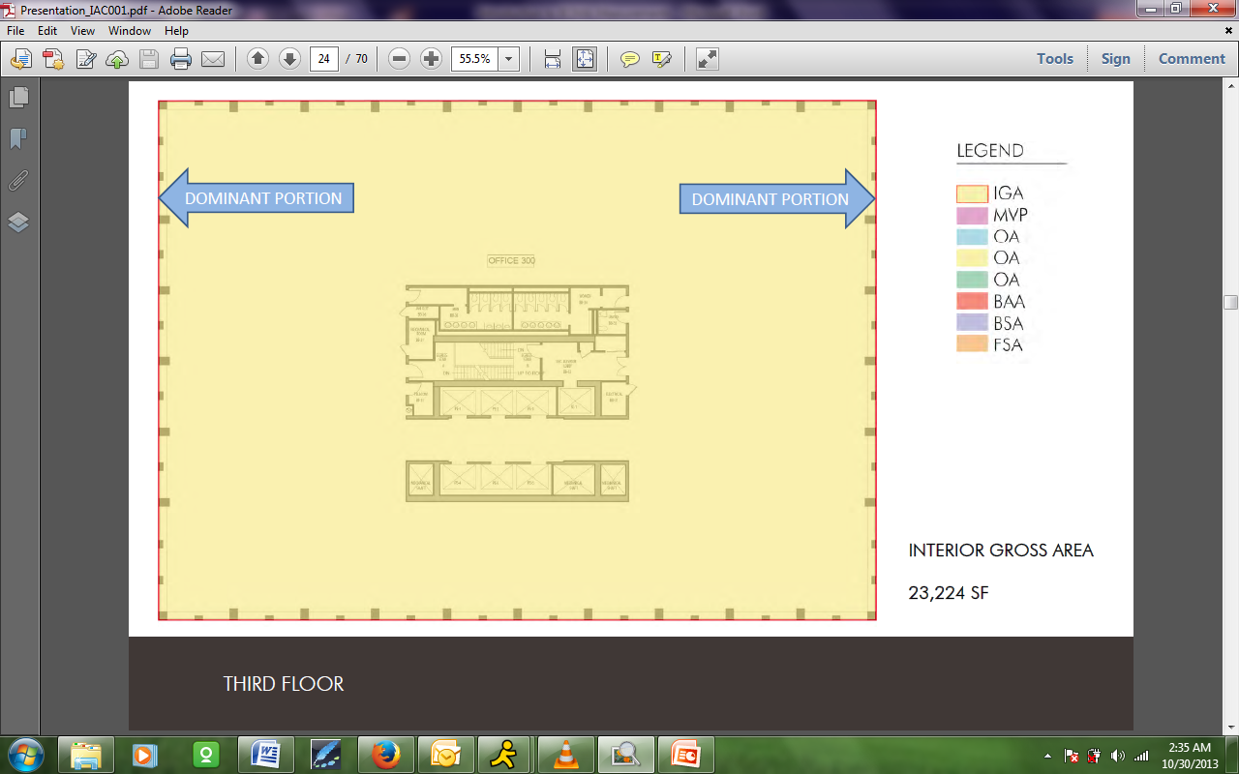
Now if I had a change in construction system and one of these sides was a big masonry wall or something like that, then I would change my dominant portion to reflect that and bring it back to the inside of the wall. But for today's simple case, we're simply tracking our dominant portion all the way around and not taking anything else out.
This big rectangle that we've established, as you can see here, gives us an interior gross area of the floor of a little over 23,000 square feet. That's what we'll be working against as we carve out all of the other spaces in the building.
Moving down our stack, on the next floor we have a multiple tenant floor which has some different conditions because of the boundaries between two office suites and the common corridor. However, the interior gross area is really looking at base building core and shell items, so none of these have any impact on how we're going to take that measurement.
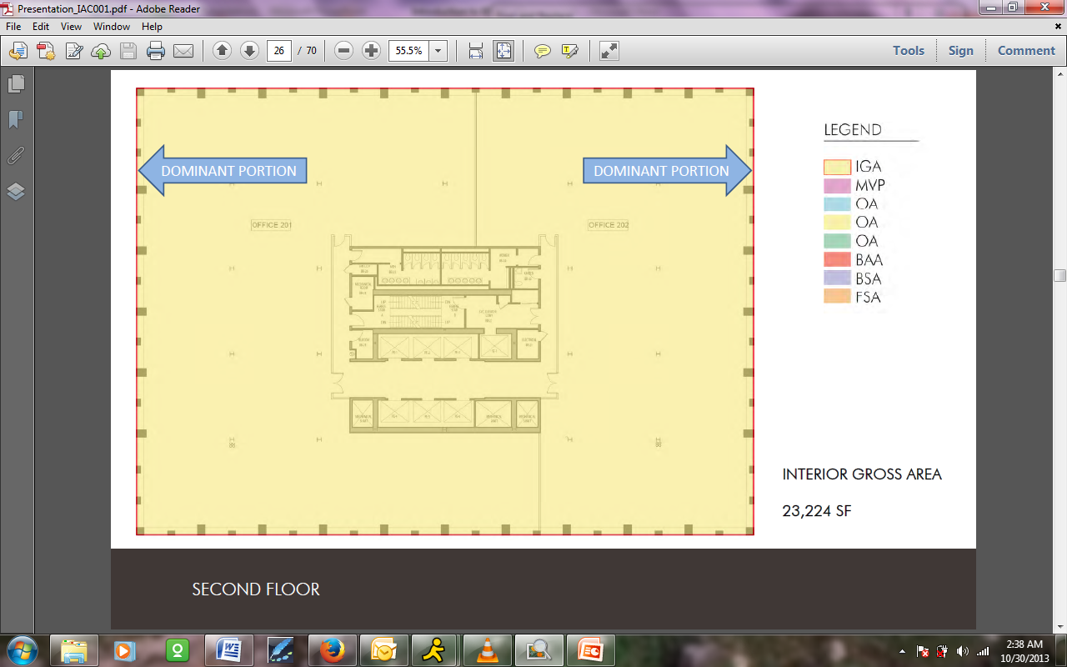
If I follow BOMA's rules and I go and find at the perimeter of the building what's going on, I still have that vertical exterior enclosure, which brings me back once again to that dominant portion; and as such I'm going to find that even though we have two different tenants on the floor and some other kinds of items being introduced, the overall interior gross area is unchanged. We're going to get the same figure for this as we did for the upper floor.
You can imagine that if this were a high rise building with a number of identical floors, then our job would be fairly easy to multiply out over them.
However, when we come down to the ground floor, then we begin to see a little bit of a different condition. As you can see here more closely on the ground floor, we've made ourselves a building where the enclosure at the top of the screen is butting right up against the property line, butting right up against the enclosure of the building above; but on the bottom, the left-hand and the right-hand sides where you see things like To Street and Plaza, we've allowed for pedestrian circulation to come through.
This is the area where we're going to get into the public pedestrian thoroughfare definition. Let's take a look at what we're going to have for interior gross area. You can see here that it's still tracking the building enclosure itself, but what may not be obvious at this large resolution is in fact that we are going to two different conditions there.
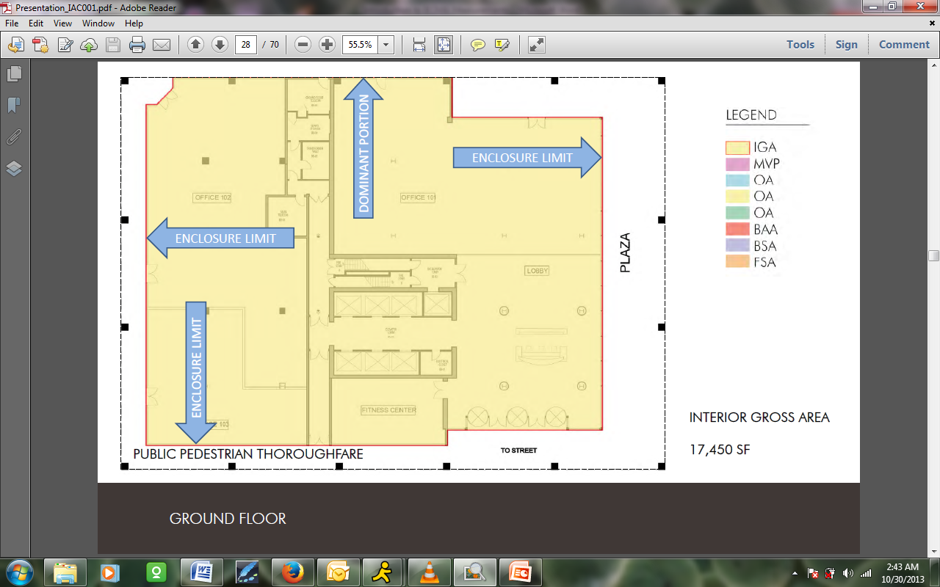
On the north side, we're sticking with our dominant portion, but everywhere that we're abutting this walkway, we're using the enclosure limit. If I were to zoom in, you would see there that we're going to the outside face of the building. As Andy mentioned, as we go around the bottom, that includes not taking into account things like setbacks for doors, like some of our egress doors are setback, or setbacks for the revolving doors that are the main entrance to the building.
To give a little context, this notion of the public pedestrian thoroughfare really came about when BOMA was addressing retail in more specific concerns, and it addressed areas where a retail tenant might in fact change the configuration of their space to building a display window or something along those lines.
They decided that they would come up to the face of the building enclosure itself. That doesn't mean here that we're coming out to the colonnade where people are walking through, but to the face of what the physical building enclosure is.
In that case, that's going to inflect things a little bit differently here on our ground floor. You can see that, with our setbacks, we have a significantly reduced interior gross area of a little over 17,000 square foot for the floor. We have now added up the IGA for all three floors of our building. We're ready to move on and look at the other items that need to come out.
Major Vertical Penetration
Andrew: Our next big, major definition after interior gross area is major vertical penetration. This includes stairways. It includes mechanical duct shafts. It includes elevators, both freight and passenger. This does not include voids, such as atriums.
With the fully enclosed stairs and the illustrations on the lower right-hand side, there are two illustrations of stairways. The major vertical penetration in an enclosed stairway is to the outside of the wall. The major vertical penetration to a stairway that's open, that is not closed – like shown in the lower one – is to the edge of the landing. There's some fine tuning you do in your calculations, depending on how your stair is designed and constructed.
Erik: That gives us a good sense of what the major vertical penetrations are.
Andrew: That's providing it's over one square foot. If you had a small conduit that went from floor to floor that's maybe a four inch conduit, obviously it's less than square foot, so that would not be counted as a major vertical penetration.
Wall Priority Diagram
Erik: So armed with this definition, we're going to go back, and we're going to start to carve out spaces. We're really into steps two and three of what BOMA defined, which is that we want to identify all areas.
We're going to forge ahead and go ahead and locate their boundaries based on what we've done. In order to do that, we're going to use the wall priority diagram, which is an illustration from the BOMA book, that simply tells us whether we go to the far side, the center line, or the near side of the wall when we're measuring from the point of view of any particular area. We can read this chart from left to right.
Some of these are rather simple. You can see at the very top here are our major vertical penetrations. Basically, when these abut any other space type, we're always going to be going to the far side of the wall. That reflects that notion of including the enclosing walls that Andy mentioned.
It's only when we're measuring two major vertical penetrations next to each other that we go to the central line between them, but since we're going to toss all of these into the same overall measurement anyway that's not of great concern to us.
However, it is of concern to us when we begin to look at occupant areas. Here you can see, at the bottom of the chart, that we are looking at the opposite situation. Coming from the point-of-view of the occupant area, we're always measuring to the near side of the wall when we set where our enclosure is, except for the case at the far right where we abut another occupant area. This is important because these occupant areas are the areas that are going to be bulked up to give rentable numbers.
When we have two tenant spaces side-by-side, we always want to be going to the central line. For the other area types which we're going to define, we simply read down in the chart and establish where our boundary wants to be in between them.
With that said, let's take our definition of major vertical penetration and track it down through our building. We are back up at our top, single tenant floor, and you can see highlighted in color in the middle of the screen the items which are defined as major vertical penetration.
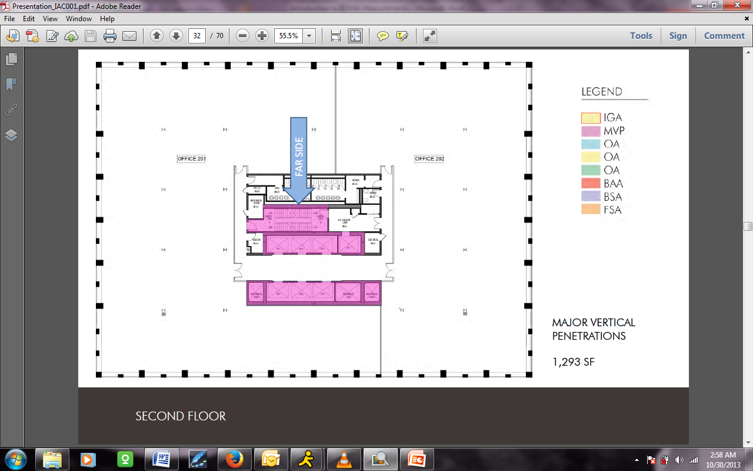
That includes the passenger elevator lobbies, the freight elevator lobby, and the fire stair (we have an enclosed scissor stair here in the center of the building). We've also identified some mechanical shafts which are serving the whole building. Certainly there could be other items, but this is all we have in our simple example.
All of the other items in the building core which are not major vertical penetrations are not getting included. You can see here that that includes things like the core toilets, the janitor's closet, floor telephone, and electrical closets and the like, which we will address separately.
Just to recap that notion, here you can see that I have located my boundary to the far side, and these major vertical penetrations together are coming up just shy of 1,300 square feet on our floor.
As we move down the stack to our multiple tenant floor below, you can see that we have a theme that's beginning to repeat here, which is that whatever has been done in the build-out on the floor is not affecting the base building structure.
I'm going to take the liberty of addressing a question that has come up related to plumbing chases because somebody has noted that I have a plumbing chase above this building. BOMA is full of judgment calls. As Andy mentioned, major vertical penetrations are limited to items which are one square foot and above. As architects, we can understand that you could rapidly get into a technical question here: is there a plumbing chase, which has been framed out as a fire rated chase in the building which might be four or five square feet in aggregate when we take it's long, narrow length together?
If that's the case and we know it, then we could put it within major vertical penetrations. On the other hand, sometimes we find that there are individual cores for the waste line and the like, in which case it would not be. Again, that's a little bit of a judgment call, and I guess it depends on your level of specific knowledge about the building. It's probably acceptable to call it either way.
Coming back to our second floor here, you can see just repeating the theme that we are going to the outside of our major vertical penetrations and we're getting the same quantity of space here on two as we did on three above.
I’m going to march us further down the stack and come back to our ground floor. Here we're seeing the same items going on. The fire stair is slightly different. We have a little bit less space, and our mechanical shafts, we are assuming, are not continuing down through the floor level here. So we have a little bit less space in the building core. In fact, we're showing that just shy of 1,000 square feet on this level is going to go into our major vertical penetration category.
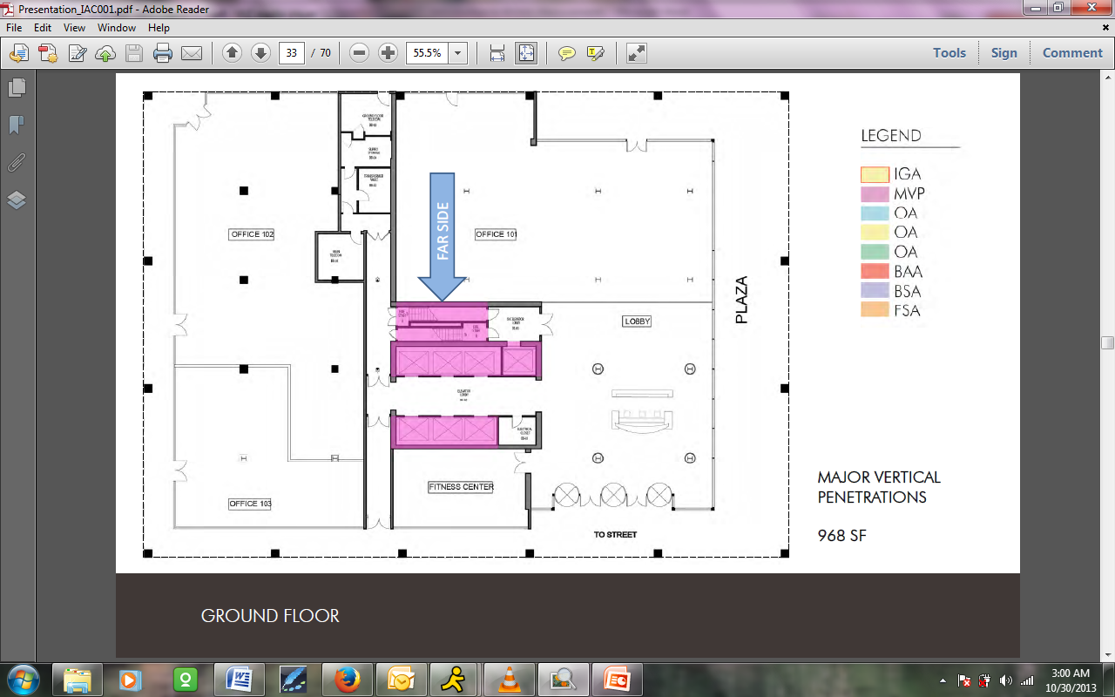
With that, we have backed out all the major vertical penetrations. There are some other items, such as parking and occupant area, that would go into some of this initial determination, but we're not going to look at those today. We're going to move right on to the tenant spaces themselves.
Occupant Area
Andrew: The major tenant space is now, under the 2010 BOMA, called occupant area. It used to be called office areas but under 2010 is now occupant. And that includes areas like where you actually have an office, where you have break rooms, where you have internal storage, and some of the corridor space.
As you see in our illustration on the right, the areas where doors are recessed so they don't swing out into exit spaces are actually included in the occupant area. Occupant areas are measured to normal boundaries, like you see to the elevator to the outside of the major vertical penetrations, but between occupant areas are measured at the center line of the walls.
This also excludes any base building circulation, which we'll learn a little later on when we're exploring in Method B.
Erik: Great. Andy, I think that we've actually addressed one of the questions that came up here, which was that the old store area definition, which we might think about on the ground floor, is now consolidated into an overall office area definition as part of the current standard.
Andrew: Correct, and it's called occupant. If you have retail on the first floor or a combination of a retail and office on the first floor, it is now all considered occupant area so there's no confusion between retail and office space.
Erik: I'm going to take us back to our stack, which hopefully is now becoming familiar. I'm going to show us that upper floor again. Highlighted in blue here is the single occupant area for the floor. As you can see, that's extending out to our interior gross area boundary at the perimeter, and we're bringing ourselves into the near side of the walls that it abuts, so we're going around our building core always to the near side of the wall.
As you can see, BOMA's system is very consistent so that is dovetailing nicely with our determination of the major vertical penetrations. One of the things that are important to note on this single tenant floor is that the space within the passenger elevator lobby and the space giving access to the fire stair and the freight elevator is included within the occupant area under this Method A calculation. Here, just shy of 21,000 of our total gross area is getting allocated as this single occupant area.
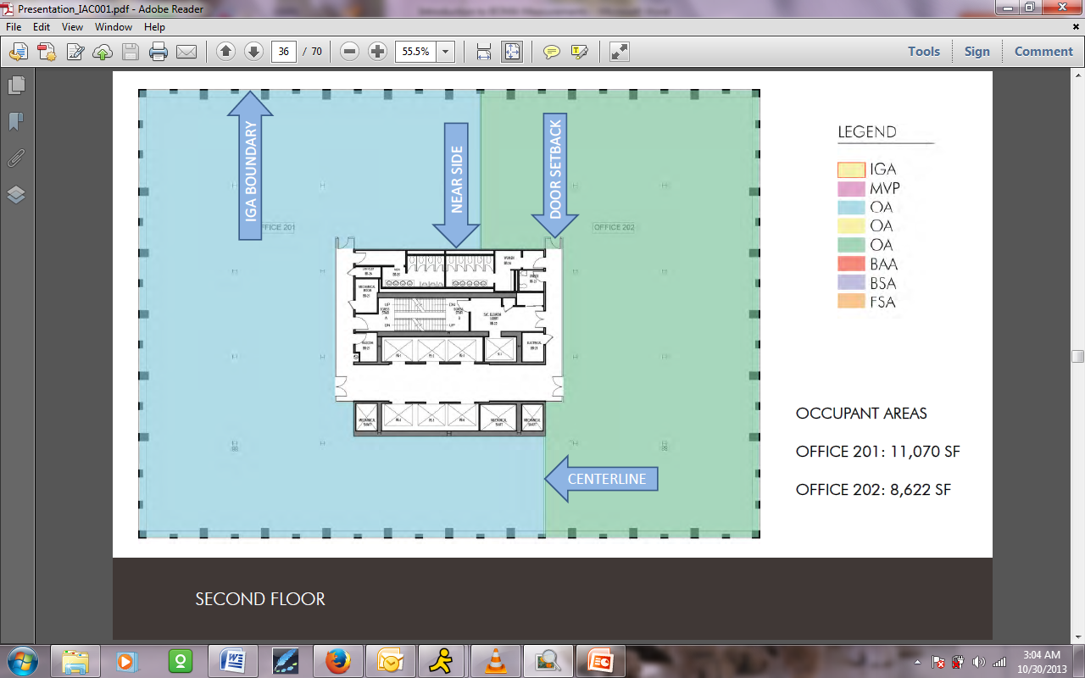
I'm going to move down the stack, and now we are beginning to see the differences between our third and second floors. In this case, following BOMA's rules and moving in from the IGA boundary at the outside, we're only coming up against the enclosing multi-tenant corridor in the center of the space. That's going to be the boundary of our occupant area. As you can see, we've also backed that out.
Other than that, the same rules are applying going to the near side, but one item is occurring here. As Andy mentioned, required door setbacks get included in the area. As you can see, these tenants have chosen to extend the multi-tenant corridor a little bit further so that their out-swinging egress doors do not conflict with other things in that. Because of that, we're going to include those little areas at the top of the core within the occupant area as they're mentioned here.
Above and beyond that, you can see that these folks are splitting the floor up between them. We're going to be going to the center line with the dividing partition between them to divvy them up. In our one office suite we have a little over 11,000, and in our other office suite we have about 8,600 square feet for the occupant areas here on the floor.
We're going to come back down to our ground floor, and I want to take an opportunity to address a question that came up about setbacks and how we're determining where the exterior enclosure is while we're back on this slide.
As you can see, on the three sides – the left, bottom, and right side of the plan – we have this significant public pedestrian thoroughfare. That's why we made the choice in that area to go to the exterior side, to go to that exterior enclosure. We've taken that all the way up to the top on the left hand side where you can see a little angled area with a pair of double doors.
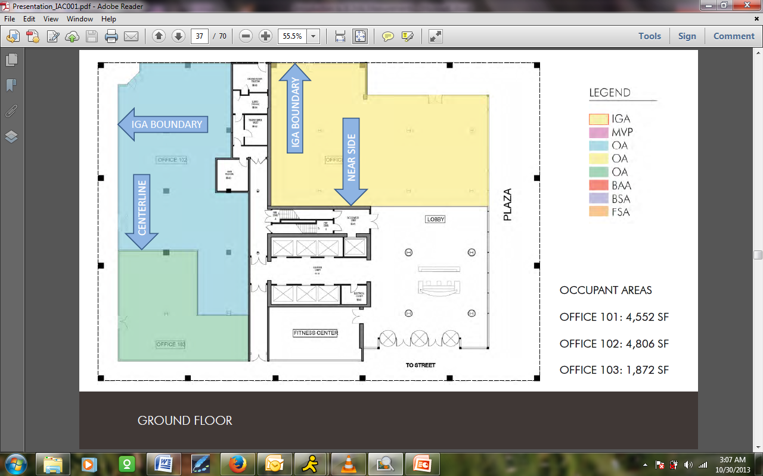
A question was asked – why didn't we treat this as a door setback? The reason is that down here, at the egress area and here at the recess, we're assuming that these are our setbacks that happened within the enclosure, so they're not going all the way up and really tracking the enclosure boundary.
Whereas here, we're assuming that this jog really is the actual perimeter of the enclosure boundary of the floor, and that's why we've tracked along it and not, let's say, drawn a line out here. I guess that if this was a partial height setback and the main line of the enclosure continued above it, we might have run that a different way.
Let's come back to our occupant areas now that we're on the floor. You can see that this is the most complex situation in that we have three separate tenants who are occupants on the floor themselves.
We're still going to apply the same rules, and we're going to work in from our IGA boundary and do what we need to do when they abut other spaces – which is to say that we're going to the near side as we hit all of those walls that are adjacent to other building items. In the case on the left, where we have two tenants, we're going to the central line. We're really just divvying these up the same way. You can see that we get three suites, two of which are in the 4,000 square foot range and one which is about 1,800.
With that, we have calculated all of the occupant areas and we're going to put those aside to enter into our calculations. We're ready now to move on to the service and amenity areas, which BOMA defines in two categories: those who serve the floors themselves and those which serve the total building.
On this slide, you can see the definition of our floor service and amenity areas.
Floor Service and Amenity Areas
Andrew: The floor service and amenity areas include places like janitor's closets, restrooms, electric closets that service just this floor only. The amenity areas would be things like if there were such a thing as a common break area. Our example on the right-hand side shows a floor service area on the first floor, which we don't happen to have on our building that we're doing today.
This would be the only place on that floor where you have a corridor that would service the tenants even thought their exits and entrances are all to the outside of the building. This is not something that is required. This is something that is for them, their convenience on the floor to access floor spaces like restrooms and janitor's closets and so forth.
This is the floor service and amenity areas. Then there are also building service and amenity areas. In the building service area, most of the upper tenant floors would not have amenity areas, per se. They would have service areas; the building service areas include elevator lobbies. The building, as you can see on the right, the definition over there, and the illustration on the right-hand side.
Building amenity areas would not show up on this floor. On the first floor of our illustration, we have an exercise facility, a health club.
Erik: These guys are using a common amenity area as an example of a building service and amenity area. Before we leave this slide, I also want to just mention one item here. This is BOMA's illustration. As we've been going through, everything that is not our building is showing what BOMA actually gives you as their example for you to determine what you would be doing.
You can see that this building lobby and the egress corridor in yellow are in BOMA's building service area category. But there are some other areas here. This service corridor is serving only tenants on the floor, which are within the floor service area. Additionally, the core toilets here on the ground floor are within the floor service area.
This will be important as we come back because it's these floor service areas, when we come to the second method, which are going to change their definition and get looked at as base building circulation, whereas this lobby area is a building service area really serving the entire building.
With those two definitions in mind, I'm going to go down through our stack and try to address these conditions. We've given ourselves a relatively simple example. One of our attendees has pointed out that we've made the example so simple that we didn't even bother to make ADA compliant toilets, which I should definitely get a slap on the wrist for. Andy, these folks are going to be very unhappy when they realize we didn't put any toilets at all on the ground floor.
Mary: At least in this renter you have two means of egress.
[laughter]
Erik: Here we are back on our single tenant floor, and I think that the diagram is getting familiar to folks. You can really see that everything that we have not filled in to date, in our occupant area and in our major vertical penetrations, is coming in under this definition of floor service area. As Andy mentioned, these are things which, and BOMA says primarily, are dedicated to serve the floor.
Someone asked a question about how you would address a restroom that is designed to service two floors as opposed to one, and I'm afraid we're going to have to punt that maybe as a BOMA 201, rather than a 101 question. Certainly, the individual floor core toilets come under this category, as do things like electrical closets, floor telecom, and janitor's closets.
It's a fairly common sense way of defining it. You can see them hatched here. They are again following the same rules. They're going to the near side at things like major vertical penetrations and to the far side at things like our occupant areas. Here we have 934 square feet rounding out the remainder of the third floor.
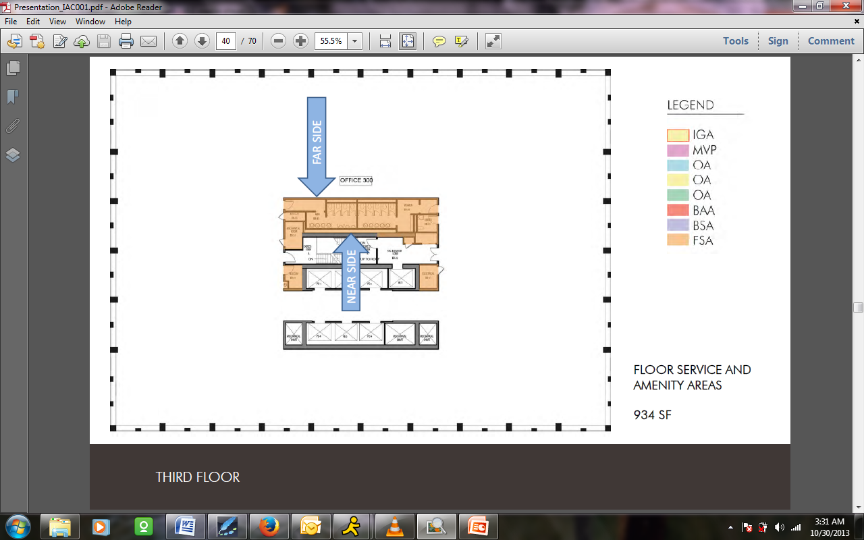
Once again now, we're beginning to look at a condition where the configuration of the floor in Method A does have some impact. As I come back and fill in the remainder of the spaces here on the second floor, we can see that, not only the same spaces that I have shown above but also that common multi-tenant corridor, is coming under that definition.
You'll see that we haven't extended that into the door setbacks, but it's following the same rules as it abuts the tenant areas and other items. Here, that has significantly increased the floor service and amenity area to over 2,000 square feet for the floor.
One might ask the question, "The landlord has moved some things out of their tenant space into common. That must be bad. The landlord will be paying for those," but as we will see when we get into the formulas, everything comes out in the wash and all things get distributed back into the allocation of space at the end of the day.
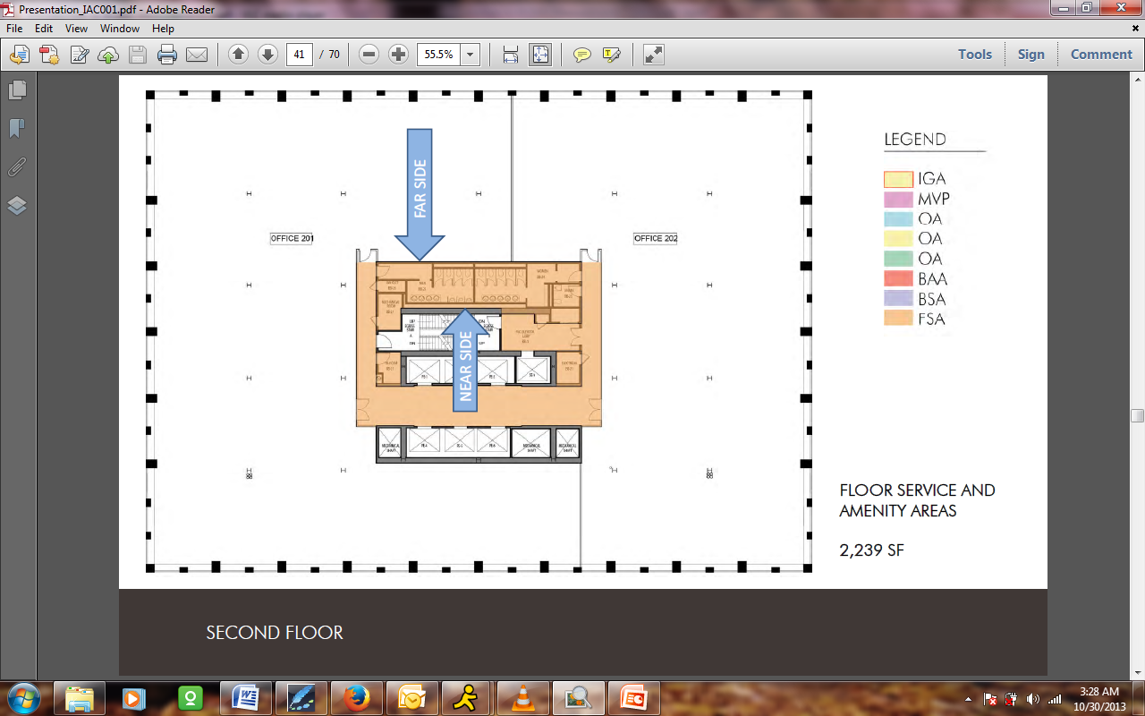
I'm going to track us back down to our more complicated ground floor, and we're going to look at all the floor service and floor amenity areas. You'll note that on the upper floors, we chose not to include a floor amenity area because, as Andy mentioned, things like that like providing a common vending area or break room on a floor, are not particularly common in today's commercial rental market.
Not a lot of landlords choose to do that. Building service areas can occur on an upper floor, such as a main electrical switch gear room or a large base building mechanical item or an elevator machine room above an elevator bank, but for our simple version today, we didn't show any of those. We are going to begin to encounter those down here on the ground floor.
For starters, we've identified a small floor service area. This is just a floor telecom room. You can see at the top that is serving these folks on the floor at 184 square feet. We're going to carve that out first. Then we're going to move on and look at the building service areas.
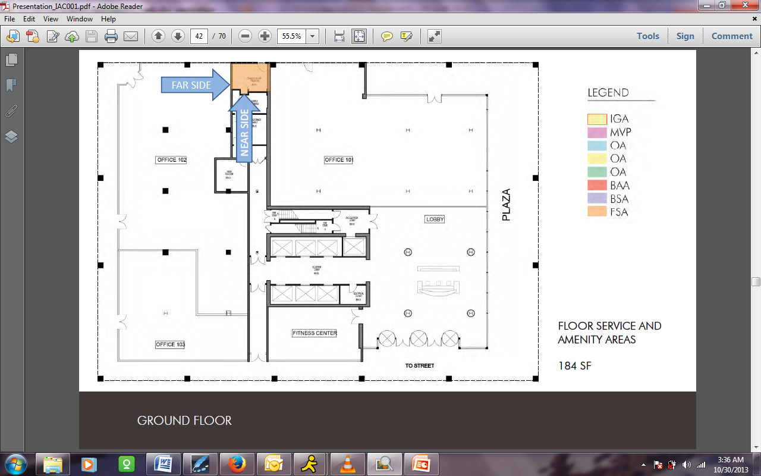
As you'll remember from the BOMA diagram, the main entrance serving all of the tenants, since everybody is coming in here to go up the elevators and the like, goes into building service area. Additionally, the main access into the freight elevator lobby here is going into building service area.
Above and beyond that, we've indicated that these functional rooms in here – a main telecom, a main electrical, and a base building storage area – are the landlord's for serving the whole building, so we've put them into this.
Realistically, if I had gone a little further into this building, I'm sure that we would see some more floor service areas serving these tenants. There might even be some additional access corridors, but really we just wanted to point out to you the basic concept that this main egress path, these main infrastructure items, and the main access have their own category to go into so that they can get apportioned out over the entire building.
These are the service items, and, as Andy mentioned, they're ones that provide people access to the space or to necessary items. There is another category, which is building amenity. I would say that this, even for a base building, is not particularly common today, but one could imagine that a landlord might provide that.
I think you folks get the sense of how this works. They're adding up to almost 5,000 square feet down here on this lower level.
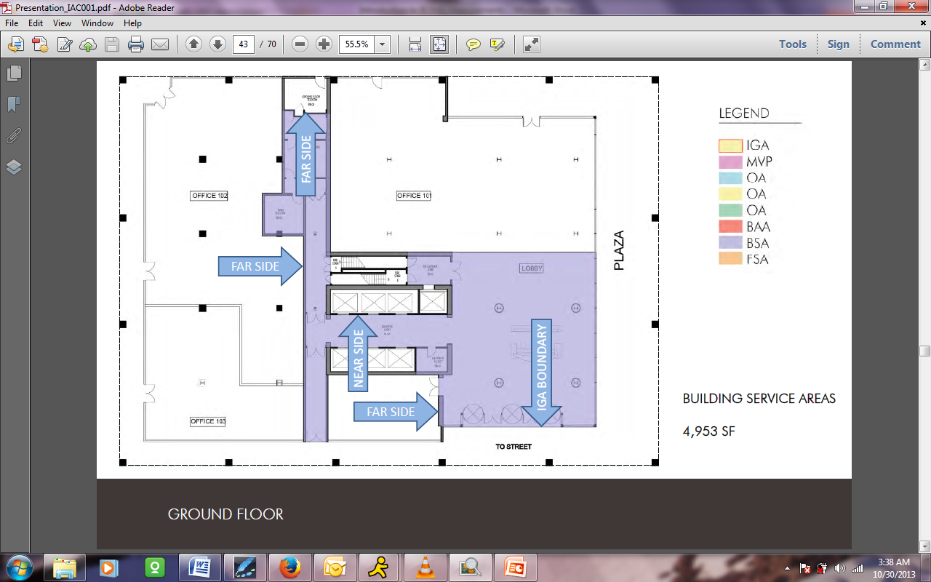
To move on to a building amenity area, we've said that this landlord has been good enough to provide a fitness center for the use of all tenants, perhaps as a draw to the building. They've located it here on the ground floor. We're going to put this in our building amenity area category. Again, we're just going to follow our usual rules, working in from our IGA boundary and using the wall priority diagram to locate the walls so that we flesh that space out.
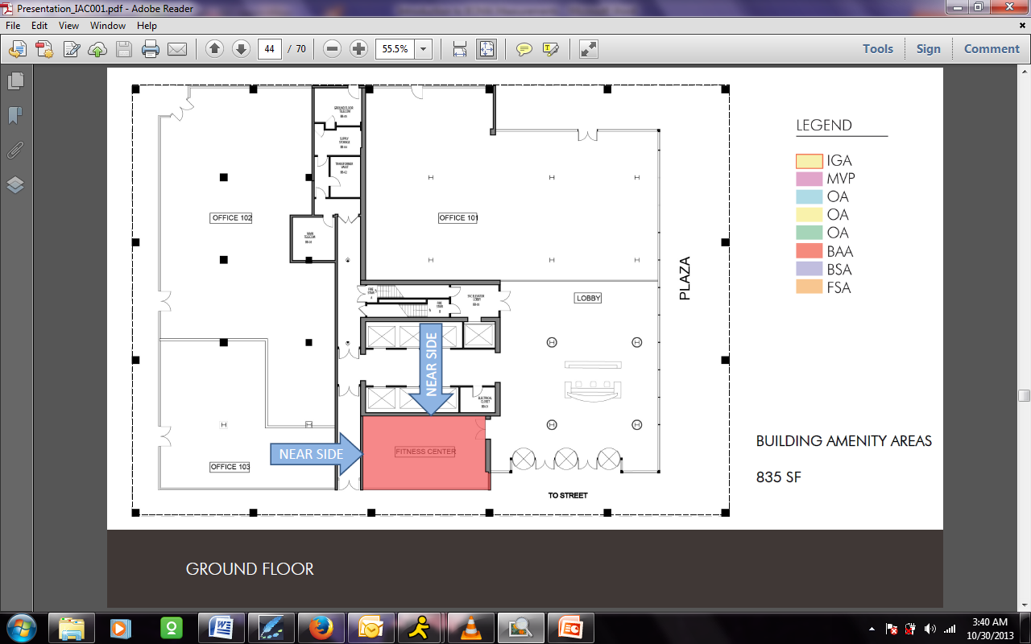
With that done, we have now, believe it or not, actually moved through all of the takeoffs that are required for Method A. We've gathered all of the information that's necessary for us to do our BOMA calculations for this building in their entirety.
Area Measurement: Method A
With that, we're going to move on and use a tool that BOMA provides in their book, and this is the Global Summary of Areas chart, this rather imposing-looking chart here. If you purchase BOMA's “Office Building Standard Methods of Measurement Book,” you will find that they provide you with this chart and they actually give you written out the literal Excel formulas that need to be plugged into each cell. While they don't provide you with an Excel Spreadsheet, they have given you absolutely all of the tools to easily put one together and know that you are applying the formulas exactly as BOMA has intended.
We have gone ahead and made our own version of this chart and we're going to go ahead and plug it in. First, let's understand the steps by which BOMA wants us to fill the chart in. There are four areas that we're going to go through.
The first one, here on the left-hand side of the chart, is known as preliminary calculations. Here we plug in the interior gross area and major vertical penetrations that we took off to lead to something called preliminary floor area. This is also where we plug in values for parking and occupant storage, if we had them in our building example.
Andrew: As a little more defined, talking about this chart, the areas that are white are areas where information is entered. The information that is gray in this block, you do not enter anything into this in this format. The areas in beige are auto-populated. It's based on the information that you provide in each of the open spaces using the calculations shown in the second line down from the top of the chart, and that auto-populates those boxes.
Erik: We're going to show exactly how that goes ahead and works. Here in the second section, we have what they refer to as the intermediate calculations. None of this is leading to actual lease numbers, as they note.
Here we're going to plug in each of the occupant areas that we defined, and then we're going to take the numbers for those building and floor service and amenity areas and plug them into the right categories. Based on that, Andy, they're going to start to total some items for us.
Andrew: Yes, they will start auto-populating. You'll come up to the final calculations, which is the next group, which will give you the R/O ratio, which is a new factor that takes the place of the R/U factor that you may have been familiar with the 1996 BOMA.
The R/O ratio is the Rentable/Occupant area, and then that produces what's called a load factor based on the calculation shown, which will then give you a rentable area. This is the most important number, that rentable area. That's the number the landlords, the owners, and the tenants are interested in finding so they can calculate their leases.
Erik: I don't want to confuse folks here, Andy. We should note that the R/U ratio actually does still exist in the precursor calculations here.
Andrew: It does, but it's a precursor calculation, not a final calculation. Whereas with the 1996 BOMA, it got into the final calculations. We also have another column on the end, on the right-hand side. This is an opportunity for the landlord, if he has a building that is so out of line, as far as building efficiency, he has an option that he can change the load factor to a lower number which means he is not being able to rent all his space. You can never go above the load factor in the final calculation, but they have the option to go below it.
Erik: We should note that we're keeping some integrity to the process there. This is not something that allows a landlord to inflate their rentable. As we're going to see in Method A, different floors have different load factors. The landlord's cap can only apply to those floors which are particularly inefficient.
Andrew: And we'll show that on our next round of calculations.
Erik: Before we come back and plug in the numbers, I just want to quickly recap. As a check at the end of the day, as we mentioned, when you establish your IGA boundary, you should not have any gaps between spaces and you should not have any overlap between spaces.
I just want to show here all of our polyline areas together, so that we can see what each floor is made up of. As you'll remember on the upper floors here, it's primarily occupant area, the major vertical penetrations, and just the floor service area. That is actually going to translate down to our second floor as well, even though the proportions are a little bit different.
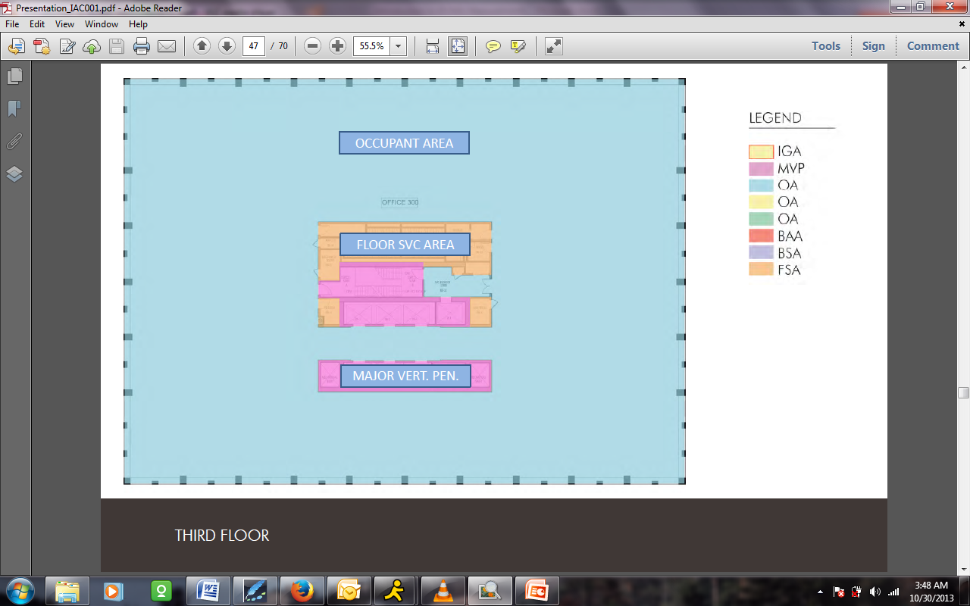
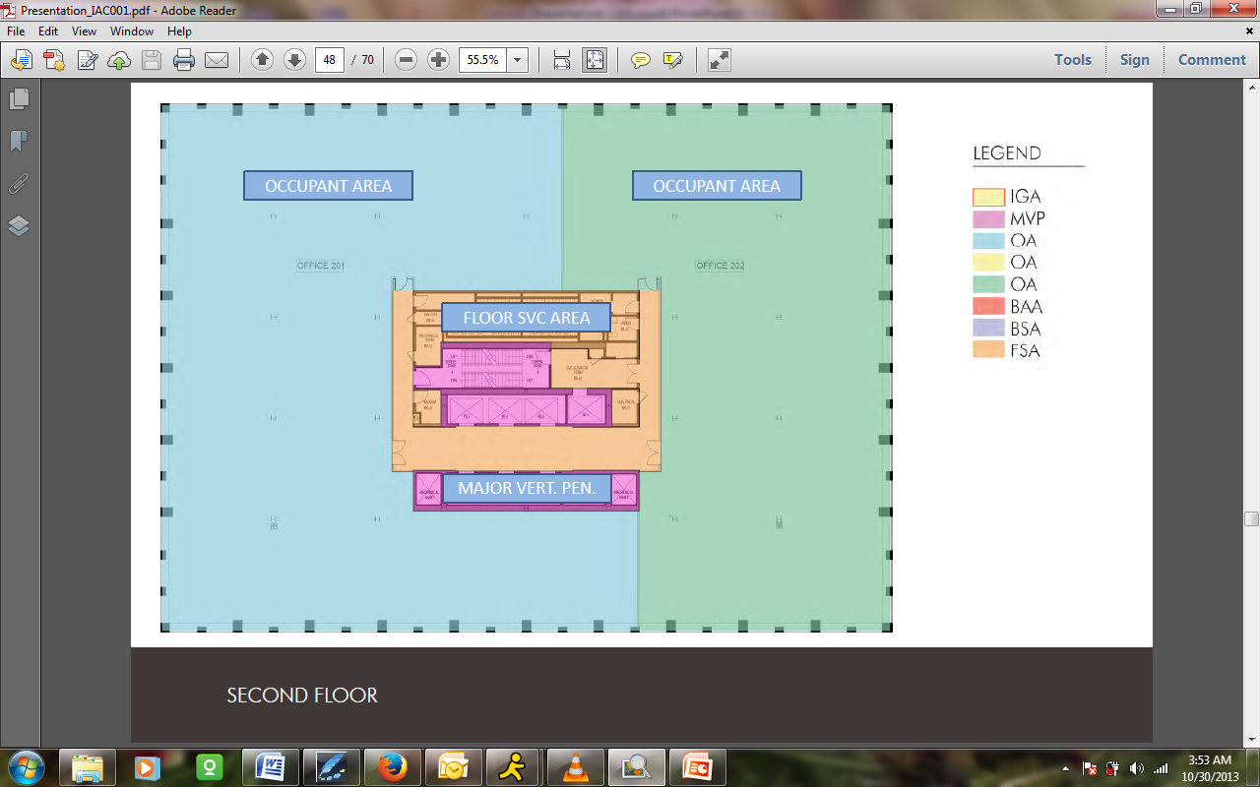
When we got down to ground floor, we began to engage a little bit more of the space categories. In addition to those three here, we also started to see the building service area and the building amenity area going into our total. Armed with this and the numbers that we've taken off, we're going to plunge right back into BOMA's chart and actually begin to fill in some of the numbers.
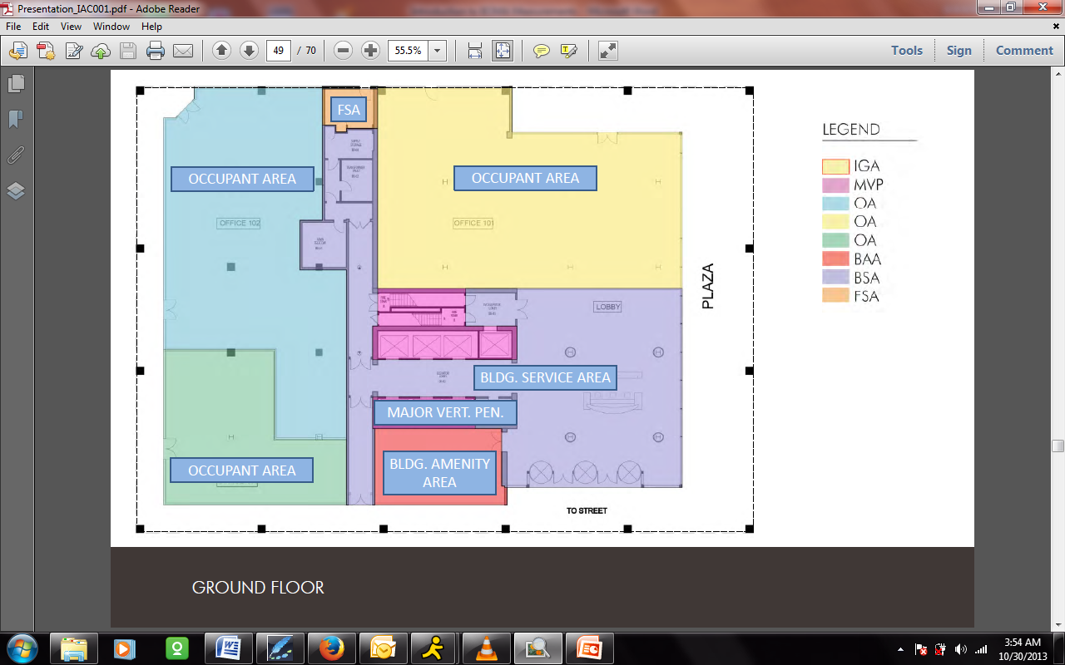
In order to do so, let's look a bit more closely at that first section on the left-hand side called preliminary calcs. As you can see, we've plugged in our three floors here in the chart, and we're ready to go ahead and put in that initial information. In Excel, we would literally just go ahead and plug in the first two categories there: Column B for interior gross area by floor, which is going to total at the bottom, and Column C for major vertical penetrations. Parking and occupant storage would also get included. As you can see, these go together here to establish something called the preliminary floor area.
BOMA puts a summary of their own formulas at the top, above and beyond the detailed information that they give you to plug in. You can see that this 60,344 square foot number is going to be familiar and come back to us at the end of the day. But once we have everything sorted out, that's going to give us the end of our preliminary calcs to move ahead.
From here, we're ready to go into the intermediate calculations and look in a little bit more detail at what we've done on a floor-by-floor basis. Here you might need to add or subtract some rows in order to get the right quantity of spaces that you've put together for your particular building, but I'm going to plug in the things that we saw on each floor.
Starting from the top, we have office 300, which is the only tenant space on the third floor. We plug in the occupant area that we measured. There are no building amenity areas on the floor there and you can see that, if you remember, the other thing that we had was floor service areas.
BOMA's calculations are actually backing those out for us automatically. Once I've plugged in the white spaces, they're reporting back to me that the floor service area, as you can see here, ought to be 934 square feet. Lo and behold, that is the exact number that we got in our take off.
One thing to be aware of is that rounding issues can occur in this chart, and BOMA has structured these formulas to avoid them. It's possible that I might have decided that this was 933, but because everything needs to add up at the end, BOMA might have rounded it up to 934. It's never going to be off more than a square foot in either direction.
Moving down the stack, on the second floor we identified those two office areas. I've plugged in the occupant area here. You can see they're adding up to a little bit less, but BOMA is understanding, backing that out from our preliminary floor area, and they're telling us correctly that we have that larger floor service and amenity area that we observed with the common corridor in place.
Moving further down to our most complex ground floor, you can see the three individual tenant spaces all getting entered under occupant area. We decided that our fitness center was a building amenity area, so we are plugging it in here. Above and beyond that, the building service areas we're taking in aggregate and we're plugging in in this location.
Somebody asked where the floor service areas fit into in the chart. They fit in in this Column L, under floor service and amenity. It really doesn't matter actually which way we would have categorized those, but you can also see, accurately, that BOMA has backed out and given me back my 184 square foot number, exactly the same way we did it in the take-off so that we are getting complete on the floor.
Andy, this is where this turns us over into the formulas that get us, again, into our occupant plus allocated area.
Andrew: Right. As you fill in the spaces under this section, you'll see that the R/U ratio starts auto-populating, and then the occupant and allocated area, otherwise known as O, auto-populates as well.
We go on to the final calculations, which is the next section. That will auto-populate. There's nothing that we need to enter in that at all. There we have the R/O ratio, which we talked about, the load factor A, and then we come up with the final answer, the rentable area. Notice that the total on Column Q at the bottom is the same as the internal gross area that we saw earlier.
Erik: It was at the end of our preliminary calcs.
Andrew: The preliminary minus the vertical areas.
Erik: So this reiterates our theme that nothing is gained or lost in the BOMA measurement. It's simply allocated.
Andrew: Everything is covered. Everything is included, and nothing is left out. This is a good double check to make sure you've allocated all of your areas properly throughout, as you go through your measuring. Those two must equal each other.
Erik: We can see one of the implications of the legacy method, the 1996 BOMA method, coming into us here now as Method A, in that the load factors on each floor obviously vary. Because we've created a hypothetical building, these are not right in line with market norms, but we can see that our single tenant floor up here has one load factor, our multiple tenant floor has a higher load factor due to the allocation of that common corridor. And, actually, we've made a very efficient ground floor here.
If the landlord were to apply a capped load factor of, let's say, 1.20, and we plug that in here, it would reduce only the items on this floor. In this case, we could say that money is being left on the table by the landlord because they would be reducing the total square footage, assuming that they're working things out on a square footage cost basis.
Andrew: Theoretically, the landlord could change the load factor on one particular floor to make it more appealing to lease, without adjusting any of the load factors on the other floors.
Erik: Right, and as we try to look at why folks might use this Method B that we're going to get in to, we can also see that the build out configuration on the floor, whether it's single or multiple tenant, could have impact on the overall rentables which could potentially cause some complication over time, depending on the timing of things like lease expirations and the like. One can understand why it might be desirable or one of the reasons to establish a single, overall load factor.
Area Measurement: Method B
With that, we are going to plunge boldly ahead into Method B. I would say generally that Method A appears to be continuing to be the most popular BOMA method. It seems like the use of Method B has been fairly limited, but there are some particular reasons why one might want to use this single load factor method. All of this stems out of this concept known as base building circulation.
Andrew: Base building circulation, under the B model, is areas to access stairways, areas to access restrooms, freight elevator areas that are needed to operate on the floor. Now they may not necessarily be in an enclosed corridor. They may just be what's assumed as open space, outside the core.
Even on a full floor tenant space, under this Method B, you're going to have base building circulation. It's going to include your elevator lobby and a width of an imaginary corridor, if you will. You don't measure it as far as code minimum for exiting, 44 inches in most cases. In this, you set up the way the building standard is, which normally would be about five feet as a circulation corridor. You can assume that if the rest of the corridors in the building are five feet, that that would be assumed to be five feet wide.
Erik: Again, the illustration that we've provided here is BOMA's own example of an upper floor and how you would apply base building circulation, even in the case of a single tenant. As Andy mentioned, you can see that it includes access for folks to come in and out by the main passenger elevator lobby to get to necessary base building functions and egress things like the fire stairs, to get us around to the core toilets themselves.
Hey Andy, I think these guys didn't provide ADA compliant toilets in their diagram either. Oh, no. They have a one-holer. They got us.
Andy: Yeah.
Erik: This corridor extends all the way over to include things like drinking fountains here at the end, and you can see that it stops at that point.
We are going to come back now and take this new concept of base building circulation. Really, this is the only thing that varies between Method A and Method B. So for those of you who thought we were going back and slog through each of the space types, have no fear. All that we're going to do is look at how base building circulation affects them, and makes some adjustments on that basis.
With that in mind, I will bring us back to our overall building here and we'll look at our single tenant floor at the top with all of the familiar areas that we had identified for our occupants, our floor service area, and our major vertical penetrations.
We're getting to know now pretty well how we get around in this building. We know where the freight lobby is. We know where the passenger elevator lobby is. And we know that we need to get all the way up here to our non-ADA compliant toilets.
If we can imagine what would be required to access them, then we can establish a minimum base building circulation with a corridor extending around on either side and also getting us in here to the fire stair and to the freight elevator lobby.
It so happens, in our example, that the only thing that this base building circulation is affecting is the area that we had measured for our single occupant area. In fact, it’s reducing that down to just shy of 20,000 square feet.
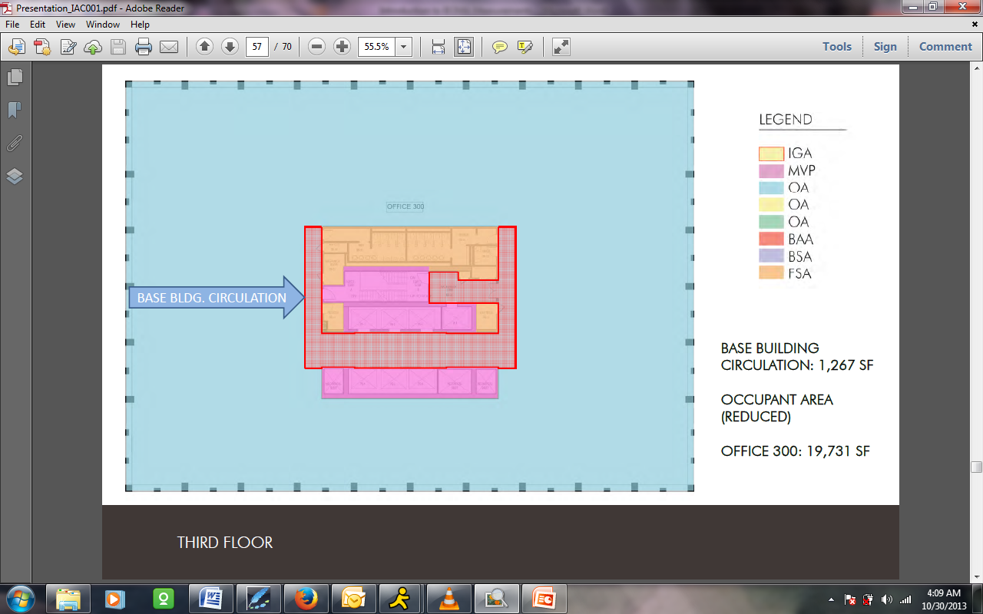
It’s not always going to be this way. We’ve given a simple example. You really need to plug this in and check whether it affects any of the other areas, but really this is the way it should happen on a single tenant floor because all you’re doing is taking space that is actually within the tenant’s leased premises and saying this is the space that would be required at minimum to get us around to all of those base building items.
I’m sure that folks have noticed as we get through into our multiple tenant floor here that there is some similarity between the things that we’ve shown because, in fact, we established our common corridor here to really conform to what minimum base building circulation would be. When we come here and look at the item that we’re going to take out, we find that it’s part of the area that we had established here as part of floor service area under method A. So we were reducing that – it was about 2,300 square feet before – and now with breaking out our base building circulation, it’s bringing it back down. You may have noticed that it’s actually making it identical to floor 3 above, but it’s giving us that same area.
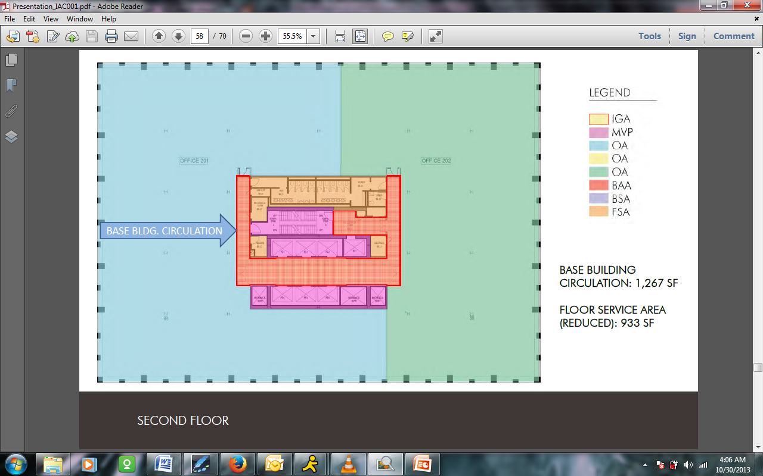
Remember that it’s not impacting things that we determined when it’s in the occupant area like door setbacks because I don’t need this to get to a base building circulation. And we’ve, again, chosen a simple example where this really matches 100%, but you can imagine that, for some reason, there might be a little extra piece of corridor here that was built.
Method B has a concept called extended circulation, which we’re not going to get into today, that addresses those items. So if what’s built doesn’t match what’s hypothetically there, they have a way to address it. You’re not driven by the built existing conditions when establishing base building circulation. You’re driven by the criteria they give you to establish this hypothetical minimum.
That gives us our base building circulation for the second floor, and we have in fact given ourselves a very easy time down here on the ground floor. This is because we have allowed all of these tenants to enter and exit entirely from the outside – realistically or not – and we’ve dedicated all of these common area here to be building service area. That means that when we come back and look at this floor, we’re going to go ahead and say that there’s no change to the area that was established in method A. We don’t have anything here that would count as base building circulation.
Somebody asked that if one of these tenants egressed out in this direction, would that make some of the space into base building circulation? That’s a little bit of a tricky question. I’m going to say that if they egressed directly into this common corridor which is already serving all building tenants, then it wouldn’t necessarily make any change to that.
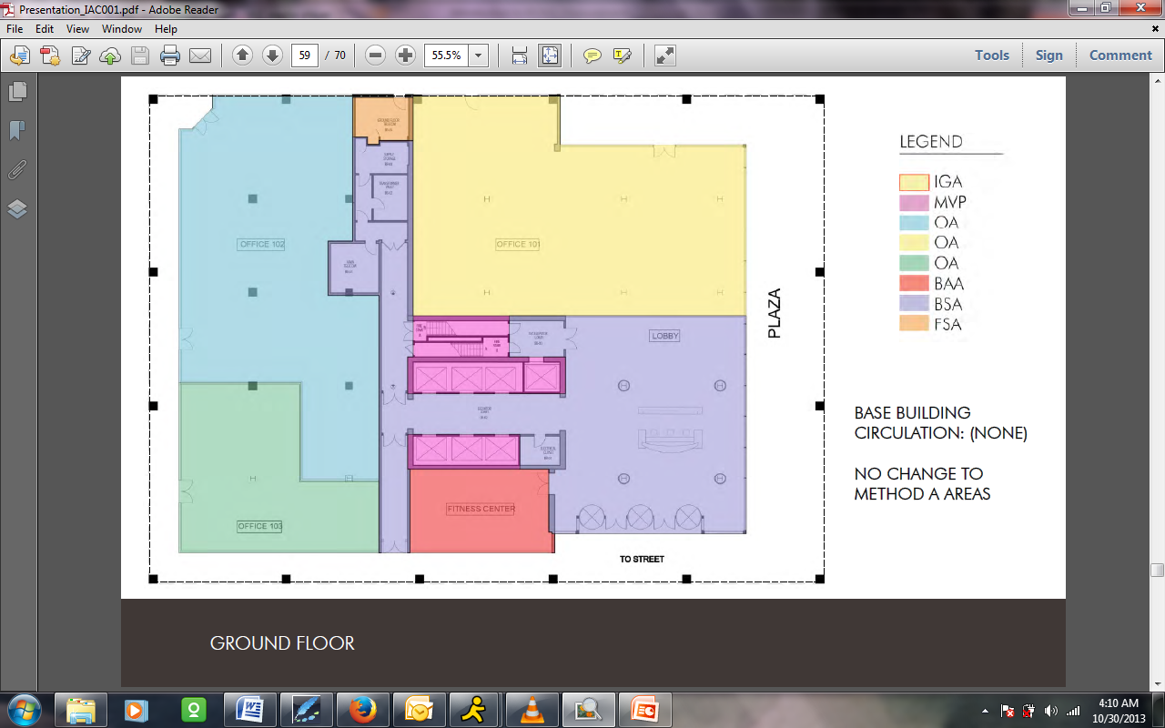
However, if, for example, we had a little access corridor here that only served these two tenants and then spilled into this main building service area, then I would say that would be the kind of thing that would go into base building circulation.
If you remember back at the BOMA diagrams that we showed where they had shown a little floor service area corridor on the ground floor, they have another diagram where they showed that turning over to base building circulation, which shows us exactly how that would work.
We’ve now gone again through our three floors and we’ve gathered all of our base building circulation information. We’ve done everything that we need to do in this example to come back and look at what the method B calculations are.
Somebody said that they thought that one of the main purposes of method B was to allocate the main lobby to all occupants. Method B is not that common. I don’t know how many folks have used method B extensively in their day to day work. I think I had a little bit of a similar conception before we got into it in depth in this presentation, but that is, in fact, not the case.
The reason is that the main building lobby is already being distributed among the tenants by value of the fact that it is identified as a building service area as opposed to a floor service area which, in BOMA’s calculation is being distributed over the people only on the floor – one of the things that leads to having the different load factors for the different floors under method A.
We’re going to come back now to this global summary of areas table, and this is the method B version.
Andrew: I noticed it’s quite a bit shorter.
Erik: Shorter, yes. Somebody had some mercy on us in Method B. But it has similar kinds of portions. It has a preliminary calculation side, it has intermediate calculations which leads us directly into rentable, and then it has those optional adjustments again at the end. Let’s just walk through with our information how we’re going to fill it in.
Here in preliminary calcs, all the information that we gathered in method A is still valid in our example. We didn’t change the interior gross area of the building, we didn’t change the Major Vertical Penetrations. We’re still ignoring these two items, and so when we plug this in, we'll find that exactly the same numbers are coming up and we’re getting to that 60,344 square feet total for our preliminary floor area.
Where we’re going to begin to see things happen a little differently is when we move into the intermediate calcs. But we are still addressing these in the same way. We’ve still identified the same spaces that we needed to take off. We’re still going to have areas for them, although some have changed. And now we have the addition of this base building circulation to plug in.
That’s all in method B that you need to do. Everything else over here is generated out automatically including, again, their calculation that everything else must be a service or amenity area. In this particular model this method B, they don’t care whether it’s a floor service or floor amenity area because again we are moving to establish a single load factor for the building and distribute everything equally.
Here we’re going to go ahead and plug in our information. I think I ran this top to bottom or bottom to top which might be a little confusing, but here’s our ground floor. We didn’t change these areas. We’re not plugging in anything for the fitness center or building service areas because they haven’t given us anywhere to plug it in. However, what we’re finding is that those areas plus our floor service area are accurately coming out here in their own calcs because they’re simply subtracting back out from the total the things that we identified. Additionally, we did not plug in any base building circulation here which would modify this calculation a little bit.
So I am coming back here to the second floor, to our multiple tenant floor. Remember that our tenant suites didn’t change because we were savvy enough to say that our base building circulation coincided exactly with what we previously had for the multiple tenant corridor. That same item is getting plugged in here. That’s the stuff that we backed out. Here you can see that familiar – it did round down 933 versus 93 – remaining floor service area that BOMA is calculating for us here.
Coming up to the top of the stack we have our easiest floor, our single tenant office 300 taking up the full floor. This is the reduced amount of occupant area that we measured because we pulled out our base building circulation. We plug in our base building circulation here, and once again BOMA gives us an accurate response. We have now tabulated up all the areas that need to be input ,and the machinery of the table with their formulas will not calculate the remainder.
Andrew: As you’ll noticed, the rentable area total of column L matches the total of column F, the preliminary floor area, as we did when we did the method A. Also you’ll notice that we have a load factor shown in column K that is identical for every floor. This is a major difference between method B and method A is that method B winds up with a load factor that is the same for all floors versus method A that has load factors that vary from floor to floor.
We still have the optional areas on that two columns to the right with the landlord having the option if he has a particular floor or the whole building that is so out of line with building efficiency that he can choose not to use the whole rentable area for the building just for the market factor of being able to get someone in this space. However, this factor would be for all the floors, not just the one particular floor that he may choose because this does have the load factor identical from floor to floor.
Erik: Right. As you can imagine, if we plugged in up here a capped load factor of 1.18 it would then dial back all these floors equally and so that reduction would be spread over the entire building.
Somebody asked whether there is a maximum load factor? That’s interesting. I don’t think I had ever thought about it in that way. I’m going to say that, theoretically, from a mathematical point of view, the answer to that question is no. We’re measuring a building, and the load factor is the result of the efficiency of the building.
However, I think that we could practically say that based on the market there is some kind of commercially acceptable maximum load factor. You’d have to talk to perhaps somebody on the brokerage side or look at your local market norms to see what you would accept as a maximum there.
And certainly, in the economics of development, no one would build a building that would be wildly out of whack of those factors. You would never see a load factor of 1.5 or 1.7 or those lines. But from a sheerly physical point of view, if I look at this from the fact that I’m just an architect taking off some spaces, then it could theoretically happen.
Andrew: Yeah. Theoretically, you could have a space that has a load factor of 1.9999, but you’d never get anybody to rent that little bit of space. Also, you may notice that the load factor goes up to four digits. It doesn’t round to the first two digits after the decimal point. The reason for that is because on a small building, rounding would probably not make much of a difference. But if you’re talking about a whole building where you’ve got 800,000 or a million square feet, those decimal points could be an appreciable difference between how you run your calculations out.
Erik: Absolutely. With our conclusion here at our total rental area matching the preliminary floor area, we’ve come to the end of our method B calcs, and so we’re coming to the conclusion of our run through of the takeoffs of the two methods.
I want to address one of the questions that have come up which was, where is the base building lobby showing up in these method B calcs?
That is coming up in column J. BOMA is getting it simply by subtracting out, we measured the area, which I’d recommend that everyone do for their due diligence. So that almost 5,000 square feet of base building area plus the floor service area of 184 square feet plus the 835 square foot area of our fitness center, which we said was a base building amenity, are all coming together here under this column J. So they basically just lump them together as everything else.
I know we want to come back and explicitly take some questions and answers. One of the items that came up that we can address as we go into our conclusion is that someone asked why you would choose method A versus method B, and is it up to the landlord to decide?
I think the short version answer to that is, yes. It is the landlord or building owner who decides what method that they’re going to apply to their building. Andy and I actually talked about this question a little bit in the run up to the presentation and we thought to ourselves, “Gee, if there was a full building tenant or a very significant tenant, could they come back and suggest to a landlord that they run the calcs differently? Would they have enough leverage to do that?” It’s an open question, but I guess it certainly theoretically could happen.
But before we get into that pros and cons, one of the things that I think is clear that everybody here should understand is that method A and method B do not have advantages to a landlord in terms of increasing their overall square footage. They’re both yielding, as you saw, the same total rentable area for a building. All they’re doing is allowing landlords to apportion areas differently within the building which might be desirable for them in terms of how they market the different spaces.
As I had mentioned, Method A is still, in everybody's experience that I've talked to, the most common. Folks who have a longer track record with BOMA than me and who had worked for the 1996 for a long time – find it familiar although some terms have changed. I don’t know that we can address all the nuance. I know somebody had asked about how the R/O or R/U calc gets done. Basically it’s very substantially similar in its concepts with some tweaking.
One example would be this idea of void area that Andy had spoken to. Now we are excluding voids before we do our IGA boundaries. So we’re getting them out of the calcs whereas previously they had gotten handled within them.
On that basis I think that even though BOMA calls it the legacy method, we’re really still seeing it, in many ways, as industry standard. However, we can see that there could be some special cases where the landlord would want to have the single factor method.
Somebody had asked about what happens if you change from a single tenant floor to a full tenant floor? Theoretically, that would have an impact on your measurements under method A, although it’s unclear exactly how often that would happen in the real world. Method B would give you a kind of change proof way of measuring the whole building. You could build out and change whatever you like. Your overall calcs are going to stay the same.
Similarly, we can imagine that a landlord might have a building that just has one dog of a floor. It’s a half a mechanical floor. It’s got chiller in it. It’s got a main switch gear room and nobody’s ever going to take space on this floor because the factor is just so high, it’s super inefficient. So the landlord has two choices. Either they tap, under method A, the factor for that, which means they’re going to reduce the square footage that they’re renting – and that does not appeal to any landlord that I’ve ever encountered.
Or they can switch to method B and they can apportion that inefficient floor among all the other floors. This is to the benefit of a tenant on that floor and somewhat to the detrement, theoretically, of all the other tenants. Although one can say in some ways that it could be considered a very fair way of splitting out those things over the building.
Andrew: One must remember that to make a change between method A or method B, or even to change from BOMA 1996 to BOMA 2010, if you have tenants already on the floor and their lease is extended and ends at multiple times at different times, you may need to renegotiate leases unless all of them end the same time. So there are some timing issues that work into that as well. Changing from 1996 to 2010, A or B, takes a little more thought and timing than just saying you're going to do it.
Erik: Just before we leave the formal part of our presentation, in very brief terms, we mentioned that you’ll probably be establishing polylines and then CAD take-offs. I would strongly recommend that you establish a separate set of layers with clear names like A area BOMA MVP for your Major Vertical Penetrations. Then you can use those on each project and allow you to keep things well organized.
Above and beyond that, we’ve taken measurements today from the point of view of how a landlord would address a whole building. Our personal experience is mostly working on the tenant side, so we’re often asked to do due diligence for tenant calcs and we’re looking at it on a single floor basis or the like.
In this case, you are dependent on getting enough information from the landlord to ensure that you're in line, and those factors at the end that we see in terms of the landlord’s Rentable Factor and the like are things that you would want to obtain from the landlord connections [1:16:22 ?].
Above and beyond that, we want to stress absolutely that, although we hope that you find today’s presentation useful and that it's something you can use as a reference tool, there is absolutely no substitute for BOMA’s own reference on it. If you're going to do BOMA take-offs, you absolutely must go and get yourself a copy of “Office Buildings Standard Method of Measurement” from BOMA. That’s the only way to be sure that you have all the information. The things we’ve given here as extracts are things really that make the most sense and look at the complete context of their book.
A quick reference is BOMA’s own website, www.BOMA.org. They're well worth a once over for a number of things. You can get the measurement standards from the page list below.
Above and beyond that, Andy and I are architects and we do this as part of our business. We do many other things, so we have a certain level of knowledge about BOMA. However, BOMA understands that things are complex. They’ve in fact issued a number of clarifications themselves, but they’ve identified a couple of commercial firms as what they call official BOMA interpreters.
The folks that you see listed here are available to answer questions. These folks are business themselves, so I don’t know how far they're willing to go before they begin to suggest that you might want to bring them on board as consultants. But we would point you towards these folk because BOMA tells us that those are really the overall experts.
Mary: Where are these standards applied? Is this a global standard used outside the United States?
Erik: That is a valid question. I’m afraid we’re going to run into some questions that Andy and I may not be fully qualified to give a good response to. BOMA is an international organization. Our experience with BOMA has been limited to its use in the United States. So I’m not aware as to whether that conflicts with another standard in Europe, Asia, or other markets.
Andrew: At this point, to my knowledge, there is no standard in Europe yet. BOMA is working with European officials to get them to establish standards because they have none. So for now, it’s just in the United States.
Mary: There's another question. Many of these are, how many angels dance on the head of a pin? We knew this was going to happen.
Erik: I am based out of New York City, myself, and as Mary knows, we have often done things using the REBNY basis here in New York. The Real Estate Board of New York defines their usable square footage terms in about two paragraphs in their manual. The BOMA book that we are working from today is about 64 pages worth of stuff, so you can get into some very fine nuance on these particular items.
One of the questions that came up was, does a vertical penetration need to serve the entire building in order to be classed within a Major Vertical Penetration? I’m not sure if that is absolutely clearly defined. But for our purposes, we’re going to say that it’s something that serves multiple tours.
We can imagine, for example, that elevator banks of high-rise building don’t serve the entire building, absolutely every floor. And certainly the low-rise, mid-rise, and high-rise past your elevator banks are all class and Major Vertical Penetrations.
The way that BOMA says it – I’m going back to their language itself – they define a Major Vertical Penetration as something that serves vertical building systems or vertical occupant circulation projects. In brief terms, no, it doesn’t need to serve absolutely every floor. But it needs to be something that’s part of a base building system that serves multiple floors.
Andrew: An example of that may be a dumbwaiter that only serves several floors within a multi-storey building. For those two or three floors that it services, that would be considered a Major Vertical Penetration if it’s over one square foot.
Erik: Somebody had also asked the question about atriums, which we thought about being excluded from the IGA. The question was, “Regarding an atrium, is floor level part of IGA, but "voids" second story and above considered Major Vertical Penetrations?”
That is almost on it. You're correct in that the floor level at the base of the atrium is considered within the IGA. I would tend to think that the most common example is that that goes into building service area because the atrium is often above a base building lobby. But remember, the voids above it are not going into your Major Vertical Penetration of the current standard. They're being excluded from the IGA entirely, so they're not getting deducted out. They're simply being left out from the total IGA.
Andrew: Those are major to the outside of the floor, so if you have a guard rail or a low wall, or maybe a soffit [1:21:46 ?] above and it’s open or it has glass, it would be measured to the outside of whatever the floor system is itself – whether it be the outside of the wall or even beyond the outside of the wall if the floor projects beyond the wall.
Erik: Somebody else had asked us a clarification question about door setbacks. They said that they presumed that required setbacks were for “to code” requirements.
This is a little bit of a gray area. BOMA says “door setbacks.” Generally speaking, these are going to get generated from a code requirement because you don’t want a door that’s projecting too far into, let’s say, a path of egress. This is also common sense good practice.
However, I would say that if you had a tenant abutting a common corridor and they had a 3-foot door and they made their setback 5-foot deep, the landlord would certainly want to be considering their occupant area going up to the edge of that corridor, so you wouldn’t get to deduct space out of your occupant area just because you made your own door setback a little bit deeper. Again, there’s a little bit of discretion.
Mary: Here’s one that is a judgment call for you. In your experience, do you always report the calculated rentable square feet or are you asked to skew the rentable square feet so that the landlord can keep the dollars square foot, rent rate, and round up the lease dollars? That’s a common question in New York. Does this apply under BOMA?
Erik: Andy, I don’t know if I can speak to that. That’s not something where I have landlord side experience that I could really give a meaningful answer.
Andrew: If it’s done in New York and it’s using REBNY, it’s not BOMA. Either the 1996 or 2010 BOMA, A or B – you can use them as projected today and as illustrated and as presented in the BOMA Manual. If it doesn’t meet BOMA exactly, it’s not BOMA at all. There is no such thing as modified BOMA. Did that explain anything?
Erik: I totally got that. What we can say from the tenant services side is that we might even be stopping short and taking the landlord’s factor, and that would likely be simply accepted as part of the discussion. “We did our measurements up to this point and you've given us your factor. Thank you.” Often, in a leasing situation, you’ll be provided with the overall Rentable Square Footage for a floor. So in a sense you would kind of back out the factor.
If you have already [1:24:27 inaudible] available, it’s possible the client might be asking you to do due diligence to check a landlord’s overall BOMA calcs. But in brief terms, BOMA gives you a limit with integrity of the total Rentable Square Footage. So really, I don’t think we would see a situation where the landlord could be pushing you to exceed that. If anything, the landlord might be selectively driving it down with those elective caps.
Mary: I think in New York we’re faced with a different standard that brings us to a certain point and once it gets in the hands of the landlord, it’s a different matter.
Erik: Yes, and BOMA is so wonderfully rational I would prefer to leave that off the table for today.
Mary: Absolutely.
Erik: One of the questions that came up was whether it’s BOMA’s choice not to provide an electronic spreadsheet was a liability-based decision. I would guess that that might be part of the case. It’s also part of the reason why we’re not able to share this to you as part of our presentation materials today. I'm sorry. I know these are very useful.
However, I would also suggest that the process of purchasing the BOMA book, going and looking at their spreadsheet, and building it up with their formulas is a worthwhile one to understanding exactly how these things break down.
Andrew: Granted, any time you transmit things electronically that has formulas, it always stands a chance of losing some of its integrity through the electronic transfer process.
Mary: There’s a broad question. How do you measure residential and commercial mix use buildings? There are standards that we did not address today.
Andrew: And those are not addressed in the BOMA 2010 document.
Erik: BOMA does have a separate standard for residential, but I’m afraid that all of my professional experience is in commercial buildings, so I’m not able to answer that. It would really be good to check with BOMA directly on. I would imagine that their residential standard might give you some senses to where to cut-off is.
One of the other questions that came up was to explain measuring to exterior glass of the individual windows not on the ground floor. Explain the 50% glass rule.
This just brings us back to our notion of the dominant of portion. We are not, in fact, measuring to the exterior of glass not on the ground floor. As you have noted, we were going to the interior surface of the glass where the glass was more than 50% of what that overall vertical section pre-finished floor and finished ceiling was. That’s how we’re establishing our Dominant Portion.
As BOMA points out, this is a situation where you cannot simply rely on plans in order to establish BOMA measurements. You really need to have an understanding, whether by a site visit or by section through the exterior, of exactly what that profile is. Really, the intent there has always been to go to the glass. That’s the starting point. The dominant portion was developed to say, “Aren’t there some cases where we shouldn’t go to the glass?” Instead, they said, “Okay. If the glass is less than 50% of the area, then you can go to the more inner ward portion because clearly it's more of a solid construction.”
Andrew: The only place that would be different than that would be when you have an exterior pedestrian walkway where you would measure the outside of the wall and not to the outside of the glass. Whether the glass is the dominant portion or not, you measure to the outside of the wall, the outside of the walking surface.
Erik: Another question that came up is whether top floor mechanical spaces are included in the overall IGA.
This is a very good question. It’s quite common to have a full mechanical floor in a larger high-rise building. The answer is yes. In the same way, you want to look at what the boundary conditions around that floor are. What is the enclosure to that floor? We didn’t go into the special details, but BOMA talks about how to address situations like louvers and the like and how to establish where that IGA boundary goes.
But basically, if you have an enclosed floor which is a mechanical floor and has mechanical rooms and the like in it, it is going to go into that total IGA boundary for building. As you can imagine, those spaces are overwhelmingly going to go into the building service area category, so that's one of the things that the landlord is going to be apportioning out, and that would be a major determinant of the efficiency of the building. How much of that space has to get prorated among tenants to get into their own rentable area?
Mary: This concludes the AIA CES course number IAC001. We appreciate your feedback. Thank you for joining us.
Erik: Thanks so much, folks, and thank you for your insightful questions. I hope that you found the information useful. Best of luck in your own BOMA take-off efforts.
Mary: Thanks to IA for making the time available for Andrew and Erik to bring us this wonderful presentation.
Andrew: Thank you, Mary.
Erik: Thanks, folks.

