Court Technology: AIA & InfoComm Guidelines, Delivery & Emerging Trends
Bob: Good morning, everyone. I’m Bob Schwartz, the Court Track Chair for this conference. I’d like to welcome you to Portland. We have some really good seminars coming up. We have four in the court track today and two tomorrow. We’re going to start off with the court technology guidelines talk. With that, I’d like to introduce Joe Bocchiaro with InfoComm.
Joe: Thank you, Bob. Good morning, again. Today is something of a celebration for this group, because a lot of you perhaps have followed the progress of the courtroom guidelines, the infrastructure guidelines project, and we’re very happy to say that we’re finished and it’s ready for you.
What is unique about this is that there was a collaborative effort between InfoComm International – which is the audiovisual trade association worldwide – and the AIA AAJ. It started from some grassroots conversations that culminated in a presentation in the Bay Area AAJ Vision 2020 Conference, where afterwards, people said, “We all have the same problems. What can we do about it?”
We put together a dream team of people from all over the world who are attorneys, architects, audiovisual design consultants, owners, and technology managers from the state, federal, and international levels. We put all those people in a room to see what would happen, and we got some great debate and ended up with some really terrific guidelines.
On behalf of InfoComm International, I’d like to thank everyone at AIA who helped us make this happen under the knowledge communities and under InfoComm’s standards and industry innovations. I’ll be here with the publication outside in a couple of different versions for you. When this is finished, you can take one with you. Thank you for coming.
Bob: Thank you. We have to go through AIA standards, disclaimers, copyrighted, that we’re in compliance. I think we gained 1.5 HSW continuing education units for this class. On late Friday, you should be receiving an e-mail for self-reporting.
You have all seen the course description in the program. We’re going to examine project delivery, infrastructure requirements, design integration, accessibility, and implementation in historic structures, and we’re also going to examine some new technologies for future court operations.
We’re going to explore technology used by the International Criminal Court. David Samura is with the International Criminal Court in The Hague. Unfortunately, his father died a week or two ago and he’s home in Sierra Leone. He’s going to try calling in, and we’ll hold the phone up to the microphone. He doesn’t have the connectivity there that you normally would have for the International Criminal Court, which is absolutely amazing.
The learning objectives: we’ll review the guidelines, developing basic infrastructure, integrating it, and an introduction to emerging technologies. As Joe said, the task force was comprised of a number of various people who design and operate courts. It was joint from the AIA and InfoComm.
Here today, myself, Jay Farbstein, who I think many of you know, and Jennifer Willard, who’s the supervising AV systems technical analyst for the California Administrative Office of the Courts. Jennifer is actually the chair of our committee. Then, David will be calling in.
Also on the committee is John Greacen. Martin Gruen and Fred Lederer are with William and Mary and operate Courtroom 21. They are at the Court Technology Conference, which is ending in Baltimore today, I believe. Donald Palmer is in charge of technology for the federal courts system. Emma Rowden – I don’t know how many people were part of this conference last year, but she called in from Australia in a breakfast session, describing some of her research. Then, Dickson Stewart is an AV consultant.
From the InfoComm staff, we have Joe, Rachel Peterson, who has really kept us on the straight and narrow, and Andrew Buskey, who really helped on finalizing the the book.
Who is InfoComm? Do you want to say who InfoComm is, Joe? We can’t say anything better than you can.
Joe: We’re an industry trade association. Like I said, we are worldwide – and by worldwide, I do mean everywhere. Right now, today in Mumbai, InfoComm India is finishing up. We have tradeshows in about 12 different countries, and believe it or not, the United States is not the largest anymore. Europe has now exceeded our tradeshow attendance, globally. Truly, we are worldwide.
All of you are invited to come to these tradeshows. This year will be in June in Las Vegas. You will be absolutely amazed by the audiovisual technology that you will see there.
Our department is the Standards and Industry Innovations. I’d love to talk to you about what we’re doing with standardization in the audiovisual industry, because I know a lot of you struggle with projects. People have been listening and saying, “Yes, we do need standards in that space.”
We’re working on commonsense things, like screen size, contrast ratio, loudness of sound systems, and all these things that you would expect. We’re finally getting around to those.
The big message we have for architects is to look to partner with certified audiovisual professionals. InfoComm has basic level, design level, and installation level professional certifications. They are ANSI ISO/IEC 17024, if you know what that means. They’re the highest level of personnel accreditation. These people are here to work with you on the design and on the integration side. Seek out firms that believe in this and are trained in standards and industry innovation’s best practices. Thank you.
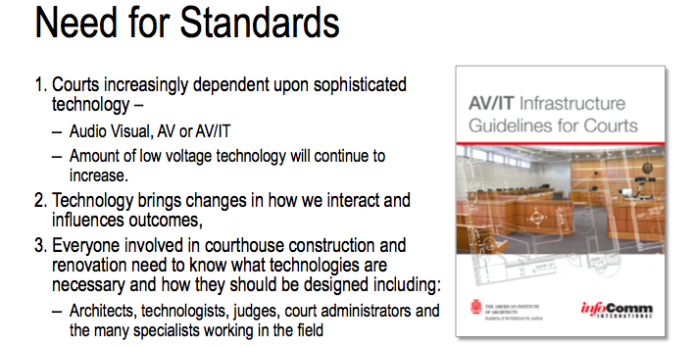
Bob: Then, we can talk about the needs for standards. As you know, the courts are increasingly dependent on technology. The amount of low voltage technology use is increasing at an increasing rate, and it changes how we interact.
I was just reading an article yesterday about how young people see things so differently than we do and how they use technology. It’s going to be impacting the courts, and then, obviously, everyone involved in courthouse construction needs to be part of the process from the start.
Here, you can see the cover to the guidelines.
Jennifer: They’ll be available outside. Go see Joe. We also have them on a flash drive – which I think is pretty neat – so you’ll also have a laser pointer.
Joe: You really want one of these. It has a laser pointer in it. Even if you don’t want the report, get the laser pointer.
Bob: In fact, I think it was really neat that InfoComm decided not to charge for the report, like they do for a number of their other publications. They really wanted to get this out there to everyone.
Why do standards matter? Jay is going to talk more about this. If the AV is not done correctly, there’s a history of it being thrown out, like in Cook County. They did a study about the bail rates for people being arraigned by video and those who were in the courtroom. There was a marked difference. Those who would do it by video got higher bails.
A lot of that has to do with the quality of the procedure and the quality of the technology. What do you see? Does the person look guilty on the video immediately? The size of the image? Do they have proper access to their attorneys or counsel who they might have in the courtroom? It has to be as close to what they would have in the courtroom as possible.
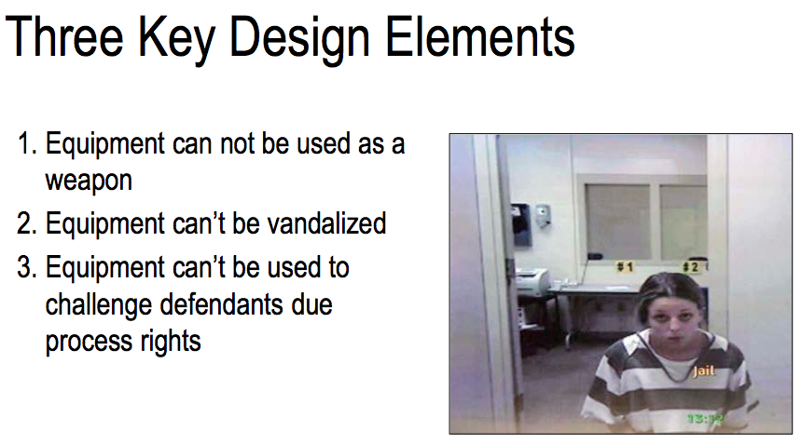
Three key design elements – that are really part of Jennifer’s bailiwick. The equipment that you have cannot be used as a weapon, it can’t be vandalized, and it can’t be used to challenge defendants due process rights. The last one is really important.
Jennifer: If I may, before we go off this, I think one and two are pretty easy, in terms of how you, as architects, look and collaborate with your partners in terms of making sure you have the right microphones, you have the right connections, you have the right floor boxes – things that are capable of the actual building infrastructure.
Number three is definitely where we are going to be seeing our challenges, especially in the future. The reason that we brought this image up, particularly, is the impression that you get – and that cant’ be reinforced enough – of this particular person in this image might not necessarily be what it is that this person has been convicted of. She was convicted, actually, of killing a 23-month-old child.
When you look at this image and you look at this particular person, it can’t be reinforced enough how important it is that, with the AV technology that you’re using and putting in, you are actually putting in as close to face-to-face and real-life in-person experience that you can, because you might not have found that in this.
Hollywood uses this type of stuff so that when you go to a movie, they want to evoke emotions. They want to do particular things. Where your camera is placed, the color, the background – you can see all those sorts of things – it evokes an experience. But when you do it in a courtroom, you’re trying not to evoke that.
Bob: Obviously, infrastructure is the critical element. Trying to future-proof to allow flexibility for future change and to be able to make those renovations as cost-effective and minimal as possible. We’re going to be talking a lot more about that, about building in special moldings and recesses for certain technology that probably won’t be there in five years.
The types of proceedings supported by AV are obviously court proceedings – whether it’s evidence presentation, recording, archiving – the remote presence of criminal defendants, and remote testimony.
Jennifer: I think one of the important things, especially around the audiovisual especially, your needing to capture the proceeding is only going to increase.
Right now, you see the word “arraignment.” You cannot do a trial – with the exception of California, who has just passed for traffic courts, where you can do an actual entire court proceeding. Otherwise, up until this point, internationally, be it, you can only do an arraignment. The reason being that you can actually have your day in court, as it is, in the California courts.
We have our person from The Hague calling in. I just want to introduce David. David is here on the phone. He is the AV technician for the International Criminal Court. They’re building a new facility. He is currently only able to join us via the phone right now, but we’ll be going through what he is actually doing, building his new facility. Say hello, David.
David: Hi, Jennifer, how are you?
Jennifer: I’m fine. You are with a room full of architects and AV professionals. Tell us about the International Criminal Court, while we have you here, and what it is that you guys do.
David: My name is David Samura. I’m from Sierra Leone. I worked for the Special Courts for Sierra Leone and then moved to the International Criminal Courts, where I work as an AV technician.
The International Criminal Courts is actually is based in The Hague, which is in the Netherlands. It is an independent, permanent court that tries persons accused of the most serious crimes of international concerns, namely, genocide, crimes against humanity, war crimes, and the crime of aggression.
The ICC is based on a treaty, which is the Rome Statute. It was adopted by 120 states on 17 July 1998. It entered into force on 1 July 2002 after being ratified by 60 countries. The Rome Statute has now been ratified by 122 countries, which have all become State Parties thereto.
The ICC is composed of four organs and [16:28 inaudible] judicial organization. We have the Presidency, the Judicial Divisions, the Office of the Prosecutor, and the Registry.
Besides those four organs, there’s the management oversight committee, which is responsible for legislative issues, and there’s the ASP, the Assembly of State Parties, which is composed of the representatives of those states that have ratified and acceded the Rome Statute. The ASP has its own secretariat.
Currently, as far as the ICC is concerned, there are 18 cases and eight situations before the ICC, namely Uganda, the Democratic Republic of Congo, Central African Republic, Darfur Sudan, Kenya, Libya, Ivory Coast, and Mali.
My work at the ICC is to provide the AV technology in the ICC courtroom as well as meeting rooms or conference rooms.
Jennifer: Thank you, David. We will keep you on the line as long as you can stay on the line. Right now, the ICC is in the process of building a new facility. One of things that we look for from the ICC is that they are so advanced.
As David mentioned, they do the most high-level criminal cases that you could possibly have. There is a lot of concern, especially about people who are participating for retribution to the extent… If you’re working in the United States, you won’t see facial and voice distortion.
But, when we get into what their new facility is going to be, you can be sure that their security, their concerns, how they actually transmission – you’re going into the AV/IT world, where you have connectivity that goes outside your facility. How are you, as architects, talking about these types of things and bringing in the right professionals to make sure that they are taken care of in terms of how it’s getting in and out of your building?
If you can hang on with us, David, that would be wonderful. We’ll get back to it.
Bob: I’m not sure of how long we’re going to have David online, so I’d like to jump into his portion and we’ll go back.
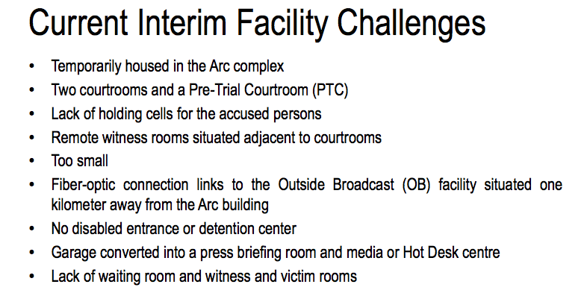
Currently, they’re in this Arc complex, which is an office complex. It has two office buildings. They have tried to make it a secure facility, as you can see. Some of the issues they have with it are the same issues we have with any courthouse. They want to be near the detention center, even though they have this tremendous amount of technology. They need holding cells. It has no disabled access. They want it to be near a detention center.
They gerrymandered the building to make it work for them, but even then, their outside broadcast facility is a kilometer away. They can’t do it from the building.
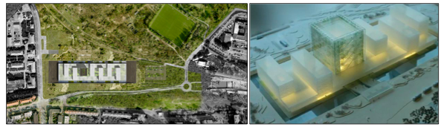
What they did is they had their site in The Hague, they had an international competition, and the Danish firm Schmidt Hammer Lassen were awarded the contract to design the facility, which is composed of these six buildings on a base. It’s under construction – it broke ground this spring – and should be done in about two or three years.
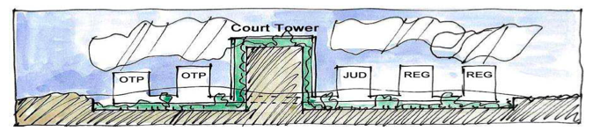
Here is one of the concept sketches: you have the court tower in the middle and these other buildings with the support offices. It’s right near the North Sea, near the Alexander Barracks where they have detention.
They wanted it to be very sculptural, that it conveys the eminence and authority of the court. Given the nature of this site and how convenient it is, they wanted it to be a very green building – literally. The garden motif is integrated into the building, and especially into the court tower – into the actual double wall of the exterior.
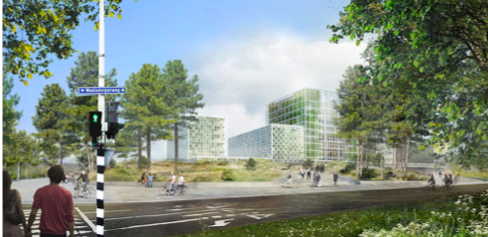
It’s all innovative materials, being suitable for both the climate and the conditions of the dunes, the gardens, the public plaza.
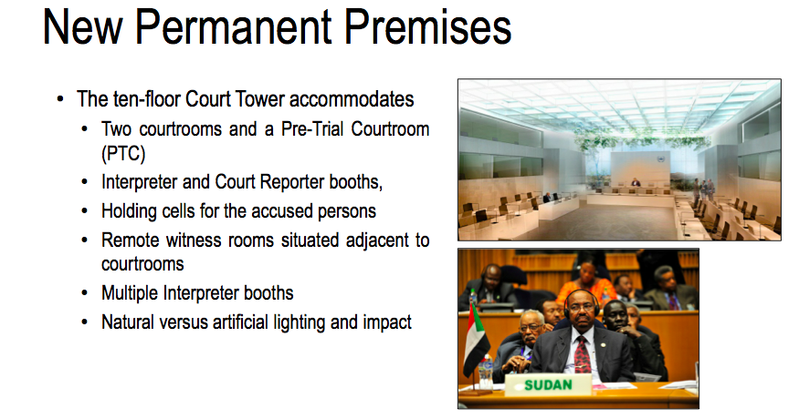
You can see ten floors. We’re showing one of the courtrooms that they’ve worked on together. You can see it has these booths around it that are used for the interpreters and court reporters, because they have two official languages – English and French – but they also translate to other languages. There are multiple interpreter booths. They have a lot of natural light and a view that you can see here. Typically, everyone has the headphones, to be able to interpret.
There are three courtrooms. The fourth one is currently housing the Media Cluster. The offices have editing rooms, judges’ deliberation rooms. David, how big are the panels in the courts? How many judges are there in a trial?
David: In a trial, there are usually three judges. For the Appeals Chamber, there are five judges.
Bob: Actually, it looks like it’s capable of even more than that.
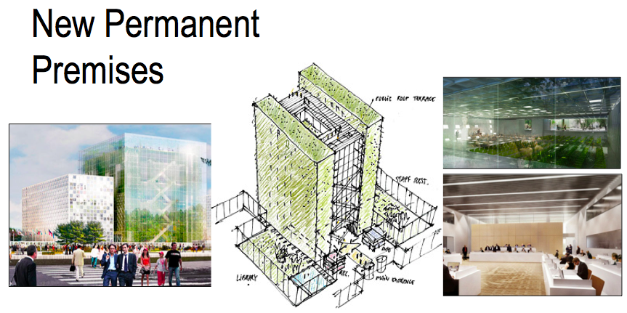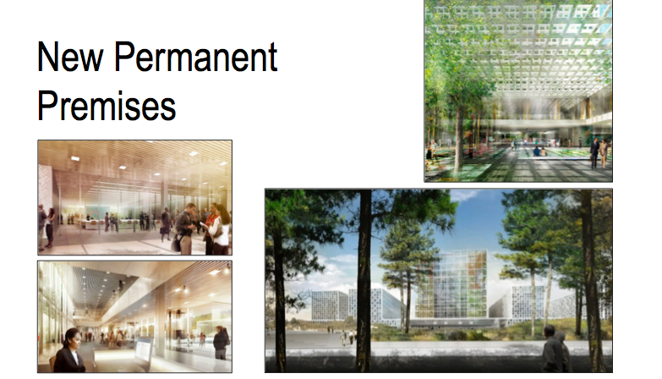
Here are some images. There is not a lot of information released on this project. These images you can find on the Internet. They’re very tight on security, so you can’t really see any of the plans other than what you see here. You can see some of the architect’s sketches for the facility and just the amount of natural light that just bathes the facility.

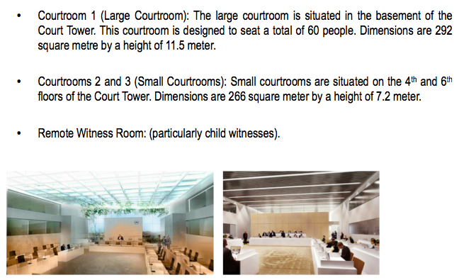
You can see the sizes. They actually divide off the spectators with a glass wall. They have headphones that can dial in different languages.
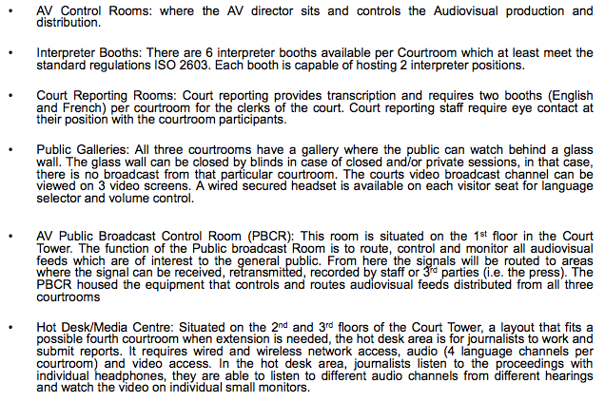
A number of booths, the court reporting rooms, the galleries, and the control rooms. They will be broadcasting this in the countries where these events occurred, and it could be that the defendant might be in another country.
Jennifer: Correct. When we talked about the security, especially from an audiovisual perspective, David or his colleagues actually fly to a different country, if they have somebody who is participating remotely. The security around the audiovisual is of the highest level.
One of the things that I think is really important that we look here – you’re seeing that there are six interpreter booths, there are court reporting rooms, there are public galleries, there are AV control rooms. All of this is used with technology.
As much as there is the natural space, the facility, and the decorum of what goes into the court, there is significant – if not more – planning that has to go into the technologies around how you can do language interpretation, how you can do assistive listening. There is a technician who literally sits in this AV control room every single time that there is a court proceeding and mans and records.
As much as you want to have that façade and you have to put the thought and planning into how that space is going to look, again, we talked about the infrastructure – we can’t say it enough – you have to prepare, plan, and work with your colleagues and partners to make sure that you have the capability, not just on day one, depending upon what you can afford, but certainly in the future and what you’re planning for in the future.
I think one of the most important things, as we said here, facial and voice distortion and delayed broadcast systems are not things that you are seeing and/or – at least as far as California is concerned – these are not things we’re building into our courts. These are not things we are actually even discussing.
But David, you actually used this today, correct?
David: Yes.
Jennifer: Can you tell us a little bit about the facial and voice distortion, the delayed broadcast system, and why it’s important for you?
David: The ICC deals with highly sensitive [27:25 inaudible] these witnesses are coming from. For instance, the Democratic Republic of the Congo. The majority of the witnesses have appear in court from the Congo, and some of them don’t want their identity to be exposed to the outside world.
For this reason, we decided to have a witness security measure in place, which is face and voice distortion. For a chamber to have to order the technician to enable witness security, this request has to come first from the witness themselves, and they have to request protective measures, be it face or voice.
Then, it goes to the chamber. The chamber will then authorize the AV technicians to enable this security. Other than that, we can just have a normal witness, an unprotected witness, testify to the courtroom. Other than that, we have to follow steps or the request filing by the witnesses themselves to have protective measures put in place.
For the delay, usually the delay is just for 30 minutes. During this session in court, if the witnesses or court participants – being the judges or lawyers – mistakenly say something that may disclose the identity of these witnesses, the judges will order a redaction to be performed before the 30-minute delay gets out to the public, which is a result if the name of the witness has been disclosed during the session by a lawyer or by the judge, particularly, or if the names of relatives of this witness or location of where the witness is coming from is being disclosed during the session.
Then this information should be redacted 30 minutes prior to the broadcast of the delay. That’s why we have the [29:40 inaudible] in place. [29:44 inaudible]. That is why we have the voice and face distortion as well as the [29:56 inaudible] system in place.
Jennifer: Thank you, David.
I think one of the important things is that you see those types of things right now in the United States. Whether it’s a football game or whether it’s a performance, we have those types of technologies here in the United States. We’re just not using them for the reasons and the purposes that they’re using them in the court.
That being said, we have to plan for that future. We have to plan for that day, especially around social media technologies – Twitter, Facebook, Internet, all of those types of things. We have to be thinking about those and how they are going to be finding their way into our court proceedings.
One of the important things that can’t be said enough around David and the ICC is he has a high level of scrutiny and he has a high level of interest. They need to have AV facilities that can accommodate beyond what we can think of today in this day and age. That’s why in their new facility, they’re looking to provide recording and editing.
This is an actual picture from the ICC website. The criminal trials that go on there gain a lot of scrutiny.
I think the other thing that we wanted to talk about is that the ICC is doing e-discovery. This is not necessarily something that is part of what we, at this day and age, think of when we talk about audiovisual. But the important thing here in terms of what they’re doing is they’re bringing everything electronic.
Right now, a lot of times you walk in, you have a piece of paper: “This is my evidence, your honor. This is what I’m putting down.” How are you capturing that? How are you storing that? How are you archiving that?
This is what we consider an audiovisual piece of equipment that I’m putting down on a document camera. That being said, we know that AV and IT are converging – and you’ll see this in our document. How are we actually working together to make sure that, once I put this document down, if I write on it …? But if I write on it, that now changes that evidence, and it has to be stored. It is no longer just this piece of paper. This squiggle that I put on that is now a new piece of testimony and it has to be stored.
The ICC is really moving forward in terms of having the storage, the capabilities, and capturing everything, be it an audiovisual. If this conversation that we’re having right now was part of our court proceeding, how is this being stored? How is this being captured? Where is this living?
All of these types of things, as architects, you need to be talking to your AV IT consultants and saying, “This takes X amount of space. How big does your IDF have to be? How big are your servers? What are we looking for in terms of our clients and tenants, in terms of our future and what they need to do?”
Bob: Some of their other technologies, the electronic documents, the [33:29 inaudible] and how you’re doing the actual transcription. I think the role of court reporter is really what’s changing the most. Between the court reporter or the clerk, who’s handling the capture of all this evidence and molding it all together?
You can see some more of what they’re doing at the ICC.
Jennifer: Perfect. David, do you have any final thoughts? Thank you very much for taking the time and joining us. We really appreciate it.
David: Okay, Jennifer. Thanks so much. I wish you all the best as you continue with the conference.
Jennifer: Thank you very much, David.
Jay: So you have a very good sense of what happens when your IT and AV connections are limited and not working maybe as well as you wanted them to, in terms of the ability to conduct a proceeding like this one.
Bob: Unfortunately. He’s the one who has to put it together in a way that works. He was unable to do it, having to go back home to his country, where he couldn’t even get good Internet service. We were trying to Skype, but obviously, it didn’t work.
With that, Jennifer, you were going to talk about the court technologies.
Jennifer: What other types of things are we doing now, here, today, and in the future? We use AV technology to do digital evidence presentation –just evidence presentation in and of itself.
As Bob mentioned, the court reporter is probably one of the most highly complex as well as controversial types of technologies you’re going to see in the future. Right now, it’s a physical body who can sit there on their stenograph and do this. There’s also a digital solution. There is a piece of software that I can turn on, if I had access to it, that can actually record my language and what’s going on with that.
One of the things that is the controversial piece of this is whether or not it is better to have a physical body. If you can’t hear me or we can’t understand what David was saying on the telephone, we can stop the proceeding. I could say, “Excuse me, stop the proceeding. I didn’t hear that. I didn’t get that.” That is an actual transcription, versus what you have right now with some of the digital technology. If they don’t understand it, there’s no software that says, “Hey, please stop.” It comes in inaudible.
There is a real controversy around whether or not to use the digital solution or whether or not you need a person there actually doing it. The bottom line is, regardless of what it is, you need to think about that AV connection.
Even if it’s a physical person, they need to be able to have a headset, because they might not be able to hear or if there’s a sidebar conversation. Regardless of whether it’s a person or a technology, you have to be considering whether or not you have the infrastructure and the capability to be able to record that.
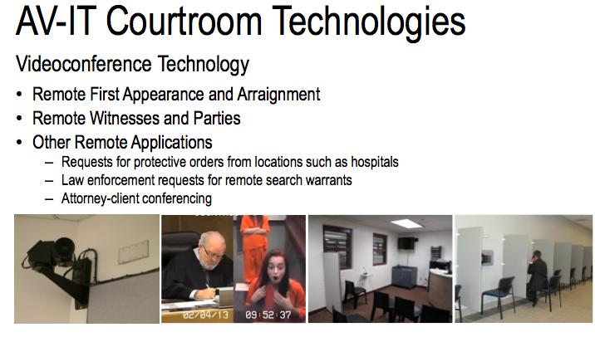
Jay is going to get into more of the video conferencing technology and the remote first appearance. I think one of the things that we really want to put forward to everybody is that we talk about the courthouses, but as you know in your entire conference that you have here, it is not just the courthouse.
Who are we talking to? You have justice partner facilities, you have a jail, and you have other visitation spaces. In working with your partners in the design and construction, you have to be thinking about who are you actually going to be talking to? If we’re using AV technology and reaching outside of the courthouse, who is it that we are actually working with?
I like this second picture. I think the part of it that I like was that it can’t be said enough: this young woman was charged $10,000 because she gave lip to the judicial officer in her remote appearance. He was not joking with her when he said that he was going to charge her. She thought that he was joking. Whether or not it’s because of the technology and she’s in another facility, he still charged her an extra $10,000 on her bail.
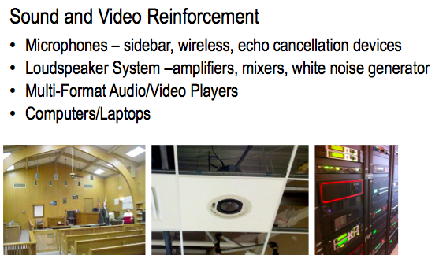
If you look at the left-hand picture, this is an older facility. You’re seeing hanging down are actually speakers. There needs to be a lot of thought that is given to how you’re actually designing. We all know, because we design courthouses, there is a lot of decorum. There is a certain dignity. There is an impression that you have around designing it. That does not necessarily match very well with our AV technology needs.
In California, one of the things we have done is it’s a requirement of a standard that you follow all of the InfoComm standards that are being developed, are developed, and will be developed in the future. The most important thing that I can say about that is that there is a standard that initializes the audio coverage uniformity.
If you look at this, this is high and beautiful, from an architectural perspective. On the left, it might be what you think of for a courthouse. But, it doesn’t help with how we’re going to actually do our speakers in the ceiling. That is not necessarily the best design for us.
By following the standards for InfoComm around audio coverage uniformity, you can have a conversation, and you can design the best ceiling that is also going to provide the best coverage for audio.
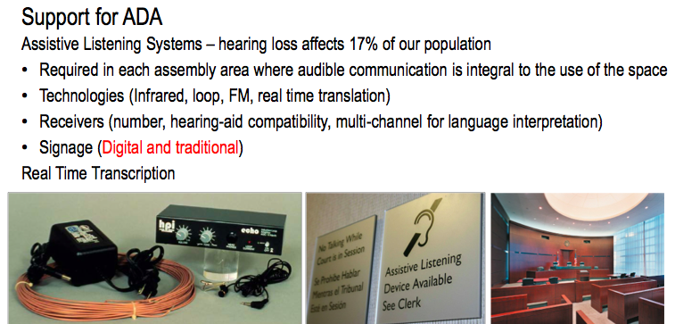
Bob: Obviously, we have to make the technology accessible. We talk a lot about the assisted listening systems. We have to have people use microphones.
Jennifer: I don’t know if yours is on.
Jay: Speaking of microphones.
Bob: I keep being told that microphone technology is very well established and it’s reached its zenith, but we still have to hold it right up to your mouth to make it work, or have a different type of microphone.
We have to have assisted listening systems that we can get now with multiple channels. You can have different languages. We can do real-time transcription. Have any of you worked on facilities that have real-time transcription that they’re using regularly? You have, Jay?
Jennifer: We build that capability into the [41:06 inaudible].
Bob: I’m just curious to how many actually do it.
You also have to have the signage to let people know it’s there and have the units. You have to integrate, depending on what type of technology you use, whether you have the radio type, or here, you can see there is a couple of infrared transmitters built into the millwork.
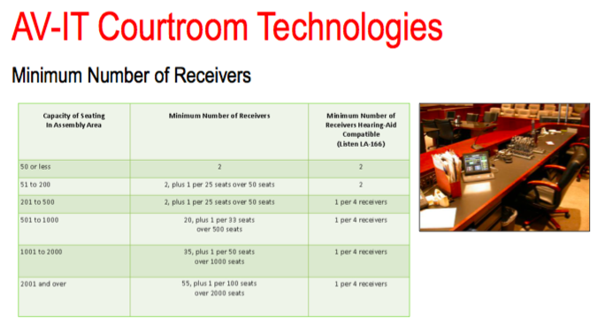
You also have to get into how many receivers you have – the ADA dictates how many receivers you have to have and how many need to be hearing aid-compatible. I walked into a facility I worked on several years ago and saw the clerk’s desk must have had 20 sitting in chargers for people, which I think is a little extreme, especially given by these ratios.
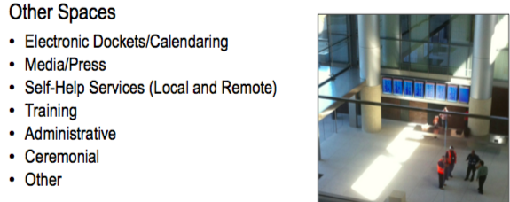
Then, the other kinds of technologies we’re looking at, as far as the docketing, the calendaring. I think we’re seeing that’s more of the standard these days. It’s easy to tie it into the clerk systems.
How you handle the media and the press and bringing that in.
The self-help and what we can do to help that process.
The training: I think most courthouses do have training rooms now, because of getting everyone up to date, the changes in the software, and even training the attorneys in how to use the technology in the courtroom.
Where has technology been challenged?
Jennifer: This goes back to number three. One and two – it can’t be used as a weapon and it can’t be vandalized – those are things that are pretty self-evident. The part about the due process is going to be something that needs to be thought very much through from an architectural point of view as well as talking with the consultants. We’re finally seeing this.
I don’t know if anybody is familiar with Jody Arias. I follow court stuff that happens in our country to see where it’s going. Her defense made a motion recently to try to ban all media coverage of her court proceeding. Even though we know she’s the one that was out there having the interviews as soon as she was convicted of something, her defense was saying she cannot have a fair trial because of the media scrutiny.
Whether you’re Lindsay Lohan… We deal with this a lot in Los Angeles. Everybody wants to see what’s going on with the proceedings. How are you architecturally providing for that? We have media pedestals in our courtrooms. That’s what we’re providing for.
But her defense, for the first time, has made a motion to say that they want to ban the media coverage from her sentencing phase, which is going to have new jurors, and it’s going to go through an entire process. That’s pretty unprecedented, because that goes right down to the fact of whether or not she can have a fair trial.
We have to provide the AV technology, but how is it impacting the court proceedings? I thought that the George Zimmerman case – if anybody knows about that case – is something that we should actually look at.
Jennifer: This is a court procedure.
[45:20–47:20 Video of Professor Scott Pleasant’s interrupted testimony via Skype]
Jennifer: The point of the matter is this gets conceivably worse, and finally, they have to cancel it. It has to be thought through. This was a remote witness testimony. This was two different uses of AV technology that didn’t come together.
They were using Skype. It’s not a professional solution. In our AV industry, there are a variety of manufacturers and solutions that you can have that are a professional level around the security.
This merged with the broadcast and the high level of media and press, and people want to be a part of it. What happened was they ended up Skyping, and they broadcast his user name, so all of these Internet trolls started actually going through and pinging him live, on TV. This is not going to go away. That was what you were seeing: everybody saw it on TV, and then they just started pinging him.
There is actually a feature on Skype. If you are in a call, you can put yourself in a “Do not disturb” status. These are the things you have to think through with your clients, with your consultants, and make sure that you’re preparing for this and these types of operational things.
It’s not just about designing the right courthouse and the right technology solution. It’s about how are people operating it? Are they educated? Are they trained? Do they know how to maintain it?
Bob: Thanks, Jennifer. Going on with the access to technology. We like to use universal design, as well, basically, making everything accessible and having just one way of doing it. Here, you can see a lectern that has some technology in it and has a spot for a wheel chair. It has the proper knee and toe space.
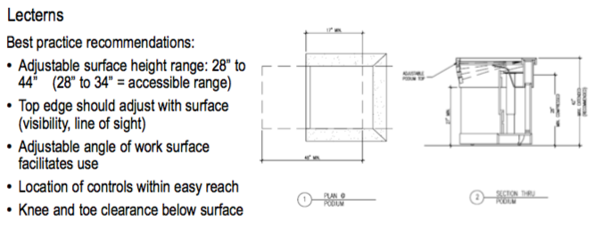
There are guidelines as far as what you need to be doing on a lectern. There are a number of lecterns available commercially that meet ADA. I’ll do a little plug here. You can also go into the Access Board site, and you can download the recommendations from the Courthouse Access Advisory Committee. They have all of this documented.
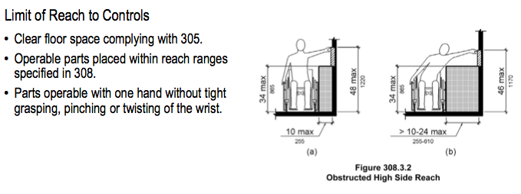
Particularly important is the reach of controls. If you have an AV cart, can someone in a wheel chair operate all of the different technologies? But as well, one that we see that is coming up is the location of microphones.
Jennifer: These are two recent projects. On the left, one is a mockup that we are able to change, but the one on the right is coming online. I’m not sure why, I don’t know, but we’re finding that more of the counsel tables are being developed so that they’re very deep. But, as Bob was just mentioning, there is an ADA reach, because you have to be able to mute it. If I have a certain reach, how deep can my table be where my microphone is placed such that it meets the ADA requirements?
Bob: Then we get into the courtroom technologies and how you handle the video evidence display. You can see there are different types of viewing that have certain distance limitations, whether it’s passive, recognizing images and text, to basic decision-making, actively engage with content can make decisions, or analytical.
You can see it’s a 1:4 ratio with a three-inch screen. Your distance is only 12 feet. You can see they did a little test in this courtroom of different sized screens to get the kind of acuity that was required and their placement.
Here, you can see this is looking at different ways of handling the placement of monitors – small, medium, and large monitors – and the aspect ratios and what the drawbacks are. This is all in great detail within the standards.
You can see some of the benefits and drawbacks, from the small monitors in the jury box, like you see on the upper right, to a medium-sized monitor that you will still get a few different locations, to the large monitor.
I always have a preference, personally, for the large monitor, at least for the jury. I like all the jurors seeing the same thing at the same time. I like them to see the witness at the same time, so they can see the witness’s reaction.
If you look historically, witness boxes actually were open front, so they could really see how the witness reacted. Now, we have modesty panels and we’re kind of limited to see what they see above desktop height. It’s very important.
With this, I’d like to turn over to Jay to talk about planning.
Jay: We’ve been talking about infrastructure. We haven’t really defined it, so I would like to offer you a definition of infrastructure. These are guidelines for AV/IT infrastructure.
Infrastructure are those permanent elements of a building or facility that are provided prior to occupancy exclusively to incorporate, simplify, and/or enhance installation and removal/updating of various technologies that are installed in the building or facility either during construction or after occupancy. It took us a long time to figure out our definition.
For the architect – for most of you in the room – this means that you need to plan your building, its spaces, its conduits and raceways, so that AV/IT infrastructure is easily accessible, installed, maintained, and can expand to meet growing needs and accommodate required technologies.
You can see on the screen some of the areas where the cabling and so on will run to support technology. The decisions that are made during design have a tremendous impact on the present and future ability to attach various technologies to these support structures.
Good planning for AV and IT isn’t that different from just good planning in general, only that it touches on very specific aspects of the operation and of the building.
Get the experts involved early. Now, we have a convergence between audiovisual technologies and IT and other low voltage, so you really need to get all the people who are touching these technologies in the room at the same time so that later, you don’t have them interfering with each other.
Coordination among all the parties is essential – having the meetings with them at the right time and a communication plan. Most of what I’m going to talk about is doing a needs assessment for these systems, and the challenges that they place.
The architect is inevitably going to be the coordinator of all these different people and the decisions that are made, including leading the workshops. Only this way can you have what you need in groundwork for a successful AV and IT design.
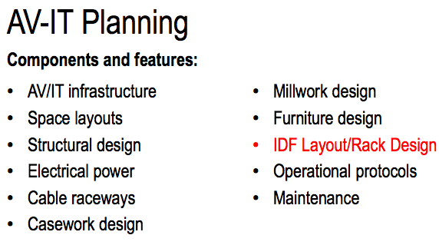
AV and IT touches an awful lot of parts of the building. The spaces, structure, electrical, and so on – I’m not going to read them all. It also touches all of the spaces.
We’ve been focusing particularly on the courtrooms, and we’re gong to continue to do that, but in the process of doing a needs assessment for AV and IT, you need to consider essentially all of the different functions that are carried out and all of the different spaces in the building so that you provide the needed infrastructure in the needed places. I’m not going to list these.
Jennifer talked a little bit about the justice partner spaces. When we look at things like remote testimony and you see the witness sitting in a room, slouching in his chair and poorly lit, and essentially not projecting the kind of professional presence that he would have if he were in the courtroom with wood paneling behind him, sitting in a witness box.
It may have been stated earlier, but I think the principle is that someone appearing remotely should look as close to the way they would look in the courtroom as possible. That touches dress, lighting, and decorum.
You mentioned that young lady who was slapped with a fine, and our friends in Australia who did research on the behavior of remote witnesses under different qualities of design settings where they were appearing suggested that these kinds of messages that the judges are always talking about – the way design affects decorum in the courtroom – are very important.
The biggest challenge is, I think, we may or may not be in control of the design of those remote spaces. If we’re hired to design the courthouse and someone is appearing from the jail, it expands our responsibilities in a way if we want the installation and procedures to work effectively for, let’s say, a remote arraignment, which I’m going to talk about more extensively in a minute. We need to go beyond just the boundaries of the courthouse. It challenges the way we work.
In terms of the process, essentially, we’re going to examine the court process. What do you do now? How does technology impinge on it now? How might it change in the future? How would we like it to change in the future? How can technology contribute to that? Finally, of course, the question we all face all the time – what if we can’t afford it? That’s really where the infrastructure comes in.
I just want to reinforce it a couple of times: if you can’t afford to buy the technology that you would like to have today, you should really strongly consider investing what funds are available in building an infrastructure that can support it later – making sure that you have power or the ability to have power and that you have the ability to run cabling or install equipment. If you can’t buy it now, at least make it work later. Make it feasible to install, and make it relatively inexpensive to install.
Who is involved? We talked about it earlier. Basically, everybody is involved. The architect leads the discussions. Depending on what you’re talking about, you may have legal counsel involved, you may have law enforcement involved, but you’re going to have all the court folks and the technology folks at the table with you.
The steps are pretty simple. I apologize – I’m going to run over them a couple of times. Describe the function, look at the options that are available now and what things might be available in the future, describe the technology that could be used, investigate what implications it has for spaces and infrastructure, estimate the costs that are associated with it, but also the savings, and that allows you to make a determination about the feasibility of going forward with one or more technologies.
The result of the needs assessment is going to be a report that documents the decisions about what you’re going to have in which spaces.
This is something you can’t really see on the screen, but it’s reproduced in the guidelines. It happens to be from a project I worked on in Santa Clara County, a 20-courtroom family justice center. It essentially shows what technologies are going to be where at the time that the building opens. That is one aspect of the documentation and the outcome of what you’re going to see.
Jennifer: I think one of the important things to look at is the difference between the “X” and the “I” – the “I” is the infrastructure. Going back to Jay’s point, it can’t be said enough: this was an actual project. We decided what was going to be infrastructure only, what was going to be part of day one, and then you have your notes.
The reason that this is becoming so critical is because we have projects now that are just physically getting installed. I’m going to tell you an embarrassing story. I walked into a room recently, and I looked at where our touch panel was located on a wall over there. It was so unfunctional. It was completely away from where the people actually operate and do their work. I looked at that and I said, “Who made that decision?” Well, going back through years of my notes, my staff made that decision. There you go.
I think the point of the needs assessment can’t be said enough. These are the decisions that were made. These are going to be in your e-mail. Those are the notes – who made them, and why.
Three years from now, you might not think that you need to make sure that you’ve documented this and looked at all of the decision making process, but you just might actually end being in that place where somebody says, “Who put this there?” and hopefully, it was not your decision, like it was my staff’s. That’s what I wanted to reinforce on that.
Jay: I’m going to take you through an example of remote first appearance and arraignment, but just a couple of comments. What we’re facing is a problem that we face in general when we try to do good planning. We’re trying to look towards the future and anticipate what’s going to happen in three to five years when the building opens, and in 10, 15, or 25 years as legal practice, society, and technology evolves.
The fact is, we’re not all that good at it. We don’t really know what’s coming. Think back five or ten years – ten years, especially. Would you have anticipated the blanketing of social media everywhere? You wouldn’t have, because you couldn’t have. In a situation of uncertainty, we’re trying to do the best job we can.
I would like to recommend to you, if this is a topic that interests you, a session after lunch that Chuck Oraftik has organized on the new court paradigm, where we’ve got a couple of futurologists from the courts in Maricopa County, Phoenix, Arizona, coming to talk about the work they do trying to figure out as best they can what the most likely futures are going to be.
This is the kind of thinking that needs to be incorporated into the needs assessment process for AV and IT. Some courts are very progressive and look towards the future; some are more conservative. We are trying to deliver a building for them that will respond both to what they do now or real soon and what we think – or they think, or we think together – might be happening in the future.
To me, that’s the biggest challenge. As I said earlier, spend the money on the infrastructure to keep the options the most open in the future.
Talking about remote first appearance and arraignment, to make it work, it’s entirely dependent on the technology. The technology has to be good. It was said earlier, early installations that tried to support these processes often weren’t very good, and the experiment failed because of the lousy technology.
But there are other issues that need to be engaged. I had a client talk to me only last week about the challenges their court faces. They would like to institute remote arraignment, and the defense bar in that location is just adamantly opposed to doing it.
You have to involve the parties. If you have parties whose needs aren’t met – if the defense attorney doesn’t have good access to their client, if it’s inconvenient for them – they may sabotage the process. You need to hear their needs, and you need to figure out what you can do to respond to them.
The process starts with research. In the case of remote arraignment, understanding what current legal requirements and constraints are, and of course, your clients will help you with that. Find examples to take them to where the process has been effectively implemented. Review the articles. Now, you have these guidelines. Put the findings together for them.
You need to walk together through the steps of the process. Who’s involved? How many people are going to be there? Are we doing arraignments of groups? Are they being done individually? Where are they going to be? How often does this happen? How long does it take? Who are the staff who are going to be involved? How are communications going to be handled? Is there going to be a hard-copy record? Are signatures going to be required and transmitted? All of these kinds of questions need to be explored.
Then, there’s the technology. I’m not going to say too much about it, because we’ve already said quite a bit. The cameras, the monitors, the lighting, the acoustics at both ends, the audio system, making sure that defense counsel has the access that they need.
Then, of course, the spaces. Again, as I said earlier, you need to cover not only what’s going to happen in the courtroom but also at the other end.
Then it comes down to the interesting question of what are the cost implications? Should we really do this? Is it going to cost us money to do it and we want to do it anyway? Will it save us money because we don’t have to transport or staff is more efficient or the process runs more efficiently?
You get into some complex questions, and they touch on many of the things that interest our sustainability committee. Does technology perhaps overcome some of the disadvantages of remote location of court and jail? Do we want to have the court next to the jail anyway, even if technology could give us another option? What are the cost implications, the transportation implications, and the staffing implications? What are the construction cost savings in the courthouse for building fewer holding cells?
The California Administrative Office of the Court is exploring right now the question of how many holding cells really ought to be provided in the new courts, because they’re very expensive and the greatest demand for holding cells is first appearances – bringing large groups of fresh arrestees into the courthouse and putting them up in these expensive cells.
You have the movement, you have the supervision, you have the actual provision of space, and if you’re not moving them because you’re able to do it remotely, you have the potential of saving substantial amounts of money.
You finally come down to the question of feasibility. Does it make sense to plan to implement this technology?
I just mentioned it can be complicated for some of the reasons I just said, but even more so, if you have a court construction budget that requires you to expend money on a technology to build it into the courthouse, and it’s going to save money for the sheriff who’s doing the transportation. In California, the sheriff is a county function, and the court is a state function. Not to say that as fiscally responsible folks that we don’t care about the sheriff’s budget – we do – but it’s not on our bottom line. These questions become interesting.
I think, with that, I’ll turn it back over to you guys. Thank you very much.
Bob: We’re going to talk some about the infrastructure considerations, the identification of what we used to call the “telephone room,” where we used to have all of our cabling enter the facility, the main points of entry, the cabling. How are we going to deliver the technology to the court? What can we afford to do?
Everyone likes to do raised access floors. Can we afford that? It used to be that it would increase the height of the building, but now there are some really low-profile systems that are more economical.
Then, the support rooms – all the different rooms that we need in the building to support the technology. Are they’re shared? Do we need one per courtroom? Maybe with rack systems? Is it on the floor, or is it maybe one for every two, depending on the system you have?
I’m working with Marsha over there and looking at a project in Michigan that uses the JAVS system – Jefferson Audio Video System – which is audio video recording. We have seven cameras doing that in every courtroom. We were able to do a seven by nine room for every pair of cords to handle that. Their system now integrates the capture of all the evidence into the system, into the record, as well.
Jennifer: To add to what Bob is saying, these IDFs, we’re talking about AV/IT. You can get a little lost around the language, especially when, as Jay was mentioning, infrastructure and how important it was and how long of a conversation it was about what does the word “infrastructure” mean to us in terms of our guidelines?
You can have four different people at the table, depending upon what you do, and you could have four different versions of what infrastructure means to them. The point in that is that in these IDFs, we are talking about AV/IT, but, the bottom line is the word “low voltage.” Low voltage is all moving into what has historically been these phone rooms, these IT rooms with servers.
The word “low voltage” is going to cover your building automation system, it’s going to cover your AV, it’s going to cover your IT, and it’s going to cover your security, because in the end, all of those things are going onto the network. We now have a rack for each single one of them, based on the ratio of one to two courtrooms, racks – what have you. The bottom line is your low voltage and your IDF closets are all merging together where they used to have separate AV closets.
We would have our equipment out in a separate closet somewhere, and I said, “Why? Why don’t we put it all in the IDF? Let’s look at putting them in the central core of the building and stack them on top of each other in the middle. You can expand your reach, plus consolidate your HVAC, your electrical, and all those sorts of things.”
I just wanted to add that’s all going into that same direction.
Bob: It’s much better to have the IDFs. The alternative is they stick all the technology into the bench, into the millwork. You might ask what size the equipment is and size it properly, but then they start attaching all of the cables to it and the cable connectors, and have space for ventilation, and it becomes very obtrusive to the amount of space you’ve got in the courtroom.
The IDF is a great way to take it out of that environment – one that can be controlled for temperature and be secure. You can see the kind of things we’re looking at. We still end up with waterlines, somehow, in those rooms, in some place, no matter what we do.
Jennifer: And not next to the bathrooms.
Bob: The places where we power and conduit cabling are not what’s in the code. It’s not minimum requirements as required by NFPA 70. The amperages, the grounding, what phase – they all have to have the same kind of phase as the power you have at the panel.
Then, types of construction. Obviously, new construction is the easiest. It’s got the fewest limitations. We can build what we think is the most we can afford into the project from the start.
Then, we have renovations, which gets entirely more complex. How do we fit these in? We don’t have the blocking in the walls for the monitors. You have OSHA and ADA considerations, as far as projecting out from the wall, and these buildings, alone, typically weren’t built to ADA standards.
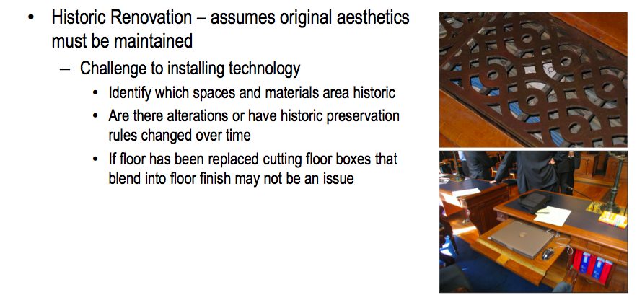
Then, to the extreme is the historic renovation, which is definitely a challenge. In fact, these are images Jay took.
Jay: These are images from the French Supreme Court in Paris, where they had restored a courtroom from Napoleonic times. They had to figure out how to run the cabling, how to get the technology into these historic furnishings. They did a very good job, but it can be really challenging.
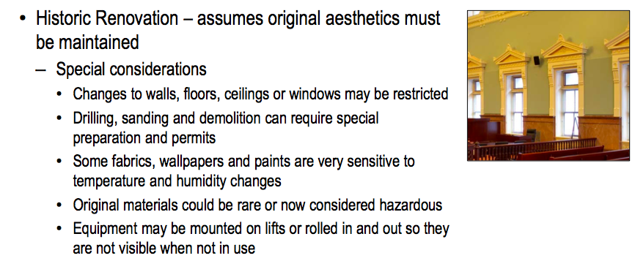
Bob: Here, you can see another project. That happens to be the Old Post Office in St. Louis, where they have, I believe, an infra-red emitter in the wall. How do we get it there? We have to run everything by the National Parks Service, because it’s on the historic register. There are very specific limitations on what we can touch and what we can’t touch. Has it been touched before? What were the historic regulations at the time? What’s in that wall?
Jennifer: It looks like we’re wrapping up.
We’ve talked a lot about the design and construction. A lot of people deal with the capital project. But one of the things as an owner and end user that has been a little bit challenging for me is that I understand from an architectural perspective, you build the building, you turn it over to your tenants, and then you move onto the next project. That doesn’t necessarily work for someone like myself or for my court users.
How and why? It is so important to plan for the maintenance, and the next slide is the training. You have to be thinking about these things. This is a life cycle. You have a one-year warranty after you actually build your building that the person who installed your equipment will come back. But how are you helping your customers to actually plan for the life cycle of their facility?
Maintenance can’t be said enough. After a year, who is funding it? I go through this question every single day. Are you going to be paying for me to maintain this new equipment that we’ve never actually had, or used, or any of those sorts of things? I don’t have a budget for that.
Are you asking your clients, in terms of, “Yes, this all sounds wonderful. We would like to be like the ICC. We’re going to have all of this facial distortion and everything like that. But can you afford it over the lifetime of your equipment? Are you planning for it, such that after that one year warranty is up, you have the capability to continue to maintain this?”
Training. I can tell you a million times, it is not about the equipment. The equipment in the AV industry and our manufacturers and everything, it’s there, it works. It’s absolutely the most advanced thing you can have. But how many judicial officers looked at that Skype YouTube video from George Zimmerman and said, “Absolutely not in my court. No way. That technology is terrible. It’s the worst thing ever, and this is not going to happen in my court. This is not going to be me”?
It has nothing to do with the actual technology itself. If you’re not training people, if people don’t know how to use it, if they don’t have that simple little step… How do you go in and say, “Do not disturb”?
The training and all of these things have to be built in the design and construction of the building so that it’s actually something that’s useful to the people. Otherwise, “The equipment is broken, this stuff stinks,” and they abandon it.
There are also different levels of training that you need to think about. Your day-to-day end user is going to want to walk in, press that one button, and everything turns on, the screen comes down – all that sort of stuff. But, are you having your AV/IT staff educated, especially around AV?
There is not a court that I know of in California that has an AV specialist. It is a specialized type of field. You have to have the experts who know how to do that. All the time, you’re going to have one of your IT staff, because they are the system administrators, they were the ones that actually put their satellite on their rooftop, etc.
You have to train them. You have to get them the manufacturer training that they need so that when their building comes online with all of this new equipment, they’re prepared to respond to it when that person presses that button and it doesn’t turn on.
There are different levels of training that you need to help yourselves with. It’s not a plug, because this is where all of our education comes from. You need to go to InfoComm.org. You will have all of the resources, training, all of the different levels, and what you need to do in order to have an effective AV solution.
Bob: Briefly, InfoComm has been taking a lead and putting all of this technology available on BIM and trying to get the AV industry to use BIM in their processes.
Jennifer: Working with their different types of partners – with BICSI and all of the different types of industries coming together – InfoComm has been looking at what are the different types of technologies that are going forward.
One of the things that is not necessarily an AV-type solution is this wireless stuff. I’m sure you’re hearing it everywhere: “Just go wireless.” Well, how are you dealing with security? What is the reach and the capabilities? From an AV perspective, we’re not necessarily there.
There are two different things: you have AV – which means high quality and lots of bandwidth, and has to be secure – versus wireless, which means we’re going to put it out for a lot of people, but you don’t need a lot of bandwidth and you don’t have to worry about being secure, because we’re going to push you off our network.
How are you merging and looking at the two different requirements and needs? Wireless is not something that’s going away. It is going to develop and keep moving forward. I’m not interested in it right now, but at some point in time, our IT guy are going to push us in that direction.
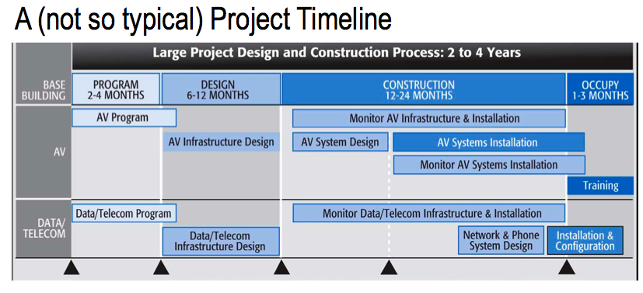
Bob: This is looking at the timeline of a project and making sure that you have the AV program as part of the building program and that you’ve incorporate it, just like you do the other users, all the way through the building process.
The appendices to the book. These are some of the information that’s in the back. A number of the authors and members of the committee have certain items that they are especially committed to and have done a lot of research. That’s in the back of the book, as well as a glossary of all the terms and abbreviations, which can be difficult in the industry to understand all of that.
This is a link to basically the publication that Emma Rowden and Anne Wallace from Australia did as part of their doctoral thesis, “The Use of Video in the Courts and Their Effects.” They’ve made that available online, that you can download at that address.
Jay: That has very useful, detailed information about the kind of procedural, behavioral, and design implications that need to be taken into account to make this work. I drew on them in my comments.
Bob: Right. We decided not to directly incorporate that into this publication because of all the research that they did, and just make reference to it as a separate document.
I think we can start questions and answers, if you have any questions for the panel. Frank?
Frank: Thanks for a really interesting and thought-provoking presentation. I have some observations and then a question. In New York, for instance, they don’t do first appearance arraignments via video. Often, that’s only one of six to ten court appearances. The other motions and that kind of things are allowed to do by video. The first one is very complicated – you need the attorneys, etc. – but all the others, often the defendant really isn’t even saying anything. It’s between the attorneys and the judge – the motions – so that’s a good one.
The second one was the most recent Court of the Future tour was in Montreal and New York. We visited the courtroom laboratory that they have in Montreal, which is terrific. Jennifer, you would love it.
The experiment that they tried there was to get the jury – I was one of the jurors in the juror box – iPads to look at the evidence. Then, you don’t have to do the infrastructure installation in the courtroom. You can do it directly over wireless – sorry. But they screwed up. They forgot to disable the chat function. All of the jurors now are commenting on the presentation of evidence by the various counsels.
Jennifer: Worse than the Skype.
Frank: The final one, very quickly, and I’m very glad you brought this up about this research. I saw Emma’s presentation last year, which was terrific. One of the biggest issues was the credibility of the witness when the setting that is behind the witnesses is crummy, like the little raccoon eyed woman in the orange jumpsuit.
I was wondering if anyone had done like the weatherman – the green screen behind the person that you can just make that image be anything. It could be the most dignified august setting possible. Has anybody tried that or thought of that?
Jay: That’s a great idea. None, that I know of.
Jennifer: We’ll comment that. That’s a great one. Thank you.
Jay: That goes in the second edition of the guidelines.
Susan: When I was observing the Cook County Courts, they had audio video court recording. I think your presentation was admirably thorough, but one thing that I think you left out is the audio video recording room, because there are people in there and there’s a lot of equipment in there, so you really need to pay attention to the comfort of the people that are occupying. Their rooms are really uncomfortable, because they’re stuck in a corner and it’s getting daylight and [1:28:09 inaudible] problems with [1:28:12 inaudible].
Bob: Susan, is that a centralized room for multiple courts or is it one per courtroom?
Susan: It’s in the Daley Center.
Bob: So it’s a centralized room. That’s immediately awkward, because they’re not seeing what’s going on – only what’s on camera.
Jennifer: It’s a perfect example and point. I think one of the challenges that we face is around whose responsibility and whose priority is what, and where is our funding going to go? One of the main reasons, at a minimum, we put the media and press outlet in at least one courtroom is because, in all of our existing facilities, if you have a high profile Michael Jackson type of case in Santa Monica, they’re throwing cables out the window.
That’s why, from the court’s perspective, it’s in our best financial decision and importance to put that special proceeding media plate that goes out to the parking lot during the construction, and put the media and press as far away from the court facility as we can, because it’s in our best interest.
To Jay’s point of the needs assessment, whose priority and who is funding what, and how can we best facilitate that, especially with technology? It’s a great point.
Duncan: Just to add to that point, I think the matrix that you described in the guidelines is very useful, but taking it another step to who is providing, all the way down to the line. You probably have your IT department doing some of the work, you have the general contractor doing it, you may have specialist vendors coming in. With the various departments in the courthouse, depending on the jurisdiction, you may have the state funding some things and the county funding other things.
I think all of us have got to that point in the budget where people say, “Well, I’m not buying that,” and then you end up value-engineering something else. I think adding a matrix to the requirements that says who’s paying for it and when are they paying for it could be very helpful.
Participant: I think this is a question for Jennifer. You mentioned in the low voltage aggregate room that there was a rack for each of the different functions. Have you had an experience where you’re integrating any of those, or do you keep them all separate?
Jennifer: Integrating in terms of?
Participant: AV, building energy management, security, all of the different functions that are low voltage now.
Jennifer: Yes. In California, if people aren’t familiar, there is a 41-courthouse capital project initiative that’s going on, and we just redid our standards in 2011. We’re looking at the building code. I think the building code has changed, so looking at updating it.
We’re just seeing seven of our courthouses come online now that are under that type of situation where there’s an IDF and we have security, rack for AV, rack for IT, and everything else, building management system. It’s working perfectly.
One of the things we’re seeing is a bit of a challenge is, again, thinking about that operationally, because you now have four different people, necessarily, who were in four different rooms. What’s your keycard access? Who’s going to be in these spaces? Who needs access to these spaces?
In terms of actually physically getting everything in there and making it work and operate, that has not been a problem, and we’re actually seeing a lot of benefits come from it. But what we’re encountering now is who actually has room for these spaces?
Especially when you get down to the MDF, the MPOE, coming in from outside of that facility, where you’ve got your Verizon and your Comcast actually putting caged areas between that outside door access versus who’s on the inside.
Some of the sheriff issues, the county issues versus the state – those are the types of operational issues that we’re seeing, but not necessarily an issue from a physical infrastructure, if that helps.
Participant: Jennifer, does California have a formal training requirement for a new roll out of a courthouse – who’s required to be in it, and that kind of thing?
Jennifer: Training for the AV equipment in terms of who oversees it?
Participant: The users of the equipment, whether it’s court personnel. There’s no standard for who receives how much training and what that training entails, or nothing like that?
Jennifer: No. My job is one of the first in the state, in terms of actually being somebody whose background is AV. I act as the owner representative and provide, per courthouse, reference back to InfoComm and what they need to do. I think we need to have that. It’s a really good point.
One of the things we definitely have and I recommend to all of the architects that we are including in all of our technical specs – not necessarily around the training of the end user and owner – is a type of certification in our industry called the CTS. You can have the CTS-I or the CTS-D. It is now part of our requirement of a vendor qualification submittal that they have certain CTS qualifications.
From the end-user training perspective, no, but I think that we are ramping up and making sure we have qualified vendors. Especially with the economy over the past couple of years, we’ve seen people who historically did fire and life safety are now moving or trying to move into the AV business, not realizing how complex and complicated it is. Without that CTS, we have had some projects that have gone a little bit awry.
Having that and having your people trained on CTS and having a CTS certification is very important, I think.
Bob: Thank you for coming. Have a good time at the conference.
Jennifer: And please find our standards outside. Thank you.

