California's New Prison Health Care Facility
Mike M: Good morning. My name is Mike Meredith, and I’m with the California Department of Corrections and Rehabilitation. I was a project director for the project that is being presented today. We have a lot of information that we’re going to be sharing, so I’m not going to dawdle. We’re going to some quick introductions and get into the meat of the program.
Colin: Thanks, Mike. I’m Colin Blaney. I was the structural engineer of record for Build Package 2.
Shannon: I’m Shannon Gustine, operations manager, Hensel Phelps, general contractor on Packages 1 and 3.
Mark: I’m Mark Radell. I’m a project director. I was working on Package 2.
Mike J: I’m Mike Justice with Dewberry Architects. I was the project manager on Build Package Three.
George: I’m George Dyckes with Kitchell. I led the criteria architect team for the project.
Paul: I’m Paul Nagashima with HDR. I was the project design architect for the DB2 Package.
Bill: I’m Bill Prindle. I was with HDR, and I was the lead architect for Build Package 2.
Mike M: I’m going to start by saying how much we appreciate the invitation to present this project. A lot of blood, sweat, and tears went into it, and we really appreciate the AIA and the Academy for Architecture in Justice for the invitation.
We’re obviously glad that we can share this project. It was a very complicated project and a very fast moving Design-Build. It was under the stress of a federal receiver implementing an end-date when inmate-patients had to be in their beds.
Why does CDCR like to use Design-Build? On this particular project, we would have never met the schedule had we not used it. Over the traditional capital outlay process, we probably literally saved two to three years.
We think that this was a two-step selection process, but it’s a best-value, qualifications-based selection. We set a stipulated sum, which in essence is, “Here is our price. What can you do for me for this price?” The selection is based on them accepting the number. They can’t qualify it. That’s the ceiling. Everything else in the selections is based on qualifications.
I’ve used this term, “master builder” approach. I don’t know if it’s quite the appropriate term, but the concept being that when you integrate designers, subcontractors, and the builder, we think that the state benefits enormously. Our experience is that it tends to drive a lot of partnering and collaboration. We get a lot of great feedback. We think that the teams are ultimately motivated to look out for the owner’s best interest – at least, that’s been our experience. We’ve had very positive experiences.
Lastly, Design-Build does afford us the opportunity to shift the traditional risk. I think the contractual structure and where that goes is most obvious to everybody in the room. That’s the baseline of where CDCR sees the use of Design-Build.
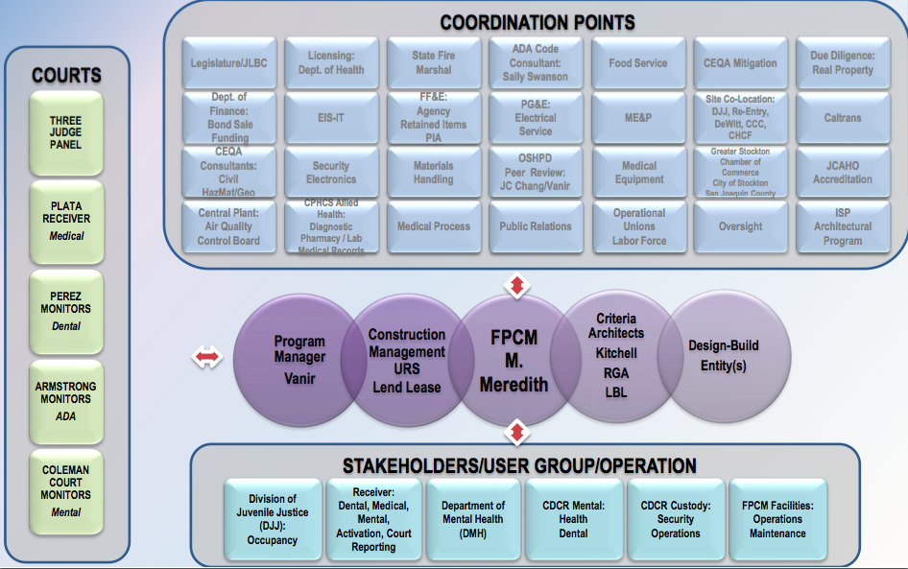
This slide represents some of the complexity of the project. We created it early on just to get ourselves and our brains around the project and whom we would have to be coordinating with. As I mentioned, the courts are on the left. There were four different lawsuits that we were trying to appease, and the project intent was to address those specifically.
You can see the variety of stakeholders, our coordination points, and the amount of things that would have had to have gone right in collaborating with all of these folks to have the project finish like it did.
George: An introduction and an overview of the project for those of you who may not be familiar with it. The renderings that you’re going to see here are from the criteria documents that were issued to the Design-Builders with the RFP for their compliance. The project consists of two main separately funded projects.
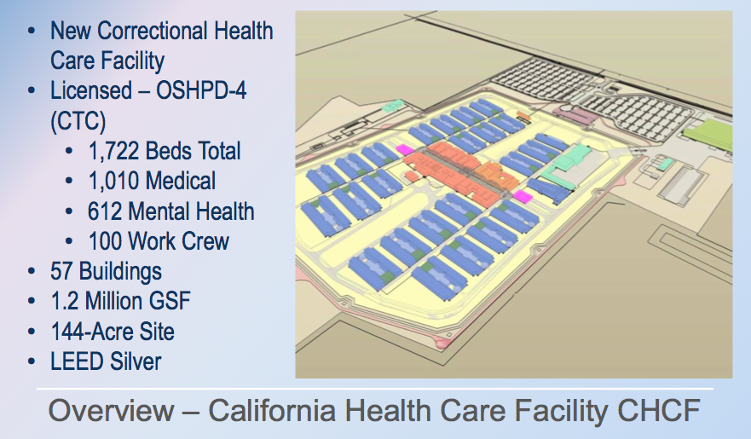
The first is the California Health Care Facility. It has 1722 beds. It is a licensed healthcare facility for both medical and mental health. In total, it is 1.2 million square feet of building. It includes all of the traditional clinical spaces that you would see in a licensed healthcare facility, together with the traditional programs and support functions of a traditional facility.
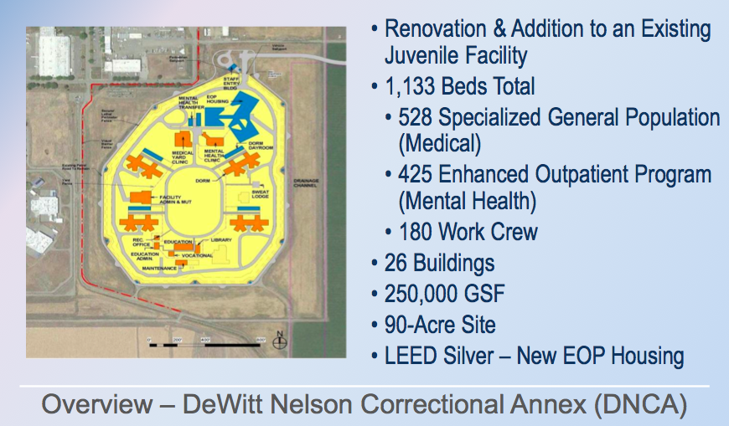
The second project is a conversion of the DeWitt Nelson Juvenile Detention Facility into an adult, let’s say, step-down medical facility. It is unlicensed, but it provides care for what we call the SGP – specialized general population. These are inmates who are ambulatory, capable of taking care of themselves, but need to be close to medical services. Perhaps they need dialysis care or something along those lines.
It also houses the Enhanced Outpatient Program, which is a mental health program in which inmates manage themselves on an outpatient basis, getting them to very structured program sessions. In total, this has 1133 beds. The SGPs were to be in renovated existing dormitories, and the EOPs were going to go into a brand new housing cluster and some of the support facilities there.
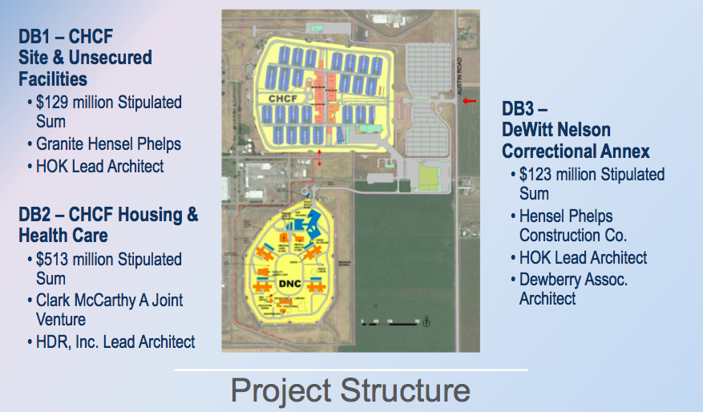
We structured the project into three Design-Build packages. You heard that when folks introduced themselves – Design-Build Package 1 was the site work and the unsecured facilities. It’s basically everything from the inside of the perimeter out. That was awarded to Granite Hensel Phelps with HOK as the lead architect.
DB2 is everything inside of the perimeter with the addition of the administration building. A $515 million stipulated sum was awarded to the joint venture of Clark McCarthy, with HDR as their lead architect.
DeWitt Nelson, we call DB3, the renovated juvenile facility. $173 million was awarded to Hensel Phelps with HOK and Dewberry as their architects.
Our challenges: as Mike alluded to, schedule, schedule, and schedule were our top three challenges. We were up against a court deadline commitment to get inmate patients into bed and get it fully occupied by the end of this year.
As you saw from Mike’s stakeholder diagram, there was a huge group of stakeholders that included not just custody but all of the healthcare providers. Those of you who have worked in those fields know that there’s a dichotomy between those two, so that was a real challenge to work through.
It was CDCR’s first Design-Build project, so we were learning along the way – not to say that the state hadn’t done Design-Build projects. We weren’t starting from zero, but it was CDCR’s first Design-Build project.
We had three Design-Build packages. There was a lot of coordination involved between them. It’s a complex project. Prisons are complex, healthcare facilities are complex. When you overlay the two of them on top of each other, it’s really a challenge.
Shannon: We’re going to dive right into Package 1, with the central utility plant. As George said, we had most of the support buildings.
To speak to the speed of the project, the central utility plant, we had our notice to proceed at essentially the end of June, the beginning of July. We actually had a head start over Package 2. We worked on design for about two months before they started. The day they hit the job, we had already ordered the major equipment for the central utility plant. They hadn’t even started their design. We were going as fast as we could possibly go in order to help support their work in bringing the facility online.
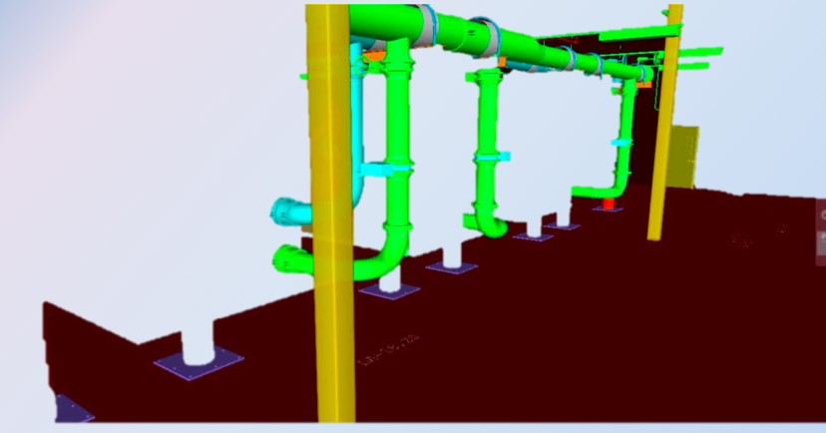
Here is a BIM shot. We did a lot of prefabrication. These are the chillers. All of the skids were made off-site. All of the piping, connections, everything was done ahead of time in our mechanical subcontractor’s yard. Everything was flown in prior to us setting the structural steel and the roof of the facility, and then we essentially just built up everything around it.
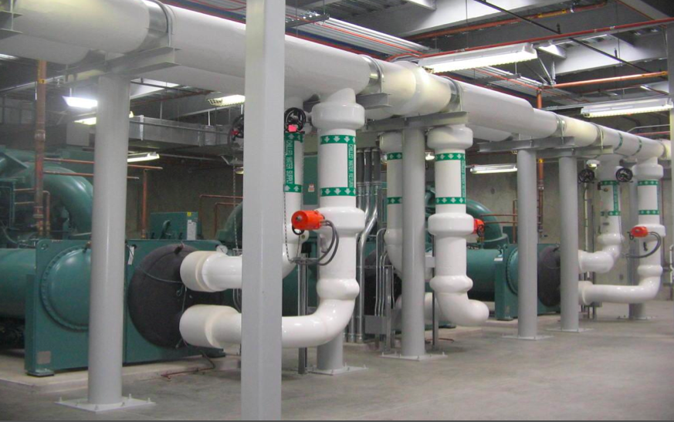
Here’s a shot of the as-built condition.
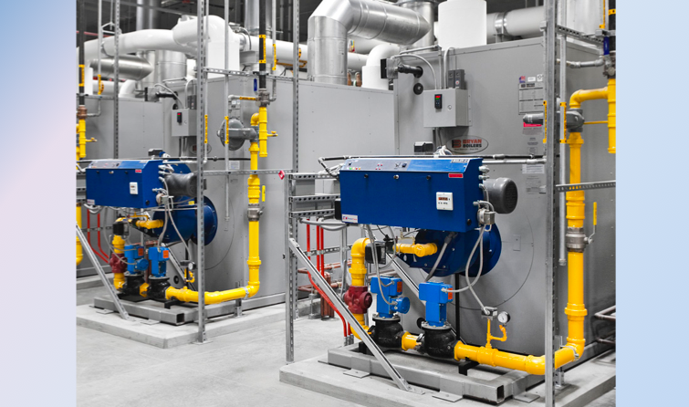
Here are the boilers.
The support buildings really consisted of a trunk radio room, the guard towers, the vehicle sallyport, communications/lockshop, armory, outside grounds, and some gatehouses.
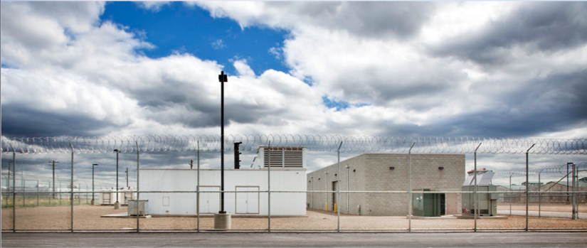
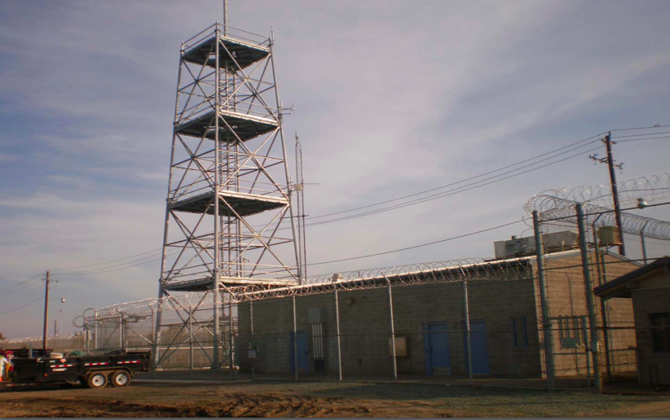
Here’s a shot of the lethal electrified fence and the guard towers.
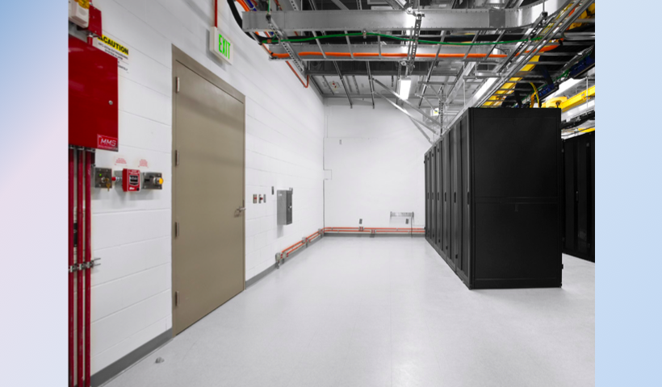
This is the communications and lockshop. As we’ll talk a little bit further, that was one of our major interface points, because Package 2 did all of the low voltage for the facility.
This is really the hub and something a little bit different for all of us on the project. This is the material service center. This is what would normally function as, say, a warehouse. But on this particular project, it’s really serving more as a distribution center. Everything that comes into the facility – whether it’s a syringe, Top Ramen, toilet paper – comes through this building, and it’s all just-in-time delivery.
Part of the struggle of working through the design and the inner workings of the material management system was really getting all of these stakeholders to wrap their mind around how we were going to process materials through this material service center and then how they were going to be distributed throughout the facility on a daily basis. This also includes all of the food distribution and all of the inner distribution inside the facility, as well.
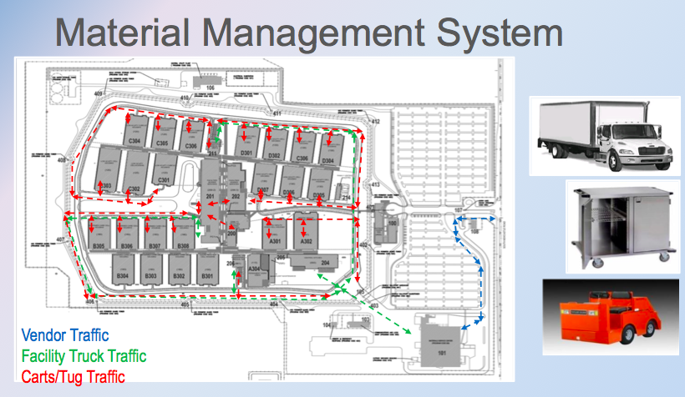
Here, you see a map. You see the material service center in the bottom right hand corner. All of these lines are the tracks of material distribution.
George: DB2, go ahead.
Paul: Obviously, as Mike said, the schedule was the real driver.
We really took a holistic approach to this, because again, it was under the court’s mandates to create a healing environment and something that’s not business as usual for CDCR. As an example, it’s hard to create a healing environment if it’s not first safe and secure. All of these things relate together holistically.
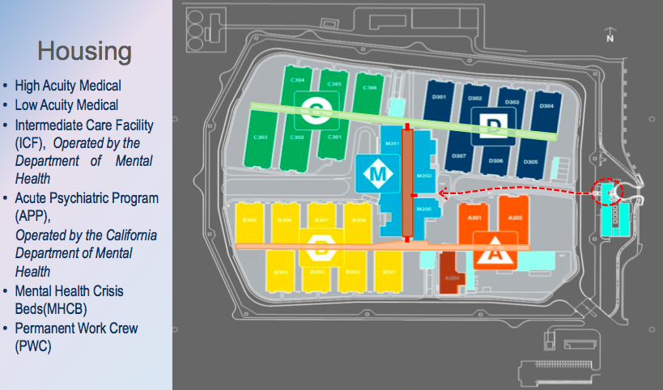
This is diagrammatic sitemap. One of the key ideas about the planning of this was that the site was organized in different villages or neighborhoods, based on your acuity. On the upper half of the site, you have an east-west street that connects the low medical housing units with the high housing units. The lower street is for mental health. The vertical street in between is really where all of the common facilities for clinics and programs reside.
The idea was that the inmate patients take greater responsibility for themselves, their own care, to make their appointments, to go to their programs, and be less escorted.
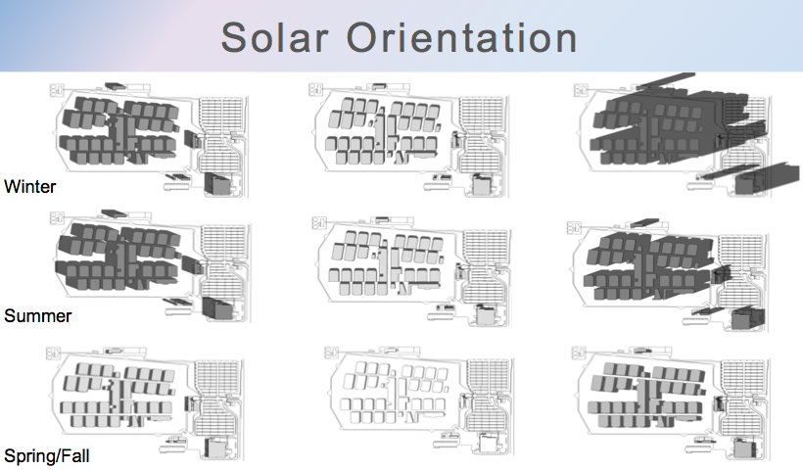
One of the key things that we did is we took the criteria documents and we analyzed the solar orientation. One of the key tenets was to create a lot of natural daylight for a healing environment.
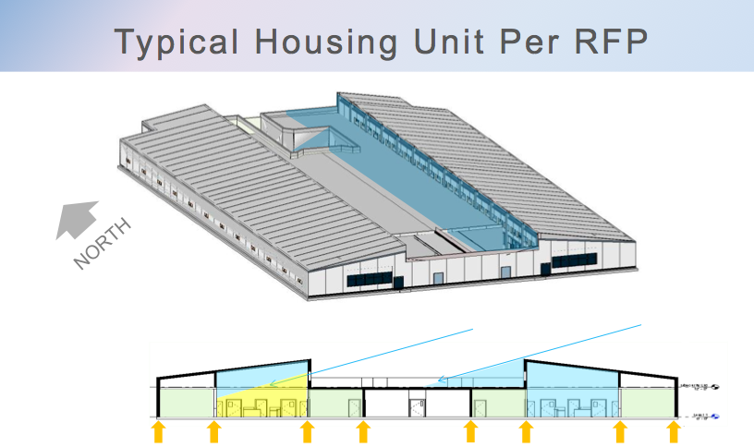
We studied it, and based on the criteria design, we had these clerestory windows. We realized that the way it was oriented, one unit would get morning light, the other one wouldn’t, and in the afternoon, it’d be vice versa.
It also showed us that there were lines of structure that were at the cell fronts. One of the things that Colin will describe a little later is that we really wanted to decouple the structure from the cell fronts, because it would give us greater flexibility to design what was inside the shell, and it would also give us greater flexibility down the road.
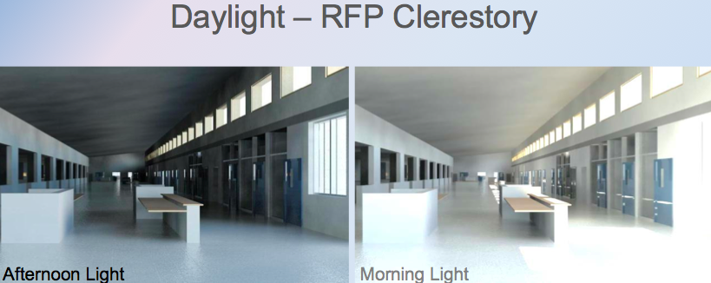
We did a lot of analysis. This is the RFP housing unit, with the daylighting analysis. We did a lot of alternative roof studies, based on that. In all of them, we wanted to clear span the housing unit.
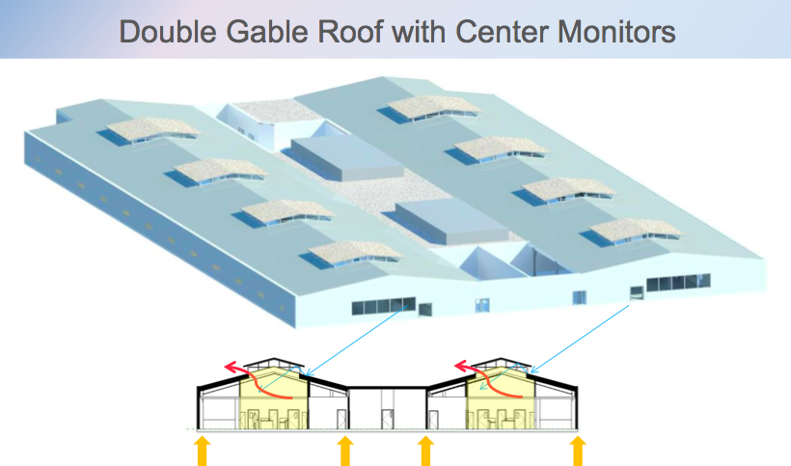
This was the preferred scheme we ended up with, which was a very straightforward, simple clerestory monitor in the middle of the unit. It provided the best daylighting, and it also gave us an opportunity to naturally ventilate smoke, in that instance.
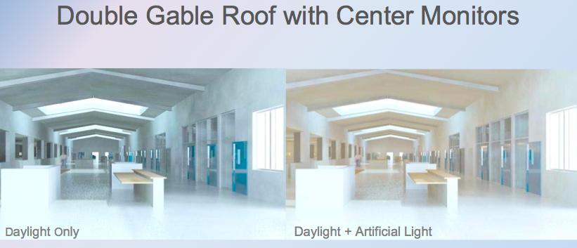
Again, here are some computer analysis of daylighting on its own, and then with some artificial lighting.
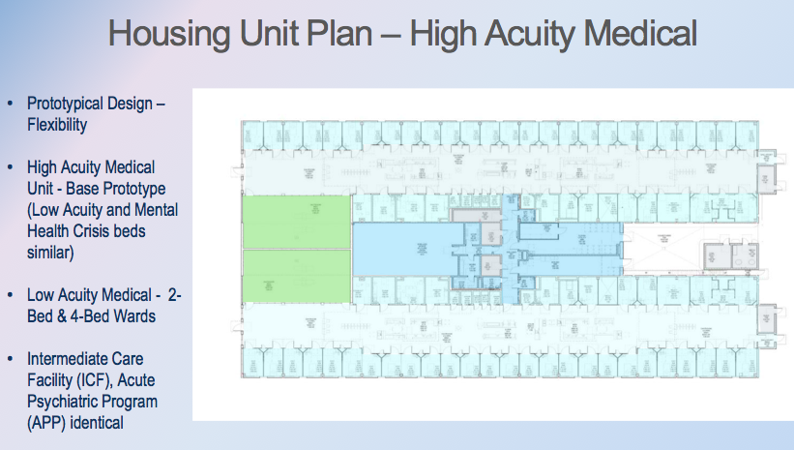
Bill: This is a typical housing unit. This happens to be the 130 building, which happens to be high acuity medical. You’ll see in this area here, this is a lot of shelled space. In a medical unit, the staffing requirements are much less than a mental health because of all of the mental health counselors. While it’s shelled out in the medical building, it’s filled with counseling stations for the various counselors to have a place to work.
Over time, no matter what we pick in terms of the mix between medical and mental health, it’s going to be wrong ten years from now. This allows somebody to come back in, create the workstations in there and convert this medical unit into a mental health unit, and vice versa. We didn’t want to build in obsolescence. We wanted to allow something to evolve over time.
Paul: By nature, these facilities are very hardened, obviously, so they don’t lend themselves to renovation. The more standardized you can be, the greater flexibility you have down the road.
Colin: As far as the structural systems, you’ll hear it again: it was speed. It wasn’t only speed of construction; it was speed of the design process, the approval process for the design, and taking away your risk from inspection and those types of things, things that might slow down the design.
Pretty early on, we noticed we needed a shell-and-core philosophy. We know we needed to mobilize Mark and the rest of the team to build, yet we needed to refine the inside of the space. We needed the design team to work with the owner, the users, and figure out that they’re going to have a building that they can live with for 40 years.
We borrowed the best concepts of a pre-engineered metal building – fast – but we actually used traditional components and conventional steel. This allowed us to clear span the dayroom very effectively, and it allowed us to give the healing environment inside, and it allowed us to give the daylighting. One of my most enjoyable moments early on was working with Paul and Phil to get a structural system that worked as a total project solution.
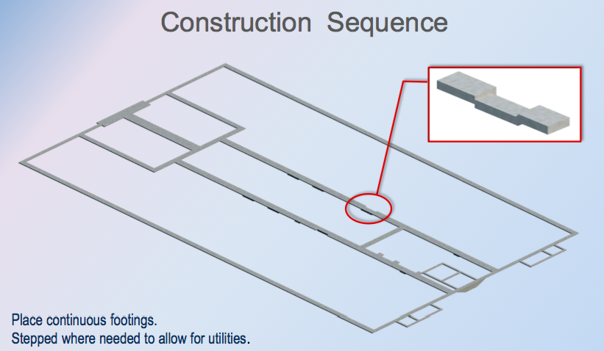
I’m going to take you really quickly through the sequence of construction. These are perimeter footings – long spanned, very simple.
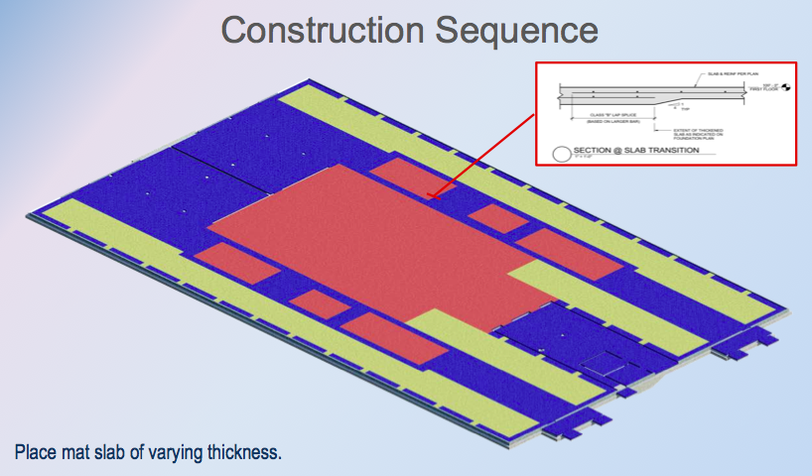
We have slabs on grade. This is a palate we wanted to give everybody. We knew that to the day we built the walls, it may change slightly. We actually did thickened slabs everywhere, and that gave a lot of flexibility during the construction, and even into the future, things can move around quite easily.
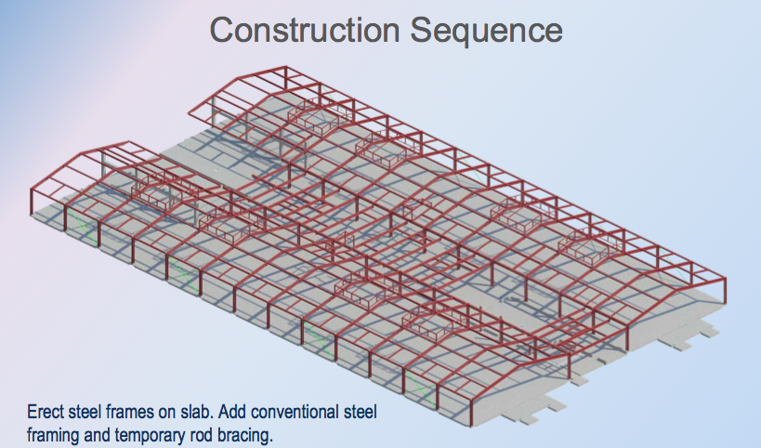
The steel went up really quickly. We had Herrick. They were fantastic. We spent a lot of time with them in tech – one of the beauties of design assist. They were in our office weekly, working out through every detail. It went up very quick, very modular.
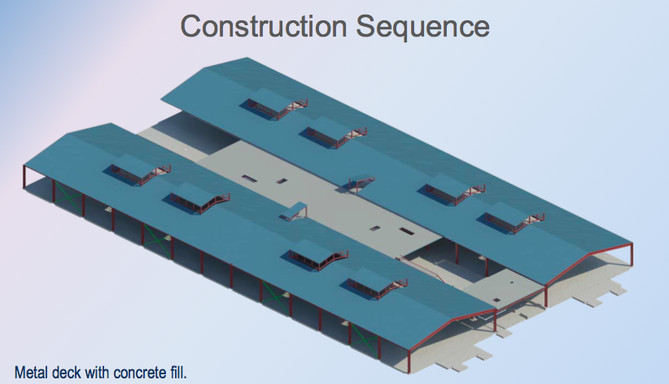
We put the roofs in place, and that gave us a place to work, to build out the inside of the building.
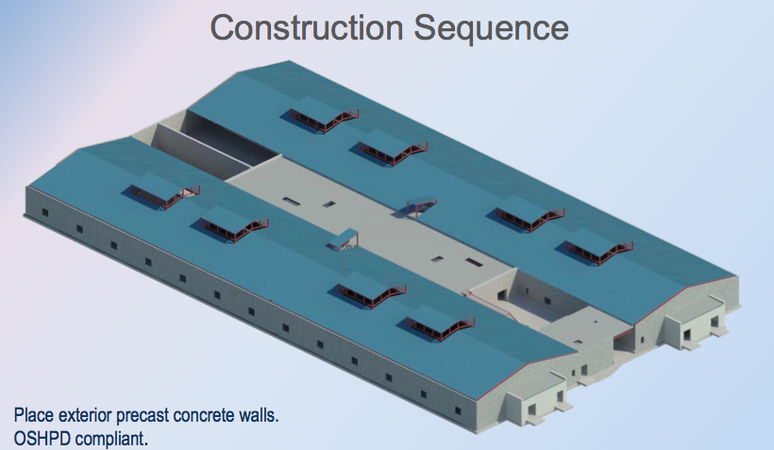
Once the walls go up, that actually made a code-compliant structure. Seismic was very important for OSHPD codes. Before that, you didn’t have a code-compliant structure, although you had a really good construction building that facilitated the addition of the precast walls on the outside. But now it’s code compliant, with the addition of the walls.
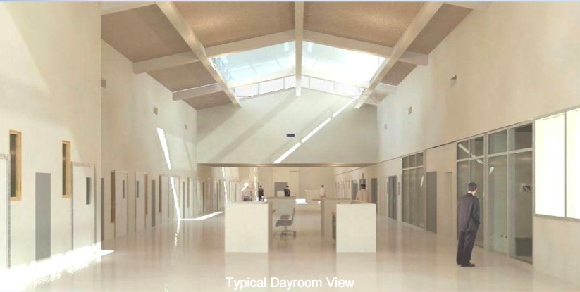
Paul: We did a lot of BIM studies to analyze the space and the daylighting and so forth. This is an early view of a computer-generated dayroom.
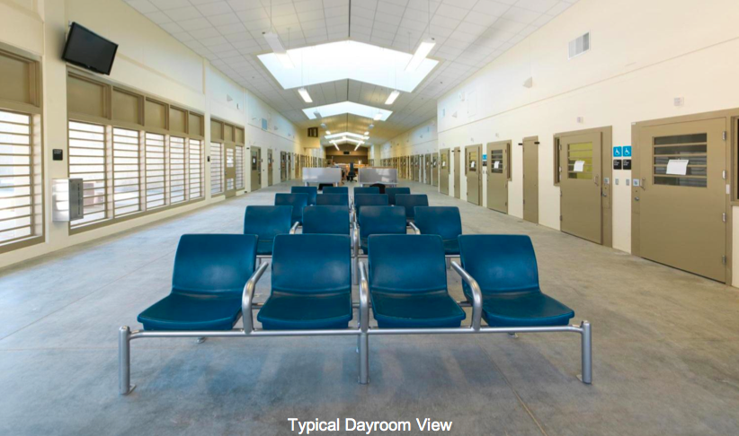
Here is the actual dayroom of a typical unit.
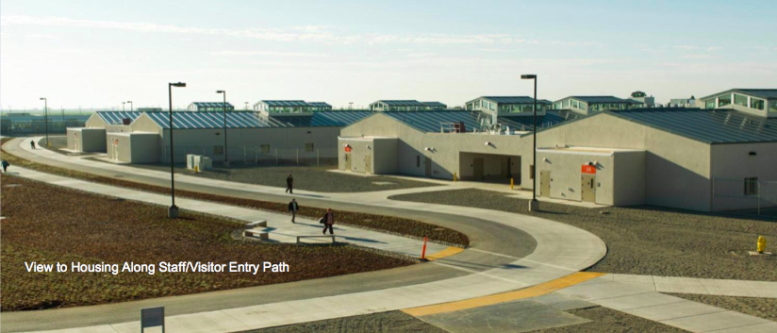
This is just the arrival from the main entry gate into the facility.
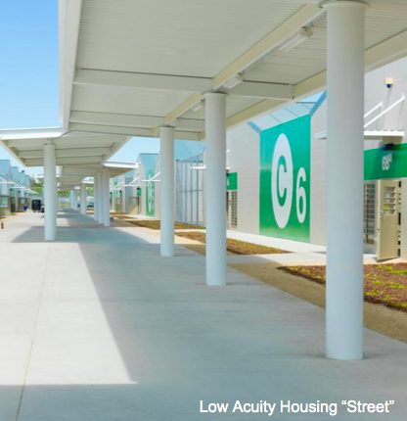
This is the view of the medical street and the covered walkways. It’s important to note the way-finding graphics, because the majority of these folks not only have physical disabilities but they have cognitive disabilities, and their ability to find their way to their appointments was really important.
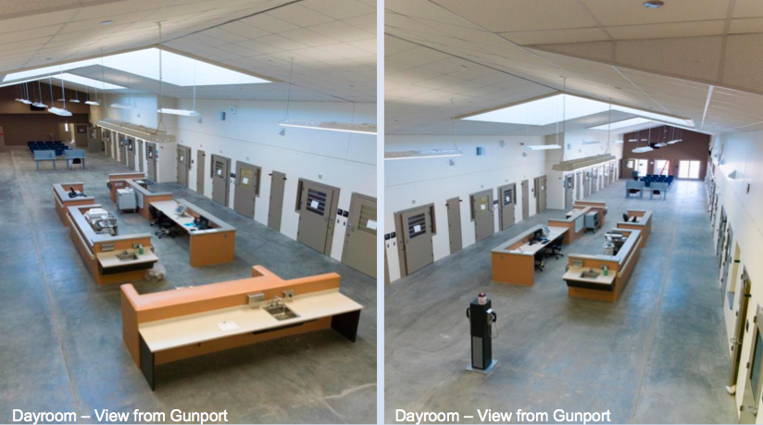
This is the view from up above. There is a gunport in each unit so they can have a clear line of sight. This shows you all of the space inside.
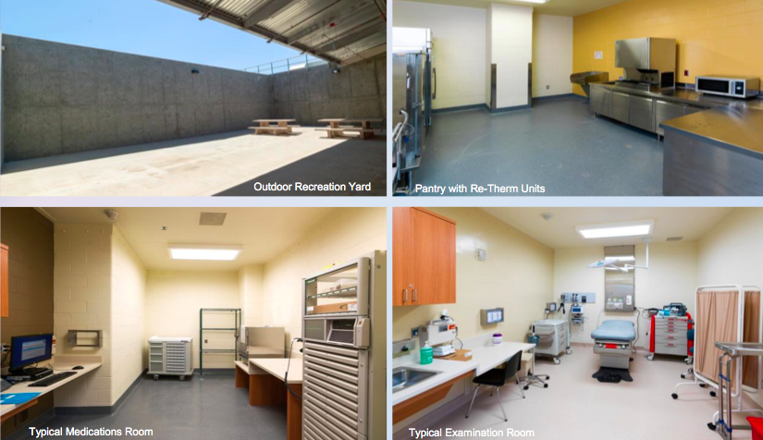
It’s kind of an interesting mix of a centralized and decentralized facility for flexibility. Every housing unit had a core set of services, like an exam room, a consult room, and medications. Every unit had its own rec yard, pantry, and so forth.
There are some of the inmate population who won’t go to the central facility, because they’re just too acute, particularly acute psych. But it gives you that flexibility to either treat them on unit or send them to a centralized place.
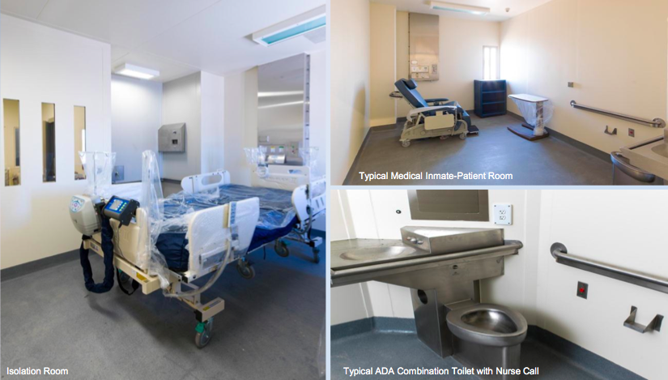
Here are some more of the other typical things. In the upper right is a typical medical inmate-patient room. Do you want to talk about the headwalls?
Bill: You’ll see the headwalls. That’s something we had to try to fabricate and design ourselves, because you can’t go out to a medical supply place and find a security headwall. This was work to put together with a manufacturer, the users, and everybody to make sure that we had everything exactly right.
Paul: The other thing to note is that even the standard ADA combination fixture was customized to give greater assistance to the inmates. You’ll also note that there’s a red button by the toilet. That’s a second nurse call button, should they have a problem at the toilet instead of at the bed.
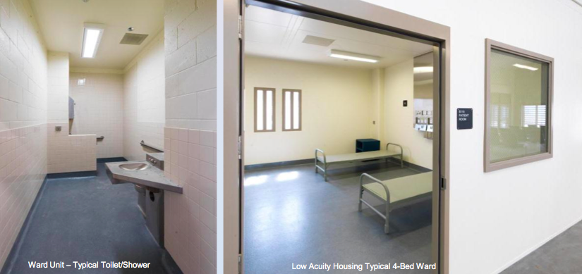
We also had a housing unit that was originally going to be dorms. They ended up being two- and four-bed wards for the less acute medical patients.
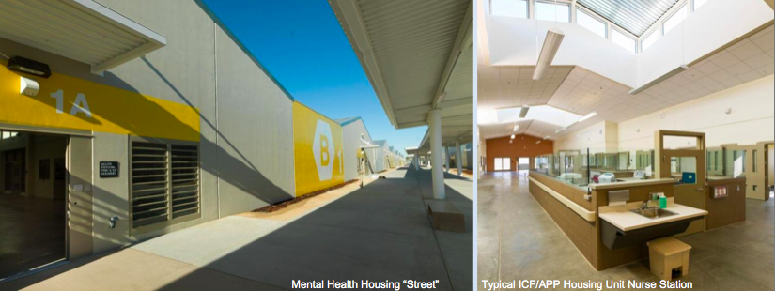
This is a view of the mental health street, in yellow. This was operated by then Department of Mental Health – it’s not called that any more. In their units, they wanted the nurse stations to be enclosed with the glass surround, so that’s what you see.
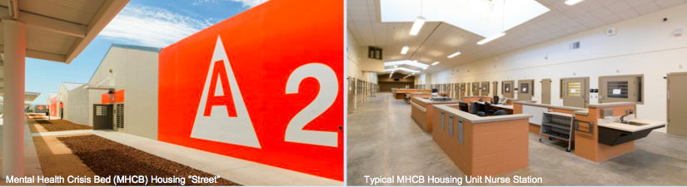
This is a mental health crisis bed. Again, dayrooms look very similar. The nurse stations are identical, except these are not enclosed.
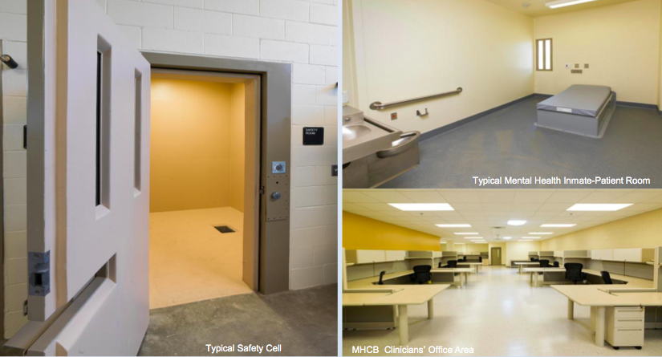
As Bill mentioned, this is an MCHB. They have a huge clinician to patient ratio, so there is a lot more support in the area that in a medical unit would have been just shelled space. In the lower right, you see the office space.
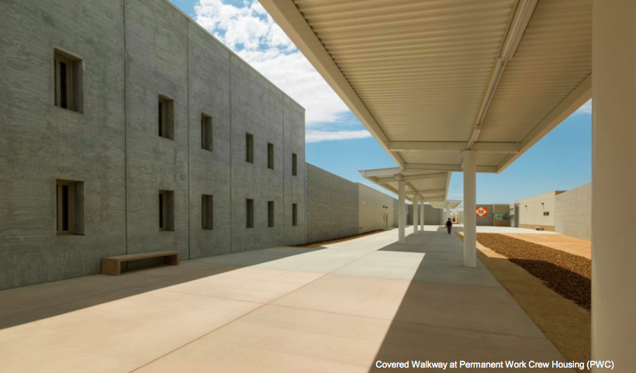
This is a walkway to the permanent work crew. There is general housing for the folks who will work at the facility who aren’t medical or mental patients.
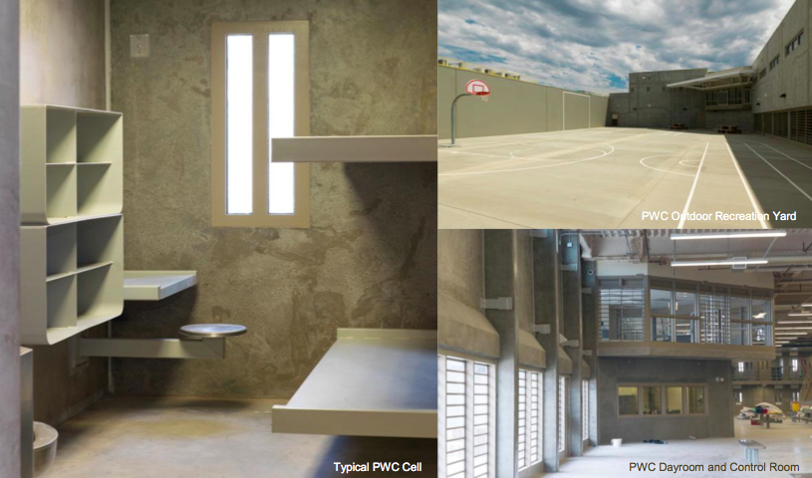
Bill: This is a standard open dayroom configuration, with an outdoor rec yard. As Paul said, these are the folks who are working in the kitchen, doing the janitorial stuff, and all of that kind of stuff. It’s a fairly straightforward approach to a typical CDCR housing unit.
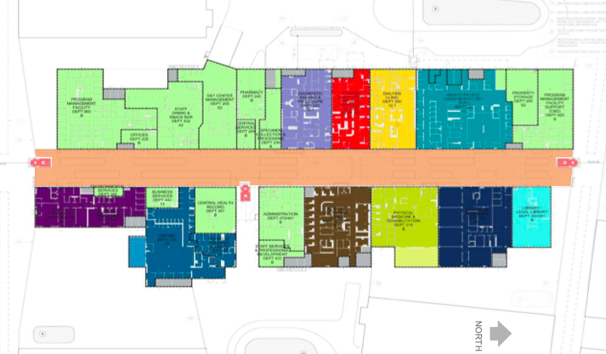
Paul: Now, we’ll go into what we call the FSS. It had all the clinics, the inmate programs, and so forth. The colored spaces are the ones for either clinics, education, vocational training, and things like that. The light green that we just added is really more or less staff-only places.
Bill: I’d like to bring up something that is an interesting challenge on that. When the RFP came out, they had a certain amount of square footage allocated to that, but through an addendum at the very last minute, they said, “Remove 30,000 square feet. We’ll sort out the stuff later.”
We took that out of our price. Then, later on, just as we get that 30,000 square feet reconfigured, they come back and say, “Now, we need 10,000 more feet, because we have different staff loads.” We were able to squeeze that 10,000 square feet into that reduced building footprint, but it took a lot of effort between the user groups, the designers, and the contractors to actually make all of that happen.
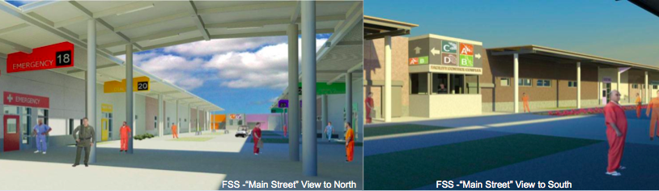
Paul: This is a computer study of Main Street.
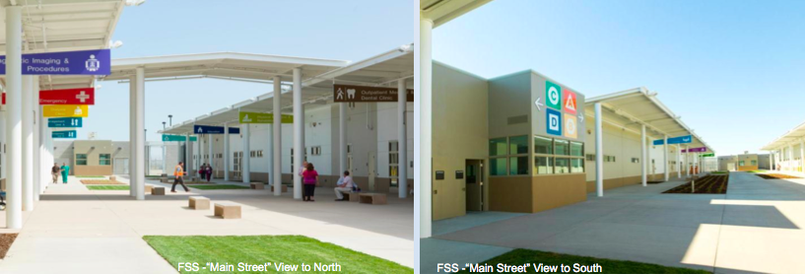
This is how it ended up. Again, you can see the importance of the colored graphics to find your way around.
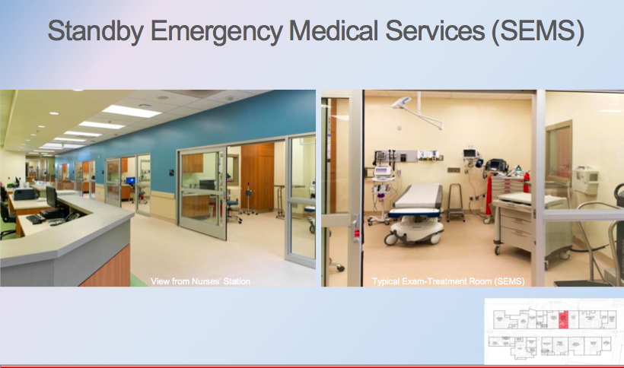
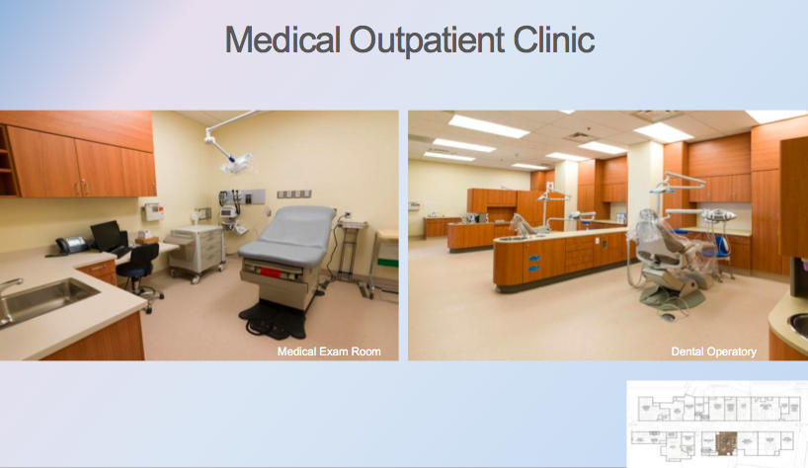
We’ll go through these quickly. These are photographs. This is the emergency area, and the outpatient with medical/dental.
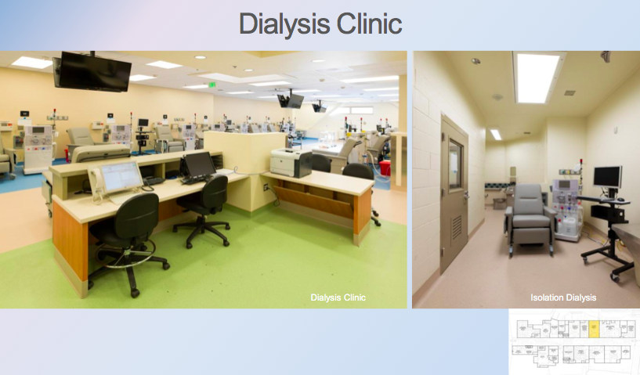
Dialysis is obviously a big thing. On the right, you have isolation dialysis.
Bill: Yes. 29 dialysis stations.
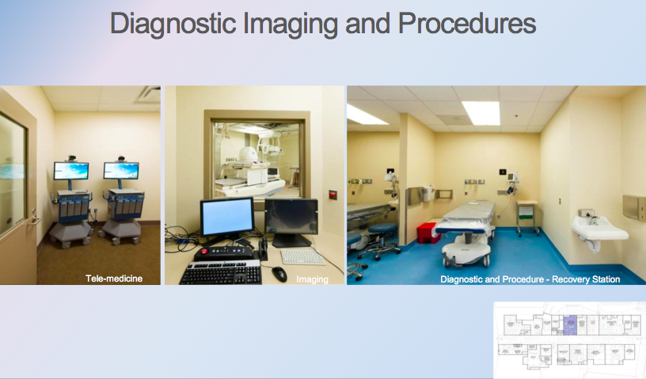
Paul: These are imaging and telemedicine.
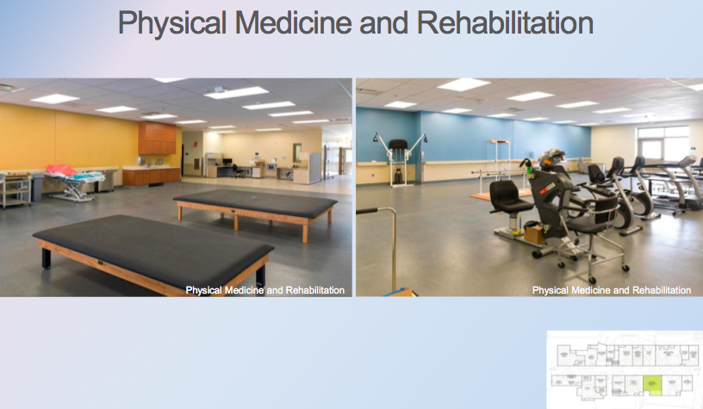
Physical therapy.
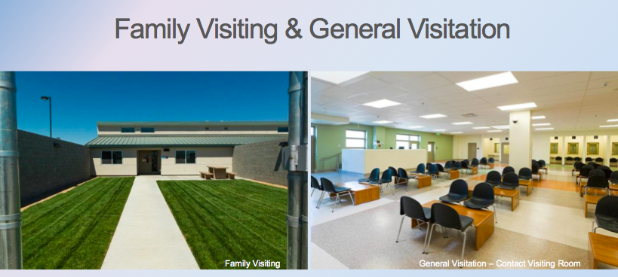
This is really about the programs. On the left, you have family visiting, which are small apartments. General visitation is on the right.
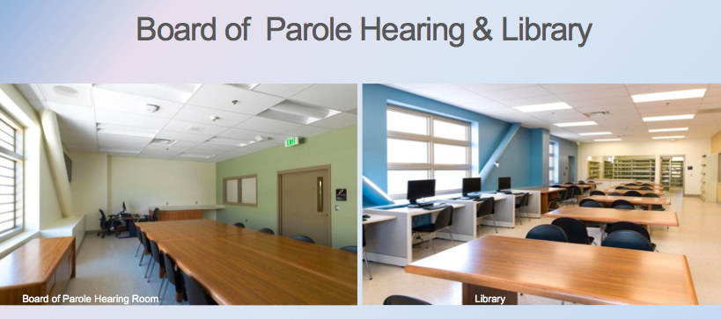
There are board of parole hearings, as well as library and legal library.
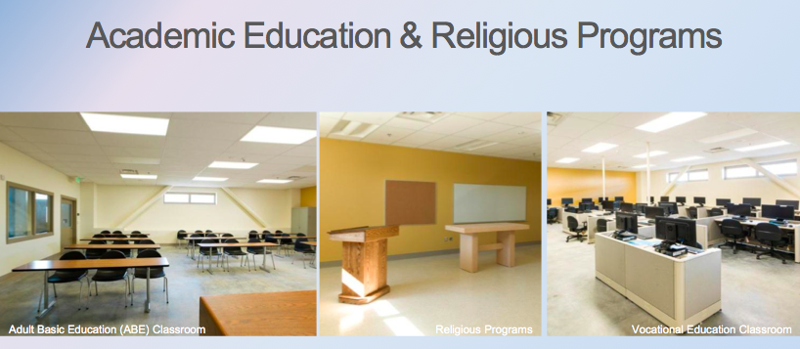
All of the education programs, chapel, and vocational ed.
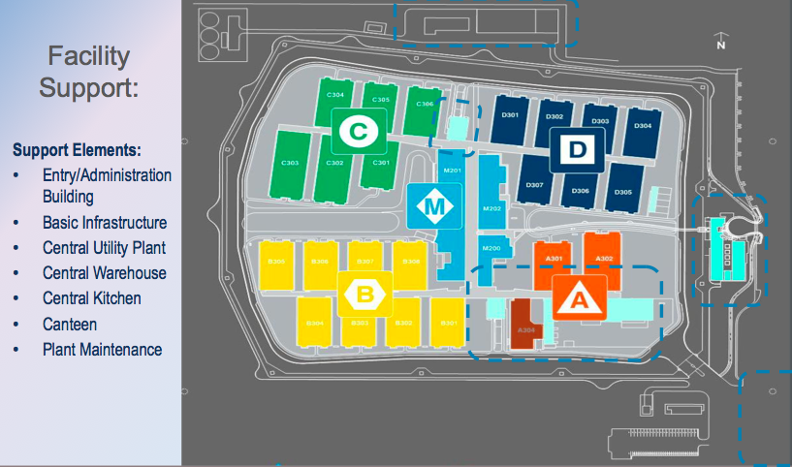
Then, there is a lot of support that goes into all of this. Shannon talked about some of that.
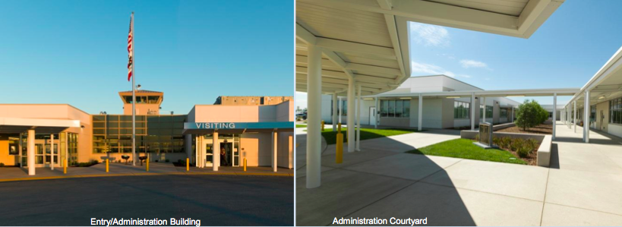
There is the main entry building, which the DB2 team did.
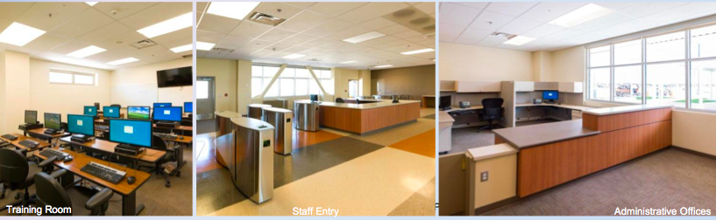
It had staff training, staff entries, and office areas, and so forth.
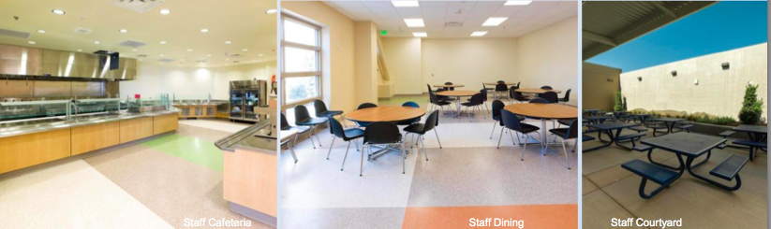
A key piece was the amenities for staff, such as the dining. That’s really important. The staff are living in these facilities a lot longer than a lot of inmates are there, so it’s important to support them.
Bill: The state is recruiting nurses, technicians, and counselors from the private sector to come work here, and they’re leaving fairly nice hospital situations, so creating a nice working environment was a very key component of what we were trying to do here.
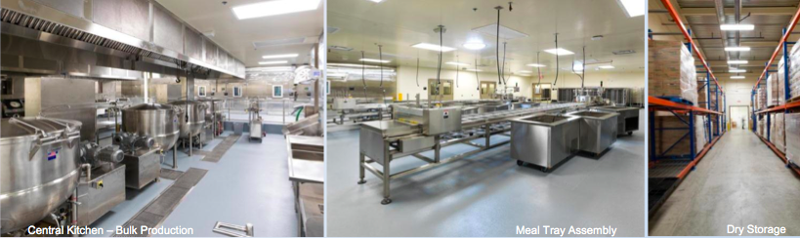
Paul: Again, the central kitchen was huge. Mark and Shannon will share some more detail on that. Even the process by how we get meals to the various places and to the inmates was a big deal.
Mark: That kitchen is an amazing kitchen. It puts out 10,000 meals a day, and they produce 70,000 within five days so that they can feed the facility over the weekend. It’s quite an accomplishment.
George: It’s set up like a hospital kitchen. Every meal is designated for a specific patient. The logistics of getting that meal onto the right cart, going to the right housing unit, and then to that particular patient presented a lot of challenges, but we worked through it.
Shannon: There were two fundamental differences. One is the remodel aspect of this portion of the project and the other was the amount of the bridging documents. The CHCF project had fairly prescriptive bridging documents, while DNCA was far more performance based. You’ll see how that turned out.
Mike J: Through a series of owner-user, stakeholder meetings during the design phase, the design team was able to develop some alternate seismic mitigations for these existing buildings, with the end goal of improving sight lines and reducing inmate movement to better meet the goals of the stakeholders.
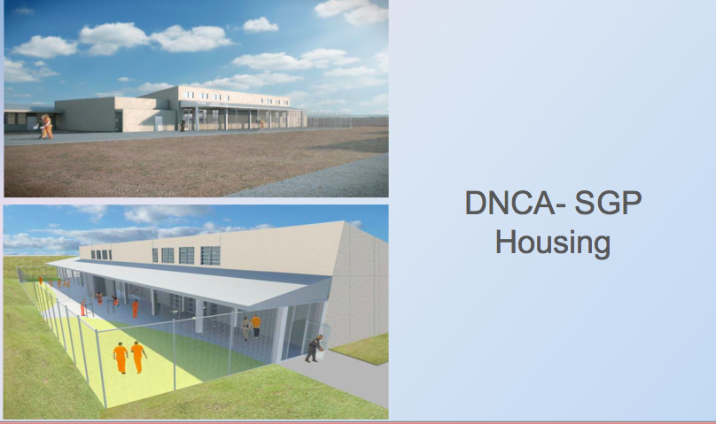
This is the exterior of the SGP housing units. Again, the original criteria documents called for separated dayrooms, due to some seismic constraints with the existing structures. The proposed design actually brought the dayrooms and the outdoor recs closer and basically internal to the existing buildings.
George: You made a silk purse out of a sow’s ear.
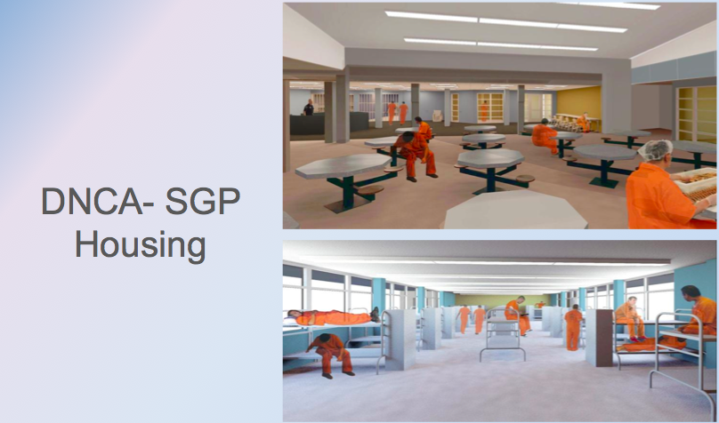
Mike J: There are some shots of the interior dayroom. You can see from a custody standpoint, improved visibility and reduced inmate movement.
Shannon: The Enhanced Outpatient Building, similar to what Mike was talking about. Craig touched on it the first day that we were here. Through the confidential meetings, through the RFP process, we were really able to validate with not only the stakeholders but also with the state fire marshal that some of these concepts were viable. As Mike used to say, “I’m not going to give you advice, but I’ll keep you between the lines.”
HOK was able to come up with a design that really limited movement, improved custody, provided for future flexibility to provide a higher level of detainee in the Enhanced Outpatient Building, in addition to providing that therapeutic environment and really a smooth transition between CHCF and DNCA.
It was actually a concern that people would want to be in CHCF and would maybe not want to come back to DNCA, so we tried to help make the environment very similar to what you would see over there.
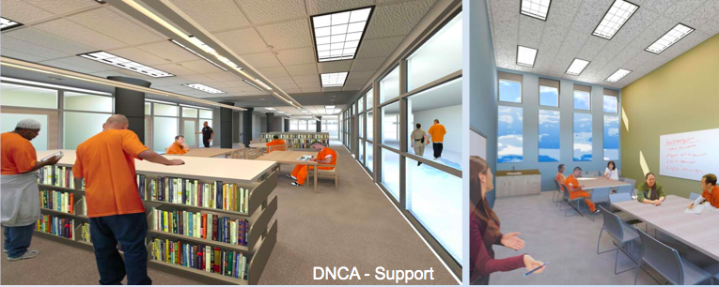
These are shots of the library and the classrooms.
Clark McCarthy and Hensel Phelps obviously had a lot of coordination points, as you saw in one of the first slides. I talked a little bit about the building loads. These guys will tell you that every meeting that they walked into for the first two months of the project, all I said was, “Where are the building loads?” Like I said, that was to validate that all of the equipment that we had already ordered was actually correct.
We talked about the material handling system and the interconnection between the facility and the distribution system that we were working on. Then, site access. If you think back to the graphic where you saw the yellow that surrounded everything in Package 2, site access was a real issue all the way through construction, not only after we closed the lethal fence, but just construction access throughout the entire project.
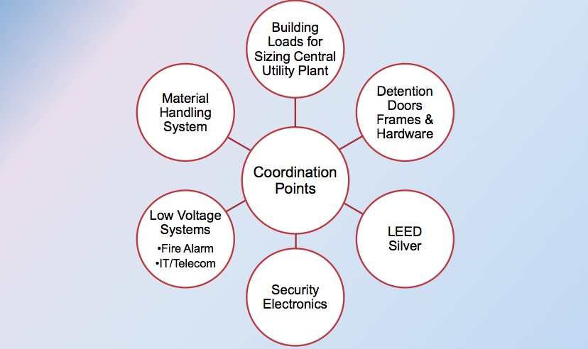
Mark: As we indicated, the project was three different packages. To make sure that there was integration between key systems throughout the facility, Design-Build Package 2 was actually responsible for several key aspects: detention doors and frames and hardware, the low voltage systems, we had all of the telecommunications. BAS, they’re building the central plant and we’re providing the controls.
We had security electronics for the entire facility, one of the most key aspects of the facility. It was a huge challenge, because as Shannon had indicated, they had started two months before us in design, and they’re going and going. They’re coming to us and saying, “We need these answers,” and we hadn’t even really started design yet. Yes, trust me, she was in my office every day.
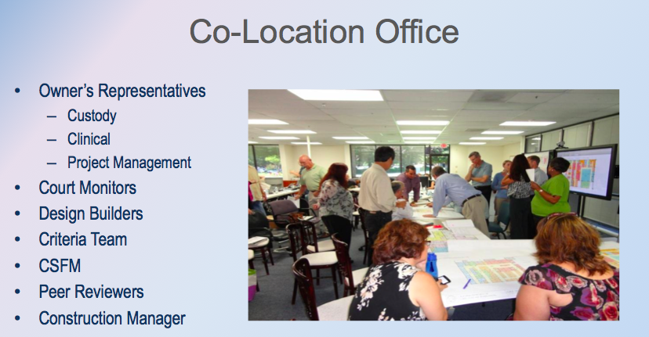
We had to develop a solution. The key solution to that was co-location. Again, you saw the stakeholders list that Mike presented to you earlier. One of key things we set up with the team is to collocate all of the stakeholders with us in a central office. That included custody, clinical, project management, and the construction manager – everybody was in one office. The two Design-Builders were in the same office, working side-by-side daily, to try to coordinate the designs as they were moving forward.
Shannon: We didn’t even lock our doors.
Mark: Until there was a confidential meeting.
Everybody, including the criteria team, was there. It was quite amazing. To me, the most unprecedented thing I had seen in my life was the California State Fire Marshal, who was one of the authorities having jurisdiction on this project along with the independent peer reviewers all recognizing the urgency of the project schedule and the complexities, especially, as I think they indicated earlier, as it’s an I2 and I3 overlay, for which really there was no code. It was trying to interpret the best code and the best solution.
They actually integrated with us. They attended confidential meetings prior to award of the project to give us guidance and direction on our designs. After award, again, they put plan checkers in our office during the design-development phase to work with us, give us solutions, and give us ideas on how to move forward.
Where the rubber really met the road, when we were at the permitting stage, we actually did real-time plan check and corrections and approvals, where they were located in our office, red-lining drawings side by side with our designers. Those red-lines were distributed to the actual CAD operators and others. The details were updated and they were slip-sheeted back into the plan set so they could approve it. Design-Build Package 3, we basically permitted the entire project in less than a month. It was pretty amazing.
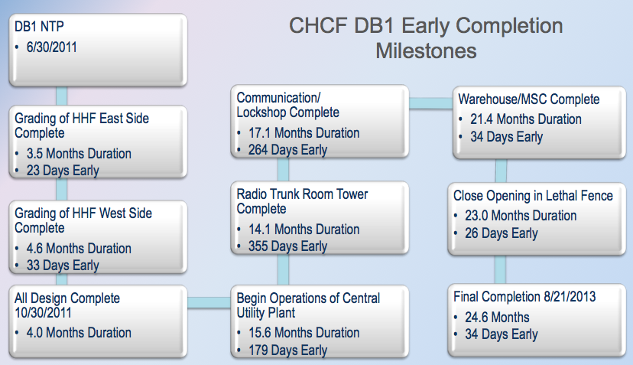
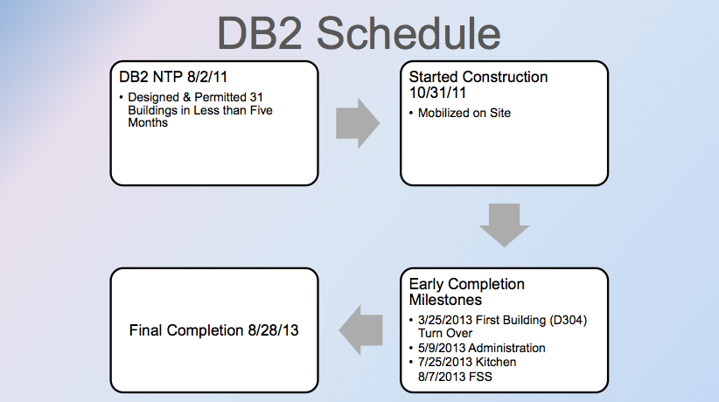
Shannon: This is really to speak to the coordination of the schedule and how we were really going to bring this facility online for the owner. As we talked before, our notice to proceed was a couple of months before Package 2.
We actually did all of the mass grading for the entire project, and through coordination process, we were able to not only do the mass grading but help get a lot closer to finish elevations for Package 2 to allow their work to start a little bit earlier.
Mark: This was a key aspect. You’ll see a little bit later some of the photos. For them to deliver the mass grading to us on time was essential for us to get the right start.
Shannon: We talked about the design process. You see we had a four-month design period to essentially get all of our documents complete and stamped by the authorities having jurisdiction.
Mark: Again, ours was roughly five months, running just behind them a couple of months.
Shannon: The communications and lockshop building was a building that we brought online pretty significantly early in order to facilitate the work for Package 2 to bring in all of the low voltage components.
The radio trunk room was an owner request. Partway through the project, the owner determined that they actually needed that building a year ahead of when it was originally planned to be turned over, so we worked to complete that.
Obviously, without bringing that central utility plant online six months early, we would not have been able to facilitate the work for Package 2. The day we turned it on is the day they started to use it for part of the startup and commissioning of their equipment.
Mark: Again, another key milestone to the project to make sure we were going to get to the end.
Shannon: We brought the material service center on early in order to facilitate owner activation, really understanding that concept of the distribution center, being able to get set up in there. They really wanted to get in there and get that going early.
Closing the lethal fence, that’s actually a date that we actually pushed back. We were ready to close it, but we kept it open to help facilitate the work of Package 2 and their ease of access into and out of the site.
Then, final completion. Really, Craig and a couple of people talked, and nobody wanted to talk about multi-prime. Here we are, a multi-prime Design-Build, a very fast project. Really, this is all showing is that through the spirit of Design-Build and that collaborative environment, we all came together for the common goal of a good project, and in many cases, really overstepping or stepping outside of our contractual obligations to either the owner or each other in order to achieve one goal of providing this facility in time for owner activation and intake of inmates.
Mark: Now, that we’ve gone through that timeline with you, we thought we would leave you with a lasting impression. This next set of slides should give you the idea of the scope, the magnitude, and the work that was ongoing.
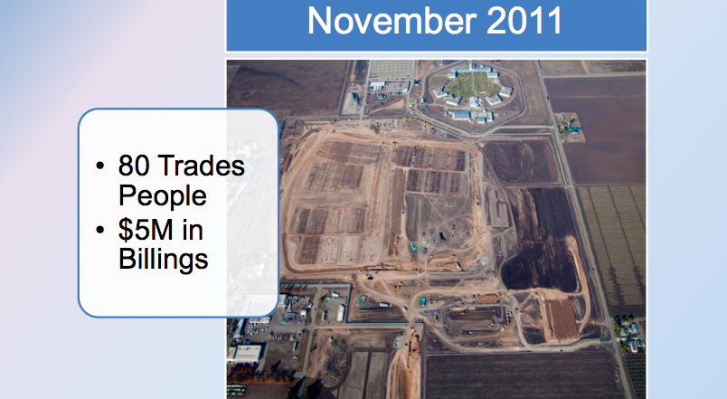
This is November 2011. We talked about that mass-grading package that needed to be done. This was essential for them to complete the mass grading and for Design Package 2 to start.
In November, basically, we had mobilized the site and we started some of the final prep of the pads there. You can see them up in the northeast corner of the site. Again, about 109 tradespeople – and you’re going to these consistently: they’re both DB1 and DB2 numbers for the month.
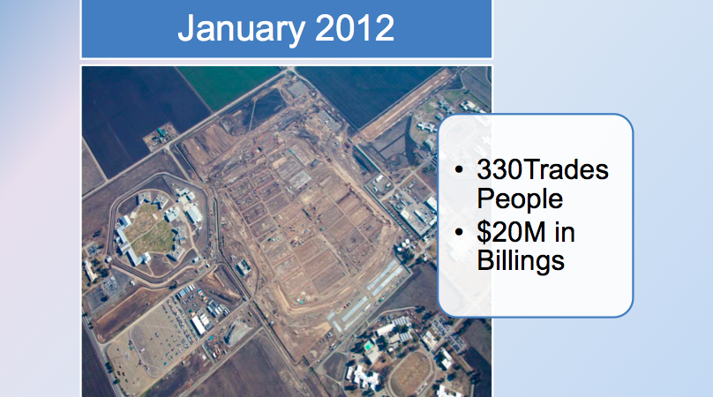
January 2012 was a kickoff for DB2 to really start infrastructure work and foundations. We’re just getting into the foundations on the first few housing units at this point in time. DB1, you’ll notice, their central plant – which is there in the corner – is actually erected out and looks to be enclosed at this point in time. It was cranking along, and they were down in the corner working on the MSC.
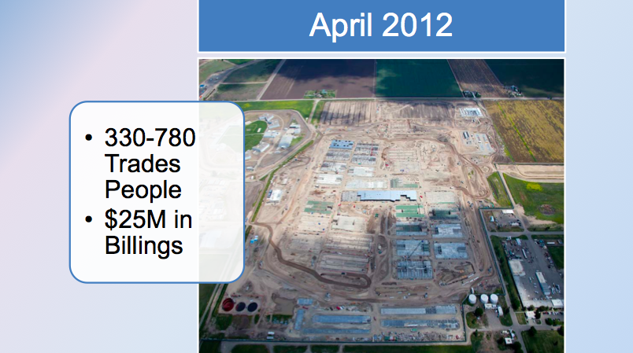
Four months later, April 2012, really starting to ramp up. You get a sense. Remember, there are 31 buildings in the perimeter on DB2. The first, you can see in the upper corner, there are a couple of housing units that are erected. In the middle, we’re already starting to erect the Facilities Shared Services building.
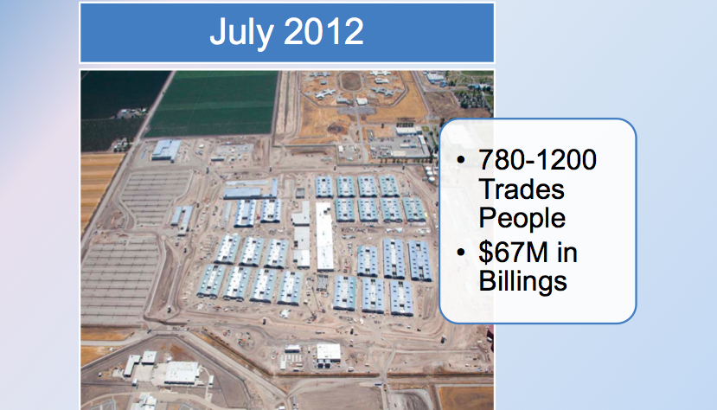
August 2012 – again, another four months or so. It’s the peak of the job. There are close to 1400 trades people on site and $70 million for a billing in one month. To be honest, DB1 is basically wrapping up with their work, and we’re in the heat of the battle. $60 million of that was put in place just by the Design-Build Package 2 contractor. Again you can see we’re pretty much enclosed and interiors are going on.
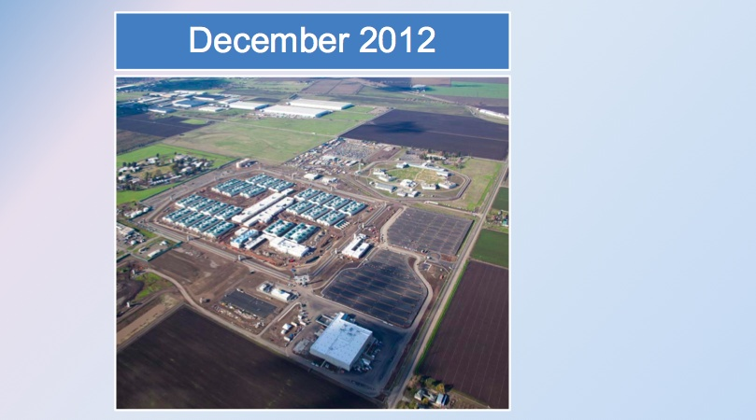
December 2012 – basically, we’re starting the primary site work. Again, we’re in interiors, and we started the functional performance tests that we talked a little bit about earlier.
With that, some stats to give you an idea: in 12 months, between the two packages, we erected over 5700 tons of steel, finished 1.4 million square feet of slab on grade, 1.5 million of hardscape and paving – and trust me, there is a lot more to go, as you saw in that last December package.
What’s really impressive – and I think it’s kind of funny – is between the two packages, we installed over 34 miles of underground duct bank. For those of you from Portland, that’s about two-thirds of the way to Mt. Hood over here, but we did that in 12 months.
We saw 1400 employees on the job site on a daily basis, but we had brought 5500 employees at different various stages through the project, 60% to 65% of whom were local to the community. It just provided a huge boost to the economy in the area. At that point, we had surpassed 2 million man-hours.
In December, we’re over. We’ve done all of the heavy lifting. From here on out, it’s a scramble to the end to get done. In March 2013, this is basically when, in order to meet the end date, we had to turn over our first building – the first of 31 buildings.
DB1 has pretty much turned over – they’re getting ready to lock things down – but we have a challenge between March and July to turn over 31 buildings. Basically, we had to accomplish that by punch listing, correcting, and back checking two buildings a week.
It was a huge scramble, a huge push, but I’m happy to say that at the end of July, essentially, the facility is complete. The lethal fence is activated, and all of the buildings are going into lockdown in preparation for their first inmate, who is arriving about a week later.
Mike M: Project successes: we obviously improved the access to healthcare for inmates. California has an enormous amount of issues. There is some form of debate in the paper daily in Sacramento, but this project was extremely significant in addressing the overcrowding issues that the state faces.
We feel that we had a completely collaborative project. It’s one of these projects that there was so much stress and everybody was so scared to fail that nobody would let anyone else down. It sort of carried the day. A difficult project, in a strange way, worked to our benefit. I think you sense that, hearing our team talk.
By the way, everybody did a great job. We’re very appreciative of all the key players and key companies. You see some of the boards that we have here that talk about the local outreach program. We had what started out as a pretty stressful relationship with the local community, and we got them completely flopped. In fact, they volunteered to endorse for us when we go into future communities. We’re extremely thrilled about that.
Bill talked about the future flexibility. We’re a department that has roughly 140,000 inmates right now, and the demographics constantly fluctuate. How do we manage that? We think this has enough flexibility to carry the day, as Bill mentioned, 10 or 15 years from now.
Finally, we actually finished ahead of where we thought we were going to finish. We have roughly 600 inmate-patients in the complex now. We finished within the budget that we had. I sit here extremely pleased.
It was literally one of these projects where the federal judges were concerned enough that they wanted to know who was responsible for certain activities so that they could potentially some day hold that specific person in contempt if they wanted to. That was the type of project. That’s behind us now. I sit here very relieved, obviously, to know that. I just think it’s a great project and one that should be talked about at these types of events.
George: We just heard from Mike – I think the project met your expectations. Shannon and Mark, as the builders, did Design-Build realize your desires for the project?
Shannon: As long as Mike is happy, we’re happy. It met our expectations.
Mark: Ditto. In all honesty, I can’t think of any better delivery method for this project. There is nothing better suited for the challenges that we faced, as far as the schedule, the coordination, and the collaboration that was necessary between everybody and the tight budget that needed to be made. I wouldn’t have it any other way.
George: And the architects – Bill, Paul, Mike?
Bill: I think I was the only one in the beginning who actually thought this would happen. I kept trying to convince my team, “We can do it.” It was based on some other experiences I’ve had in the past that were very stressful, just like this one.
People touched on it throughout the day and this presentation: all of us failed at one thing or another, sooner or later in the project. We all missed a deadline, we all missed this, we all missed that, we could have done better at that.
But instead of some of the traditional jobs where they say, “Oh, that’s a delay,” or, “I’m impacted,” or, “I have to charge for that,” people would pick each other up and carry them across the finish line. The next thing you know, that person who carried you across that finish line, they need to be picked up and carried. It was a great collaborative effort.
I think the fear of all of this is that once you accomplish the impossible, it becomes the new normal. It was an incredible effort on everybody’s part, and fortunately, no one died of stress-related issues. It was a fantastic project.
Mike J: I would just say that this project exemplifies partnership. It really was a true partnership between all of the players – architects, engineers, contractors, builders, and the owner and the stakeholders, and eventually the end users.
George: Time for questions?
Participant: How did you collaborate the operational switchover when you had to start? You turn over the facility on day one, but staffing has got to be on site, custody has got to be on site, inmates are showing up. How did you start that operation, that training, and housing? How did you schedule that to get rolling?
Mike M: CDCR has a group called our activation group. The group was formed at the beginning of the project, and so they were one of the stakeholders. They carried that plan and that mission. But more than any other project, it forced the Design-Builders and the architects to engage those people. We did have to hire custody officers and people to run the kitchen. All of that had to be filtered in.
Luckily, this is a project where the sequence of the construction allowed us to be working while we were actually punch listing in other areas of the complex and backfilling those buildings with staff and people. There was an awful lot of coordination and people involved with deliveries, owner-furnished equipment coordination, and just to get product into the complex in order to meet licensing. It had to be licensed. There was a lot of concurrent work.
You’re trying to pick where the critical path is, where that first patient needs to go, and figure out what you need to do to support that person. It’s a pull-back schedule, in a pure sense. What do we need to do to have this person licensable and to be able to take care of them from the first day that they’re in?
George: It was an incredible effort and a lot of activities. The activation plan and detailed critical path schedule for just the activation activities was in place before the Design-Builders were on board.
Mark: And incorporated into our schedules. We coordinated closely with them to get them built into our baseline schedules so we knew what days we had to meet.
Bill: The printout of that whole thing where you have the first review for punch list, the second review for punch list, the first review for licensing… When you look at that for all these buildings – custody getting in and doing their searches, and all of this other kind of stuff – I look at this and say, “Whoa. This is Tuesday. Oh, we need to be in 306.” It was amazing. The coordination of this thing was impeccable. That’s what got us there.
Paul: We really pushed a lot of the stakeholders out of their comfort zone, particularly the licensing for the medical. They’re normally just coming in when everything is built, and then they look at things. That was such a risk to us, trying to meet this deadline.
We actually took them on a virtual tour of the whole facility with the computer and walked them through every space and got their feedback, based on the virtual model – which helped us, but it also helped them understand the facility. They’re small group, and how are they going to license 33 buildings in that amount of time? It helped them plan their work, as well.
George: There are some real complexities in this facility, not just in the design but in the operation. We have a hospital-level central plant. We identified that as an area where the criteria required an extended transition period that is staffed by the Design-Builder’s experts to basically balance, maintain, fine-tune the systems, and train the new CDCR staff on how that’s supposed to operate.
We did the same thing with central kitchen, and we’ve done the same thing with the material handling system. We identified those areas of complexity that potential failures just in the transition of the operation over to CDCR, and provided experts supporting CDCR to ensure they succeed.
Participant 1: You said that you had a code official on site, [48:13 – 48:16 inaudible]. How did you make that [48:19 inaudible]?
George: We’re not sure, either!
Mike M: The department knew that that, obviously, could be a major speed bump, so you have to reach out and offer, “Can you go out and hire some people? Can we supplement your budget?” Go to them early enough to where they know the tsunami is coming and give them a chance to deal with this flood of documents that are going to be there. They bought into it.
I’m sure we got through the project with a little bit of luck, so it could have been that there were some other projects… Our court system, I know, has a lot of drawings going through now, and those seem to have gotten financially delayed or the Department of Finance had delayed them.
We may have got some benefit with the amount of workflow that was going through their office, that type of thing. But it was mostly reaching out to them and bringing them in and saying, “We have this big deal, and you don’t want to be the person who the judge ends up finding out delayed the project.” There was a little bit of that, but they did step up.
Bill: It was super critical, because there is no code section in the IBC for this building type. We were taking the I2, which is hospital, and I3, which is detention/corrections, and overlaying them. It’s like, “Take the most restrictive,” but sometimes that’s mutually exclusive. It’s not the most restrictive. A lot of times, it’s mutually exclusive.
Every issue had to be negotiated, worked out, run up the chain of command, approved at the highest levels of the code people, and come back down. We wouldn’t have been able to handle it any other way unless we had people there every day, because every day was a code review day.
Paul: We literally would get the markups, the CAD people were right there, and the next morning, it would be signed off.
Mike M: If it isn’t obvious, we also enjoyed the benefit of we self-certify. We don’t go to OSHPD as a department. It’s a legislative delegation. That helped. You always hear the stories about how long OSHPD takes. In essence, we had concurrent peer review going along, but the department actually self-certifies.
George: For those of you who haven’t done healthcare work in California, OSHPD – the Office of Statewide Health Planning and Development – oversees all licensed medical facilities, design, and construction, in the state of California. A more bureaucratic review agency, I don’t think exists anywhere.
Participant 2: Will there be a kind of deliverable to those authorities regarding this project type? It’s such a massive project, that you might lead to some changes…
George Some clarity in the code?
Participant 3: I was part of the task force to change the code, as a result of this exercise. Basically, we recognize that there is I2, I3, and there is a lot of ambiguity. It’s more appropriately represented by [52:14 inaudible].
So a few of us from the industry joined a special task force with the fire marshal group. It will be in force. It’s all as a result of all this practical knowledge that [52:37 inaudible]. It was a blessing that we went through this, so they recognize that the designer should be a part of the group as well as the [52:53 inaudible].
Bill: The only stab in the heart is you’re walking through with the Fire Marshal, and they say, “You know, in our new code, we’re not going to require you to spend all that money doing this.” They were kind of cautiously conservative, and once they all had a chance to think about it a little more, they said, “We can probably lighten up on some of these requirements in the future.”
George: Of course, that’s for California. From there, it will need to migrate into the IBC.
Participant 4: I know when this project was starting, there was a consensus in the construction industry and the design industry that this [53:28 inaudible] project, that it was deemed to be an impossible undertaking. People who had considered going after this project decided not to because they felt it couldn’t be done. This being really an incredible piece of work, you’re to be congratulated.
Having said that given its size, given its speed, there had to have been, somewhere along the line, occasions where the process broke down and you had to correct as you went along. I would just love to hear about where that happened. Did that happen? What did you do about it? I know it had to happen.
Bill: I think I can take a first shot at that. Partnering was a big part of what we were doing. When we did encounter some of these… It’s like creating a battle plan. It’s only good until you engage the enemy, and then you have to do something different.
I think through the regular partnering process, we brought up issues: “Do we really need to do it this way? Wouldn’t it make more sense if we did it another way?” We were able to use the partnering sessions to identify the roadblocks, find an alternative means that provides the same kind of protection that that roadblock would provide, but do it in a different manner that would help expedite the program.
Mark: There are a couple of things I could add for DB2. One of them, when the process kind of broke, it really isn’t a process as much a timing on the project. One of the challenges I think we all faced was timing [55:12 inaudible] when the project was awarded to us, versus the time when we started procuring the project.
The economy had turned around, so a lot of the numbers are going up from the contracting community. We struggled a lot with the costs coming in from the subs that we had bid in the future.
One of the fundamental things, as far as the Design-Build process – I won’t speak for DB1 – because of the speed of ours, the complexity, and the number of buildings, the biggest challenge where it didn’t completely break but at times it almost did was the stakeholder buy-in and approval process and confirmation of our design.
It didn’t break as much as the process lapsed, and it was a struggle in the end to get through it and make sure that we were actually providing the facility that they were looking for.
George: If I can elaborate on that a little bit. I don’t think it was a broken process. It was a process by design, out of necessity, because of the deadlines that DB2 was working towards.
The critical path to get into construction is getting the fire marshal’s and the authorities having jurisdiction’s stamp on your plans. Consequently, that was the sole focus of the DB2 team – to get through design.
Consequently, some of the stakeholder concerns that had been expressed kind of languished until after that had already happened. That caused some concern, as you might imagine, among a user group that says, “We told you two months ago that we wanted this changed, and you’re still showing it this way.”
I think we probably could have fixed that by better communication of how the process was going to work. But there really was no other way it was going to all come together without the focus on getting the authorities having jurisdiction’s approval, above all else, because construction had to get started. Maynard?
Participant 5: To add on to what Jim said, did you ever have to use your conflict resolution plans?
Shannon: No.
Mike M: There was one issue, I think, that went over my head that you could argue was utilizing that process. But it was mostly done in the spirit of, as a project with the time frame which we set, how long will you wait and let an issue fester on the site before it’s elevated? It was more done that way.
Jim, things that I can think about that didn’t go smooth… It was like there were two owners. That’s never a good thing. There was the receiver and maybe the medical community. Their optimal design and optimal operation was different than custody, and that drove a lot of internal debate. You figure out ways to deal with things, but you never feel like you’re being very efficient about it. We were just shooting ourselves in the foot sometimes.
We started off with a CEO who was like a chief medical person, who was going to be the warden. But he left, and then we got a more traditional warden, and so his view of operations was different than maybe the original design was. That caused several things to change and morph while we’re trying to meet the schedule. That, from my perspective, was very frustrating.
We weren’t confident that activation could finish in the timeframe that they needed to have. On a project that was accelerated, my boss one day said, “Let’s accelerate it some more.” I think both contractors actually finished 60 days in front of their written contractual obligation. That frustrated and put forth a lot of energy, just to manage that.
But again, I do think a lot of it hadn’t really been done before in the state, so our stakeholders really weren’t sure how this might work in its best, most efficient way.
Bill: I think the pleasure everyone gets as you do these projects is walking in after it’s been occupied and seeing the people, the user groups, and the folks that you worked with during that time period. Paul was over there the other day, and I experienced it before.
These people are literally coming up and hugging you, saying, “This is so fantastic.” There are a lot of very happy people. One of the most opinionated, let’s say, characters on the team – I won’t mention any names – when we had the dedication ceremony, he came up and said, “You got it 98% right – and no one is 100%.” I took that as a great compliment to our team.

