AIA Philadelphia COTE

Committee Evolution:

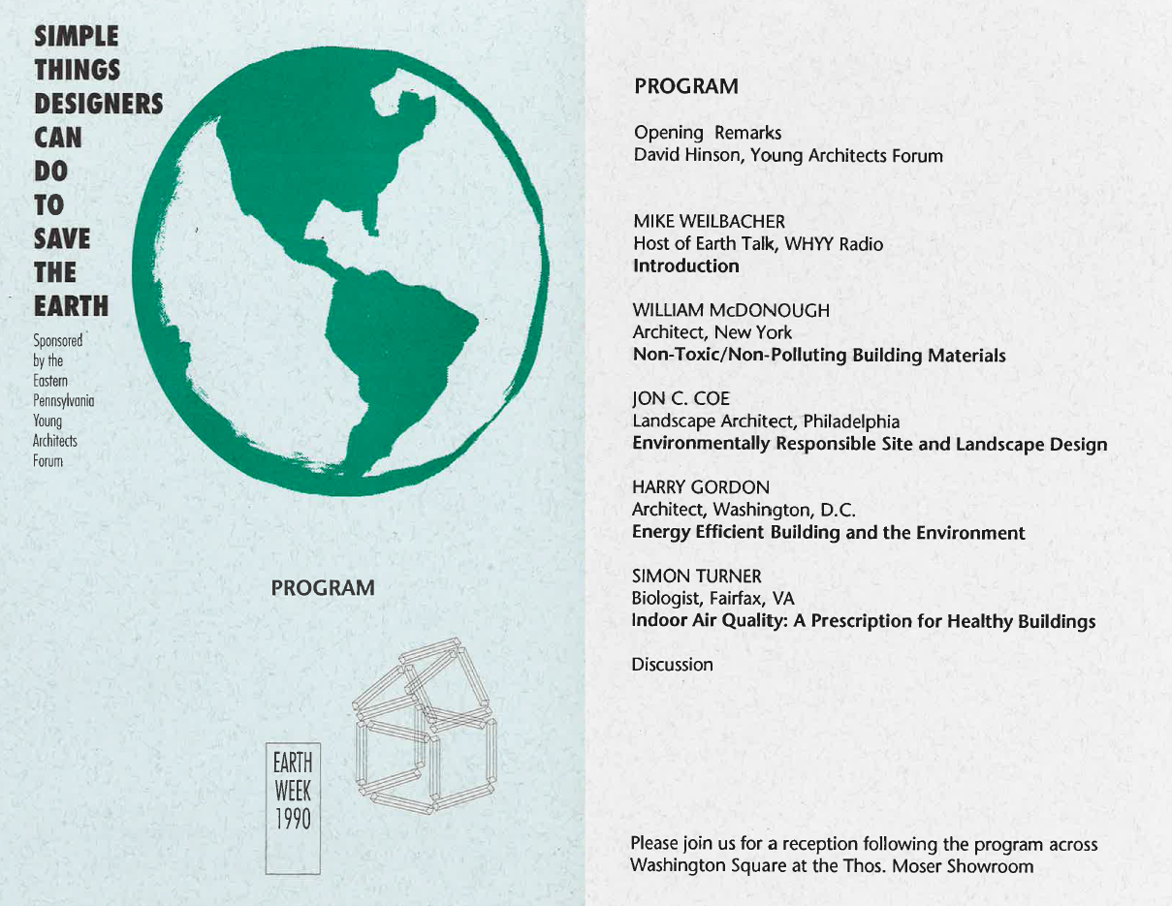
Program for the Young Architect’s Forum event sponsored in April, 1990, a celebration of 20 years of Earth Day Celebration.

Following a local conference organized by the Young Architect’s forum,, sustainability-focused architects formed the Philadelphia COTE in the fall of 1990. This group formed the kernel of sustainability leaders who later helped with AIA National and the development of the Delaware Valley Green Building Council (now Green Building United). Over time, as more groups joined the movement, sustainability events were sponsored by an umbrella under the GBC control, and COTE specific events became less frequent.

Starting in the mid- 2010s, AIA Philly and AIA PA members met to re-engage the architectural community by focusing on what sorts of activities AIA was positioned to provide - programs that were of specific interest to the architectural profession. The mission that was hammered out was that simple - to identify programs and focus groups best served by architectural / AIA membership. The group began by focusing on AIA initiatives - the AIA 2030 Commitment and the AIA Top Ten Toolkit (now called the Framework for Design Excellence).

In 2020, the group has continued to grow - starting a subcommittees on Zero Waste and Environmental Justice, while and increasing connectivity with COTE National and regional efforts to cross fertilize ideas and efforts across the industry. The group did not miss a beat as the monthly meetings and special evening programs transitioned to virtual with the rest of the region as the pandemic hit Pennsylvania. The virtual sessions have averaged 75 to 150 attendees monthly, with both attendees and presenters coming from local and far flung locations as the COTE network shares opportunities for learning and collaboration across the country.

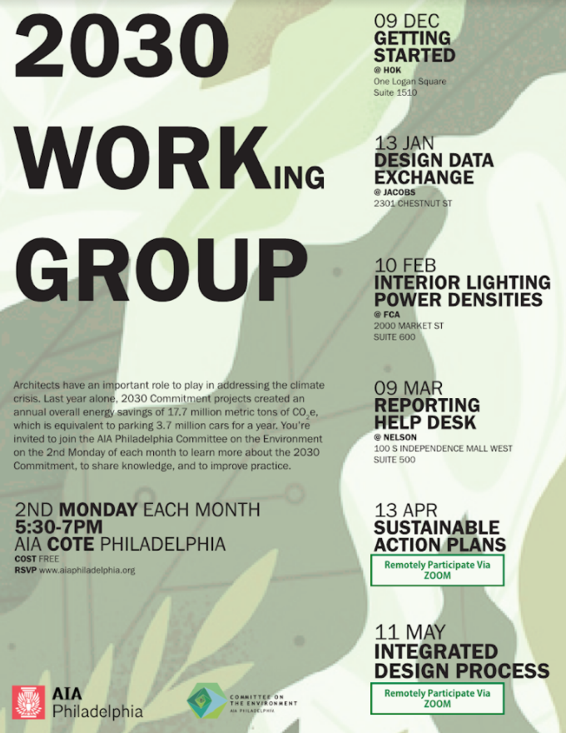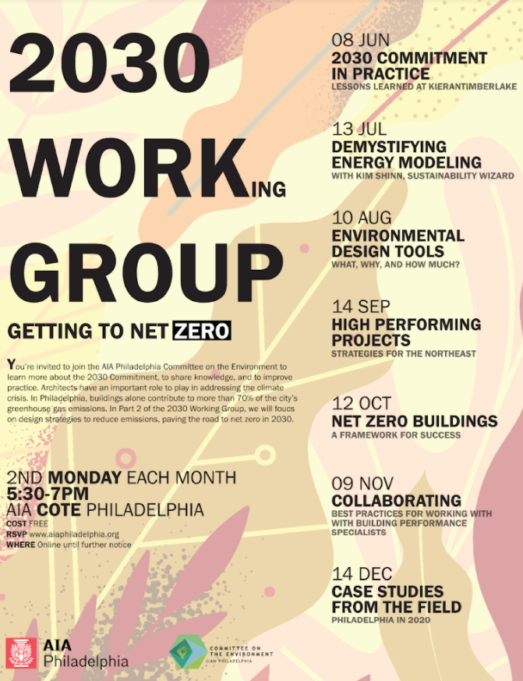
2019-2020 COTE Philadelphia - 2030 Working Group Flyers

Achievements:
Philadelphia COTE members leveraged its committee network to put together collaborative presentations for local conferences - on 2030 Commitment, on Zero Waste, and the on Top Ten Toolkit, among others. The committee structure lends itself to multi-firm perspectives, which is very useful in presentations.

The 2030 Commitment Working Group set ambitious goals of education and outreach to the community, holding monthly open sessions ranging from 50 to 75 attendees. These sessions have included local and national experts, and have successfully transitioned to online presence this year during the COVID 19 pandemic

The Design Awards subcommittee has worked for three years to implement a set of increasing requirements for all submissions to the annual chapter design awards. Each year the entry form has been expanded and adjusted based on feedback from previous years, and has incorporated the Common App framework along with a few additional customized responses based on committee feedback. This year the form was exported to AIA Pennsylvania and AIA Pittsburgh as well.

The Zero Waste Committee was formed to address first the waste reduction goals for events held at the Center for Architecture, with future modules to address company operations and other events. During the pandemic this group is finalizing its draft and adjusting it accordingly as the industry changes.
The Advocacy and Policy group has worked with other local advocacy groups, lobbying in Philadelphia and Harrisburg for sustainability related policies and legislation.
Environmental Justice group has initially focused on outreach to potential partners, elevating the voices of those already working on environmental justice within our local community, compiling EJ educational resources for our group, and attending EJ conferences to be more informed and aware.

Lessons Learned:
Start slowly. Start off by holding meetings, capturing interest, and adding activities that are most closely related to AIA initiatives. Branch out if there is sufficient interest.

Don’t reinvent the wheel. Find allies and complementary groups in your region to collaborate with rather than create a new initiative similar to others in the area.

Delegate!. Find subcommittee co-chairs to run separate initiatives - this will keep the activities generated in scale with the level of participation / level of interest of your group. It will allow it to ebb and flow with the available bandwidth and hopefully minimize burnout.

