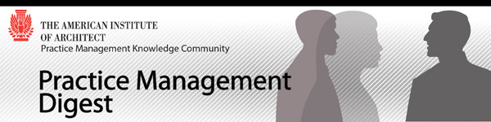

Advancing the Practice of Architecture | Summer 2013 Issue
As the Practice Management Knowledge Community, our mission is to advance the practice of architecture through discovering, generating, organizing, and sharing insights, resources, and tools that enable architects to practice more effectively.

Features
________________________________________________________________________________

Letter from the Editor
By Deborah M. DeBernard, AIA, NCARB, Architect AIBC, LEED BD+C

In one of my past positions, I found the need to overhaul the existing annual review process that had been in place for decades. It had grown to be the worst example of providing feedback to employees where supervisors spent the least amount of time possible writing an evaluation for the people that reported to them, and those being evaluated were simply emailed the completed form. The entire process needed a serious make-over that looked and felt entirely different from its predecessor.

After collaborating with the senior managers, we developed a process that included time for self-evaluations, goal setting, joint reviews when employees had more than one supervisor, follow-up activities as needed and a meaningful way of communicating and documenting all that transpired. Most employees had never been asked to complete a self-evaluation and wanted to use the previous (dismal) evaluation form format as a guide for what they should cover. We wanted entirely different results so we encouraged everyone to start in a completely different way. The advice for completing a self evaluation was simple; it needed to fit on one 8 1/2” x 11” piece of paper and if words were chosen as the medium, the font could be no smaller than 10pt.

There was more than one person who thought this was a crazy idea but the rest of us waited impatiently for the results, hoping that our experiment would bear the hoped for fruit.

We were justly rewarded. The self-evaluations were amazing. They were filled with personal stories that supervisors needed to hear, aspirations that had previously not been expressed, and experiences that were important to the employee but had gone unnoticed by others.

The reason to mention this is to draw a correlation between that experience and the one thrown out to emerging professionals in this summer edition of the AIA PMKC Quarterly Digest. I asked, “What would you like other members of the profession to know?” I tried hard not to offer more guidance other than it should be between 800-1000 words and that I wanted an image that related to the article. With that very open call for ideas, I waited impatiently for the results. And again, the results are amazing. Our contributors have shared the difficulties of their professional choices, their aspirations for design, ideas for transforming the professions and programs that are working to bring students and interns into professional practice. I hope you will enjoy this edition as much as I have.

- We begin with Jim Draheim, AIA, who recently took on a new position leading the architectural practice at Dewberry. He has been busy getting oriented, as you can imagine, but has taken the time to ask his staff what they want him to know. He shares their thoughts. Read...
- Royce Brown, Associate AIA brings us on his personal journey towards registration. In “Finishing the Race” Royce offers valuable advice to architectural students and anyone who has trouble achieving their goals. Read...
- In “A Profession at a Crossroads”, Kathy Denise Dixon, AIA, NOMA, LEED AP BD+C, NCARB challenges the readers to consider some unorthodox yet interesting possibilities for the future of the profession. Read...
- The Ft. Worth firm of Hahnfeld, Hoffer, Stanford created the Future Leaders of the Company (FLOC) group to provide a forum for young professionals to express new ideas to the firm from the point of view of the advancing architect. Four members of the FLOC have collaborated on “A Role for the Future”. Read...
- If you have not been to Atlanta yet, you will find one more reason to put it on your “bucket list” after reading about some ideas that Shelly Anne Scott, AIA, NOMA, LEED AP BD+C has put into place in her article “A Six Year Journey of Community Involvement + Architectural Development”. Read...
- While some practitioners complain that some architectural programs are not preparing graduates well for the practice of architecture, Marie Zawistowski, Architecte DPLG and Keith Zawistowski, AIA, GC are doing something about it. “Designing Practice - Business Acumen and Entrepreneurship for Architects” describes their program at Virginia Tech. Read...
- Jason Pierce, AIA and a member of the PMKC Advisory Group has some ideas for those struggling to retain staff as the economy improves in “Losing Emerging Professionals to Your Competition”. Read...
- And finally, Brian Dobry, in “Help for Getting Your Architectural License”, describes a program that he and three others have initiated at MulvannyG2 Architecture. Read...

For those that would prefer to download the entire edition: simply click here and take a single PDF with you for ease of printing and reading later.

Upcoming Issue

Beginning in June I am taking a staff position with the AIA as the General Manager - Contract Documents. So my brief stint as a volunteer with the AIA PMKC Advisory Group and as the editor of the AIA PMKC Quarterly Digest has come to an end. As you are reading this edition, I am finding my way around the headquarters building and getting to know the incredible Contracts Document team. Please stop by to see me if you are in Washington DC or send me an email at deborahdebernard@aia.org if you have suggestions for anything related to AIA Contract Documents.

I know you will join me in welcoming and supporting the new Digest Editor once appointed. The next edition will examine architects “doing good”. If you fit the criteria (or know someone who does) and have something to share with the AIA PMKC Community, please contact Donald Simpson at dsimpson@kpsgroup.com The deadline will be here before you know it so send Don your thoughts this week.

Out of the Mouths of Emerging Professionals
By James R. Draheim, AIA, LEED AP BD+C

I recently took a new position as the President of Dewberry’s architectural practice. Dewberry is an 1800-person firm with highly skilled architects, engineers and consultants working on technically complex, challenging projects all across the United States. In my part of the organization, I have 175 professionals that focus on courthouses, civic projects, libraries, hospitals, schools and prisons. It is a very broad marketing effort with tens of thousands of projects in our portfolio. There are staff members who have been with the firm for more than 30 years with cavernous institutional memories. And then there is me with 25+ years’ of prior experience but almost no time with Dewberry - the epitome of the new kid on the block - and so much to learn.

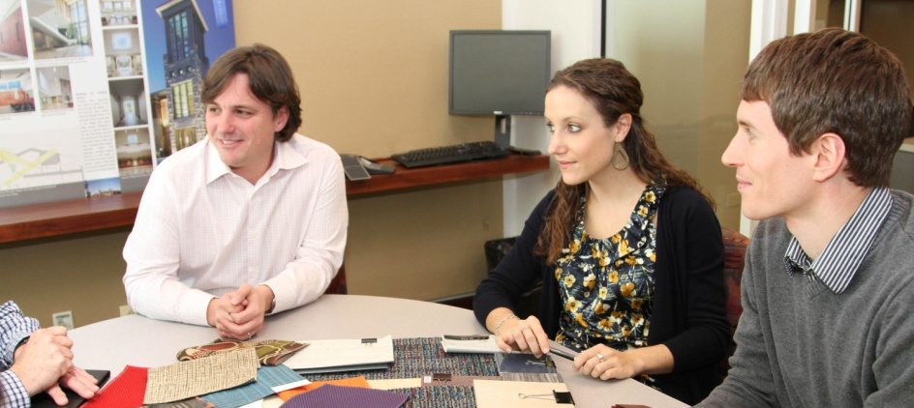
I spent the first few weeks on the job trying to absorb information about our clients, projects, processes, technology, and policies but the most important aspect of this education was building an understanding of the people that work here. I have had a lot of discussions around the firm but I recently had a chance to ask some of our emerging professionals what advice they would like to offer me and to other more seasoned members of Dewberry. What came back was a wonderful collection of ideas, some offered to the original target audience and other ideas offered to their peers. I would like to share some of these thoughts with you:

The value of an architect - “I have heard many emerging professionals say that architects can sketch, draw in CAD, create 3D renderings, build models, and understand construction. I suggest we describe ourselves in other terms. We are critical thinkers, planners, creative minds, solution providers, graphic specialists, and problem solvers. We did not complete four or more years of education to only be able to draw, and we certainly have the ability to do more than operate software. Understand your value and communicate it to each other and to clients.”

Build Mutual Respect - “The best way to foster respect from the Millennials is to meet them one at a time at lunch, or at the office. They need a level of personal attention and the most effective way to do this is in person. Don’t text, don’t e-mail. Simply talk and do a few things together. While this may sound like a mentorship, it is not. It is building mutual respect.”

More Architects Should Lead - “One of my biggest pet peeves with others in our profession is their constant abdication of the leadership role. Let’s put an end to it. Recognition, respect, and compensation come with confidence and leadership. Become knowledgeable, know your value, and speak with conviction. Focus on strengths and lead the project team.”

Get to Know People - Not a Generation - “In order for the generations to get along, and therefore successfully transition, people need to spend time together out of the office. This time out of the office could be during the work day reviewing construction, or over a leisurely lunch without a business agenda or even Happy Hour. This time is needed to tell stories; to share a perspective and life experience. In this way, time fosters understanding of the person. While understanding a particular generation is nice, it is really all about the individual and their perspectives and priories.”

Do Not Lose that Radical Spirit - “Our design education teaches us to embrace radical or disruptive change, yet that spirit is often forgotten as we are hampered by the “realities” of everyday design. Do not lose that radical spirit…it is how we will grow as a profession. BIM is not the answer to everything, just as AutoCAD was not. Think big, and do not get bogged down in the tool of the week.”

Make Suggestions - “Keeping in mind your firm’s leaders and company culture, navigate as necessary to inspire change. You have new ideas and energy that more experienced staff may not. Make suggestions. Just because something has been done for a long time, does not mean it is the best way to do it. Be respectful of the past, but do not write off the opportunity for improvement.”

Collaborate with the environment - “Reading, attending seminars, lectures, or lunch n’ learns are all perfectly acceptable, viable, and even necessary means of educating ourselves with regard to design or any subject of interest. However, we must not limit ourselves to these, more academic forums. Design, in particular, deals with how we relate, via our senses and emotions, to the world around us. And the world, through the order and beauty of the natural (as well as built) environment, has so much to teach us—so much that we can learn from. Successful design involves a kind of collaboration with the world which requires that we be in tune with it—in tune with it in such a way as can only be achieved by getting out in the world and taking it in—in all its beauty.”

Think like the ‘higher-ups’ - “Just this week I heard a colleague say, ‘I don’t know much about that because it was always handled by the higher-ups.’ I challenge all of us to think like a ‘higher-up’ every day. What would you do if you were leading your firm? If you hope to make important decisions in the future, you should consider them today.”

Be the Change - “I encourage all emerging professionals to be the change our profession needs. We need your ideas, your energy, and your enthusiasm. With ambition, the right mentality, and the guidance of more senior colleagues, our generation can transform the future of our industry.”

Conclusion
I am encouraged by the level of discourse I am hearing. We need to ensure that we have good listeners, thinkers, planners and activators that can embrace these concepts, turning them into a brighter future for those professionals that one day soon will have ‘fully emerged’.

About the Authors:

James Draheim, AIA, LEED AP BD+C, is president of Dewberry’s 175-person nationwide architectural practice and has more than 25 years’ experience working on significant healthcare, higher education, and science and technology projects, in both the public and private sectors. Dominic J. Spadafore, AIA, LEED AP BD+C, NCARB, RID is a project manager focusing on sustainable design in the Tulsa office of Dewberry. He holds a M. Arch. From Texas Tech. Chris Waible holds an MBA and M. Arch. from the University of Illinois. He is Director of Business Development in the Peoria office of Dewberry. Eric Vogt, Associate AIA, is an intern in the Tulsa office of Dewberry having graduated with a B. Arch from Oklahoma State University.

Finishing the Race
By: Royce Brown, Assoc. AIA
Three men run a cross country race. The first guy takes the recommended path with barely any detours and minimal distractions. He gets to his destination relatively quickly. The second guy takes a shortcut but this path has more obstacles than the recommended route. He reaches his destination a few hours later than the first guy. The third guy wants to take the recommended route but cannot because his GPS redirects him several times before he reaches the final destination a day later. While you are waiting for the punch line to what sounds like the beginning of a joke, think about how real this story is for many students wanting to become architects.

Like many architectural students, I had the ambition to become a renowned architect. My ‘race’ began with the great fortune of landing positions with some terrific firms over a seven a year period after finishing school. It was not until my second year though, while working as a construction administrator for HOK, that I realized my path was different than some of my co-workers.

I discovered that my current degree was not from a National Architectural Accrediting Board (NAAB) accredited university. I had a four-year Bachelor of Science in Architect Technology degree. I was extremely discouraged once I realized that my journey would be longer than I had expected. Then came the downward spiral of the architectural profession in 2008. I was not sure if I had the time or money to gain a professional degree. I was laid off for two years during the recession. I had a family to support and the job market seemed to be drying up before my eyes. I worked in many mindless jobs just to support my family and to stay on top of my increasing debt. I was exhausted from dodging phone calls about my student loans. It seemed like my education, money and experience were going down the drain. The feeling of failure began to set in and frustration reared its evil head in my daily thoughts.
It was a true battle within my mind but I learned along the way to push through it. First, I had to determine how important it was for me to be a registered architect. Was I willing to put in the additional time? What would I have to sacrifice? I decided to go back to school… to get back on course and finish the ‘race’. As a new husband and father, I knew that my personal time would be extremely tight. Yet it was my responsibility to my family to finish what I had started and let my self-discipline be a positive example. One of my mentors said it best, “Identify what makes you happy in life, make it the priority and aggressively do it. Do not let anyone or anything get in the way of that, including you”. The most important part of his advice was that last sentence. I could not make any excuses for myself that would lead to regrets. It became my responsibility to ensure that it would happen…not the firm’s…not my peers’…not my supervisor’s. It is my responsibility to finish the race and ensure my professional success.
My experiences have been valuable but I would not wish my path on others. I hope everyone is the ‘first guy’. To do this architecture students should:

- Become familiar with the National Council of Architectural Registration Boards (NCARB) requirements. Keep in mind that NCARB is the regulator of the architect profession. NCARB has created useful tools for intern that can lead them through the process of registration.
- Earn a professional degree (even if you have to go back to school). This is essential if you want to finish the race swiftly. This does not mean it will be easy but it will relieve some of the headaches of those alternate paths.
- Take the Intern Development Program (IDP) seriously. Should you be fortunate to work in a firm, be proactive with your supervisor to ensure you receive all the required hours for your NCARB record.
- Continue to immerse yourself in architecture publications, online education and design competitions. These additional tasks keep your skills sharp and mind focused on the goal.
- Take personal responsibility for your development. I have learned that the torch is not always passed willingly from one generation to the next. Sometimes you have to just grab it and run.

“The race is not given to the swift nor the strong but to he who endures until the end” - a truism that rings in my head when it seems that my goals are bigger than I can handle. As emerging professionals, let us continue whether the race is long or short, knowing that if there is anything to make time for, it should be to reach our goals.
About the Author: Royce Brown, Assoc. AIA, has an architecture degree and several years of experience in the field of architecture and construction administration, having worked in a variety of architecture and engineering firms in Maryland, Washington DC and his hometown of New York City. Currently Royce works as a Manager for Continuing Education Programs at The American Institute of Architects (AIA) where he ensures quality educations from providers around the country. He previously worked as a Specialist with the Emerging Professionals also at AIA, where he assisted in guiding other interns and recent graduates along the path to licensure.

A Profession at a Crossroads
By Kathy Denise Dixon, AIA, NOMA, LEED AP BD+C, NCARB

For the past couple of decades, I have heard the comment that the architectural profession is at a crossroads. Typically I hear this when discussing that another discipline has somehow encroached upon the traditional responsibilities of the architect such as interior designers or facility managers and thus our profession feels threatened about its future existence. Occasionally the comment is in reference to the relatively low salary that architects receive based on the number of years spent obtaining academic degrees, licenses and various certifications in comparison with other professions such as law or medicine. The “crossroads” comment is sometimes used in reference to the disjointed relationship between academia and the practice of architecture where it seems what is learned in school has little relevance to what architects do on a daily basis.

Do these reasons indicate that the architectural profession is fated to a death spiral that has been circling us for at least twenty years? Some people may ask, “After all this time, why hasn’t someone developed a solution to the problem? After all, architects are problem-solvers, right?” Architects do take a myriad of factors, criteria and obstacles and turn them into an aesthetic and functional design solution. Why have we not “designed” a better profession, if not for current practitioners, then for the ones coming after us?

Some Early Concepts

I say we can do this and should do this. So I want to present three concepts to help the conversation move forward. These are concepts that could be developed to craft a solid solution to the problem. But just like an initial architectural design phase, they need to be fleshed out and examined in detail to become a realistic opportunity. Most importantly they are an invitation to you to offer your thoughts on the subject.

Let’s Go Public - Have you ever thought what could happen if architecture firms were more readily traded on the stock market? Only a few very large architecture firms are actually traded today. Why is investing in the raw materials for buildings seen as lucrative while the creative use of those materials to shelter people in offices, hospitals, fire stations and homes is seen as less of an investment opportunity? Publically-traded companies can receive an influx of cash from their stockholders which, if applied wisely, can be used to invest in the firm, seek and obtain projects and otherwise grow the business. But most architecture firms are too small to be publically traded. So, is there a way that we can design a new paradigm that would enable groups of firms to be traded? Imagine if firms had the ability to leverage the company’s capital to take part in or even develop their own construction projects without needing to rely on a commission from a client to exercise its design expertise. The architecture firm collective would become simultaneously owner, developer and client.

I Always Wanted to be in Pictures - Are there other individuals or industries that can use the information that an architect creates beyond building owners? Just as Hollywood uses set designers to create physical environments for movie storylines, the architect could sell virtual environments for upcoming movies. Imagine if architects could capture the digital collection of buildings in their portfolio to design a virtual interior, town or city and sell them to movie producers or others.

The Ultimate Recycling Project - What if commercial architects took a page from the playbook of residential architects and repurposed previously completed designs for new clients? Does every job need to be designed “from scratch” or could a client select from a catalog of previously built commercial projects for site adaptation and completion? Is it sacrilege, to suggest that a client could have a more economical option and the architect is able to earn revenue from a product as well as a process? Big box stores and companies like McDonald’s Corporation have been site-adapting prototype plans for decades. Could this model also work for other facilities such as office buildings?

The Challenge

If the architecture profession is at a crossroads, are we concerned enough to design a solution to the profession’s problems? If so, let us take the challenge to create a future for ourselves and for future generations of architects that everyone is eager to pursue.

As individuals, architects are innovators and have incredible vision for the physical environment. Yet as a profession, we are slow to change and suspicious of any non-traditional thoughts, regarding what architecture is…or could be…or will be. Meeting this challenge require at least examining new paradigms…paradigms that forsake tradition and accept some risks or apply new business models perhaps taken from other disciplines. Only then can the profession make a decision about which path will eventually lead to a better place for future generations of architects.

About the Author: Kathy Denise Dixon, AIA, NOMA, LEED AP BD+C, NCARB is the current President of the National Organization of Minority Architects (NOMA). She is in private practice (K. Dixon Architecture, PLLC) in the Washington D.C. Metropolitan area and is registered in MD, DC, VA, GA, and NJ. After graduating from Howard University's School of Architecture (1991) with a B. Arch degree, she matriculated from the University of California, Los Angeles, Graduate School of Architecture and Urban Planning with a Master of Arts in Urban Planning degree (1993). Ms. Dixon worked for the U.S. Department of Justice - Facilities Department, McDonald's Corporation Real Estate Development Department, Jacobs Engineering, McKissack and McKissack, and Arel Architects prior to starting her own firm. Currently she also works as full-time faculty at the University of the District of Columbia, Department of Architecture.

A Role for the Future
By Cole Lorenz, Assoc. AIA, Ping Cai, AIA, Jeff Sloan, and Collin Ward

There’s a group of us who regularly gather to talk. We discuss a diverse range of topics, such as work environment, delivery methodology, client relationships, business models…topics that concern us in terms of how to survive and even thrive both as a firm and as emerging professionals in a time of rapid technology development. Our discussions generate heat. We do not always agree on what is best for us individually. However, when pressed harder, it is the existential angst for the profession as an entirety that wins out. Here are some different takes:

Our Evolving Roles

As the role of architect has shifted from that of ‘master builder and craftsman’ to ‘the intellectual architect’, the degree of control an architect enjoys has slipped, as well as the perceived overall usefulness provided to a client. Over time, architects have chosen to disassociate themselves from the construction field, and given up that risk and liability (control and power) to the contractors. This decrease in control of the project should lead us to ask, “What’s next for architecture?”

Current generations of architectural graduates are less schooled in the art of construction. Rather, our courses focused more on critical thinking and problem solving. A typical design studio may ask students to graphically analyze a piece of jazz music, re-map that analysis using various prescribed concepts, create a rhythmic collage based on said analyses, and eventually transform that collage into a logical sequence of 3-dimensional spaces. While the skills learned from this type of exercise do not inform a student about how to construct a building, they train the mind to attack a problem in an unorthodox way opening the realm of possible solutions to questions that designers deal with daily.

However, both the shift in training emphasis and the shift away from a driving role in the field may be setting the stage for a future where the architect’s role is transitioned to that of a creative or managing consultant, with the burden of execution and liability completely lifted from their shoulders. With the technology of building systems becoming increasingly complex, and subcontractors detailing these systems ever so intensely, today’s architects spend an inordinate amount of time researching pre-manufactured products and systems and ensuring that there is no conflict among consultants’ work. It is not too hard to imagine that architects are becoming the ‘creative coordinator’, assembling buildings from a prescribed kit of parts, laying to rest the concept of ‘the master builder’.

Not All Doom and Gloom

That may well be an inevitable trend; yet there have always been and will always be ‘Architect t as Visionary’ and ‘Architect as Craftsman’. From the activist to the maker we all belong somewhere along that spectrum. Regardless of the realities, we continue to enjoy a utopian reputation that many people carry when thinking of an architect. Architects are here to make a better place, pure and simple. That reputation, however, also places a distance between architects and their clients. Engineers and contractors, inhabiting seemingly more practical roles, are the parties people are more likely to turn to for service in the current framework of the design and construction industry. Should we compete by marketing ourselves in more definable terms? Or do we try to make our value more evident, by living up to our reputation and creating better spaces and places? Can these spaces and places be more than merely functional, code compliant, and pleasant? Can these spaces and places inspire and make people optimistic about this world?

The pedestrian bridge on the Trinity River in Fort Worth, designed by Rosales + Partners and completed last year, is a joy to behold and experience. It is at once subdued and glamorous, bare-boned and polished, so unified with the place yet so unburdened by the urge to conform to the vernacular. It speaks to the optimism of the people who came together to realize it. For the moment when you are around it and on it, this pedestrian bridge lifts your spirits ever so buoyantly.

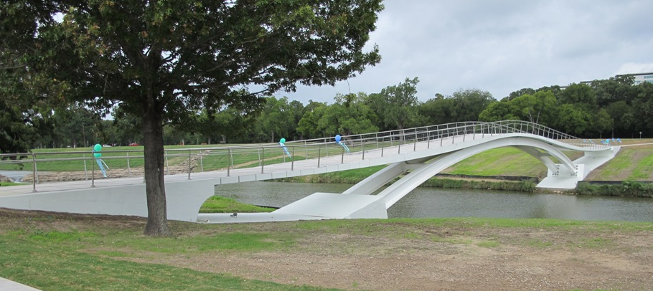

Shared Vision

The designer of the bridge had a good client. They shared a vision. More often the architect-client relationship revolves around presentations and the rejection or the approval of the presentations. We pitch ideas to them, fall short, and bemoan their lack of a sophisticated sensibility. At the same time clients think our job is to dictate the look of a project (and little more) and complain when we move the conversation to a larger potential. With little understanding of this larger potential, clients can see us as whimsical or simply as somebody who wrangles the consultants.

Some architects try to convince clients that they know what is best for them, when what we really need is a partnership with clients. We need to work with clients to develop their vision by soliciting their opinions and most importantly, let them behind the curtain so they become a part of the design process. When we can demonstrate to clients that their priorities are our own we will have the opportunity we crave to truly shape a project.

Beyond the Client

If we accept the premise that architecture is the expression of the technological capabilities and the aesthetic sensibilities of a given society, we know that it’s necessary for any built environment to accommodate not only the specific needs it was built for and the needs of the society as a whole. How do architects bridge the gap between these two aspects when they are at odds?

This goes beyond a mere partnership with our clients and delves deeper into understanding the impact our creations will have upon not only the end users, but also the community and the larger society. This larger picture may not always be clear in the vision of the client, and the responsibility of clarifying it falls on the architect. Take for example Louis Kahn’s Trenton Bath House. On the surface, the programmatic requirements appear to be quite simple; provide an entrance and changing rooms for the Trenton Jewish Community Center in Ewing Township, New Jersey. That seems easy enough. But what Kahn did was to create a piece of architecture that embraced the social, cultural and physical needs of this post-World War II Jewish community by accommodating the cultural functions that replicated the social structure of the synagogue. In the end, this fairly miniscule project has grown to represent far more than its original, simple programmatic requirements. It functions as the visual expression of the society at a certain point in history.
This concept of architecture as the embodiment of who we are and what we value mandates that we as architects understand not only the needs of our clients but also the needs of our community, not only where we fit within the current framework of society, but also that of our past and of the future.

Conclusion

Quickly disappearing are the days of the architect working his or her magic in a mystical, secluded place, only to emerge with what they believe the client “should” want. While our convictions may not coincide, we all agree that as architects, our goal is to enable everyone to envision a more relevant and meaningful built environment.

About the Authors - Cole Lorenz, Assoc. AIA, Ping Cai, AIA, Jeff Sloan, and Collin Ward are part of the Future Leaders of the Company (FLOC) team at the Fort Worth, Texas architectural firm, Hahnfeld Hoffer Stanford. The FLOC provides a platform for the firm’s young professionals to exchange ideas. It also serves as an open line of communication between the younger members of the firm and the management, ensuring that the firm, as a whole, remains knowledgeable about current trends from the point of view of the emerging professional.

A Six Year Journey of Community Involvement + Architectural Development
By Shelly-Anne Scott, AIA, NOMA, LEED AP BD+C

Staying Motivated

At a very young age I learned that you have to set goals and sometimes fight against all odds to achieve them. My goal was to become an architect. I realized how hard it would be to attend a university because I just could not see how a US, out-of-state tuition would ever be affordable to my single-parent Caribbean family. Regardless, I attended a college fair in Trinidad, where a university admissions coordinator helped make the process easier and gave me a chance to use the work study program to help pay for my tuition and a special extended repayment plan to make attending university possible. Even then it was not a linear process for me as I paused my studies after each degree to gain professional experience and add much needed financial resources. I would start one year not knowing how I would pay for the next. Through sheer determination, I managed to get there by searching for every opportunity to find scholarships, discounted housing, cheaper supplies…whatever I needed to complete my architectural degree. After graduation in 2007 I moved to Atlanta - a young, vibrant city rich with possibilities.

Networking within the Community

In Atlanta I sought new opportunities to grow, learn and share by participating in several religious, social and professional activities. Before each weekend I selected from a myriad of options including volunteering at art and music festivals, building with Habitat for Humanity, hiking or simply exploring the city through photography. One Saturday I showed up at an AIA Atlanta tour of some townhouses on Ponce de Leon Avenue. I enjoyed the free architectural tour so much that I have since served as Chairperson, Public Relations Chair, Tour Coordinator and Tour Photographer for the committee which brings behind the scenes architecture to the public. It was a wonderful opportunity to challenge myself to be in a leadership role and motivate my peers to participate.

Continuous Growth and Development

I have since participated in events with the Young Architects Forum (YAF), Networking Women (nWW) and attended several AIA National Conventions. In Boston I attended the convention as a Boston Society of Architects scholarship winner (which enabled young professionals an opportunity to attend). I was able to meet and network with the other scholarship recipients from all across the US.

In one session, several interns gathered to hear about Habitat for Humanity from its founder, Millard Dean Fuller. It was inspirational to hear the story of how a small idea blossomed into a successful international non-profit organization reminding us that we can all make a difference. In a night-to-remember closing gala at the Boston Public Library, we were privileged to witness then AIA President Marshall E. Purnell, FAIA being presented with a copy of the AIA certificate of the first African American AIA member, Paul Williams, FAIA by his granddaughter Karen E. Hudson. On my return from Boston, I was already finding out about how I might attend the 2009 convention in San Francisco.

I volunteered at the San Francisco convention in exchange for free registration and convinced two of my friends to do the same. I attended sessions discussing how we could adapt designs to the culture and locale, women in architecture and socially responsible architecture. I discovered that I do not want to get caught up in the excitement of a multi-million dollar project and lose focus on what architecture is about for me….helping people and building communities, especially those who need it most. I want to use my knowledge and passion to challenge myself and others on even the smallest of projects.

I understand that interns and young architects sometimes get lost along the way or that things never seem as great as imagined or they might not get to do all the things they want to do now. Growing and learning never seem fast enough. Yet the journey is worthwhile. After much learning, growing, studying and preparation, I became a registered architect in early 2010.

Am I there yet? Absolutely not! I am still climbing on the cliff face to a mountaintop that I know is there but cannot always see through the thick clouds of the recession, adversity and some colleagues who try to place limits on my growth. This recession has been a blessing and curse to many as some have had to explore hidden passions and alternative paths. In spite of the reduced opportunities, I continue to find avenues and means to use architecture and design to build the community.

Find Your Place in the Community and Combine it with Your Passion

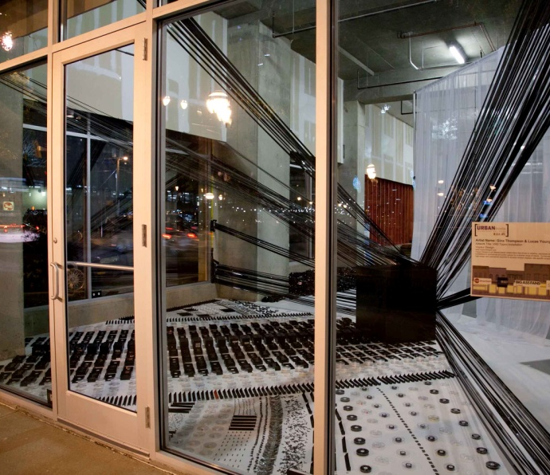
As the current Public Awareness Director for AIA Atlanta, I envisioned creating an exhibit which would bring together local artist, architects, sustainability champions, real estate professionals, property owners and the local community. Last April, I reached out to the AIA Atlanta Board and to my network to explore the feasibility of creating a series of ‘pop-up’ galleries for Atlanta, similar to other cities. After a year of planning we launched AIA|ATL URBANfronts Storefront Galleries, an exciting community outreach and educational design exhibition, which took place from April 7 – 20, 2013, in midtown Atlanta.
Artists: Gina Thompson & Lucas Young

URBANfronts Storefront Galleries activated empty retail spaces and lobbies by temporarily altering the urban landscape to reflect the visions of up‐and‐coming artists through visual, textural, audio and kinetic movement mediums. Cultural destinations were created which increased the foot traffic in these areas offering opportunities for discovery, revelation and evolving visions through art, design, architecture.

URBANfronts Storefront Galleries was an expression of AIA Atlanta’s commitment to public education and awareness and it provided a platform for design dialogue within the community. It was planned, executed and promoted by a very small committee, with representatives from the design, construction and real estate industry including National Organization of Minority Architect (NOMA); Networking Women (nWW); US Green Building Council (USGBC) and Commercial Real Estate Women (CREW).

The property owners welcomed the idea of having a visually stimulating display in their otherwise empty storefronts. Some of our property sponsors were Tishman Speyer, The Loudermilk Companies, Dewberry Capital & Jamestown Properties. Our main event space of over 9,000 square feet, vacant for five years, was transformed into a great exhibit space with seating vignettes and art displays of photography, sculpture, furniture, and paintings. After two weeks, three big events, five property locations and 30 artists later…we received a lot of great feedback for URBANfronts from the entire community. People have already started taking about the next event.
Artist: Ted Freeman

Dream, Plan and Execute!

You can infuse your passion, commitment and energy to help build our community using your architectural education in traditional and non-traditional ways. So do the research, reach out to stakeholders in the community and network with everyone to see where help is needed. Your doctor, dentist or mail carrier knows someone who knows someone who needs your help. I am encouraged and I want you to be encouraged too.

About the Author - Shelly-Anne is from Trinidad & Tobago and studied Interior Design at Miami International University, completing her Bachelor degree in Jamaica at the Caribbean School of Architecture, University of Technology and completing an M.Arch degree at Florida A&M University. She has over eight years of experience in architecture and design and has worked in Trinidad, Barbados and the USA.

She is currently employed at Leo A Daly and serves as the Director of Public Awareness for the AIA Atlanta Chapter. She has been involved with the execution of several new initiatives like the 1st Young Architects Forum Photography Competition, Under-construction Tours for Architects and the Architecture Enthusiast, the first annual joint publication of all the subcommittees for the chapter Design Equilibrium and the first ever storefront galleries exhibition, URBANfronts, utilizing empty retail storefronts in Midtown Atlanta.

Designing Practice - Business Acumen and Entrepreneurship for Architects
By Marie Zawistowski, Architecte DPLG and Keith Zawistowski, AIA, GC

Architectural education has been the subject of fierce debate for centuries, leading to major reforms, counter reforms, and countless approaches to pedagogy and curriculum. Continually driven by both socio-economic context and the evolving aspirations of architects, the profession itself is ever-changing. In this light, the academic community has a responsibility to adapt, but more importantly an opportunity to define possible futures for the profession.

Unfortunately, many recent architecture graduates feel ill-prepared for the practice of architecture. Concepts such as marketing, communication, management, value engineering, contract negotiation or administration seem irreconcilable with the image of the creative genius that architectural education has constructed for them. Paradoxically, practicing architects are keenly aware that mastering these issues is fundamental to achieving high quality architecture.

The pervasive perception among many academics and legislators is that “practice” is a technical competence, acquired with some basic on-the-job training. This fundamental misconception is compounded by the division between “starving artists”, who refuse to think of architecture as a profitable pursuit, and “business men”, who trade their design soul for profits obtained as service providers. As a result, professional practice is often placed on the sideline of our education and taught as a prescriptive lecture-and-test model. Because professional practice is marginalized in academia, schools often simply hire business savvy practitioners to teach the course. In effect, we take a group of individuals who have been inspired to be creative problem solvers, make them read an 800-page how-to manual, lecture them about accepted norms, then scratch our heads about why the vast majority of them tune out!

Designing Practice, a required three-credit professional practice seminar at Virginia Tech's School of Architecture + Design, was created to counter this one-size-fits-all approach and to circumvent the ambivalence to business that this approach has engendered among architects. Instead of patronizing the business of architecture as a necessary evil that must be endured, the course introduces practice as a design problem - like any other.

Design Thinking

The premise of the Designing Practice course is that there is not one way to practice architecture. Students are encouraged to define the nature of practice for themselves, making decisions and value judgments about quality-of-life, career aspirations and long-standing professional conventions. This is not the “Provisional*” model of architects working “out of the box” in allied disciplines. Rather, it is a fundamental rethinking of how architects practice architecture, and a challenge for students to design their own approach.

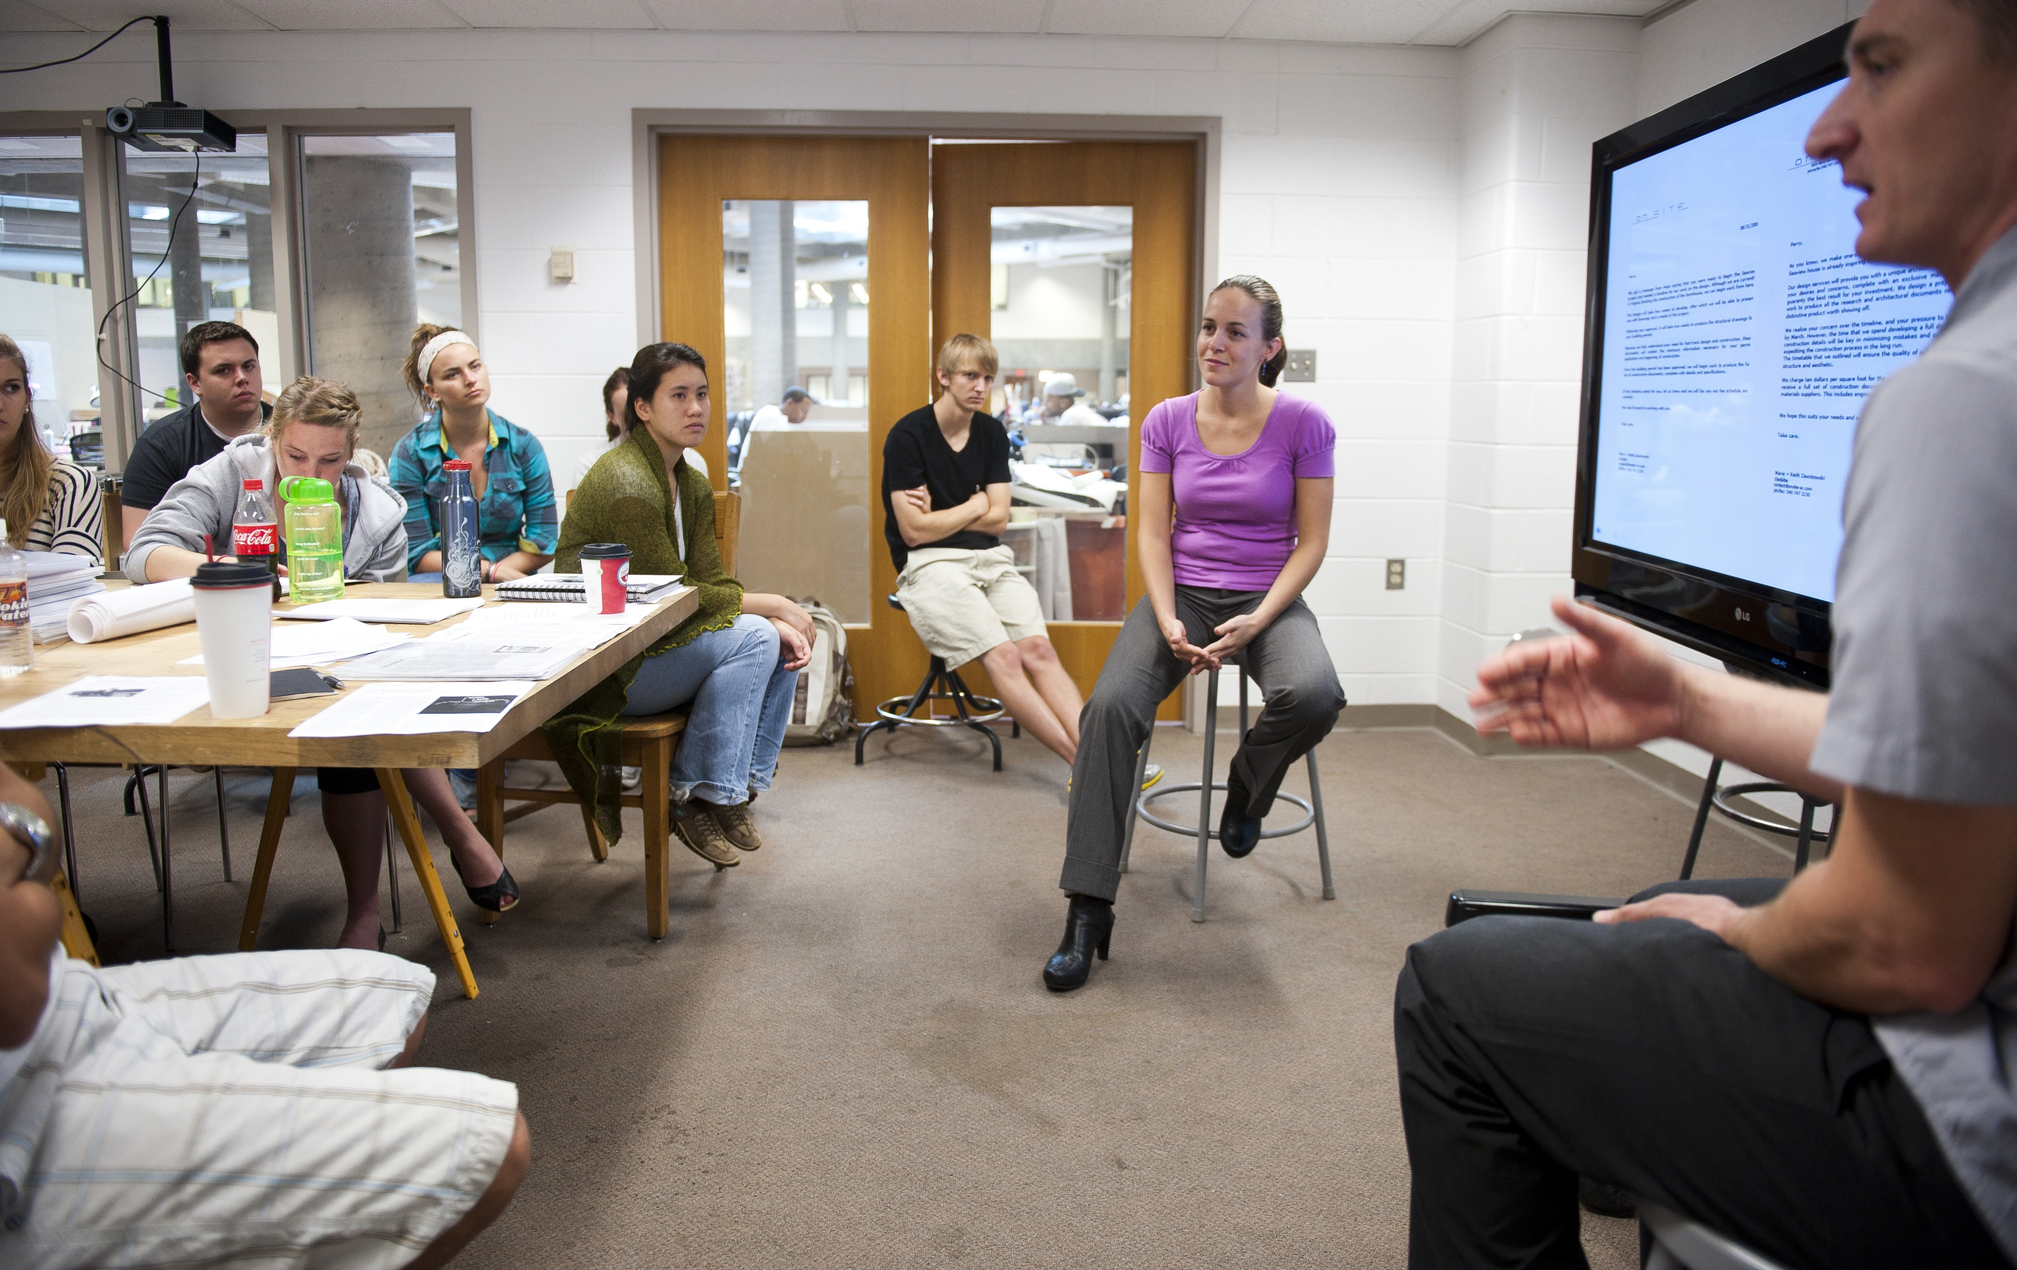
Designing Practice is a one-semester course that meets for three hours, one day each week. Each week is devoted to a topic, such as “what is an architect?”, “managing risk”, “people skills” or “getting paid”. Each meeting contains a review of assigned readings (usually from blog posts or professional journals), a round table discussion with the faculty or an expert guest, and digital media content used to illustrate and debate the subject matter. These case examples range from filmed interviews with the principals of prominent firms to video clips that reflect cultural perceptions and stereotypes. To this end, it is not uncommon to stumble upon the class laughing uncontrollably at an excerpt from the popular sitcom How I Met Your Mother showing “Ted Mosby, Architect” as he competes against a "Swedish Architecture Collective" for a coveted commission; or exhaling loudly at the behind the scenes perspective on client management from advertising master Don Draper in Mad Men. Designing Practice embraces contemporary media as a powerful lens into how society (and perhaps students) views architectural work and its role. This insight proves a valuable sounding board for students as they imagine ways to deploy the tools of business in furtherance of a successful and meaningful practice.

The core of the course is a practice mockup - a design exercise in which the students are asked to critically apply the curricular content by conceiving their own virtual architecture firm. Students define the scale and type of practice they envision and the scale and type of projects they plan to undertake. They reflect on questions such as management structure and office organization through the design of the firm’s work space, they brainstorm issues of branding and advertising through the response to a virtual Request For Proposals of their invention, and they wrestle with the impossible math problem of how to keep the lights on while balancing work load and payroll through the analysis of operating costs with spreadsheets and graphs. Design studio style pin-ups are held at regular intervals throughout the semester to evaluate progress and to share ideas. In this environment, reviews are led by students, and faculty members are simply advisors who bring resources to the discussion and refocus or encourage as needed. Students react to propositions developed by their peers, and faculty positions matter as much or as little as anyone else in the room. This laissez faire approach allows for exploration and innovation, which can reach beyond the faculty’s knowledge, and is therefore not limited by it.

Operational Creativity

As students progress through the Designing Practice course they begin to notice that the architects which they revere for the quality of their design work all have sophisticated practice models defining key roles within their respective firms, the number and kind of projects undertaken and even the way they and their staff dress. Everything is calculated, coherent, and facilitates a particular kind of work and working.

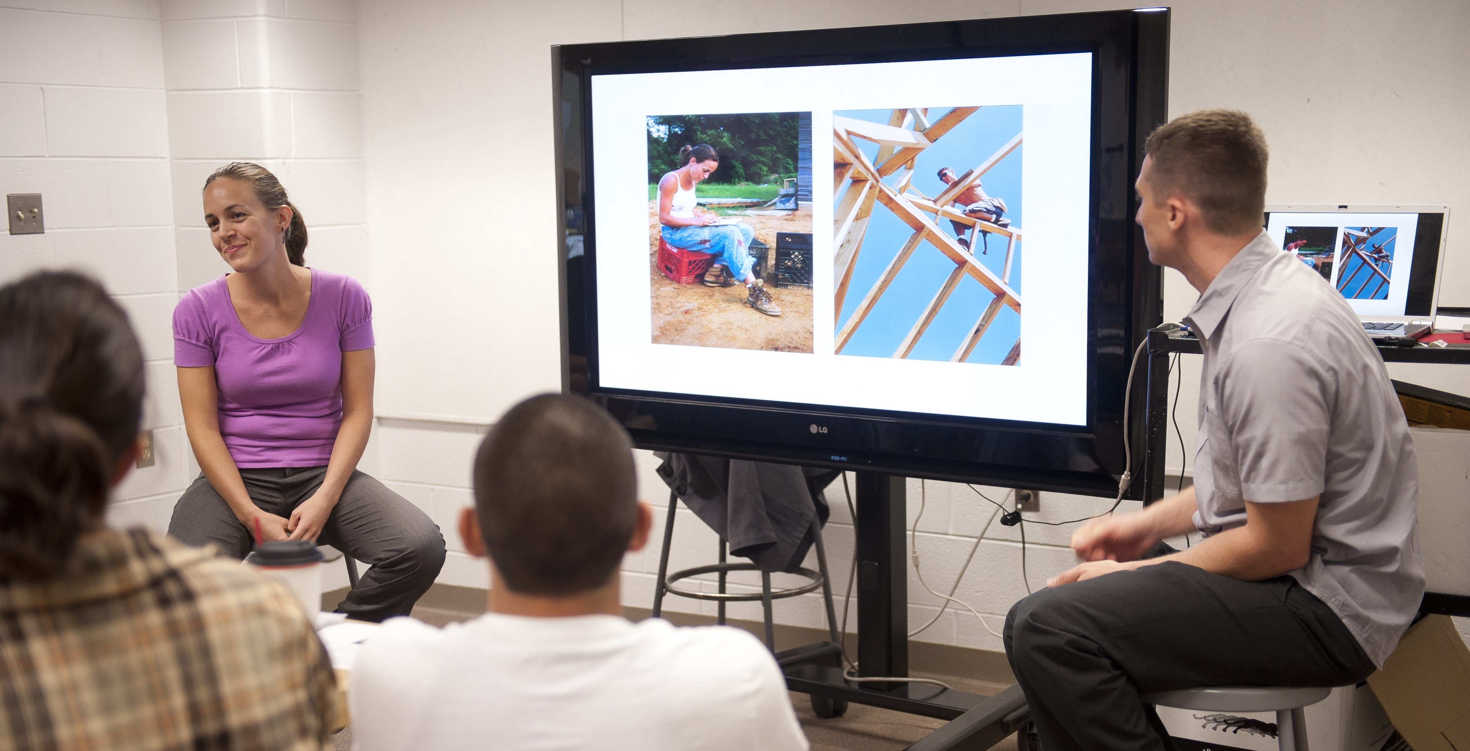
The practice mockup challenges students to focus on the details that can transform a naive whim into a carefully considered strategy. From a mobile design and fabrication barge visiting exotic port cities to a strategic investment architecture firm working at risk, from a for-profit/non-profit collaborative to a corporate architecture franchise, the range of aspirations is broad and optimistic. The most successful practice mockups are produced by students who come to understand that their creativity can be used to develop a unique approach to the business of architecture, and thus sustain the quality of life to which they personally aspire, while making architecture on their own terms.

As architects, we are trained to look critically at all things and to shape them into what they might become. The imperative of Designing Practice is to inspire architecture students to design the future of their profession.

*Provisional – Emerging Modes of Architectural Practice USA, Elite Kedan, Edited by Kedan, Dreyfous and Mutter, Princeton Architectural Press, New York, 2010.

About the Authors - Marie and Keith Zawistowski are partners in teaching at Virginia Tech's School of Architecture + Design, in practice at OnSite and co-founders of design/buildLAB and the Designing Practice course at Virginia Tech. Both OnSite and the design/buildLAB have been recognized with numerous regional, state, and national design awards. The Zawistowski's are the recipients of the 2011 NCARB Grand Prize for the Creative Integration of Practice and Education in the Academy and the 2012-2013 NAAB Education Award for Best Practices in Design/Build Education. They have been included in the Public Interest Design 100: The top 100 Individuals and Teams Working at the Intersection of Design and Service and have been featured in prominent publications such as Architect Magazine's "AIA Voices" and Metropolis Magazine's "Observed".

Losing Emerging Professionals to Your Competition
By Jason Dale Pierce, AIA

As the architectural billings index (ABI) rises and the profession slowly recovers from the recession, firms across the country that have successfully weathered the past five years have changed. Regardless of whether firms have reduced staff and become smaller or been acquired by another firm and become larger, most, if not all, are thinking differently on how they do business. Marketing, project staffing, benefit packages, billings, project delivery methodologies are all issues that firm leaders are tweaking (or overhauling) in order to remain viable. There are so many pressing concerns that firm leaders are responding to. It is easy to see why staff development and staff retention, specifically with emerging professionals, is getting less attention than needed.

Background

It is almost expected that architects will change jobs several times within their career. In fact, it is not uncommon for today’s emerging professionals to change employers three or more times within the first few years after graduating. There are some understandable reasons for these employees to change firms, as they seek to experience varying:

- office sizes
- project types
- project scale
- design challenges or
- delivery methodologies.

Beyond these reasons, some emerging professionals are changing firms to simply advance their career. Like most professionals, they want to move into positions where they gain more responsibility and respect among employers and colleagues, and get a salary increase commiserate with the role they will be assuming. Many times they move from firm-to-firm not because they view their current firm or position poorly, but rather they sense that their current employer does not:

- view them as having the skills necessary to be promoted
- train them
- plan on training them or
- have a discernible path for them to follow that adequately paints a picture where they will grow and be given the training, promotions and salary increases.

Turnover Hurts the Bottom-Line

In a profession where teamwork and client relationships are critical to the success of a project, inadequate staff retention significantly hurts the bottom line of firms. According to the U.S. Department of Labor, the average cost to replace an employee is roughly one-third of that employee’s annual salary. For an employee receiving $75,000 annually, the cost to replace them is approximately $25,000, which does not even include the cost of productivity loss, additional overtime of the team to pick up the slack of the lost team member and the decline of office morale as other employees consider whether or not the firm is still a good fit for them. This number also does not take into account the possibility of an employee taking a client relationship or other employees with them, which could have an even larger impact.

Why Would Staff Leave Now?

As the economy strengthens and firms start to recruit and hire staff again, we are already seeing anecdotal evidence that emerging professionals who have survived the recession are looking to make a move. Over the past five years many employees have been hit hard. If they managed to stay employed, they probably:

- had little or no pay increases,
- had their hours reduced to stabilize a bottom line or
- took a pay cut, but maintained or increased the hours they worked.

Many firms have been practicing with fewer employees on projects and therefore those that remained have worked more hours to make up for smaller teams with little or no compensation or other incentives. For these reasons, and perhaps others, employees are looking to move.

What Can an Employer Do?

What can firms do to show emerging professionals that they are valued and their work and dedication during the recession was appreciated? What can firms do to stabilize their staff and give them the support they need? According to a ZweigWhite survey the three influences in retaining staff are challenging work, advancement opportunities and educational growth. Firms that can ensure their staff that career advancement is feasible and supported can gain respect from employees. Conversely, if emerging professionals feel stagnant in their careers, they will be looking for a change.

However, it is important to be honest with employees. Firm leaders should talk candidly with their staff regarding the financial situation of the firm including workload projections. Let them know if things are getting better or not. Open communication about the realities of the firm’s situation is a pathway to trust and respect for the next generation.

If the firm can afford to, it should address the lack of pay increases over the past several years. If your firm has not given a pay raise over the last few years, or worse, you have asked employees to take a pay cut, at the very least bring your employee’s pay up to the current average.

Conclusion

According to the US Bureau of Labor Statistics, the architecture profession is expected to grow by 24 percent by 2020; faster than the average for all occupations. Firms that want to stay in business should work to maintain as many of their current staff as possible by training them for their future, showing how they can chart a long-term career within the firm and by better matching their compensation with their responsibilities. By doing this, firm owners will be building better teams and a better business.
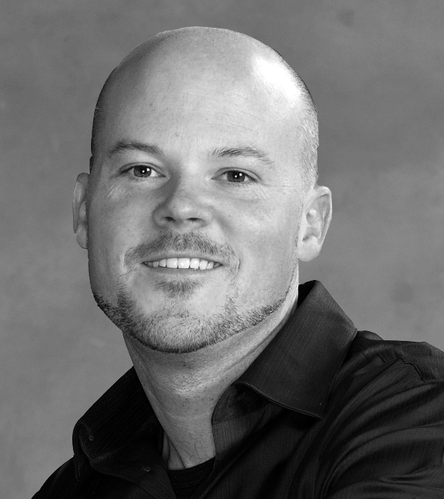
About the Author: Jason Dale Pierce, AIA is a project architect with HOK in St. Louis. In addition to being a member of the advisory group for the Practice Management Knowledge Community, he is also a member of the AIA St. Louis Board of Directors and Chair of the AIA St. Louis Mentorship Program. Jason recently finished a two year term as the Regional Director Advisor for the national Young Architects Forum.

Help for Getting Your Architectural License
By Brian Dobry

In 2005, I earned my architecture degree and shortly thereafter landed a job. As I found out later, 2005 was not the most auspicious year to graduate and begin an architecture career, with the 2008 recession crippling the economy and hitting the building industry particularly hard.

As a result of the recession my firm asked the principals to focus more on winning work, leaving less time for mentoring junior staff and guiding them through professional licensure. While the firm reimburses for the cost of the Architectural Registration Exam (ARE) upon completion of each of the exams, they began to allocate fewer resources to pay for study materials and preparatory classes. That is not to say my firm does not encourage licensure efforts – it does – but the formal programs and some of the financial incentives that were available prior to the recession are no longer in place. Though this phenomenon is understandable, in the long term this could hurt the profession if it leads to a shortage of licensed architects.

So what can aspiring licensees do? Quite a lot, if you decide to take responsibility for your own professional development. In my firm, there were a number of staff members in the same stage of professional development and we quickly realized the advantages of pooling our knowledge, resources, and enthusiasm. This approach has been very beneficial. Beyond the personal motivation and satisfaction each of us receives, we are also recognized by our principals for taking this initiative.

Engage in Some Positive Peer Pressure.

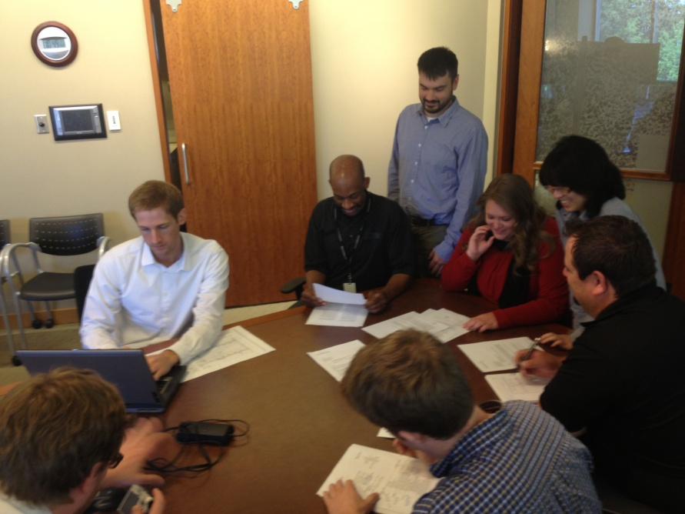
At MulvannyG2 Architecture, a group of four emerging professionals began the ARE Peer Group. The group meets monthly to discuss National Council of Architectural Registration Boards (NCARB) updates, the process of taking the exam, study tips, and issues relevant to the members. We also arrange study sessions for specific exams. This support group provides a structure for colleagues to get together, hold each other accountable, and encourage each other towards licensure. However, we don’t do it alone. Rather, we enlist the support of a principal within our studio who acts as our champion and advisor.

What Works

Share Your Resources - Start an ARE blog and wiki for employees to share information, ideas, and resources across all offices. We identified our current study material, taking an inventory of what we had individually, and securing new resources to fill any gaps. We are currently adding sections for NCIDQ and LEED AP©, keeping the information current and sending reminders to the firm to let them know that these resources are available.

Create a Learning Environment - Design an environment to make studying and learning easier, more effective and more convenient. We coordinated with our IT department to provide a computer in each office to run the NCARB vignette software. (Since NCARB’s practice vignette program only runs on 16- and 32-bit systems, we had to find computers still running Windows XP.)

Practice What You Study - Seek out projects that allow you to gain experience and knowledge from beginning to end. This could be a small project, a pro bono project, or a Habitat for Humanity effort. I was part of a team of junior staff that proposed an initiative – at the height of the recession – to design a sustainable and self-sufficient school campus in Africa. The firm generously gave its blessing, affording us an opportunity to improve our skills, learn more about sustainable design, while at the same time making ourselves more valuable to the firm. Projects like this provide a practice ground for the principles studied with our ARE Peer Group giving us greater confidence to tackle the ARE.

Add to the Culture and Success of the Firm - The ARE Peer Group effort has already encouraged more senior staff to pursue their licenses as well. We are proud that our discussions add to our firm culture, build valuable institutional knowledge, and help with staff retention.

Widen Your Circle - Invite guest speakers to your study sessions to educate and help prepare the group for exams. Seek out recommendations of friends and licensed coworkers that have used services they found helpful. For example, we have invited recently licensed individuals from our firm to share their experiences, along with structural engineers and other consultants to discuss items on the exam from their areas of expertise.

Be Inclusive - The ARE Peer Group model can work for other tests besides the ARE. For example, we include those studying for their interior design certification and LEED accreditation exams. Other examples might include the Project Management Institute certification or the even an MBA program.

Work with the AIA - Ask your firm to host an AIA ARE preparation series. By providing the venue, the AIA offers non-member employees the AIA member rate, which is a discount of 50%. You also have the chance to meet colleagues from other firms and share their experiences.

Conclusion

Regardless of the state of the economy, licensee candidates must take ownership of their career development. No one else can do it for you. Taking the initiative in preparing for the ARE exams has benefits beyond the obvious one of achieving licensure. It can lead to more interaction with clients, exposure to a wider range of ideas, more rapid career advancement, and in the end, could make you a better architect.
About the Author - Brian Dobry is an Associate at MulvannyG2 Architecture. He received his Bachelors of Architecture from the University of Oklahoma in 2005, and began working at MulvannyG2 in 2007. He has completed all of the IDP requirements and currently is in the middle of taking his ARE exams.

Best Practices
________________________________________________________________________________
One of the PMKC’s initiatives is to continuously improve the AIA’s Best Practices. AIA Best Practices represent the collective wisdom of AIA members and related professionals. We like to highlight one or two new best practice articles in each issue of the Practice Management Digest. We encourage you to read this edition’s pick:

03.02.18 Know Your Next-Gen Leaders—Inside & Out
Leadership transition is one of the toughest challenges facing executives in today's architectural, engineering, and environmental consulting industry. For the most part, the industry's next-in-line leaders are a smart, hard-working, and capable generation of professionals. But many of them are starving for the direction they need to take on new leadership responsibilities. Click here to read the full text...

Webinars
________________________________________________________________________________
Our upcoming webinar - Project Management Series: Project Work Planning with Stephen C. Evans, AIA presents the process of project work planning and the elements of a good plan. All projects, large or small should have a project work plan and certain characteristics will be common across project size and scope. The use of the appropriate level and number of tasks in a plan is discussed and this may be different between Project Managers and project types. The approach is to simplify and produce project work plans that serve the project team, not to produce plans that must be served.

In this session you will learn to: 1) Understand the benefits of project work planning,
2) Create the project plan and understand the roles and responsibilities of project team members, 3) Understand and apply the principles of top-down, bottom-up and combination plans and budgets, 4) Monitor the plan and recognize the root causes for plan adjustments

This webinar will be presented on June 13, 2013 from 1:00-2:15 EST. Registration is free but required. You will earn 1.25 CES credits. To learn more or register Click here

Online Resources
________________________________________________________________________________
See everything that the Practice Management Knowledge Community has to offer at http://network.aia.org/practicemanagement/home/
Visit the Practice Management Digest archives page for past issues.

Connect with Practice Management on:

