Renew Expand or Replace: Making the Tough Calls
Duncan: My name is Duncan Broyd. I’m a justice director with HOK. I’ve been doing courthouses for 23 years across the country, small to large. I really enjoy the courthouse as a building type, not necessarily because of the technical issues but because of all the people we get involved with and the places. It’s really a lot of fun.
Beside me is Jim Beight of Dewberry, a justice architect also with 25+ years experience across the country. I would especially like to thank Jim, who is not actually on your program today. He stepped in when some other people had to step out. He very graciously jumped into the fold and put a presentation together for us.
Next to him is Douglas Bray. He is the trial court administrator for Multnomah County. An interesting thing here that you should take note of, he is a lawyer with an MBA, so if you want to get into a argument with him I’d make sure you’re pretty well prepared.
Michael Bowers is a former US Navy civil engineer, and as he explained to me, the Army Corp of Engineers deals with water, and the navy deal with dry land and buildings. Don’t ask me about that. He’s been a facilities director in the public sector since 2006, and he and Douglas will walk through the project that they’ve been talking about for many years, in fact, even from before they were even around.
Renew, Expand, or Replace
I really want to make a very strong point here. We’ve had a lot of discussions this week about different types of delivery systems, different types of funding mechanisms, and what we’re going to pay for things. But, please take this point very seriously: if it’s on time and on budget, and it’s the wrong building, you haven’t solved the problem, and there is no one solution.
People ask, “Well, should I renew or should I replace?” It absolutely depends on the circumstances and many, many factors. There is no simple answer to this. How do we get actually get to the crux of that issue? By understanding what people truly have, especially in court systems that are scattered all over counties – it’s amazing how many departments you find halfway through the design phase that people forgot – what they really need to move forward, and what should change.
The fascinating thing is to find very depressed, dysfunctional court systems – quite frankly, for a lot of reasons – who are doing business the way they do because they have to. A new building is an opportunity to change some things. That’s a very great opportunity to really get into that and try to solve some problems.
What should you know that you don’t know? This is becoming more and more prevalent, especially in Design Build and P3 projects where people very quickly point out that 80% or 90% of the cost of the project is operations and maintenance for the next 30 years. Does anybody ask what it costs to operate and maintain today, and how that factors in your calculations?
We have seen court systems literally pay for an entire building by consolidating rents, leases, and operational savings. That has happened. That’s way better than figuring out if you need ten or eleven courts.
What’s the realistic goal? If you’ve been involved in courts for any number of years, there are so many two-inch thick master plans sitting on shelves gathering dust that were done and people said, “We can’t do that,” and that’s the end of it. So focusing the effort into something that will actually get done, I think is very important.
The political environment: it doesn’t matter how good the business case is if you have a split commission. If commissioners have to – in effect – put their suit on the line to vote for a project, you’ll find out quite quickly where loyalties lie. So understanding the environment that you’re in and who your champions are.
The projects that succeed usually have four or five people – political, non-political, a judge, quite often a trial court administrator, or elected clerk – who become the champions of the project and drag it kicking and screaming up above the political frame. That’s when they succeed.
Then the “pay now or pay later” issue. We’ve all bought or leased cars, we have all probably bought houses, and you walk away from closing thinking, “I never realized I was going to pay that much over the life of the loan.” I would suggest, on a P3 project, it would be nice to have a one-page summary for buyers’ remorse to say, “Over the next 30 years, I will pay $3 billion for my $200 million courthouse.”
That being said, I get the benefit of making a few statements and then sitting down, not having to back them up. Jim?
Jim: I appreciate the opportunity to be here today. Hopefully, I’m not too big a disappointment from my predecessor. What I’m going to talk about today is a project in Albemarle County, Virginia.
I think it’s important to frame the discussion of what it’s like to work in this area. For those of you not familiar with it, Albemarle County is the seat of where the University of Virginia sits, as well as where Monticello sits. It’s an area very steeped in history and tradition, and the culture of Virginians is also grounded in history and tradition, albeit they’re a it selective in their recall of it.
The agenda we’re going to talk about today is the scope of the study, the background on how we developed the information to get to a point were could start trying to test out some options, and really how that worked and developed into a final solution, if you will.
To further set the framework, there’s an old joke that goes around. How many Virginians does it take to change a light bulb? The answer is five. It’s one to change the light bulb and four to sit around and talk about how much better the original one was. That’s really what you’re dealing with when you work in this state, and more so in an area as grounded as Albemarle County.
The scope of the study was to review previous studies, as Duncan had said. I think this thing had been beat to death for 15 years, and they never came to any conclusion on what to do. We had to go back and re-look at their forecasts, their space projections, and re-analyze all that to try and come up with some options that truly were something that everybody could embrace, move forward with, and ultimately implement, because they were woefully out of space.
We developed some order-of-magnitude cost estimates to test those things, and finally actually got everybody to agree on a preferred solution.
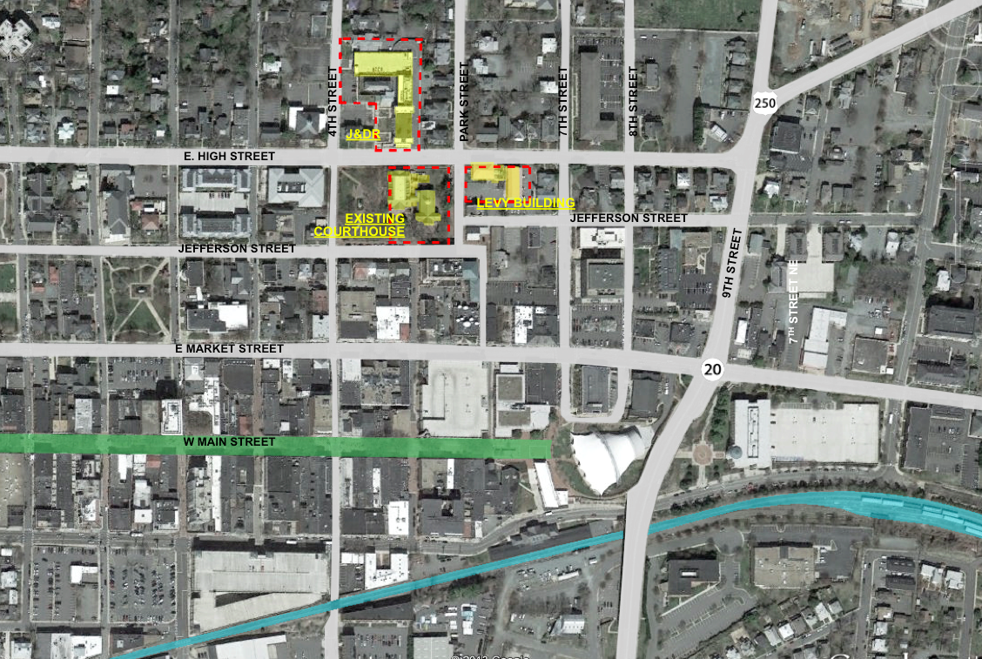
Here is the location of the existing courts complex, if you will – the existing courthouse in the center, and then a couple of other buildings in play to either side: the Levy building and the new JDR court.
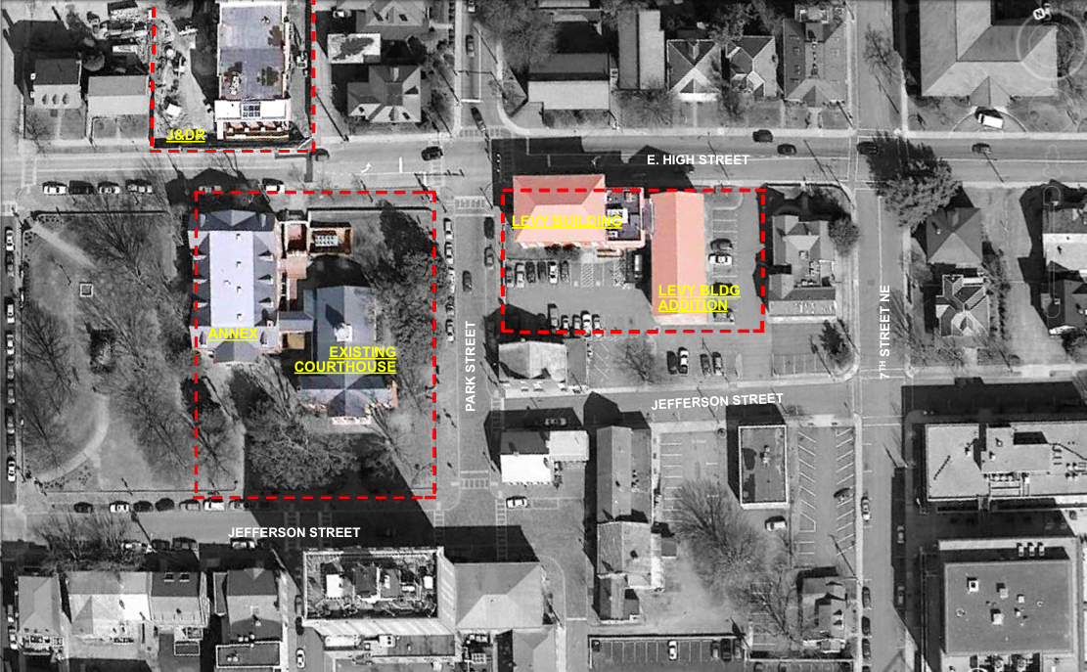
The existing courthouse actually dates back to the mid-1700s. What’s particularly unique about this building is that three presidents tried cases there: Thomas Jefferson, James Madison, and James Monroe. So, as you can imagine, there’s a tremendous precedent set in an unwillingness to walk away from this particular historic asset.
Next to that, to the left, is what’s called the New Annex, which was built in the 1890s. North of it is the JDR court, which is actually a new facility, less than ten years old. Then the Levy building to the right, which is an old opera house.
It’s like pretty much any project:
- You start out with the existing buildings that are woefully inadequate to house the operations,
- Security was a joke. There’s no space, the inmates, public, and judges operate and move in the same circulation path,
- Courtrooms are inadequate. They’re too small, except for the historical room, which is of adequate size but with no amenities,
- ADA issues, code issues, you name it.
On top of that, the building was reaching a point where it needed some significant infrastructure upgrades to revitalize it if they’re going to move forward with the building.
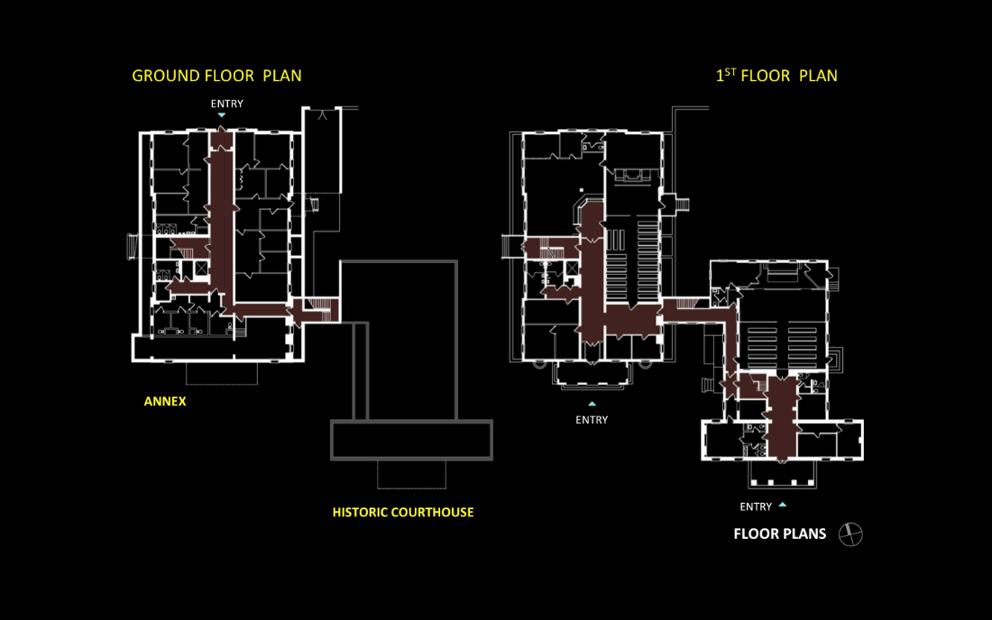
Really quickly, the ground floor of the annex had the Commonwealth Attorney and some limited holding. The first floor of the courthouse housed the historic courtroom, which was completely chopped up, on the right side there, and then that long cigar-shaped piece housed the District court on the lower level of the annex.
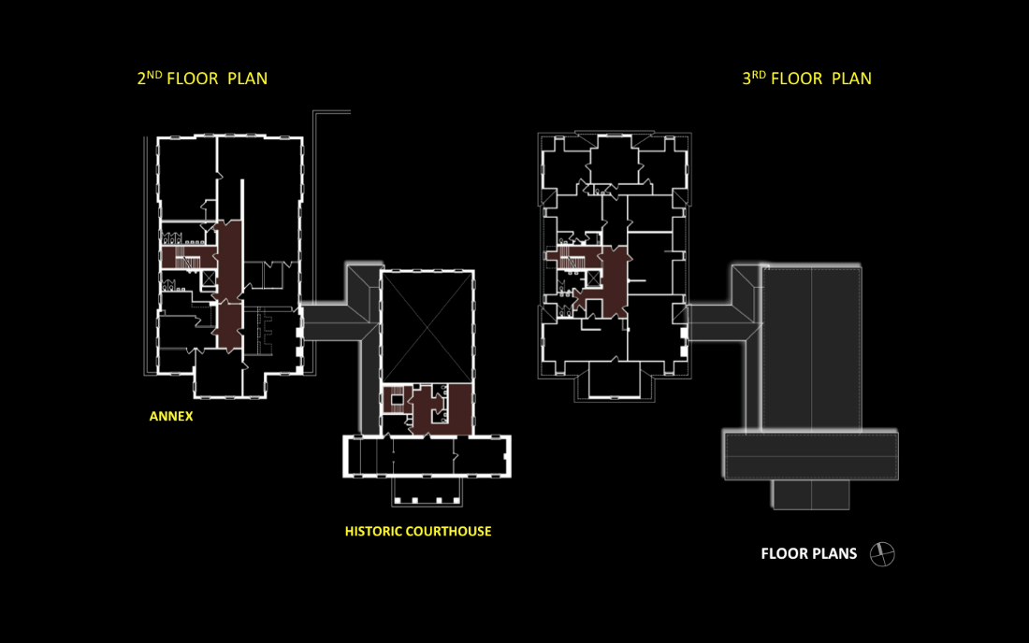
The second floor of the annex was the Circuit court, and then the very top floor of the building is where the judges’ chambers were, so you imagine that the judges had to get in the elevator and go down to public circulation to go to court.
The next building in play is the Levy building, the old opera house. The outside of the building has been pretty well preserved, but the inside was completely stripped long ago and turned into office space. The Juvenile court occupied this building at one point in time, and basically, it has been mothballed since they moved out of it.
One of the previous studies tried to shoehorn the District court into this building in an as-is condition, and we were able to convince the County – although they didn’t like the answer – that is was a really horrible thing to do, and that wouldn’t really be appropriate and they should move on.
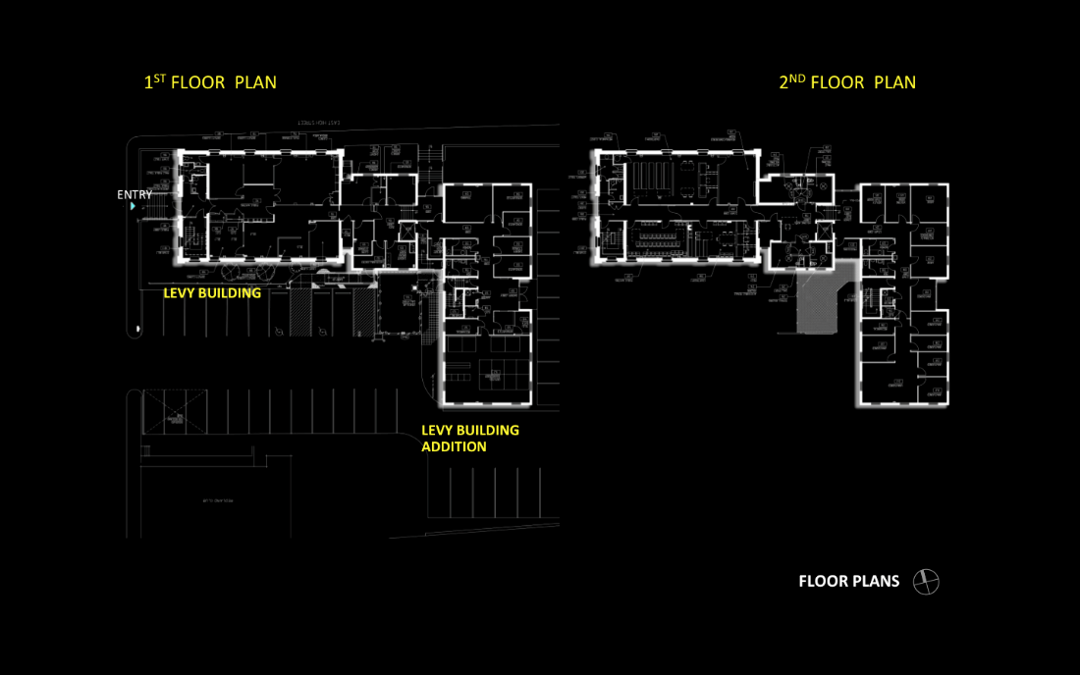
You can see the Levy building is the rectangular piece on the far left, and then the addition that rambles off to the back of the building.
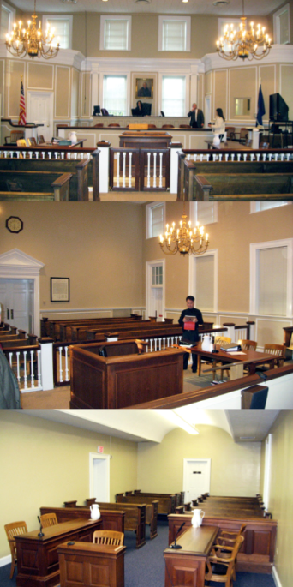
Here is a picture of the historic courtroom. It’s also been significantly altered over time. Those wings, if you will, on either side of the judges bench were added to try to create some much needed space for a judge working area and a meeting room.
The building had a balcony to the rear that was taken out at some point in time, so it’s really not sure it’s a level that we can restore that to.
If you contrast that to the courtroom below, that is the second circuit courtroom, and they actually hold case in that space.
The first thing we did was come up with what their shortfalls are, in terms of their support space for their courts, which is completely inadequate or non-existent – jury rooms are remote from the courtrooms, judge’s chambers are remote, there’s no witness waiting, there’s no adequate public waiting space – to come up with the delta from where they are now to where they need to be. Then we took a look at the caseload analysis.
It was important to demonstrate to the county that in many ways their shortages were not related to growth – which is always highly controversial, can you justify how much we’re going to grow – but that 80% of their space shortages were the fact that they didn’t have what they needed today.
Chang Ming is here today, I believe. Chang worked with the national center on all the space forecasts. It was moderate growth, not tremendous growth, for both the Circuit court and for the general District, and a little higher growth in the JDR court.
What did that translate into for the number of judges? They started out with one judge for each court: Circuit, District, and JDR. For those of you not from Virginia, which most of you probably aren’t, Circuit court is the court of record, which tries your higher level courts, while the District court is more of your traffic court and small claims.
They wanted to plan for two Circuit court judges, which is double what they have today, three District court judges, which would triple what they have today, and then the JDR court, in the course of the study, it was realized that it was adequate to stay where they’re at for the long term.
We had a benchmark of how much space they need, and what we were looking at was is there any way to reuse what they have downtown? Is there some opportunity to reuse the historic courthouse downtown but perhaps relocate other functions to a remote area, which we called the split solution? Or, do you just pack your bags, build a new courthouse, move, and abandon what you have?
We had the County on one extreme. They were all about building a new courthouse, and a lot of that was the drivers of politics. They were, quite frankly, sick and tired of dealing with the city of Charlottesville and all the demands that the city would consistently put on them. They wanted to build a new facility, walk away, and not have to deal with the city any more.
To tell the judge that she, in this case, was no longer going to try her cases in the existing historic courthouse was completely unacceptable to her, and I was pretty much threatened with bodily harm if we were to go down that road.
They were are opposite ends of the spectrum, and quite frankly, looking at this to start with, we really didn’t think there was any way that you could reuse this thing. It was just a rabbit warren of cut-up little spaces, and security was a nightmare, but to do our due diligence, you really have to take a hard look at these projects.
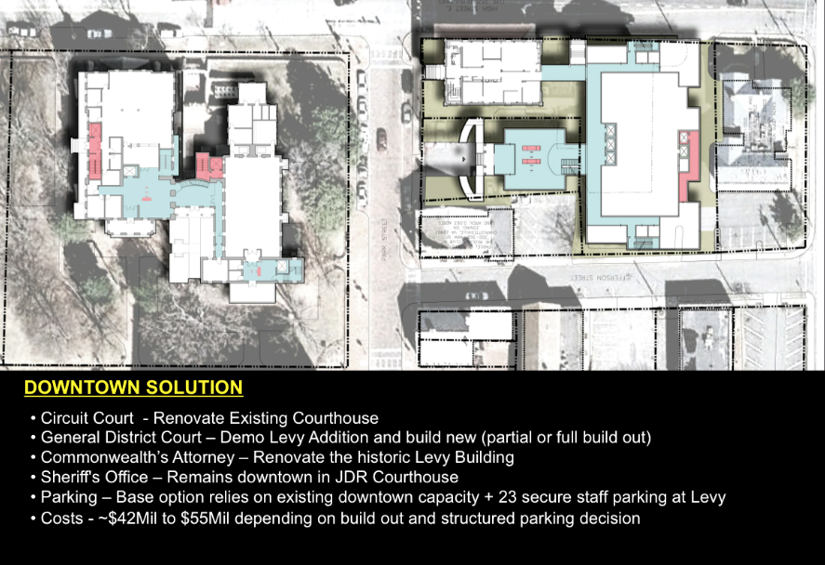
Downtown Solution
Ultimately, the Downtown solution was keeping the Circuit court in the existing historic courthouse and completely filling that out, moving the District court over to the Levy building and reusing the historic opera house, and then tearing down the addition and building a new courthouse behind that so that the Levy building could help mitigate the scale between the new building and the existing courthouse complex.
Costs ranged from $42 to $55 million, basically because you can’t put a number to something like this. The base option relies on getting the city to agree that they don’t need any more parking – which is probably unrealistic, even though I think the numbers will bear that out – and also, to what degree, if they go down this road, that they’re going to restore the existing courthouse to its original condition from a historic standpoint. Those answers have yet to be determined.
Split Solution
The split solution basically takes a piece of property adjacent to a County office building, but it’s just far enough way where you can’t walk back and forth, so you have to get in your car. It ends up being an operational problem for the Sherriff and for the Commonwealth Attorney to try and service both of these buildings. But it gets the District court in an adequate sized building, the right size for their space, with adequate security and adequate parking for the public, so it’s easy to get in and out of.
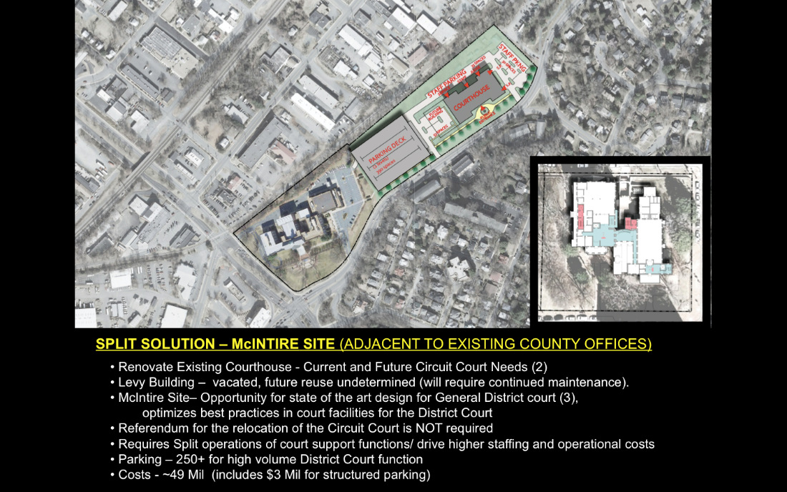
For them it’s very viable, and it’s an opportunity, if they wanted to at some point in time, to integrate the JDR court into this complex. As I said, the Circuit court takes over the historic courthouse.
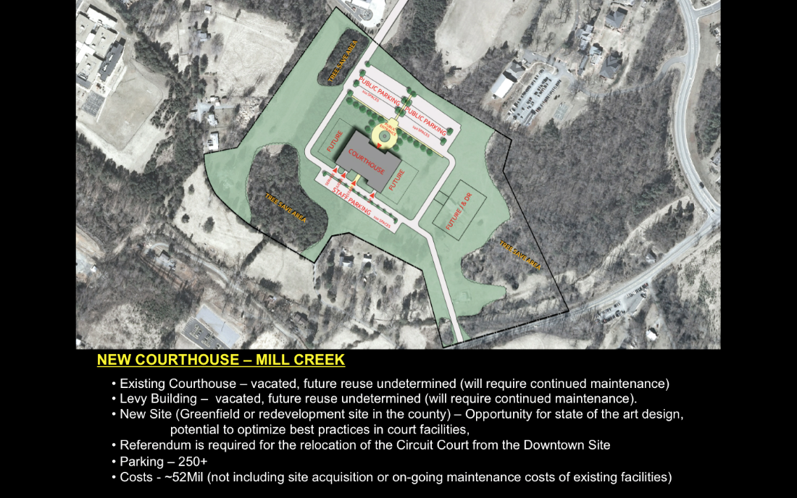
New Courthouse
That’s contrasted with a new courthouse on a greenfield site. In this case, the County own this piece of property. As you can see from this aerial photo, there’s not a lot of context here. This truly is a greenfield site. However, it would be easier for the general public to get to, they don’t have to navigate to get to downtown Charlottesville. It’s a one-stop shop, they know where everything is when they get there. It’s big enough for future expansion, more than adequate for setbacks, and other County functions could be located out here at a later date, including the JDR court if they desired.
It was the most expensive of the three options, primarily because of the infrastructure – electric, water, sewer – that had to be delivered to this particular site. However, in addition what’s added to this price is the ongoing operational cost of maintaining – at least in a mothball condition – the Levy building, which dates back to the late 1700s, and the historic courthouse. You’re not going to tear those down, and you can’t just turn your back on them and let them slowly deteriorate either.
So, what are the pros and cons?
Downtown
Pros:
- It maintains the presence of all the courts located downtown,
- It maintains the use of the historic courthouse,
- As in the split solution, it allows the Country to restore the building into something that could really be a living museum, as opposed to something that nobody ever sees.
Cons:
- That future growth or expansion is going to be a real challenge for them. We’ve lobbied that they should, perhaps, build the District court annex bigger than it needs to be, but at some point in time, they may be faced with some sort of remote court facility at a remote location.
Split Solution
Pros:
- For the District court, it’s fabulous. They get a state-of-the-art project,
- An ample site for that to work,
- They could also bring the JDR court there if they wanted to.
Cons:
- The parking deck that you have to build, so you’ve got an infrastructure cost,
- More importantly for the Sherriff and the Commonwealth Attorney, the operational costs of trying to service two buildings, where they have to go back and forth. The Commonwealth Attorney saw that as a real nightmare. They can’t control their caseload, they can’t control what building they’re going to be in, and she was arguing that there would be a fairly significant uptick in her staff to be able to support this operation.
New Courthouse
Pros:
- New building,
- Adequately designed, with adequate setbacks, and it’s state-of-the-art
- Much more determinate in terms of cost, where the other two projects are a little fuzzier because you don’t know what you’re getting into when you’re renovating something
Cons:
- At the end of the day, they’re stuck with the white elephant of the historic courthouse and the Levy building. What do you do with those?
There were some discussions about opportunities. Could you make the courthouse a museum? But people argued if we build it, they might not necessarily come. When you have the University of Virginia and Monticello as landmark tourist destinations, thinking about somebody coming to see an old courthouse is kind of unlikely. They figured they were just going to have to maintain these buildings with no real determinant function for them for perhaps forever, quite frankly.
That point got the County off the dime, who said that between that and the judge threatening a lawsuit, perhaps they should take a harder look at the Downtown site. So we did that.
The first thing though, if you’re looking to renovate a building how do you get there? You have to have a phasing plan, because while the judge wants to stay in her courthouse, she also doesn’t want to be fettered or bothered with the inconveniences of the renovation or the construction.
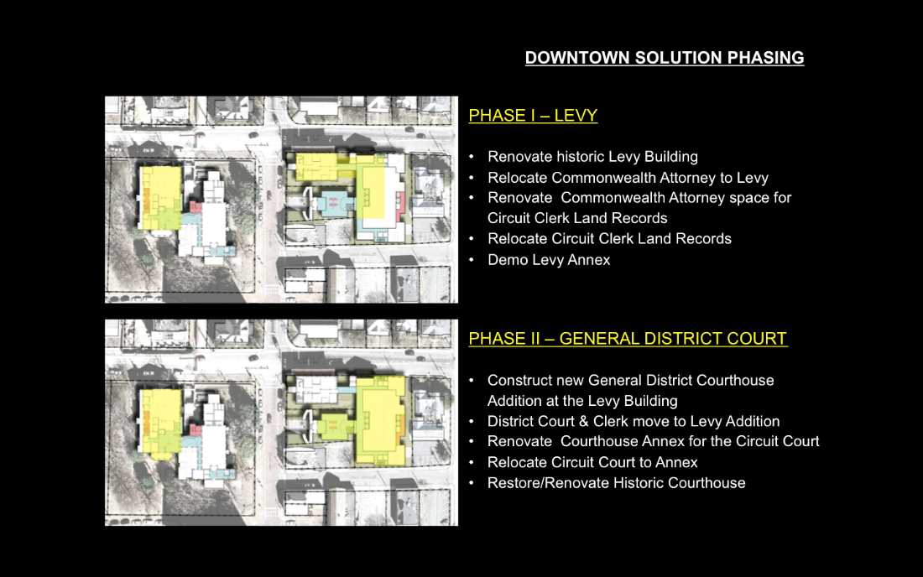
Downtown Solution Phasing
In phase one, the idea was to take the historic Levy building and go ahead and renovate that so we could get the Commonwealth Attorney out of the basement., and then renovate the basement. Then the clerk agreed that she would take that space, and she could live in that space for three or four years while the rest of the work is going on. It actually is as much space as she has now, so it’s not that big of a stretch for her.
The next phase of the project is to tear down the annex to the Levy building, so that we can build the new District court. Then you can move the District court out in total to the building. That frees up the whole annex of the historic court building on the lower left-hand side to renovate for the Circuit court. The Circuit court then moves into that building, and you can go back and renovate the historic courthouse. So it’s possible to get it done with a minimum inconvenience to everybody.
The other thing is you’ve got to drill down a little bit deeper, because it’s not a numbers game. A numbers game, you could do with the new building. You can come up with a list of spaces and you know you could design it any way you want, you can make it work. The only thing that’s going to change on that is are the grossing factors adequate, or we’re perhaps a little overly ambitious in how efficient we could be in the design.
But, when you get to an old existing building there’s no way to backfill square footages from a spreadsheet. You have to actually do the design. In this case, we took it to a conceptual level to understand how it would work.
The biggest challenge in these old buildings is how you separate out the circulation between the judges, the inmates, and the general public. In this building, it was quite a significant feat, and coupled with that is the ADA issues that go along with moving people through the building. Code was actually the least of the issue to solve in this building.
We actually ended up having to add three new elevators to the project to make this work, because the floor plan was so spread out. Two of the elevators were for inmate delivery, two new public elevators, and then the judges would use stairways or double up with the inmate elevator on an operational basis – where they would clear the elevator when the judge needs to use it.
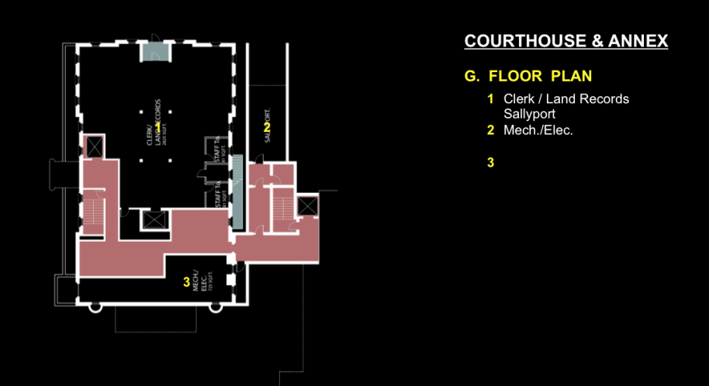
The basement will ultimately be the Clerk/Land records. You see the elevator in the center of the plan – that’s a public elevator that dumps into it – then the holding with the new sally port backs up into that. In the red area, you can see the circulation getting to the two elevators, which will ultimately deliver an inmate directly to the courtrooms without crossing the public traffic.
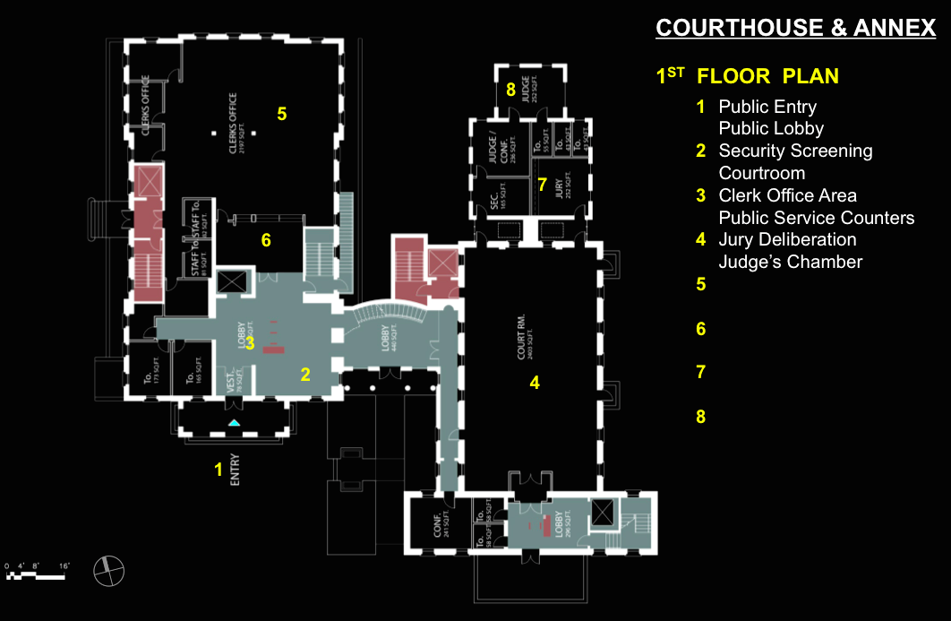
Where you see the number 1 there, that is the new entry. We’re essentially using the 1890s addition as the entry to the courthouse. You go in, you go through security, and the Circuit clerk court functions are right there on that floor. You take a right and go through a new connection piece – where we propose to completely blow out the existing connection piece and put a new piece – to go to the Circuit courtroom. You’ll see the square on the back labeled 7 and 8: that is a new judge’s chamber and new jury deliberation suite, so they can be adequately housed and not have to cross the public traffic at all.
We will, in fact, maintain in partial use the historic entrance to the old Circuit court building for special programs, but typically, that door will be locked. They finally agreed to one entry for the whole complex.
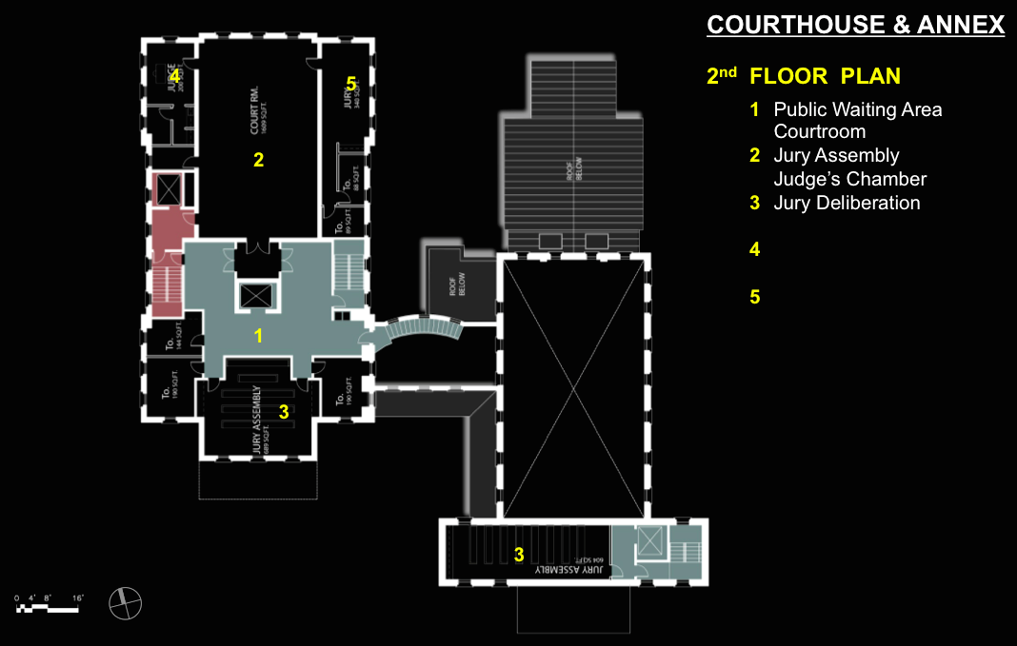
You go up to the next floor of the building. Where you see the number 2, that’s the second Circuit courtroom. The idea is to basically blow that floor out and actually cut a two-storey space where that room will be, so the courtroom is of adequate demeanor and dignity to at least try to be compatible or comparable with the historic courthouse, which you’ll see with the big X over it. It’s a 20-some odd foot, very grand space.
There’s an inmate elevator directly into that space, and on either side of it, we have a judge’s chamber and a jury space, so that it works as it should. There are a couple of meeting rooms, as well. We also have a jury assembly on this floor. The two things that are marked 3 can be jury assembly or hearing rooms. They’re sort of multi-functional spaces depending on how they want to use them. We haven’t really decided at this point how that is going to go.
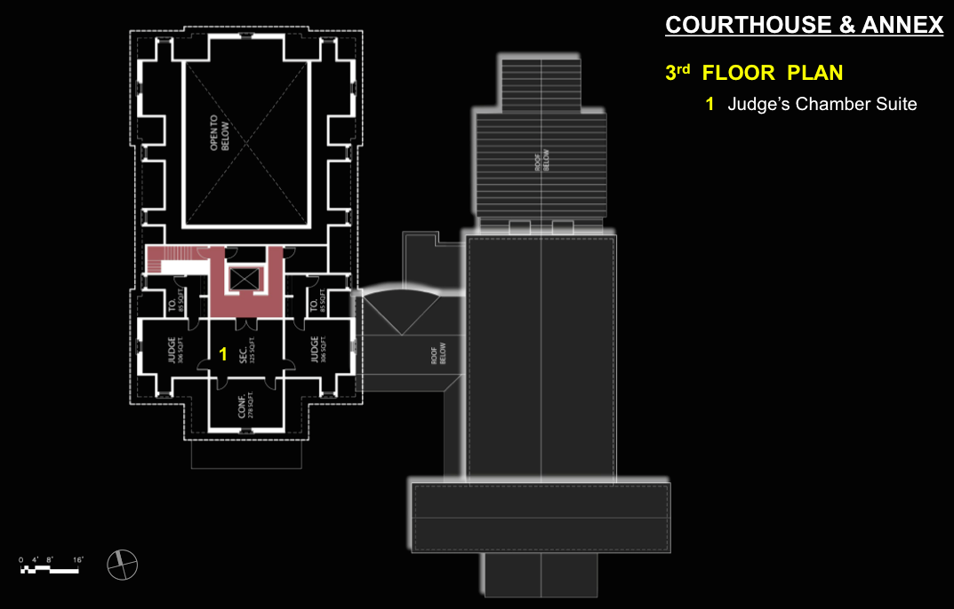
You see the new Circuit court cutting through the top floor of the existing courthouse. There is some space left over which just future expansion, but it would accommodate additional judges way down the road. At that point in time, they would have to share courtrooms.
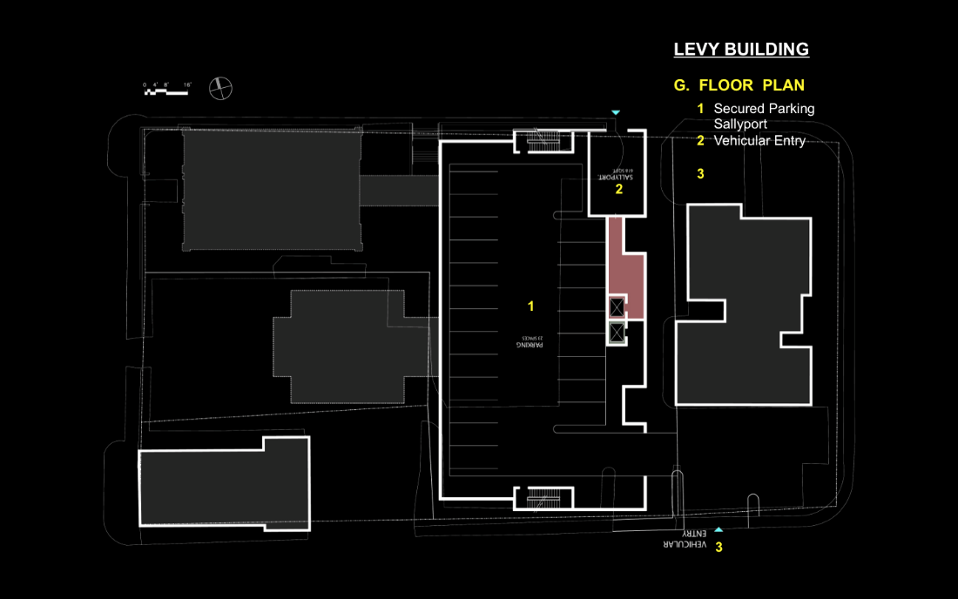
A little more straightforward is the new District court building. Secure parking on the lower level for the judges and the Sherriff.
On the main level is a new main entry, which will front the historic courthouse into a lobby, and then you come on into the District clerk. Space number 7 is the Levy building, with three floors of that there for the Commonwealth Attorney.
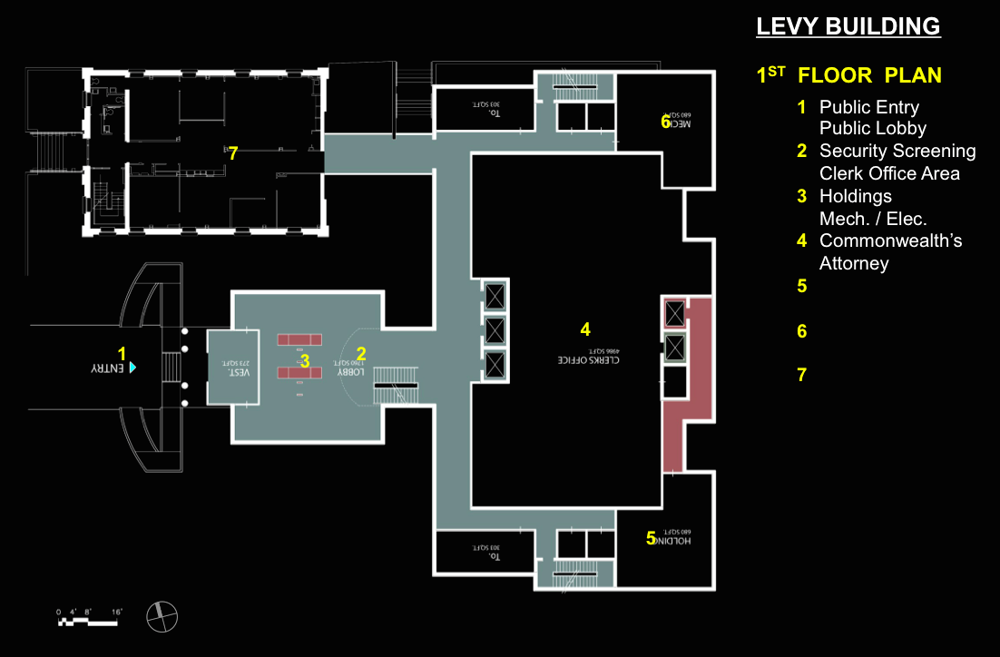
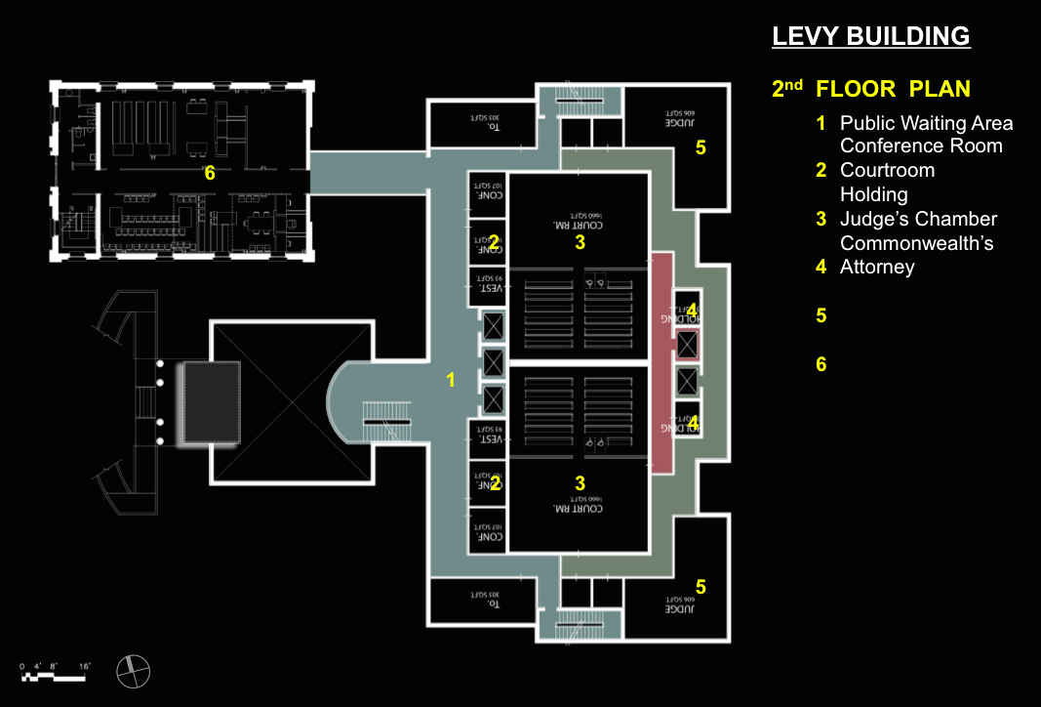
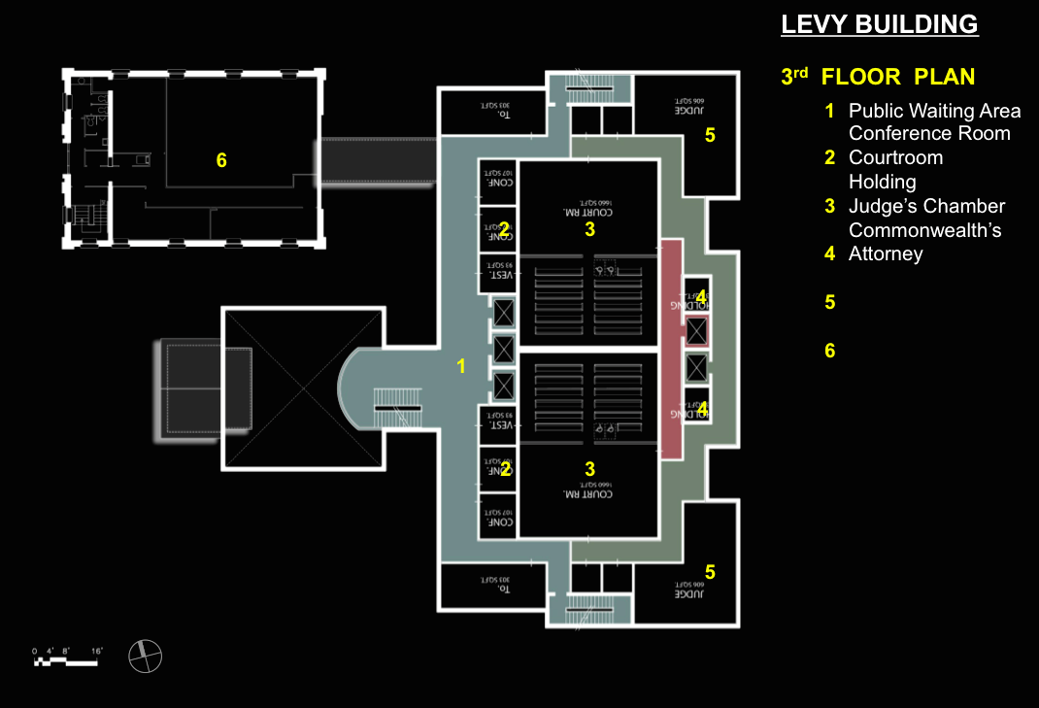
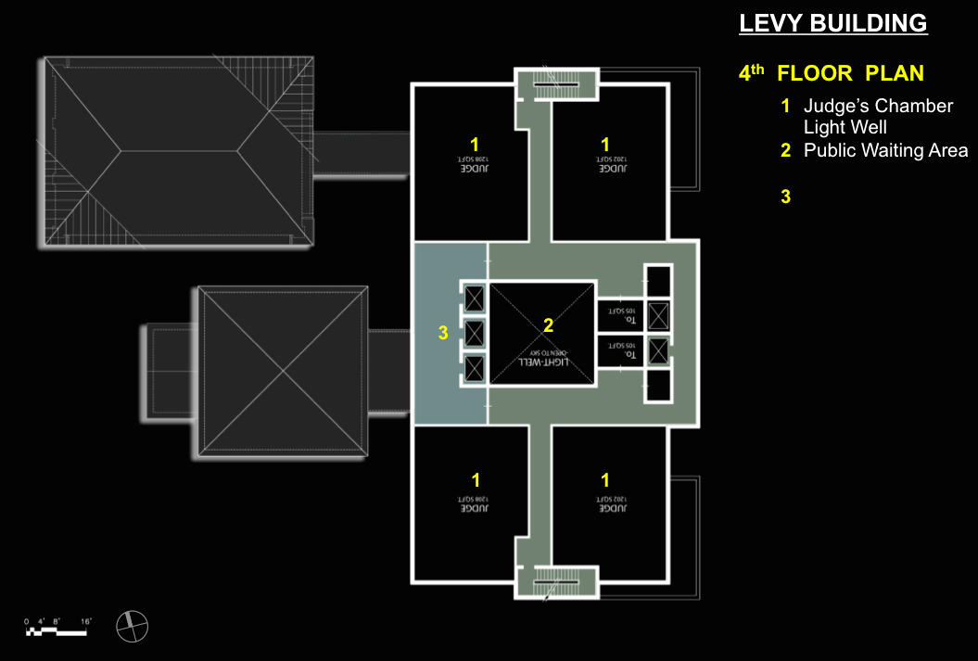
The next two floors are basically courtrooms and judges’ chambers, and then the top floor is future expansion space. You could do the whole program in a floor less than we’re showing, but we’re trying to convince the County that this is won and done. They ought to at least build it out for what zoning will allow them to occupy the site with, as opposed to the program, so they have some future expansion.
We demonstrated to the County primarily – because the judges were willing to believe just about anything to stay where they were – that this really would work, and it is not really any more expensive than going out and building a new building.
At the end of the day, there was agreement, a consensus to stay Downtown. The County is now in the process of trying to take the next step forward to get the funding to implement the project.
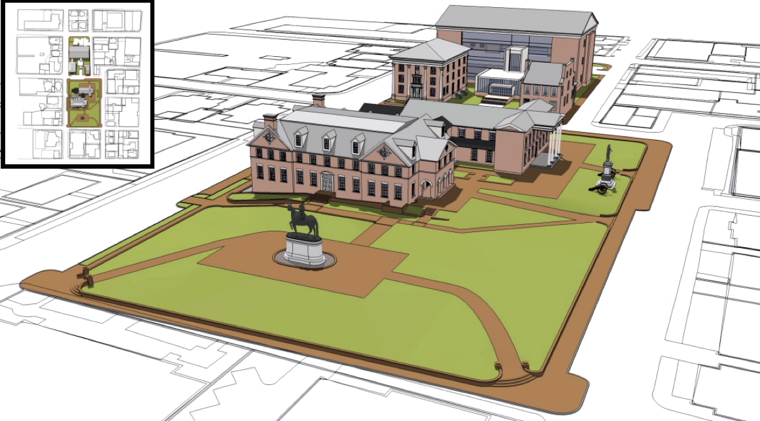
Just a couple of quick models here. You see the 1890s annex in the foreground, and a large public green-space there. You might ask why we didn’t look at that. Well, that was just completely off the table. That was not even to be considered.
You see the historic courthouse in the middle ground there, and the Levy building in the back, and the proposed court addition being the furthest back, trying to use the existing buildings. The one on the right of the Levy building is a private property. It’s actually a lawyers’ private club, if you will, and it dates back to the 1700s, as well.
We use those buildings to mitigate the scale of the new building, and fortunately, the scale picks up in the city as you go in that direction.
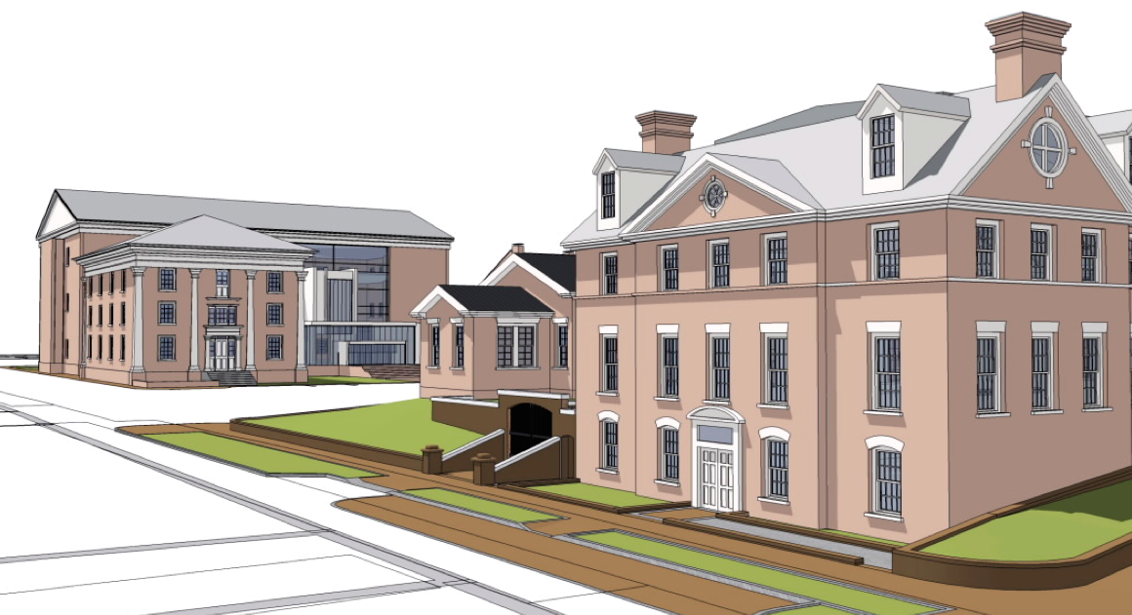
Just another quick shot of it. This is more of a rear shot, showing where the new sally port is, and a little bit of the massing of the Levy building and the new addition, as well.
With that, that’s that project, and I’ll turn it over.
Michael: Good morning. I’m Michael Bowers. I’m the Facilities Director for Multnomah County. Who would have known a year ago that the AIA would make special measures just to come to our County to deliver a conference where we could hear lessons learned about our cool project and incorporate them.
It’s almost like we get a free industry forum out of this, so I have a few staff members that are at the conference today. We’re pretty excited because some projects are a little behind where we are, and some projects are a little ahead, and it’s fascinating going to each forum and hearing tidbits of wisdom that we can incorporate. That’s probably the most exciting thing for us: just walking across the street and coming over to the Hilton Hotel.
I would like to point out that is an interesting profile of this city, looking eastward to Mount Hood. Keep that picture in your mind, because it will be interesting in terms of what the city looked like back in the day our courthouse was constructed, what’s happened around it, and why we have some of the issues we have to tackle.
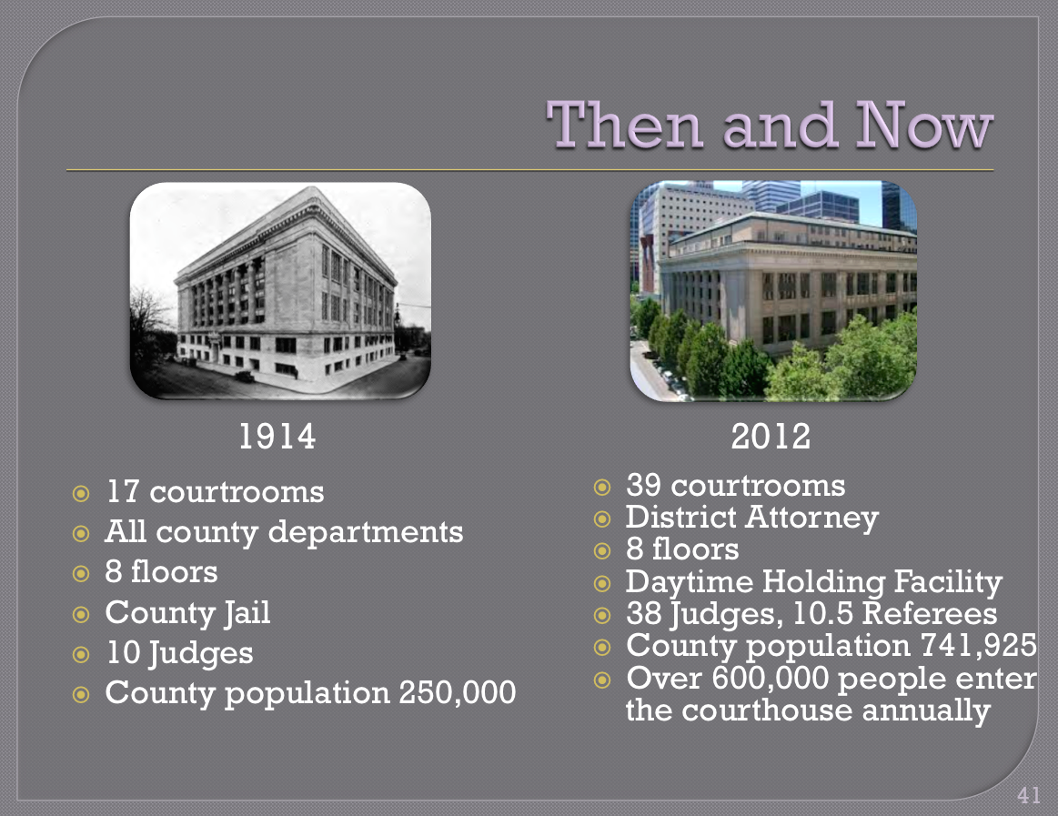
Then and Now: Multnomah County is the 77th largest by population county in the country. Our population is 750,000 people. That includes the city of Portland, which is about 500,000. Unlike many other courtrooms that have been modified over a hundred years, we had 17 courtrooms back in 1914 when it opened. It was a 1909 to 1914 construction project. Doug is going to share a few slides from the court’s perspective from the user, the owner – the occupier, if you will. We though that was going to be fun to integrate.
How did we get from 17 courtrooms to 39 courtrooms? Those old grand courtrooms from the early 1900s have been carved up either vertically or horizontally – not all of them; there are some historic courtrooms. But just think about the population of 250,000 people with 10 judges. That was the jail, that was the Sherriff’s office, that was the seat of all county business.
Now, we have 3.1 million square feet of facilities across the county, which is ten times the footprint. We have literally outgrown, in many ways, the usefulness of that facility. There are eight floors, 38 judges now, 600,000 people. That’s not a number per person per se, but that is the number of people that go through the turnstile every year. There’s a big difference.
There’s a reason that our court didn’t make the high score for the tour this afternoon. We lobbied very hard, but there were a few rationales for why the score didn’t come up there as a modern, cool, court.
If you want to see some real cool things not to incorporate into your design, this would be it.
- There are serious seismic deficiencies. We’re talking $40, $50, maybe $60 million depending on the size of the seismic issue that we’re trying to accommodate.
- Insufficient security. The Sherriff’s office, when they give a presentation, is incredibly nervous about one doorway. Everybody goes through the same magnetic detector every day. The inmates are the only exception. There’s a little popup elevator that comes out of the sidewalk and shuts down the multimodal transit lines for an hour or two. It’s crazy. Fortunately, it’s no longer operated just by a pull-chain, but we have to use the pull-chain sometimes because this thing breaks down. Getting parts for something that’s 80 years old is not easy.
- Obsolete mechanical and electrical.
- Inadequate technology.
- Jim talked about the flow of how modern courts worked, with the separation of functions. That’s impossible in our building.
- Expensive logistics, hard to get parts, and intensive operations and maintenance.
You remember the show “MacGuyver.” I have about 50 people on staff who I refer to as MacGuyvers. How they fix things in that building is amazing. I’m fascinated. How they find things that need to be fixed is incredible. Fortunately, there are no little body outlines in the building from some maintenance person who got lost and we couldn’t get them out. But I was surprised that we don’t have that.
The work to date: I can’t compare it to Jim’s demographics in terms of age – I can’t beat the 1700s statistics – but hands down, I have him beat on the amount of studies – and the time it’s taken to do these studies. I don’t know why. We’re talking west coast/east coast. Maybe we’re talking size of the court, in terms of complexity. There have been 28 studies since 1969, and some of the staff refer to some 1950s studies that looked at this court.
My job as the new facilities director a year ago was to break the paralysis by analysis, if you will, and build some momentum. I’ll talk to you about momentum after Doug does his presentation. We did a couple of recent studies to talk about the need for a 400,000 square foot nominal court. That’s one third bigger than our existing court of 300,000 square feet.
However, we’re bringing on the National Centre for State Courts, who we contracted with back in August. We’re doing a very serious program analysis of every function in the court. We don’t want to be like GSA and over-build federal courts beyond the capacity or even the ability to even hire judges.
Multnomah County is a fairly landlocked, stagnant population. There are a couple other growing counties in this state that are much faster growing that us, so when the judge allocations happen over 30 or 50 years, the likelihood that we’re going to get ten more judges is pretty low.
We’re looking at a business model to do court business differently for the next 50 years, as opposed to how we do business today or for the last hundred years. Our business model, in how we do court operations, is going to be pinnacle in driving the facility that is going to accommodate that. It’s very, very important.
We are getting ready to hire an owners’ representative to guide us through the project process. I will point out JD Deschamps at the back of the room. JD is a project manager we pulled on board two weeks ago. He’s taken the fire hose approach of 28 studies and is continuing to build some momentum in that.
The political commitment is looking solid. I will make one quick momentum comment when it comes to solid. As many of you know, solid is a relative term in terms of time. Solid means we have state legislature, we have county commissioners, and the chair’s office and others aligned at the moment. That’s a great thing. Not only do we have solid but we have unification, which is good.
That obviously can change. I think I’ve heard in the conference that sometimes when you have Republicans, Democrats, Conservatives, Liberals, or different opinions come to the table, that can become a serious momentum killer, and it can create the need for a 29th or 30th study to slice something in a different direction.
We’re moving fast in three years or less with the unified elected official team, and we’re going to even expand that to City of Portland elected officials, or maybe the metro-regional government, and perhaps other stakeholders that would like some governmental space in a new courthouse that’s compatible for that.
So seizing on that momentum, building on it, just like a sports team, it’s very important. Everything that we’re doing to line up the schedule, and I’ll point that out after Doug talks, is seizing that momentum and keeping things moving very quickly according to the decisions that we need to make at the right time.
With that, I think it’s your nickel, Doug.
Doug: I’m going to stand in for the judges who would like to be here and tell you what they want. We do have some concerns about the various issues around how do we get modern court space?
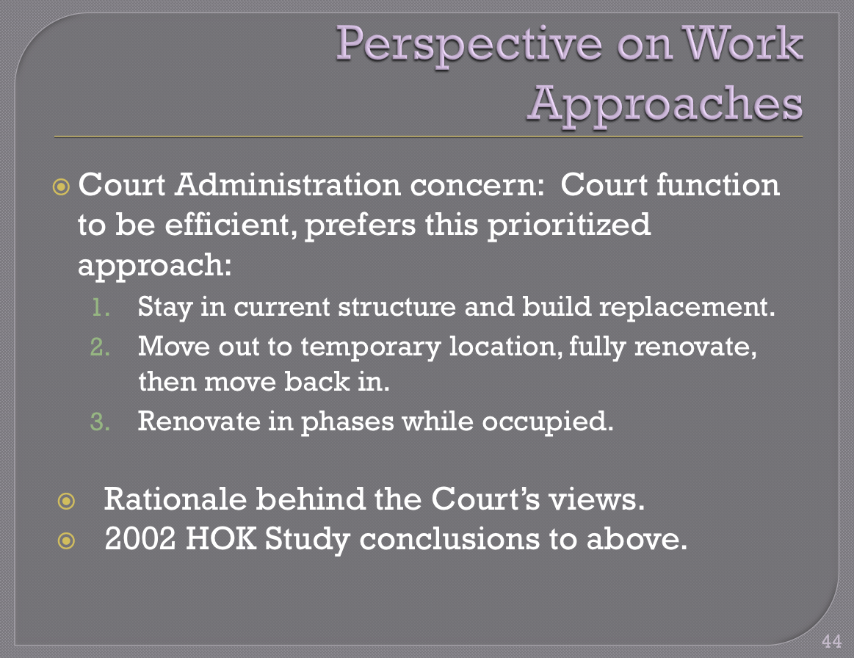
This is a slide that talks about our preferences, and I say up there that we’d prefer this prioritized approach, and I’ve listed the three priorities in order of preference. Of these options, we would probably take any one of these to get a modern court facility, but clearly we have a definite bias and definite perception as the occupant and major user of whatever facility comes out of this.
Option 1 permits the most efficient operation of court business, and it works bests when building for the 50-year useful life that we would like to get out of the structure. Fortunately to fifty years is a reasonable expectation for useful life for a building that is going to cost this much.
It is arguably the least expensive of the three alternatives, but it does leave behind a structure that has to be reused in some other capacity by the County, and that is a constraint. It’s a constraint that is avoided by the other two options.
Option 2 really should be considered only when it’s a complete renovation to a full modern court facility, with full functionality. Option 2 usually possesses constraints imposed by the historical fabric you’re trying to preserve and by modern design limits that didn’t exist when the courthouse was originally built. Clearly there are often zoning things that come into play, which limit the amount of functionality or flexibility you have in designing a full renovation of one of these facilities.
This option also has the obvious risk of cost overruns, because when you get into a 100-year-old building and you’re doing a full renovation, there are always surprises. There are two other facilities in this city, both fairly contemporaneous with the courthouse: the 1895 City Hall and the Portland Public Library, which was built around 1900 or 1905. Both of those had surprises in them that resulted in cost overruns and significant delays in the delivery. Both of them now have delivered beautiful, wonderful buildings, but they are buildings that really are showpieces and are no longer seen as the heart of what business has to be done in those facilities.
City government exists in buildings all over the city. The city councilors, the city attorney’s office, and some other key functions are now in the City Hall, which used to be the seat of city government. The central library is just a downtown facility, as regional libraries have been built all over the city and county to service that need.
With a courthouse, we don’t want to have that diffusion, we want to have a concentration. That’s the dilemma we get into with a renovation of the building. Option 2 is a renovation of the building where everyone moves out of the building, and you’re able to lodge yourself in temporary space – it’s a challenge to find temporary space for a full general jurisdiction Circuit court, but that’s presumed to be available – and then move back in, but we still have some significant limits in that approach.
Option 3 is the court’s least favorite. It would be our last priority. Limited remodeling and renovation while the court is in business happens from time to time. We go through that periodically. We may have even a quarter of a floor shut down while significant things are done.
Most recently, we all have new steam pipes running through our offices, because the boiler system has begun to fail and the pounding of the pipes was so loud that the County finally had to come in and replace all of that. They had to move through the building and replace steam pipes all over the building. They did a nice job, though. The pipes look like they’re bronze and they’re quite attractive.
The renovated phases while occupied really becomes very problematic, and we’re going to talk about more of that. We really think there’s a premium on construction under this phase – that’s not really our issue, but we think it’s probably the most expensive option overall – even though it does avoid having to then reuse the building into other kinds of county office space when the project is done.
Option 3 also erodes the court’s efficiency. You’re constantly moving throughout the remodel period. In addition to a building that’s at about 120% subscribed for its total capacity, you’re having to move a major chunk of your operations outside of the building just to get enough space in the building to start shuffling through the floors and doing the rework that has to take place. Days are lost in all of these transitions, confusion exists in where certain functions are, and there is an immense amount – from the court’s point of view – of operational inefficiency in this.
We might get pretty good at this over the five to six years this project would take. It does take a lot longer, because you are working in an existing operational facility. You do have premium costs, because a lot of your heavy construction and demolition has to take place off hours. Over that time, you may get very efficient at moving people around the building, but it is chaotic and not desirable for the court.
In 2002, there was a HOK study done on these three options. The study was led by Chuck Oraftik and Pamela Adams. They reviewed all of these issues and recommended to the board of County Commissioners that:
- Option 3 was unworkable,
- Option 2 had greater cost over the 40-year planning horizon because a second facility would be required eventually, because of the limits on the amount of expansion that could be done within the fabric and the zoning on the current facility.
The study left for the future planning the disposition of the former courthouse, recommending that it be converted to county office space. The County has the least office space all over the city, and as commented earlier, they could really cover a lot of the cost of the seismic movements and renovation of the current courthouse into a functional county office building simply by doing that and then consolidating those agencies that are out in this space into that area.
The County board of Commissioners at that time did approve the HOK recommendations, and they formed a blue-ribbon committee to pull together a plan. The project steamed along for more than a year. Then, at that point, suddenly, key commissioners were term-limited out of office, and the study really foundered and hit the rocks on the conclusion that the voters of Multnomah County would never support what was then a $180 million project to replace the court facility.
The County had recently had an experience that it is living with today, where in the mid-1990s in a spirit of making society safe, there was a public environment that thought you couldn’t have too many jails. They built a jail with a public bond, and the jail was finished in 2000. It’s never been commissioned. It’s never been opened.
It sits empty to this day, but every time the County Commissioner begins to talk about a building project, that building is raised by the public and editorial boards asking, “Are you just building another Wapato jail?” which is the name of the facility. So in 2002, 2003, and 2004, this study went to the shelf like so many others.
In 2007, we had a new board of commissioners. Essentially almost everyone had been replaced. In 2007, they said let’s look at the courthouse. We had done a lot of work with the commissioners, we had done a lot of education with them, working hard to try to make them aware of the problems that existed. Certainly, facility staff who continued over were very experienced in this and had a good perspective on it.
But the board seized on – maybe on the advice of local private developers – that the thing to do, the thing you could sell the voters on, is that you’re not building a new building, you’re going to renovate the current building, and you’re going to avoid the cost of having to relocate all of the court services if you just put some of them outside of the building. That’s what will sell, that’s what will pass.
And that’s the direction that the board took. It created two subcommittees: one on finance and one on the project approach. The project approach subcommittee continued to focus on renovating the courthouse with the courts in place operationally during the renovation.
The focus was based largely on a strong commitment that there needs to be a historical preservation of the building. They saw the City Hall and the public library, gorgeous period restorations, and said, “That’s what we should do. That’s what the public is going to understand, and it does come in at the lowest cost.”
SERA Architects, led by Don Eggleston, were commissioned in 2010 to find a way to implement only option 3. SERA did a remarkable job. They pulled together a program plan that did put together a scenario that would use option 3 and go through the process of renovating the courthouse.
The project had ballooned out to six to seven years in time, because of the premium on operational time for construction to be in the building. The cost range at the high end was really about what we would pay for constructing a new building.
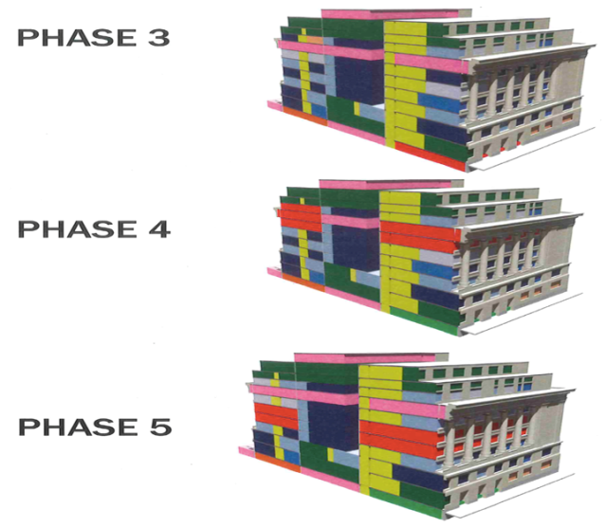
But it was a plan, and it was very well done. We have just one page out of the plan. It was nine-phase plan, and it was well thought out. In fact, if option 3 was the way the board finally decided to go, that plan would be what they followed.
The plan was published in 2011 and presented to the board. The board of County Commissioners took no action on the report pending further study on the issue. That sounds familiar to all of you.
The court’s concern with the plan was that there really was limited growth into the future. We really ended up with only four or five more courtrooms for future expansion, and it appeared that maybe not all of the functions that were moved out to make room for the renovation, in phases with the rest of the court’s operational, would actually make it back into the building, and there might have to be split operation of court facilities.
We have a unique jurisdiction. We are the only court, really, in Multnomah County. We’re the municipal court as well as the general jurisdiction court. We do everything from parking citations all the way through to the most complex cases.
There are things that people say, “Well, we could handle this in another facility.” From an administrative point of view that simply means we already have four court facilities we’re running, and that would mean we’re adding another court facility to manage – that was a concern – and then judges having to rotate back and forth between the facilities.
The plan also dealt with some of the prisoner transport issues, because it created a basement holding area and a more efficient way to transport prisoners into the building, rather than unloading them from a bus parked on the curb next to the sidewalk, walking them down what was essentially a freight elevator into the basement, and then bringing them into the jail. But there was no secure judge’s parking, and not all courtrooms in the remodeled building would have secure separate prisoner access to those courtrooms.
The added limit is one that has emerged only over time, and that is that the court right now – as you saw by the earlier slide – is really pretty much limited to court functions and District Attorney’s office, and then our Sherriff’s security people who staff the front entrances to the court and who maintain the prisoner transport.
None of our business partners have space in the courthouse any more, and that’s come to be a key problem in the community. People who leave court needing to make connection to mental health services, to social services, or to probation or supervision services, never make it to the other facility that is four blocks down the street. They just disappear.
What we really need to have is a facility that combines in the courthouse an efficient way for those people to make that connection into the services, where they are at least screened, admitted, and assigned to programs that they will later be dealing with in other facilities around the county. You really fail if you don’t get them in immediately after the event.
We are also having a tremendous problem dealing with mental health issues and the involuntary commitment of the mentally ill. Right now, the courthouse is not set up well for that. There wouldn’t be space in this for the kind of facility that we would envision, which would be really a small mental health facility with some psychiatric staff – a psychiatric nurse, maybe – and a holding facility for people waiting for their hearings on an involuntary commitment that was really appropriate for the medical situation these people are in.
Those were the limits that we saw with this approach to a renovation.
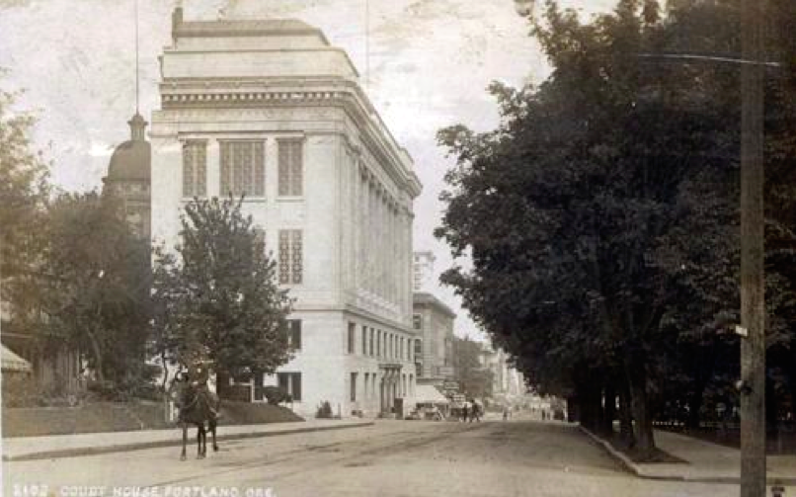
I used this yesterday in a presentation. This was actually how the original courthouse was built. On the back here, this cupola is the top of the 1860 courthouse that was replaced by this building. This building was built by chopping off the whole front yard of the 1860 courthouse.
They built the first quarter of the building, left the court functions all intact in the previous building, and then moved everyone in to the new facility. Then they built the other three quarters of the building around the rest of the block, leaving the light well in the center. This had eventually been filled in with odds and ends built in the ’40s and ’50s that all have to disappear, because the building is just a seismic wreck.
It’s all unreinforced masonry walls, and the fact that they built it in two parts, apparently substantial lateral forces will lead to those two parts bounding together and added destruction. We like the idea of leaving the courts intact and getting the new facility going. It worked in 1909, and we would like it to work now.
Michael: I will try and wrap up the Multnomah County presentation by talking about what we have done in the past year to take 28 studies, three or four decades, and create a path in a year, and make it make sense to all the stakeholders at the table.
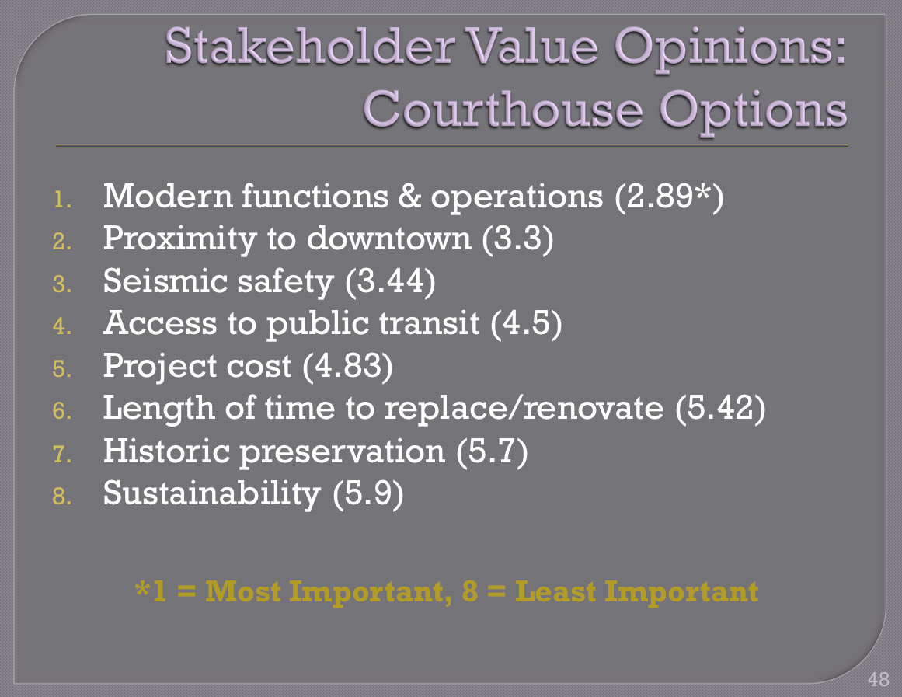
First of all, the two commissioners leading the charge out of the five had some evening listening sessions at the court building, a couple of times last fall. I think there were 400 stakeholder interviews that were solicited either online or by attending public forums.
The only observation I’ll make here is that you can see from a scorecard perspective that modern courts’ functions and operations is the number one concern at the top, and historic preservation is number seven. There are a few things in between, but we know where the stakeholders – the Multnomah Bar Association, and the judges, the staff, and other stakeholders – really care for us to put our money.
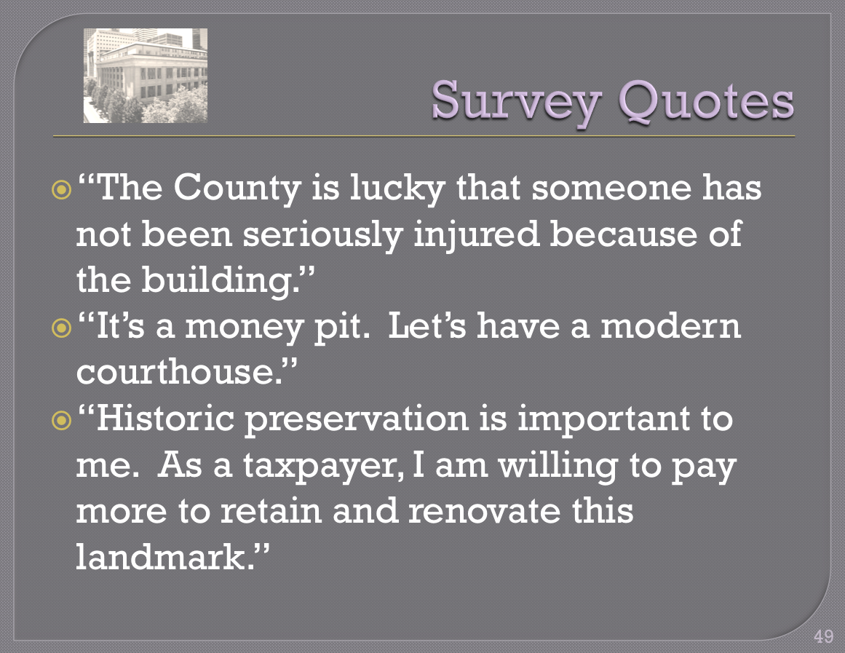
I think some of the quotes are quite interesting, and somewhat humorous. “We’re lucky that nobody has been seriously injured in this darn old building that certainly doesn’t meet all the ADA requirements and a bunch of other things.” We have two pro-new quotes and one saying historic preservation is important.
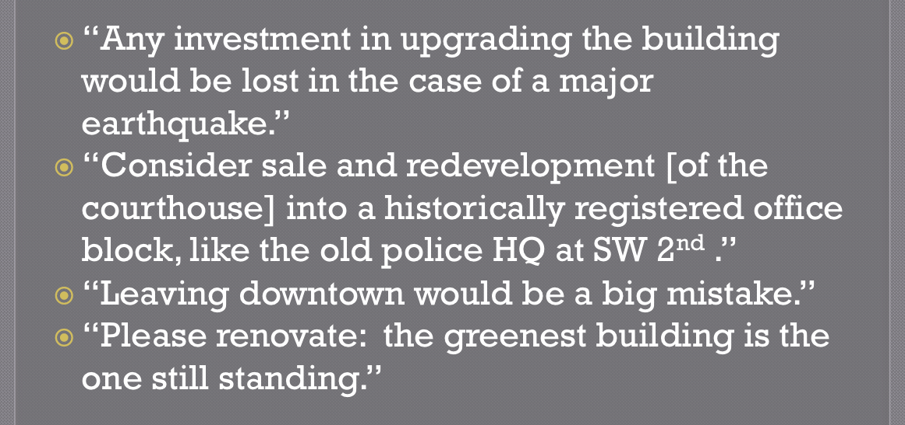
We allowed the public to provide some written opinions as well. “This thing is going to be a pancake in an earthquake.” Okay, no surprise there. The final comment is interesting: “The greenest building is the one that you choose to renovate or repurpose.”
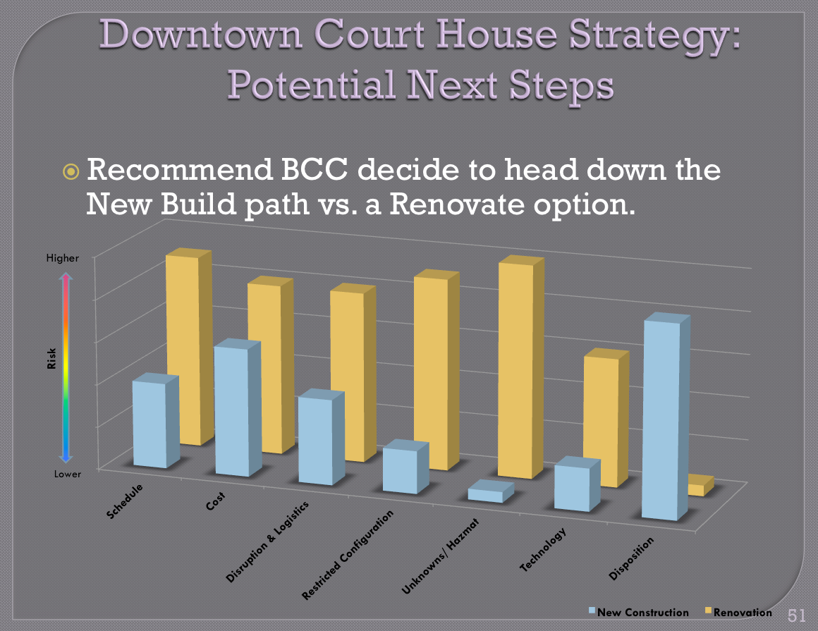
My task as the new kid on the block last summer, as opposed to doing more study, more elected official opinions, and whatnot, is to wrap a bow around 28 studies in a nice cool graphic, to recommend that we stop the studies. As the new kid on the block I knew I would either be thrown out of the office or my job would be okay.
Without a scorecard approach, we took a 30-year veteran of the business who put some relative bar charts together that a simple person could understand. The gold is renovate, and blue is new construction. You can see that new construction has a lower risk threshold, that’s what the height means.
The bar chart as it goes across is:
- Schedule,
- Cost,
- Disruption and Logistics,
- Restricted Configuration,
- Unknown/Hazmat Issues (what are we going to discover that we can’t know now),
- Technology Implementation,
- Disposition.
The only really scorecard challenge that we’re still going to have is what we do with the old courthouse. That’s the thing that’s off the chart and still an unknown. Just like Doug said, all the other things are going to create some competitive advantages to providing a new court, not just now but for the next 50 years. We still have the challenge about what we’re going to do about the old court. We’re going to cover that probably this spring through the owner’s rep process.
However, this stopped the studying evolution, we landed on a decision point, and I communicated to the commissioners, “We could continue to study the renovation option. We’re going to spend two or three million dollars doing engineering analysis, seismic analysis, a forensic evaluation of the things we don’t even have ‘as builts’ on, and we’ll be two years down the road and we’re going to lose momentum. What’s the time value of money cost? What’s the real estate cost? What’s fuel, construction prices, you name it, going to be six years from now?”
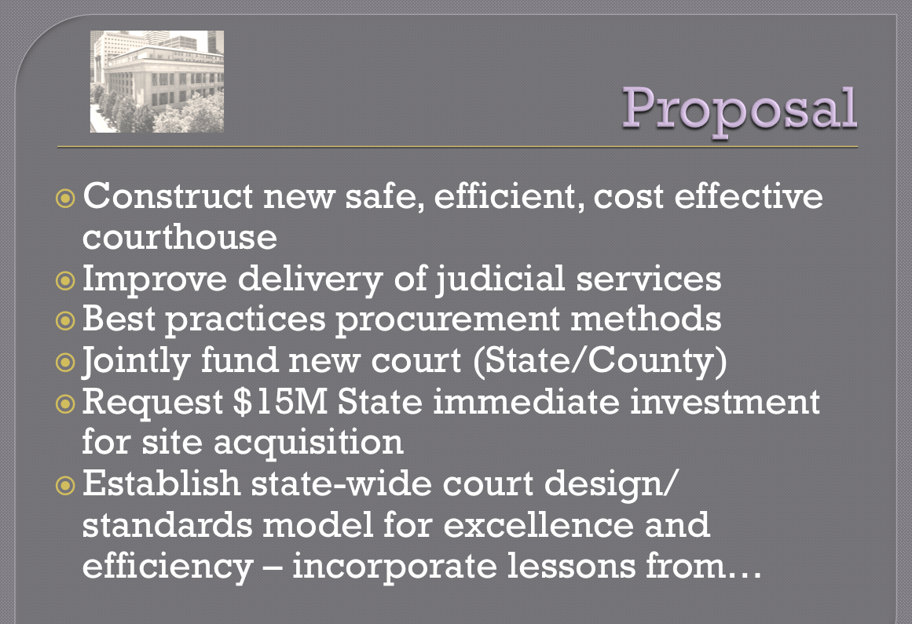
We’re seizing that momentum, and I was very happy that they didn’t throw me out of the office with a new job. Here’s our proposal. We also pitched this proposal to the state in February and March, because the legislature was in session. The two commissioners want the State to be a partner, as it’s the State employees that are in this building. The State doesn’t have an obligation, or didn’t have an obligation, to pay a dime into this project. That has changed with good lobbying and political unity.
I have $15 million in a theoretical bond measure – it’s basically a loan of the general fund – that we can buy a site with. That’s positive momentum. Then we’re bringing the state Staff in as part of the design team to start making sure that at the end of the day, this design will create some efficiencies for the state.
If we do our job, all the other counties in Oregon that have 100 year old courthouses, if we do this right my little point paper said the rounding error on this courthouse may be paying for another courthouse somewhere in the state, because of all the efficiencies and opportunities we have.
Then we’ll have a template, like many states and counties have done, on how to do business differently, how to configure the business differently based on the demographics of the court situation and the modern model.
We know that 1 out of 100 cases in the court system goes to trial. Does that mean that our buildings are 80% empty in terms of actual court things happening in those rooms? Why would I spend $500 a square foot over time for an empty building? It doesn’t make sense.
Those are the thought processes that we’re putting into the equation. Likewise, I have 40,000 square feet of stored paper in that building and in leased space elsewhere. If I spend $1 million in digitizing that over three years before we break ground, that’s a $20 million saving. That’s a 20 to 1 return on investment. If I study that, I can apply that model for all of the county facilities with lessons out of this building. That’s the thought process we’re tackling.
Here’s a quick schedule. The fiscal years for the County are July to July. At the end of the day, through the hiring of National Center for State Courts, and owners representative, and doing a P3 business case analysis next spring, we hope to be ready to put out draft procurement documents a year from now for a Design-Build. a Design-Build-Operate, and a P3 analysis based on the due diligence that takes place through those three studies.
I want to make it clear that our approach is the right consultant for the right time for the right decision that we need to be making. I’ve seen the World Hunger approach, with bringing in a big giant consultant team for five years. It was very expensive. I want to put that money into the building, so we’ve phased this intentionally with the specialist we need at the right time.
Momentum. We’ve just build a 1/10th scale model of the new court system out in East County. It’s the East County courthouse. It’s a $24 million project. Fabulous design, beautiful facility. So we have a living model of the new court system and how it’s going to operate, so we just need to get some new lessons learned into that. But the commissioners are excited that we accomplished this on time and on budget, great design and sustainable elements in the building.
John Lindenthal assisted in the project management of that building. As a matter of fact, he just won a Northwest Regional Award from the Portland Business Journal for leading a lot of those MacGyvers to do some fabulous cost containment in our county, so I’m very pleased with my staff.
I think that’s the end, and we’re open for questions.
Duncan: Thank you. I think what we’ve seen here is a couple of projects where people have really taken on the challenges to make something happen. I think in both cases, we’re going to end up with projects that maybe people didn’t think they were going to get when they started.
I think our profession is broken into two project pursuit processes, where people design something and then try to sell it to somebody for many years, or we actually roll our sleeves up and get in there with the owners and users and figure out what they want to do and what will get done.
With that, any questions for anybody on the panel?
Participant: Do you have any ideas about what you’ll do with the abandoned courtrooms? I know there are some interesting uses for what to do with outdated courthouses, other than spend a lot of money renovating. Is there some interesting reuse strategy we can…?
Michael: In the spirit of time, I left some of my notes off the last page, because I wanted to have time for questions. In Multnomah County, the other thing we’re doing is evaluating in a strategic plan a recapitalization of our county assets. We have an average of 50 year old buildings across the portfolio, 100 plus years to modern. I’m going to be disposing of some buildings, so one question is can I recapitalize and move those functions – as I think Doug alluded to – into that building? Could that be some county offices?
The other partnership we’re doing across an 18-month period is partnering with other local governments. I may have a surplus another county, state agency, metro, or city may have a need of. As we compare and contrast, this is probably fairly innovative for government – my gosh, getting five jurisdictions to talk and compare assets that we don’t need with your assets that we need. We’re leading that charge in Multnomah County, because there are several city jurisdictions, metro, and the City of Portland.
As we look at some of these buildings that we might want to keep, can we reuse them and consolidate several government agencies, or do a public/private type of deal with that? Or a condo arrangement in that building? Maybe it could be legal offices.
Between the time we finish the courthouse study and the time we finish this other 18-month process, we’ll be including this building as part of that debate and looking at options. I’ll probably be looking at the real estate development community for quite a bit of input on that – do some RFIs and whatnot – but I’m taking my whole portfolio: they’re keepers or they’re sellers.
If they’re sellers or excess, then what are the options? Both government and private. We’ll be there next summer by exploring some of those.
Participant: Doug, I’m curious about as you move forward out of this and into the new building, where are the judges on things like full service courtrooms as opposed to courtrooms for just doing domestic relations, or certain kinds of things? Where are the judges going on that, or is it too early to know?
Doug: I can tell you very definitely the presiding judges over the years have all aligned behind having to move to what really are the modern functional kinds of court facilities that are being built today. Those don’t include a lot of the traditional set pieces we have in a 100-year-old courthouse, with every judge having a courtroom, having a closed-door suite of offices attached to the courtroom, and having a jury room attached to the courtroom. We are educating the judges, and it is a process of education.
When the County built the Juvenile Justice facility that opened in 1995, we designed it with chambers separated from courtrooms, and with pathways in between so the judges could go to the courtrooms. The practical reality is we have six courtrooms and six judges, and they all have their own staked-out territory, but we have the functionality to move people around when we need to, and we do that.
The judges who go out there now have discovered that it’s really quite nice to have a collegial space where just judges can work together. On the East County courthouse – because of the footprint of the building, also – we put one courtroom on the first floor, two jury trial courtrooms on the second floor, and the judges’ chambers and the judges’ staff area on the third floor. The judges are in offices, and the staff are in open areas that will be unlandscaped. They will simply be out there working in the judges’ staff, both the judicial assistants and the clerks.
We are moving in that direction. We’ve worked closely with both the National Center and the architectural studies that have gone on over time in this county on committing ourselves to a situation where what we’re presenting as the judges’ needs are the lowest possible cost alternative commensurate with the dignity of the proceedings that have to take place.
It’s an ongoing discussion with all of our judges. We’re going to leverage the National Center’s talent to help communicate some of this, and we’re sending judges out to the East County courthouse to get a look at what the future might be.
Duncan: Thanks very much.

