ARCHITECT’S AND DESIGN PROFESSIONAL’S HIDDEN LIABILITY:
HAZARDOUS MATERIALS IN CONSTRUCTION
Abstract
A brief discussion of hidden hazardous materials liability carried by Architects and other Design Professionals on construction, renovation and demolition projects.
Architects and Design Professionals often consider the responsibility for hazardous materials on a project to be the Owner’s, the Owner’s Consultants, and the Contractor’s. Such a strategy, frequently used in the past, is no longer reliable.
This paper includes discussion on why not addressing hazardous materials in plans and specifications does not eliminate this liability, and suggestions for reducing and managing the liabilities surrounding hazardous materials in construction.
ARCHITECT’S AND DESIGN PROFESSIONAL’S HIDDEN LIABILITY:
HAZARDOUS MATERIALS IN CONSTRUCTION
Michael C. Sharp
msharp@hazmanage.com
OVERVIEW
Historically Architects, and other design professionals, involved in a construction project strive to avoid liability for hazardous construction materials such as asbestos, lead, PCBs, mercury, etc. Architects typically consider the responsibility for hazardous materials on a project to be the Owner’s, the Owner’s Consultants, and the Contractor’s. Such a strategy, though often effective in the past, is no longer reliable. Recent lawsuits and regulatory citations have pinned responsibility on design professionals and building owners who seemingly had nothing to do with the exposure that caused, or could cause, a crippling illness.
The handling of asbestos, lead, mercury, PCBs, silica and even mold during any construction project is not construction work - it is hazardous materials work, with completely different liability issues. Companies involved in any facet of a demolition, renovation or even current construction project that fail to grasp this salient fact expose themselves to litigation from injured parties as a result of contact (real or perceived) with hazardous materials. And, there is no statute of limitations, lawsuits can, and are, being filed decades after project completion.
Specific to Architects - The AIA’s Document B503™ – 2007 Guide for Amendments to AIA Owner-Architect Agreements (2007 edition) states in section 12:
“If the Architect is required to perform services related to mold or hazardous materials, the Owner agrees to indemnify and hold harmless the Architect, Architect’s consultants, and their agents and employees from and against any and all claims, damages, losses and expenses, including but not limited to attorneys’ fees, arising out of or resulting from performance of services by the Architect, Architect’s consultants, or their agents or employees related to such services, except where such liability arises from the sole negligence or willful misconduct of the person or entity seeking indemnification.”
This agreement between the Architect and the Owner, if the Owner agrees to this, is believed by many to protect the Architect from hazardous materials liability. However, it carries no regulatory authority or protection.
This paper, the first in a series of white papers, is geared particularly toward Architects, as well as Engineers – the design professionals most likely to misjudge their legal exposure when it comes to hazardous construction materials. This paper can also be of significant value to Construction Managers, General Contractors, Building Owners, and Facility Managers.
Relative to projects involving the handling, disturbance or removal of hazardous materials, the following topics are discussed with the body of this paper:
* Misconceptions and myths concerning hazardous materials, including regulatory liability
* Potential liability for design professionals, including uninsured risk, and
* Methods of reducing liability and controlling costs.

Though not written by lawyers (so further consultation with legal council is recommended), this document discusses how Architects, and other design professionals, can reduce their liability exposure to the greatest extent possible, while providing the best possible service to their clients. This includes how the designer of a project (or any portion of a project), can protect themselves, their company and their clients from liability associated with the mishandling of hazardous materials even though dealing with these materials may not be within their contractual responsibility.
Unless a remediation contractor removes all potentially hazardous materials within or on a building undergoing renovation, previously installed hazardous construction materials may be disturbed during the course of reconstruction. Thus, it becomes incumbent upon project design professionals to take steps to ensure that a design team is assembled that can address those materials properly. It is most time and cost effective to address these materials early on in the project design process.
Architects and design professionals that address the liability associated with hazardous materials, will also be able to provide their client with estimating services which anticipate and control the cost of handling these materials – a value added service.
THE PROBLEM
Regulatory confusion and misconceptions regarding hazardous materials liability have caused many Architects to believe they can avoid liability by not directly addressing the hazardous materials issues on their projects. Consequently, they often decide to not include hazardous materials consultants on their project teams.
As an example of this confusion, please note the following definition from Cal/OSHA’s Asbestos in Construction regulation - 8 CCR 1529(q):
“Asbestos consultant” means any person who contracts to provide professional health and safety services relating to asbestos-containing construction material as defined in this subsection, which comprises 100 square feet or more of surface area. The activities of an asbestos consultant include building inspection, abatement project design, contract administration, sample collection, preparation of asbestos management plans, clearance monitoring, and supervision of site surveillance technicians as defined in this subsection.
This definition appears to require the presence of an Asbestos Consultant on the project team for every project where the asbestos work conducted exceeds 100 square feet. Confusion in the industry regarding this requirement likely stems from the fact that, at this time, it is unclear if Cal/OSHA has ever enforced this specific requirement of regulation “8 CCR 1529” in regards to an Architect conducting contract administration on a project involving asbestos-containing construction materials. Even if Cal/OSHA were to start enforcing this requirement, only those Architects conducting “contract administration” on a project where asbestos related work is occurring would likely be required to be a Cal/OSHA Certified Asbestos Consultant or to have a Cal/OSHA Certified Asbestos Consultant on their project team. Even though Cal/OSHA does not appear to be actively enforcing this portion of its asbestos regulation, it is still in effect and can be enforced at any time.

Detailed examples of misconceptions about hazardous material liability are found in the following pages. These misconceptions and regulatory confusion in general create liability, inefficiencies and financial issues Architects must deal with. The following facts should be understood by the entire project team:
- Architects are now being held responsible on projects they design, draw, or specify when asbestos-containing or other “toxic” materials are disturbed inappropriately and a consequent nuisance or contamination occurs. See Appendix 1 – City and County of San Francisco Emergency Abatement Order 14-0514.

- Projects where hazardous materials are mishandled will, at a minimum, suffer delays and cost overruns. Alternatively, if Architects have someone on their project team who can properly address hazardous materials during all phases of a project, they can help ensure a project does not suffer from these delays and cost overruns. In the event hazardous materials are mishandled despite this proactive approach, a hazardous materials consultant, who is familiar with the project, can help limit the cost increases and schedule delays. See Los Angeles Time Article concerning delays on a project in Huntington Beach caused by management of the existing hazardous materials: http://www.latimes.com/local/lanow/la-me-ln-asbestos-scare-school-closure-20141010-story.html

- A project team without a qualified hazardous materials consultant is less able to accurately estimate the hazardous material portion of the project.

- With a qualified hazardous materials consultant on the project team, Architects can deliver the highest quality product to their client, including a significant reduction in project liability.

MISCONCEPTIONS REGARDING HAZARDOUS MATERIAL LIABILITY
There is an inaccurate belief within the construction, renovation, and demolition industry that hazardous materials are the sole responsibility of the Owner and the Hazardous Materials Contractor. This belief has been reinforced over time due to underlying misconceptions and construction liability myths such as the following:
Misconception: Insurance carriers won’t allow Architects to address hazardous materials in their specifications.
Fact: Architects are typically not insured for hazardous materials issues. Yet, when working on projects which include renovation or demolition (even some projects involving only new construction), they are often asked to design projects that will disturb hazardous materials. The concern often expressed by Architects is, “If I address hazardous materials and something goes wrong, I may be held liable and my insurance won’t cover me.”

While this could occur, even if an Architect does not address hazardous materials in the project specifications, and hazardous material issues arise on the project, the Architect may be still held responsible. General liability insurance policies typically contain a “pollution exclusion.” This exclusion eliminates coverage for any liability associated with most hazardous materials, including those not addressed in the specifications for the project. In other words, Architects can be held liable when hazardous materials are disturbed, but they often do not have insurance covering that liability.
Therefore, when Architects have projects that involve the handling of hazardous materials, the best way to reduce exposure to liability is by bringing subject matter experts (hazardous materials consultants) onto the design team to develop contract documents (specifications and drawings) which adequately address the hazardous materials.
Misconception: If Architects address hazardous materials in their specifications, they are then responsible/liable for how the hazardous materials are handled.
Fact: Architects do not need to address hazardous materials in the specifications in order to be held liable for how the materials are handled. For example, if an Architect draws plans that require a wall to be removed, and the wall is painted with lead-paint or contains asbestos, the Architect can be held liable if the wall is not removed properly. See Appendix 1 – City and County of San Francisco Emergency Abatement Order 14-0514 for a copy of a citation issued to an Architect for project plans that required the disturbance of materials. The Architect was apparently unaware that the materials contained asbestos. Still, everyone involved in the project, including the Architect, the Professional Engineer, and the Owner, were issued an “Emergency Notice to Cleanup and Abatement” order. The Architect was named as a “Responsible Party” despite the fact they did not address the hazardous materials in the plans or specifications. The Professional Engineer (Structural Engineer) and Building Owner, as well as the contractor doing the work, were also named as responsible parties in this case.
This issue is also well documented by the actions of the flooring surface manufacturing industry. On almost any box of floor surfacing material that includes instructions on how to prepare an existing floor for installation of a new floor, one will find a warning that old floor surfaces and mastics that are to be removed may contain asbestos. This warning is the result of lawsuits filed by those following installation directions for a new floor surface. These directions instructed them to remove the flooring surfaces and, thus, expose themselves to asbestos. There is no way flooring manufacturers could know whether the old floors contained asbestos or not, yet, they were held responsible for the exposures experienced by those following their instructions.
Because Architects may be held liable either way, they are better served if they control the liability. By using a hazardous material consultant to directly address hazardous materials requirements within the contract documents, Architects protect not only themselves, but also the entire project team and the Building Owner. The only way to control this form of liability is to ensure that a thorough inspection for hazardous materials has been conducted and that any hazardous materials that may be disturbed are clearly indicated. Requirements for the handling of these hazardous materials must also be adequately addressed.
Misconception: Abatement Contractors have licenses and certifications that are at risk if they do something wrong, therefore, Abatement Contractors will follow the rules.
Fact: The belief that hazardous materials regulations are strictly enforced is often incorrect. In reality, hazardous materials regulations are enforced by regulatory agencies about as often as speed limits are enforced on freeway drivers. With the exception of local air districts (for asbestos and demolition projects), most projects will not have any on-site regulatory scrutiny concerning hazardous materials.
In addition, when regulations are enforced and Contractors are caught doing something wrong, it is already too late to protect workers from exposure. It is also too late to protect the Architect and the Building Owner from the liability associated with that exposure.
Another misconception is the belief that Contractors are licensed to do hazardous materials work. In California, the Contractor’s State Licensing Board trade license for asbestos abatement was not established until January 1, 2015. Only a small percentage of those conducting asbestos work currently have this license. There is no trade license required for handling lead, mercury, silica, PCBs or many other hazardous construction materials.
Finally, many Abatement Contractors’ workers do things incorrectly so often that they no longer remember or understand what the regulations require. Most workers, and often the supervisors in charge of them, have never read the specifications for the project they are working on. It is not reasonable to expect workers who have never read the project specifications to understand and to follow those specifications. Many hazardous material workers also have very little cogent understanding of the regulatory requirements governing their work.
The best way to protect the project team from hazardous materials liability associated with worker-related errors is to have the abatement work monitored by a hazardous materials consultant. In order for the Consultant to protect everyone from this type of liability, they must document that the work was conducted in accordance with the specifications and in both a legal and safe manner. As discussed below, “legal” and “safe” are not the same thing!
Misconception: Hazardous Material Contractors deal with hazardous materials for a living, therefore, they will do it well.
Fact: On construction projects involving the removal of fiberglass insulation, workers will protect themselves more thoroughly from fiberglass than from asbestos, lead, and other hazards that may exist. When handling fiberglass, protective suits are often worn with the wrists and ankles taped. Every hole that is torn in the suit is usually repaired as soon as it is noticed. Gloves, eye protection, face protection, and hardhats are generally worn consistently.

Fiberglass is a material that, for the most part, makes a worker uncomfortable for a few hours. On the other hand, asbestos, lead, PCBs, mercury, silica and other hazardous materials can make workers sick and potentially kill them in a slow and painful fashion. Nevertheless, when handling asbestos, lead, mold, or a number of other hazardous materials, it is often a battle to get workers to wear personal protection equipment properly and to decontaminate properly when leaving the work area.
It is a tragedy for those exposed to hazardous materials to develop illnesses and diseases later in life from exposure they did not realize was occurring. It can also be a liability issue for those involved in the project. See Appendix 2 - Foley & Mansfield Freedom of Information Act Request for a copy of a letter, concerning a lawsuit filed in 2012 requesting documentation for a project on which the plaintiff claims to have been exposed to asbestos. The project took place between 1972 and 1974. When reading this request for documentation, keep in mind:
- The letter is being sent to the Building Owner by a member of the project team (General Contractor), not directly from the Plaintiff.
- Nothing in the letter claims any regulations were violated during the project.
- The letter requests documentation despite the fact the attorney that wrote the letter knows the documentation does not exist.
- The letter was received nearly forty years after the project was completed.

The only way the project team could have protected itself and the Owner from this type of lawsuit would have been to document the activities of the Contractor on the project and report that the work was conducted in a safe fashion. That is the only way to limit an Architect’s liability on today’s projects as well.
Misconception: As long as the Hazardous Material Contractor does his work legally, the hazardous material work has been conducted safely.
Fact: This misconception was proven false in the previous topic. The plumber exposed himself to asbestos in the 1970s. Then, in 2012 the plumber sued those who allowed him to expose himself to asbestos, although he did not appear to violate any regulations.
Even more telling is the fact that while there is “no known safe level of exposure to asbestos,” Cal/OSHA (as well as Fed/OSHA) refers to a “permissible” exposure to asbestos. This kind of exposure is defined as “a level at which it is legal for a worker to remove their mask while working with asbestos.” How can there be a permissible level of exposure if there is no safe level? Though this question has an answer, the answer has little to do with safety and is irrelevant to the discussion of Architect and design professional liability.
In another example of this issue, the current permissible exposure limit to lead per Cal/OSHA is 50 micrograms per cubic meter of air (ug/m3). According to a study published in November 2013 by the National Institute for Occupational Safety and Health, the California Department of Public Health and UC Berkeley, the level at which someone can be exposed to airborne lead without increasing their blood lead level above a level of concern, while working an 8 hour day, is between 0.5 and 2.3 µg/m3.

It is currently legal to expose yourself to 50 µg/m3 but it is not safe to expose yourself above 0.5 to 2.3 µg/m3. There is something wrong with this picture. At the time of the writing of this paper, Cal/OSHA is in the legislative process of lowering the permissible exposure limit. This process is expected to be completed in 2016 or 2017.
The only way to assure a project is conducted both legally and safely is to have a hazardous material consultant on the project team who understands the difference between “legal” and “safe.” The consultant must write specifications for the handling of the hazardous materials in a fashion that is both legal and safe and document that the project was conducted in such a manner.
Misconception: When the Hazardous Material Contractor has completed his job, hazardous material issues are no longer of concern on a project.
Fact: This myth most often becomes an issue on projects where partial removal of hazardous materials is conducted. Even on projects where specifications are written to assure the safe and legal handling of hazardous materials, if any hazardous materials are left in place during the renovation or demolition activities, then all the issues and types of liability previously discussed continue to exist. Not only that, there are hazard communication and construction regulations that require all contractors working in areas where hazardous materials remain to be notified of their existence and specific locations. In addition, these workers must also be at least “awareness trained” on the hazards involved with the inappropriate disturbance and exposure to those materials.
Many project team members believe that it is the responsibility of the Contractor to train his people in the hazards that exist on project sites. This approach would be fine, provided the Contractor is informed about hazardous materials remaining on the specific project on which they are working. However, who on the project team is responsible to assure that this training has actually been conducted? If a Contractor is allowed to employ untrained workers, it is not only the Contractor who is liable but also the controlling entities on the project. The controlling entities can include the entire project team and the Building Owner. See Appendix 3 – U.S. EPA settles asbestos case with Bay Area construction consultant for an explanation of a citation issued to the Contractor, Construction Manager and Building Owner for work impacting asbestos conducted by untrained workers. Again, proper project design, monitoring and documentation is the only way to control this liability.
Misconception: If any project team member issues specific direction to a hazardous materials contractor, they become liable for the means and methods used by that contractor.
Fact: With most construction work, the product for which the Owner pays is the completed work. With hazardous materials remediation, the “product” that is paid for is actually the process by which the removal work is conducted. In Appendix 4 – Department of Consumer Affairs, Legal Affairs Division – Consultants vs. Contractors, you will find a letter from the California Department of Consumer Affairs, Legal Affairs Division that specifically states a hazardous materials consultant can stop work by a hazardous materials contractor if that work is not in compliance with the written hazardous materials remediation plan/specifications, without taking the responsibility for the means and methods employed by the remediation contractor.
THE SOLUTION:
Architects can limit their liability when it comes to the handling of hazardous materials but they cannot eliminate it. The best way to limit an Architect’s liability is to control the dangers that present themselves. In the past, and while there are exceptions, Architects typically excluded dealing with hazardous materials altogether. This approach can no longer protect them from liability, and never really has protected them. Liability from past projects remains. Remaining uninformed and not addressing the handling of hazardous materials on projects exposes Architects to greater liability associated with the actions of every construction worker on the project.
We are not trying to suggest Architects and design professional’s start addressing the handling of asbestos, lead, mold, and other hazardous materials directly themselves. However, no renovation or demolition project should be conducted without a hazardous material consultant involved in some capacity early on in the design process. In fact, having a competent consultant on board as early as the conceptual design phase can help the team avoid costly pitfalls by noting hazardous materials early in the design, and potentially suggesting ways to avoid their disturbance, thus providing cost-efficient alternatives that can help a project’s budget. Even on projects where the Building Owner has his own hazardous materials consultant, the Architect should at least ensure the information provided by the Building Owner is thorough and sufficient for the project at hand.
The responsibility for proper handling of the hazardous materials during construction, renovation and demolition projects is the responsibility of the entire project team, as well as every contractor and worker on the project site. This includes the lowest level Sub-Contractor, the Building/Facility Owner and the Architect. Not addressing the hazardous material activities in project specifications increases the Architect’s potential liability, rather than decreasing or avoiding it. There is no way to avoid or transfer the liability that comes with the disturbance of hazardous materials. All an Architect can do is manage the potential liability, and keep it as low as possible as often as possible.
As with mechanical, structural, electrical, and other various engineering disciplines, the Architect cannot be expected to be an expert in everything that occurs on a project. An Architect’s only means of control for these engineering issues is to have Professional Engineers on their project team who the Architect knows can be trusted to perform as professionals. A competent and qualified hazardous material consultant is no less important.
Items Cited
Appendix 1 – City and County of San Francisco Emergency Abatement Order 14-0514
Appendix 2 - Foley & Mansfield Freedom of Information Act Request
Appendix 3 - U.S. EPA settles asbestos case with Bay Area construction consultant
Appendix 4 – Department of Consumer Affairs, Legal Affairs Division – Consultants vs. Contractors
Linked Item – Los Angeles Times - Asbestos Scare: Huntington Beach Elementary School Closed Indefinitely: http://www.latimes.com/local/lanow/la-me-ln-asbestos-scare-school-closure-20141010-story.html

Topics To Be Discussed In Future White Papers:
- What to think about when hiring a Hazardous Materials Consultant.
- What a Hazardous Materials Consultant can and cannot do for you.
- How to assure you have a complete, thorough and regulatory compliant inspection on your project.
- How to avoid conflict of interest issues surrounding the handling of hazardous materials.
- Tips, tricks and warning signs to watch for when hiring a consulting firm.
- How to find a legitimate, competent Hazardous Material Consultant.
- How to understand the information provided by the Hazardous Materials Consultant.
- Why Specifications for construction trades tell Contractors what to do but not how to do it, while, on the other hand, specifications for hazardous material work should tell a Contractor (or Consultant) not only what to do, but how to do the work. (There is a Worker’s Compensation issue for the Building Owner to consider here.)
- The “product” of a construction trade is most often something that has been built or altered. The “product” you are paying for when hazardous material work is conducted is the “process” followed by the Contractor.
- Why, on projects where asbestos and other hazardous materials remain in place after the remediation work is complete, the Hazardous Material Consultant should remain a vital component of the Project Team.
- How hazardous materials disturbed inappropriately by non-remediation contractors carry all the same liability (short and long term) as hazardous materials inappropriately disturbed by remediation contractors.
- What to look for in specifications written by a Hazardous Materials Consultant for remediation work.
- Typical list of activities for Hazardous Materials Consultants on a renovation or demolition project before, during and after the remediation work is conducted.
- Peculiarities and common mistakes concerning the remediation of mold.
- Other Hazardous Materials including PCBs, mercury, radiation sources, Freon, etc.

Author:
Michael C. Sharp
Director of Training Asbestos and Lead Courses - UC Berkeley Center for Occupational and Environmental Health
CEO/Director of Training – Hazard Management Services, Inc.
Founding Executive Board Member – Association of Northern California Environmental Consultants
Board Member Lead and Environmental Hazards Association
Cal/OSHA CAC 94-1564
CDPH I/S/M 3763
msharp@hazmange.com

Co-Author:

JD Grothe, AIA, Retired - jd@jdgrothe.com

Editor:

Regina Coony, Architect - rcoony@openspaceauthority.org

Contributors:
Tom Wangerin – Wangerin Environmental - tomwangerin@gmail.com
Jim Sharp – Founder, Hazard Management Services, Inc. (209) 551-2000
Philip Goodwin – Hazard Management Services, Inc. - philycheese@sbcglobal.net
Joe Vuglia – Hazard Management Services, Inc. jvuglia@hazmanage.com
Burt Olhiser – Vantage Point Consulting - burt.olhiser@comcast.net
Peter F. Connell – PFC Industrial Hygiene Consulting - pfcih@earthlink.net
Butch Reynolds, CIH - lsreynolds3@gmail.com
Jim Wilson – ACC Environmental - jwilson@accenv.com
Cory Suppes – CMS Consulting Services - csuppes@sbcglobal.net
Bob Sutton – Sensible Environmental Solutions, Inc. - bob@sensibleinc.net

APPENDIX 1

CITY AND COUTY OF SAN FRANCISCO

EMERGENCY ABATEMENT ORDER 14-0514

ISUUED TO ARCHITECT AND OTHERS

APPENDIX 2

FOLEY & MANSFIELD

FREEDOM OF INFORMATION ACT REQUEST

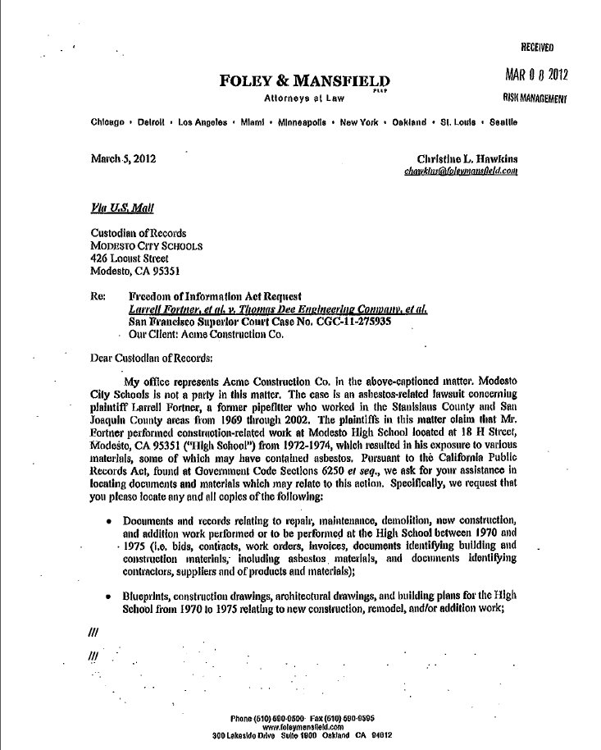

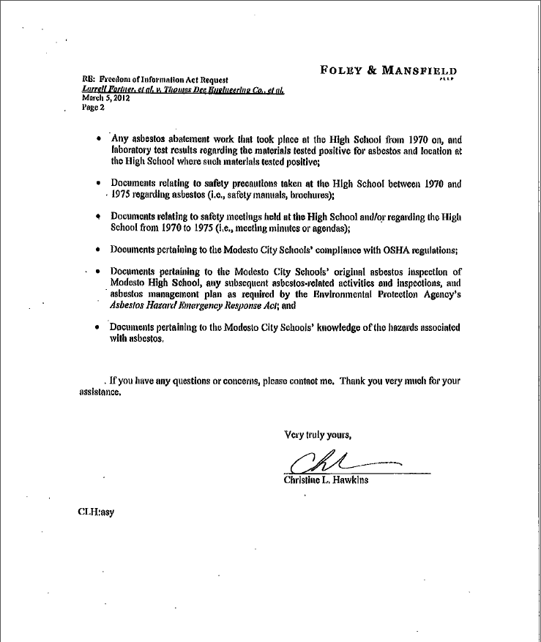

APPENDIX 3
U.S. EPA SETTLES ASBESTOS CASE
WITH CONSTRUCTION CONSULTANT

APPENDIX 4
U.S. EPA SETTLES ASBESTOS CASE
WITH CONSTRUCTION CONSULTANT

