California Highway Patrol, Grass Valley Lessons Learned: A Case Study
Mike: I’m Mike Smith. I’m with Nacht & Lewis architects. We’re presenting on the California Highway Patrol Grass Valley Area Office Replacement – Lessons Learned. This is a case study of a Design-Build-Finance project for the California Highway Patrol.
We have the usual copyrighted material warning here at the front end from the AIA. This is slated for one and a half learning units. They’re sending out an e-mail on Friday evening for us to respond to to rate the courses and get our credits.
Our learning objectives:
- A description of the California Highway Patrol Design-Build-Finance program,
- Risks encountered in the project that we recently completed,
- Approaches to mitigating those risks,
- Lessons that each of the participants in the group have learned,
- Suggestions for revisions to the program.
These may have more general implications, as well, because a lot of the things that we’re talking about were talked about in the earlier sessions, but we have specific examples and suggestions about what next steps we might take.
Let me introduce the team. As I said, I’m Mike Smith with Nacht & Lewis architects. I’m senior project manager there and was the project manager of this particular project. With us today, we have the other two parts of our development team.
Pat: I’m Pat McCuen. I’m partner in Capitol Avenue Development & Investments in real estate development. I’ve worked as either an owner, an owner’s rep, or a construction project manager for my 30-year career doing a variety of commercial buildings, hotels, and some law enforcement and technical facilities.
Erik: I’m Erik Winje. I’m with DPR Construction. I’ve been working in construction for the last 38 years or so, and DPR for the last six years. My role on this particular project was a Design/Build manager. We at DPR were responsible for the Design/Build of this project, and our contract was directly to Pat McCuen and Capitol Avenue Development.
Mike: The California Highway Patrol has 80 plus offices throughout the State of California for the patrol crews spread throughout the State. The buildings, for the large part, were built in the ’50s and have reached the end of their useful life, and they have a large deferred maintenance issue. It is beyond deferred maintenance to “just need to replace.”
The issue is so large and so urgent that they have decided to approach replacing them in multiple delivery methods. Some are traditional capital outlay. Some are less traditional Design-Build-Finance where they are bringing in development teams to respond to a programmatic level or bridging document and not only Design/Build the facility but finance the project, as well.
The lease, in these cases, are 25-year leases and 20-year firm term. That, as we will get to later, is a critical element of this in that these are very specialized facilities, so any shorter-term lease creates an imbalance in what the product delivered in the useful life of it and the impact of that on financing. We’ll hit that a bit toward the end.
The Grass Valley facility that we all worked on is the first one to be delivered by using the Design-Build-Finance method. What’s curious is it was also nearly the first to open in this round of work even though it started six years after the first capital outlay project. We have a more rapid delivery process than the traditional state process. This certainly confirms one of the major advantages of Design/Build, which is that you can turn projects out more rapidly. That was certainly the case in this project.
Pat: For this particular one, the State selected the property that they wanted the facility to be on. They did that for completely justifiable reasons, in that not every piece of real estate is going to serve their programmatic requirements in the same way. If they went out and bid multiple sites against each other, part of the analysis in figuring out if one is better than the next gets to these intangibles about how does this site serve the program compared to the other site? So they chose a specific site and had all of the teams bid on that site.
They created a complete set of bridging documents that was a little bit beyond schematic, and we responded to that. They had done quite a bit of due diligence on that property to make certain it was suitable from a programmatic requirement, as a developer will. But it wasn’t a complete set of due diligence, and that introduced some of the challenge in the bid process. They only partially released the due diligence, and that polluted the bid process.
It was during the bid that those with more curiosity found the questions and answered those questions – and that happened to be our team – and addressed issues that they had left open without truly disclosing.
They had done complete schematic design of room-by-room layout, with exterior architecture completely identified, and then requested a 25-year lease, 20-year fixed term, with purchase options starting in year ten.
Mike: Pat was talking about with unresolved due diligence, and this is an issue whether there is one site or multiple sites competing against each other. One of the big risks out there is that the site that’s selected won’t be suitable, won’t be able to get its CEQA certification. A certain amount has to be done to allow that to happen, and that’s why the State went as far as they did with their documents.
One of the major things that we’re doing in this presentation is looking at that the risks that we faced were and how we mitigated those risks. A lot of getting to a successful conclusion with these projects is identifying those risks and eliminating them as quickly as you can or taking advantage of opportunities that you find as quickly as you can.
In this case, the State’s geotech had gone to the Department of Conservation who had to okay the geotechnical report, because you’re not allowed to build an essential services facility – and this being a law enforcement facility fit that mold – within a flood zone, on a property with earthquake faults, or in mining areas. This is in Grass Valley, California, which is where the original gold rush took place, and there are mines quite nearby. That was something that needed to be looked at.
The geotech of record had put in the report some suspicion that there might be some geotechnical issues – there might be fault lines, there might be mines – but didn’t really resolve it.
Pat: In fact, they had done some amount of work that came back with ambiguous results in their field studies, so rather than take it to the next step and resolve that ambiguity, they left that ambiguity out there.
Mike: The State had actually commented on the ambiguity that was there and asked for follow up but none had been given back to them. But none of the bidding teams actually knew this. We found it by going in and actually talking to those departments, and talking to the geotech.
We raised the red flag, and looked for ways to mitigate that. One of those was to talk to a local geotech who had mining experience, and they had records that showed that it was unlikely that there were mines on this site because there were no claims in this particular area. They also indicated that with a trench through the site, we could satisfy the issue of the faults. We had a certain amount of risk going forward, but we knew what the risk was, and we proceeded from there.
By the way, the picture here is a five-foot diameter, 40-foot deep well found on the site, lovingly referred to as the “mine shaft,” which was not picked up in the electric resistivity testing that was done by the geotech. What they did pick up was a lot of tree roots, and that’s what all the questions were about: a bunch of tree roots.
Pat: That is part of our under-1% contractor-initiated change orders. We had to fill the hole.
Erik: Pat talked a little but about what we were given as part of the program documents. One of the things that they represented was they laid out the building on the site. The way that they envisioned it was a flat site, but actually, when you go out there to the site at Grass Valley – it’s up in the foothills of California, a beautiful location – it had a 30-foot fall across the width of the site.
It led us to a problem, because also in the contract documents, it said that we were to get this job done in ten months. You can see that if we’re going to make this a flat site it would be a lot of work on the grading side, and probably no way that we could finish within the ten months. What the team did is come up with a way of answering some of the questions or concerns –Mike talked a little bit about the mine at the beginning.
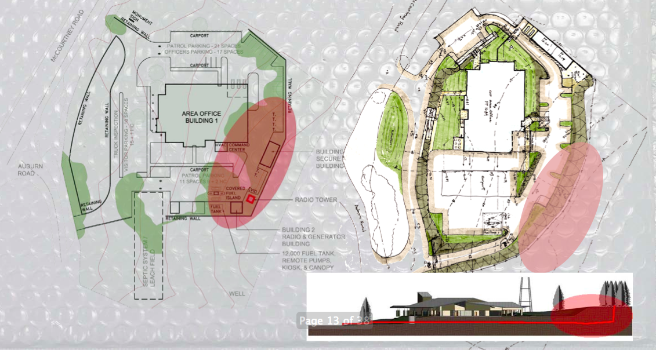
On the left side is the original – how they thought the area office should be laid out. That big red circle is the area where we thought the mines might be. You can see they’ve located a radio tower, which is 120 feet high and the footings are about 20 feet deep or so, right in that area. That was problematic.
On the right side is the way that we ended up, which is more of a tiered or sloped type of approach. Down at the bottom you can see that cross section the way that it was originally intended. You would cut that site flat, and you would have this huge retaining wall at the back side.
What we ended up doing was a solution that you can see where we have it stepped and we have that radio tower located away from the mining area, and we’ve taken advantage of some of these huge pine trees in the back as part of our landscaping. It’s a much more elegant solution to the problem.
Pat: It becomes a case where the bridging documents needed to be referred to from a programmatic level, but from a schematic design level, we almost had to throw them out and start over, go back to the relationships and go back to the program, and start from that point and take it forward.
Erik: In the program, it talks about some of the ways that we can build the project. It talks about using a wood frame structure and a fiber cement lap siding. With that type of construction, the water requirements are high because of the fire sprinkler requirements.
As a team, we said there’s a better way to take care of this. This is again one of the things that Pat talked about: as a team we’ve taken certain liberties with that program. We constructed it out of noncombustible materials. The walls were a CMU block, a lap side block, and the roof structure was a structural steel with light gauge metal framing, which we’ll get into a little later.
This noncombustible construction type made this alternate means of protection request possible by counteracting the low flow of water available on the site. It was a nice solution to a problem that the site already had.
Because of the site being rural, we had to put a septic system in. We haven’t put a septic system in a project for a long, long time. This problem of being in a rural setting had its own unique sets of problems.
Mike: It’s actually at the junction of the urban-wildland fire interface. You could have wild fires that would come down through this site. One of the things that we were concerned about was making sure this thing was as noncombustible as possible, and we had as much of a buffer as possible, so that there isn’t damage to these buildings.
The next thing that we looked at was some entitlement risks. We’re competing on the basis of best value, but of course, price is not an insignificant part of the equation. One of the things we were worried about is the impact to the local jurisdiction for permitting and for entitlements.
We went to the planning department and talked to them, and they were not happy with the particular fencing type that was proposed. It was this very high security fencing with splayed pointed tops on it. It was a pretty forceful image. They were not a real popular group in that part of the state – none of the law enforcement is terribly popular in that part of the state – so they didn’t want to project that kind of image. They wanted to soften it.
One of the benefits of having stepped this site up and put the public access slightly lower than the building, is that now vehicles had a much more difficult time actually getting up into the site and invading the area where building entrances were or parking was, so we could go with a lesser fencing to soften that.
This is really part and parcel of a lot of things, though, not just the fencing. There are things in this type of building – like 120-foot radio towers and above-ground fuel tanks – that aren’t the most popular thing with the local jurisdiction, and so we had to be careful about the way we approached those. We had to go to the local jurisdiction and talk to them about those issues in advance and do some visualizations for them, as well, to make sure they understood what this was going to look like. You can always imagine a lot more problems if you don’t have the visualizations to look at and really understand it.
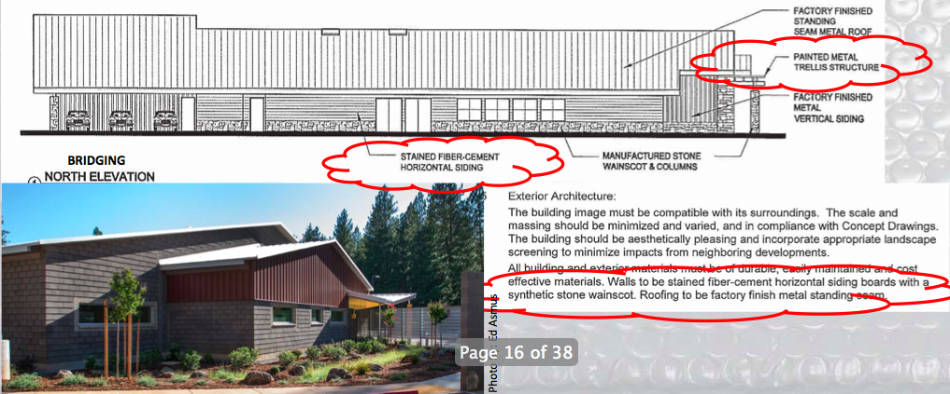
Along this same line, there were maintenance risks. One of the things that we noticed about the program was that it was calling for this stained fiber-cement siding. In this particular area, the team had some experience with stained fiber-cement siding and how it held up, and didn’t feel that it was a particularly good material for appearance over a 25-year period.
Pat: Keep in mind that our group owns this building for at least ten years before it’s sold – potentially 20 to 25 years – and so it was critical to us to make decisions on all materials that have longevity, because we’re responsible for them.
Mike: I think that’s a bit of a difference here, too, between just the straight Design-Build and the Design-Build-Finance where there is ownership over a long period of time. Now, the team that’s putting this together really has to make sure that it’s going to hold together over a long period of time. It’s not just a matter of giving a warranty and then heading out. It’s a matter of actually having to live with the results of it.
The other thing that was noted is that they were talking about painted trellis structures, so we decided that we were just going to go with galvanized metal structures and work the aesthetic around the galvanized metal structures.
We are in a community that had a lot of mining and ranch buildings, and that type of thing, so the aesthetic wasn’t out of keeping. The State actually made the observation that they wanted things to look very simple, look like they had not spent a lot of money on their facility, and so they wanted it to be more industrial in look.
Pat: In fact, the metal siding you’re looking at is the only truly coated finish on the exterior of the building. The balance is CMU with integral color, and then galvanized roof panels. The fencing is in some cases coated aluminum, and in other cases, we did it out of rebar so that the rust became part of the aesthetic.
Mike: We actually have rusted rebar fencing, and that’s seen on the right side of that photo. It’s reinforcing bar welded to tube-steel fence and pre-rusted. It gives it more of a rustic – if you will – appearance and it also discourages climbing, because not too many people want to climb over a rusty fence.
This next one is about the permitting risks of parallel paths.
Pat: The parallel paths are introduced because of the private ownership of the public facility. In California, when the State builds for itself, it plan checks itself and can ignore the local jurisdiction. It’s building on it’s own property. Once it owns the property, it has jurisdiction. But, in this case, the real estate and the building are privately owned, leased to the State for their benefit, so we are obligated to go through the local permitting process, just like any other private building.
In addition, because it is an essential services facility, we have to go through the Department of the State Architect and their permitting process. With parallel paths now, we introduce the challenge of conflicting requirements in goals and priorities.
Mike: You’re also looking at the State Fire Marshall and the local Fire Marshall both checking the project. There’s a lot of potential for problem there.
Recognizing that, we actually sat down with those entities in advance. We said to the local jurisdiction, “We’re paying permits to you on these things. We’re going through the process of getting it checked by the State. You will want to look at these, as well, because it’s something that if the State were to walk away, this would have to be permitted locally. How do you want to do it?”
We sat down and we came up with a plan by which we would bring the plan check that the State generated to the local authority. They could see the comments made by the State, they could see our responses, and they could have a copy of those permitted plans from the State. In addition to that, anything that was specifically local to them – like going out into the street to make connections, or street improvements, the things that are more specific to a local jurisdiction – would be permitted and plan checked by them.
This kept it from being redundant. The same thing happened for the Fire Marshall. The local Fire Marshall generally looked at response issues, water flow, and hydrants, and the State Fire Marshall looked at more life safety issues. The photograph shows the State Fire Marshall and the local Fire Marshall on the site, studying a fire hydrant rising. That carried on throughout the process through construction.
This is something that everybody has been getting to in these, and that is how do you quantify the unquantifiable in design excellence? Bridging documents can give a subjective, general feel for what they’re looking for, but unless you’re going to go to the really detailed bridging documents where it’s actually spelled out completely, there is a certain amount of ambiguity to this, and these are issues that are vulnerable to construction cost control.
What we adopted ourselves is more of a poetic pragmatism approach, which is to say anything we put out there as an aesthetic element also has to function in some way as a pragmatic functional element to the facility, as well. This way, we can compete on price and still incorporate aesthetic elements into the facilities.
Part of that is looking at where the spending counts. In this particular site, because it’s a sloped site, the approach that the bridging documents had taken and the design guidelines of the local community took was you need a lot of variety in your roof forms, you need to break up the mass of that building, you can’t have a single ridge on a building – a traditional approach on massing. When we looked at it we said, “But you’re not really going to see the roof very much.”
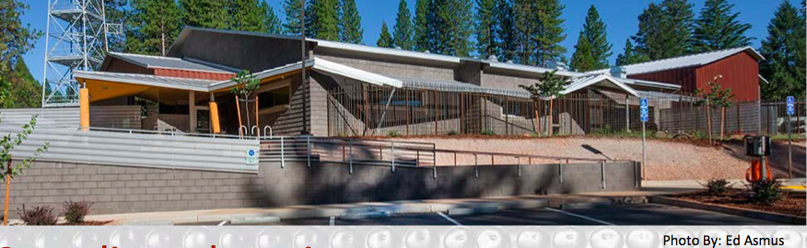
The approach we took was to take the lower edge of that roof and add the complexity there. We did it using a canopy system that wrapped the building and provided weatherproof cover at the entrances and screening to screen out the western sun. This edge of the building that’s the public edge is also the west face.
You can see, in this picture, you have a large piece of glass, this is the late afternoon, and it’s shadowed by the screening material that we have – in this case a corrugated perforated metal panel on that canopy.
Erik: Mike talked a little bit about some of the aesthetic challenges. On the construction challenges, I want to go over a couple lessons that we learned. We talked earlier about the type of material. This block that we’re going to use is a shiplap block. We thought it was a great solution, because it’s durable and you don’t have to spend a lot of time painting it and worrying about it. We thought, from the planners’ viewpoint, they love that shiplap, that texture.
But what we didn’t account for is that shaped block takes a little bit longer to install. The critical path through the project is getting the foundation, getting that structure, getting the building watertight, and it runs right through these walls. It took a little bit longer to get the masons to get the production up to where they wanted it.
It pushed us into a period where we caught a bad winter, and we were under that very tight, ten-month construction schedule. It forced us into some of the rain and the problems thereof that caused us probably to shove the completion back about a month.
The point being, we just have to be careful as we introduce new materials into a project, and we really have to assess what that impact is. We have a pretty good idea of the cost – we have the feedback, and we’re looking at budgets all the time – but the production caught up to us a little bit. We didn’t expect that.
Pat: The second element of that production that was a challenge was that – as we said before – this is an essential services facility, so it is structurally designed with a 1.5 importance factor. All of your structural loading is increased, and so the standard details the industry is used to don’t apply.
All the subs, as they bid it, they bid using the production rates that they’re comfortable with. But they get out there and they find out that there are twice as many connections and every connection is inspected. That telegraphs the issue and made it increasingly difficult to get from the walls onto the roof and get weather-tight.
Erik: Going back to that picture again, on those gable ends, part of the idea was trying to simplify the roof structure, but in the end, it complicated that gable end. It’s a lot of work that ended up pushing out getting that envelope done of the building.
The next thing that we want to talk about is the roof. The program required a sloped roof. We were under the auspices of the Department of State Architect, and they have their safety factors. We originally thought we could do something very simple with a pre-engineered truss system from a local subcontractor who could manufacture these items. The problem we found was that these manufacturers used proprietary software. The DSA were not comfortable with it, they wanted to see the hand calculations.
Sometimes, you wonder if it prevents a little bit of that innovation going on, because you’re really going to solutions that have already been established by the DSA. No one wants to step out a little bit and push the envelope, because it just delays the process. Pat’s watching time and the money associated with that time, and there is risk as the schedule pushes out.
We ended up going back to a regularly designed structural steel, with the framing of the attic as a light gauge metal stud frame. Again, because of the DSA requirements there was a lot of bracing and close attention to the joints. The roof went up quickly, but getting that attic took a little bit of time.
Mike: The other thing is that the light gauge metal framing turned out to be 16-gauge light gauge metal framing, which neither the structural steel guys wanted to touch nor did the light-gauge metal guys want to touch. We ended up in a strange in-between land.
Wall protection: one of the things that we noticed when we were looking at the bridging documents was that there was no provision for protection of the wall surfaces in the corridors. For any of you who have done law enforcement facilities, they are very vulnerable to damage due to the leather gear worn by officers, and so usually, there’s at least a chair rail or a wainscot of some kind in these corridor situations.
We also had a lot of rooms that were required to have a 50-STC sound transmission, and that was going to require us to have three layers of gyp board. What we decided was one of the three layers of gyp board could be substituted with ¼ inch hardboard – Masonite.
It’s a material that got a lot of use in the ’50s and early ’60s. It’s not used so much anymore. It has twice the density of gypsum board, so from a sound standpoint, we were able to substitute it, and we could create a finish that didn’t require any paint touch-ups and was relatively inexpensive to replace.
We proposed it. We went in and demonstrated it to CHP. They looked at it, kept it for a while, scarred it, scraped it, kicked it, and after a while said, “Okay. We’ll take the chance. We’re going to do this.”
It is an ongoing experiment, because this is something that does scratch over time, and if you replace it, you’re not necessarily going to get something that looks exactly like the one you had. There are some issues with it, but we are all aware of it and we’re watching it to see how it works.
It ends up with an interesting aesthetic where you have a wood feel to the corridors as you walk down, but it was addressing an issue.
The next one had to do with concrete. This one was that they had originally put stained concrete in a lot of the areas of the facility. Stained concrete isn’t necessarily the most environmentally friendly process because of the acids and the neutralizing agents used. It also has a tendency to wear over time. We suggested they think about doing polished concrete instead. They said, “Sure, here’s our spec for polished concrete.”
Unfortunately, their spec for polished concrete meant that we had to have a super level slab and certain aggregates, and none of that was in our pricing. We said, “Okay. Let’s take a look at it as if it were a retrofit polished concrete. What’s that going to look like?”
We went and found examples of that, and went back to CHP and DGS and said, “Here are some examples of what you would expect if we came back and did this. We can do that for no additional cost.” They looked at it and considered it. There are some imperfections, but they said, “You know, the maintenance benefits are great. We’ll live with that.” So we went forward with that as an approach.
Along the edge of the wall here, you can see where there’s a little bit of a different finish. You have areas of concentration of aggregate, some areas where there’s very little aggregate. There’s a bit more variation than you would expect in something where you actually set out to do that, but overall, you have a polished concrete hallway, and generally, it doesn’t look too bad. It looks good.
Pat: It’s a breeze to maintain. We’re very happy with it.
Mike: Now, lessons learned from each of us.
Pat: Keep in mind as a developer here in this particular project, and the way we set this project up, we are simultaneously part of a Design-Build team doing a Design-Build structure for the State, but we are also a Design-Build client, because we hired the general contractor on a Design-Build basis. The contractor, in turn, hired the architect to complete the design for them.
That turned out to be the absolute perfect contractual arrangement for this project. It kept the risks managed by people who could deal with the responsibility. As developer, our primary issue is financing and taking care of the building long-term. It is not for us to get into the details of what the State wants in various components and trying to rethink that, so it kept us out of trying to play the matchmaker between the architect and the contractor and changed answers to the State. We could not have been happier with that arrangement.
Now, specific to the CHP project we’re dealing with, these are special-purpose facilities. This is not something that can be reused at a market rate reflecting the cost invested by any other user in the market – which is to say, these buildings go in at $600 a foot. A commercial office building, if I did it for $200 a foot, I’m having to charge a premium rent. At $600 a foot, I had better be in San Francisco! I’m not. I’m in Grass Valley.
If the State were to ever leave, if the tenant were to ever leave, this building’s economic residual value is about 15% of the investment. If that is not a bulletproof strong lease I cannot attract investment, I cannot attract finance, I cannot attract debt to the project.
The lease has to reflect the fact that this is a special purpose facility. I either have a term that can amortize out and be favorable – in this case that’s what we had, a 20-year term – or it needs to have something similar to the federal model where you deal with unamortized extraordinary TIs should there ever be a termination of the lease prior to a specified year. Those terms are critical when you’re trying to finance a special-purpose facility.
Second, the entitlement, land-use, and permit process has a tremendous impact on the success or failure of the project. I cannot state this enough. We have all been involved in projects where it gets stuck in permitting. When it’s stuck in permitting, you don’t lose a day, you don’t lose a week, you tend to lose a month at a clip.
And when we bid the project, we bid the project for a certain duration and projected a certain interest rate environment when we move in. The longer that duration is, the more that we have to do to mitigate that risk of an uncertain financial market.
If the project goes three months longer – for any reason, even if it’s an excusable delay from the State, weather, or an act of god – our only coverage from the State is extend your contract duration. That doesn’t protect against interest rate cost, it doesn’t protect against interest rate market risk. So a predictable, controlled schedule is critical to the success of the project from a developer standpoint.
Thus, we were very aggressive in working with all the jurisdictions involved, getting ahead of the permit issues, and involving them before it went into plan check to test the questions and make certain that the path we chose would be one they would approve. We pulled the permit to the day that we predicted in the bid schedule. The only delay we had was a one-month weather delay at the end. So, from our standpoint, without that amount of control of permitting, land-use approval, this project had every potential to be a disaster.
Again, it’s a special-purpose facility. A 120-foot tower. That’s not a friendly neighbor. Auto-shop. That’s not a friendly neighbor. The fencing. All these things have the potential to irritate and frustrate your local entitlement process. We aggressively managed up front, managed to mitigate their concerns, and stay on track.
Finally, to a smaller level, split accountability creates risk in the project. That is areas where we have responsibility but not full authority. In this case, we had issues where some of the inspections done under contract to the client state entity were inspections that needed to be completed for us to complete our permitting requirement.
Well, the people didn’t do their inspection reports accurately up front. So, having arranged signoff when the inspections were done, when they couldn’t do the inspections themselves – they had to be done by this third party under contract to the State – resulted in, today, we finally received the final signoff on those inspections. Today, four and a half months after we completed the project, we finally got those things wrapped up. It was a tremendous source of discomfort.
In other areas, there were IT issues, where we put in a security system that ties into their information technology network, and their IT people have control over some parts of the network and not the other, and when the security’s not working, everyone is pointing at each other, and there are some people we control and some people that we can’t control.
Again, it increases risk, but we need to be aware of it when we go in and find ways to make certain, as in all contracts that we do, that we try not to split accountability. Authority and responsibility need to stay in lock-step.
Erik: From a contractor’s viewpoint, just echoing Pat’s comments on planning, I think one of the highlights, the big success stories, was that the team was able to make and meet our commitments with one another.
What we ended up doing was pulling some lean principles in terms of last planner. We did a milestone alignment plan together with the right group of stakeholders. We met weekly. We planned and ensured our interim planning. We made commitments. We checked in weekly. We did this throughout the job.
I can’t echo enough what Pat said about it being very complicated getting through from starting the design through entitlements to that DSA point. It’s very complicated. There are a lot of things that are in play. The only way you can do that is by constant meeting and planning together, and having the right people in the room.
The other thing had to do with target value design. From our viewpoint, we had to commit to Pat on a Design/Build cost of this facility, based on schematic drawings and the effort Nacht & Lewis did prior to us turning in a number to Pat that he turned into a lease rate.
What we’ve found is it’s important to establish these buckets – a bucket for site work, a bucket for drywall, a bucket for steel – and begin to start peeling that off and bringing the right trade partners in at the right time.
We’re not going to go out and design it without input from our trade partners or our design-assist subs. We’re going to get them involved at the right time through the design phase so that we can begin to get input from the people who are putting it in, the guys who are actually building it. We can start giving their input and get those suggestions and ideas inputted into the drawings. Once we start the construction, that makes it very smooth.
The last thing that I wanted to talk about was that we took advantage of some of the tools that are out there project-wise, such as Box in order to share documents in real time. As Mike is developing with the team, he has that on Box. The other trade partners can pull the latest drawings from Box.
We tried to make things as transparent as we could for the team. We’re not operating in an IPD contract, we’re a typical Design/Build, but I think this idea of trying to pull people in, make them part of the team and develop that trust, made us a better performing team at the end.
Mike: From the A&E team side, these are the lessons learned. There has been a lot of talk about trust in each of the partners in the process, both in the earlier sessions and in this session. I think it’s not just trust but also understanding.
I think you have to understand each other’s motivations and what risks we each have, because they’re all different. I think the more understanding you can have of that, the more trust is developed as to how someone is going to react, and act, and what their motivations are, and it’s easier to work together and create synergies that will advance the project.
The next thing was that, on the flipside of that, there is a desire within this kind of process to try to streamline the process and bring in the trade partners to do as much as possible so that you’re not being redundant with your design work and drawing, and shop drawings are not a repetition of architectural drawings. To some extent, I think there are areas we really need to stress detailing on the architectural side, and hold on to some of that control. The roof and the waterproofing are two examples of those. I think it’s really critical.
The split responsibility is another area where that comes into play, too. In this particular case, at the time the State was putting out a specification, it was not a full specification, but it was a pretty detailed spec. We adopted their specification and filled it out to make it a full-on specification. Unfortunately, that spec didn’t necessarily have all of the teeth that it needed. That’s where that split responsibility question comes in.
Since then, the State has changed the way they do things. They’ve put out a spec to establish a level of quality, but they expect us to put out our own not using what they have done. They want us to step up and take the full responsibility for the spec and make it ours. I think that’s wise, actually, because it puts it back in our responsibility, and it’s important to do that.
The other thing that we ran into was that trade partners, especially on smaller projects, are reluctant to step up and do the modeling for BIM. In the case of mechanical contractors who are trade partners, they are used to using BIM-like processes to do their actual production, but they are also used to doing that late in the process, not early. It’s also usually proprietary software that isn’t really easily integrated into the Navisworks clash detection process that we’re used to doing.
Unless it’s their understanding that they’re doing this work up front, it’s really hard to drag them kicking and screaming into the process, but it is very valuable to do it. I would really recommend encouraging participation of the major trades in the BIM process.
These are the recommendations that we came up with, looking at this afterward. One of them had to do with bridging, so it’s interesting to hear the bridging discussions today and yesterday. We’re more in alignment with the earlier discussion on bridging documents than the one today.
This project showed that the criteria architect really didn’t have enough time with the problems and the process to know some of the things we were going to run into. We found ourselves having to do a lot of revision on the site side of things. That really turned out to be wasted effort.
Although it helped from the standpoint of going through the CEQA process and establishing the general parameters, I think it was a bit of a wasted effort in that there was all this work and now we’re going in a totally different direction.
Our preference would be to keep the documents simpler:
- System performance requirements,
- Room-by-room descriptions,
- Adjacencies for site and building development,
- Lease and process requirements. What are you going to come to me with for review and when? And what the lease terms are.
Pat: There’s another contributing factor there, and that is the unfortunate fact that our building architect had far more law enforcement experience than the bridging architect. The bridging architect was really swimming outside of his pond. He did the best he could with the experience and knowledge he had, but it really didn’t see the complete picture, and the client didn’t catch it early enough to correct his work. So we ended up correcting it, because we had a tremendously experienced law enforcement team.
Mike: The second one is the ability to evaluate change. This is something that I see as a bit of a shortcoming right now in the process, for any project on a Design-Build or Design-Build-Finance standpoint.
One of the reasons for leaning on heavily developed bridging documents is a fear of losing control over things and not knowing what’s going to happen. The beauty of having three very qualified teams proposing on something and going into detail is they’re going to through a lot more permutations and options than the one architect who’s putting a bridging set together is really capable of doing.
If you have a way to evaluate those other approaches, you’re going to be more likely to accept they possibility of change. I think that’s the takeaway that I would like to see us develop.
Something that I would like to see go out to the AIA/DVIA is: how do we put together something along the lines of a “choosing by advantages” method where you identify for each system, each material, what the criteria are, in measurable form, allow the client user of the facility to give weighting to each of those criteria, and then divide the result of that point total by the lifecycle cost of that particular system or component?
I think if the clients could do that and establish this performance criteria – very different to a standard CSI type of formatting – it would give them the tool to evaluate, and it would give the teams a way to really understand what the criteria are and what kind of latitude they would have to work within that system to come up with better ideas on how to approach them.
Erik: Choosing by advantages forces you to put it in writing. It becomes historical, and as you do your design, you can say, “What about this idea?”
“Well, we did that and we’ve already evaluated it. We have some basis that we’ve moved forward on.”
Mike: I think that would also quickly give a client who is doing multiple facilities a way to have that historical data to go back and say, “You know, we looked at that on X project, and that didn’t score quite as well,” or, “We found this problem with this particular system.”
I think for somebody who is doing multiple facilities, it’s a good way for them to look at multiple options and get to the answers more quickly.
Erik: Yes, because over time their attributes will change, and they way they weight it will change, too, depending on the site. At least, you have that done historically that you go back and evaluate and revise it if you need.
Just wrapping up. Again, the project started construction on the day we said it would. We spent a great amount of time together building a pretty good team. We made commitments to one another, and I think that we started on time was an outcome of that.
Like we talked about, it was a very complicated process to get from design through DSA, and allowing DSA enough time to evaluate the drawings and approve it before we could build it.
We talked a little bit about how the rains delayed construction. Part of the problem was that for some of the structural systems that we ended up choosing, we didn’t allow enough time, and it pushed us into some of that rainy weather. Unfortunately, we ended up starting almost mid-year, and we were backed up to the inclement weather.
The other point is just that the State had change orders, but the point being that most of those change orders were negotiated through the design phase and all those were included in the design drawings that went to DSA. So, when we built the project there were no changes once construction started. It made for a very smooth process, other than unforeseen conditions that came up, like the mineshaft.
Pat: The contractor-initiated change orders were well under 1%.
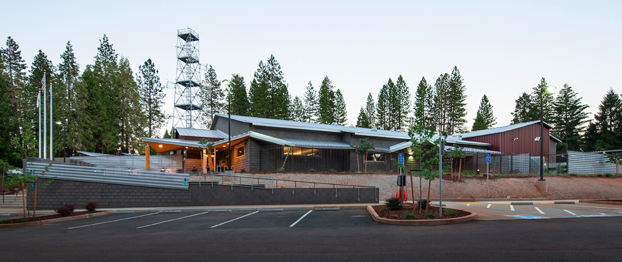
Mike: This is looking at the facility from the public side. You can see a lot of the corrugated, perforated metal, the shiplap concrete block pattern, and some prefinished metal panel on here.
The prefinished metal on the right is there because we actually have our mechanical equipment on the ground, because of the sloped roof. That’s hiding the ductwork as it’s rising up. You’re looking straight at the mechanical equipment right there.
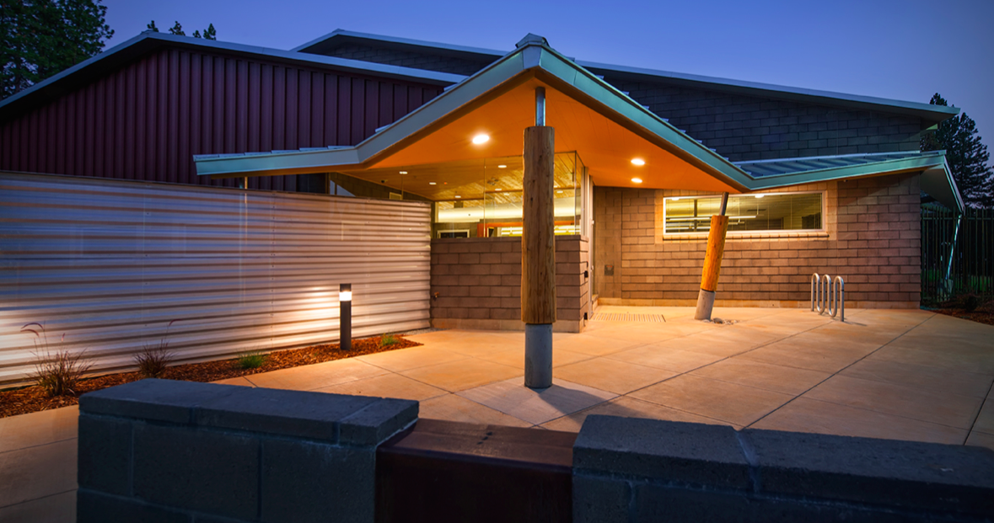
The front entry: some of the rusted metal here in the foreground.
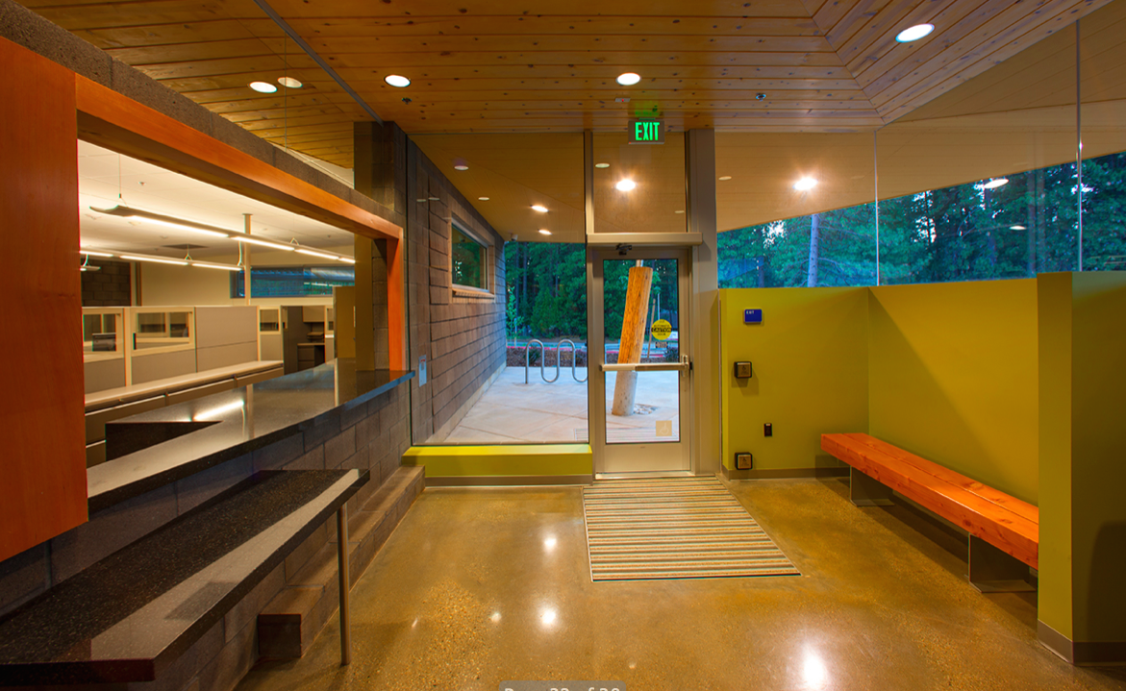
This is the lobby. The lobbies that they have are quite small, and one of the things that we did was try to get that indoor/outdoor connection to really open it up and give it more of a warm feel for the people there, yet that low wall where the bench is is solid granite block, so it acts as a ballistics shield for the people at the front counter.
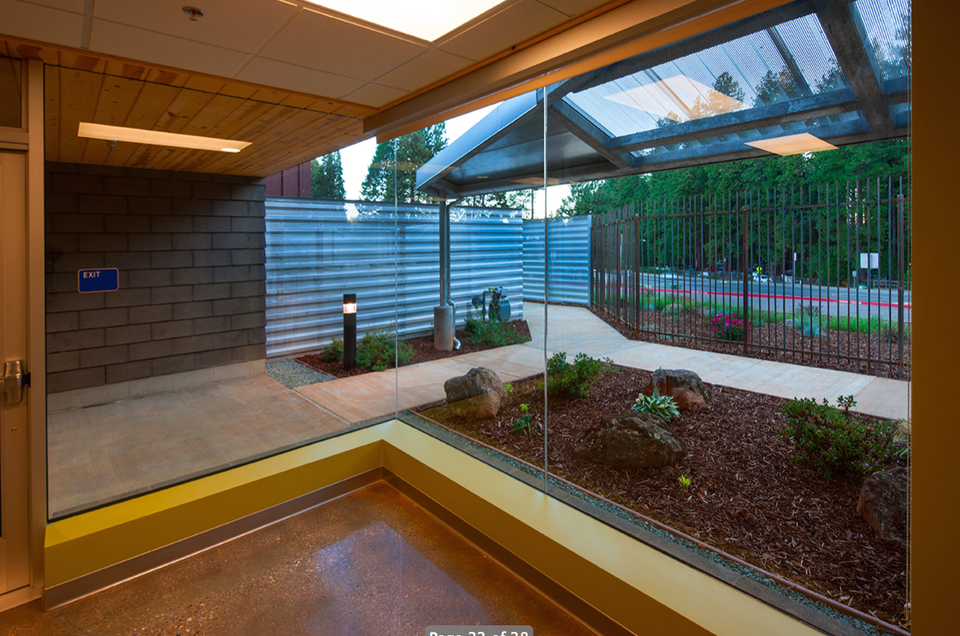
This is from the break room. It’s a nice place for the people to go for a break during their time in the building. You can see that rusted rebar fence, which, by the way, every panel has rebar welded front and back of the bar. The front are dots and the back are dashes, and it spells out CHP in Morse Code. That’s just a little sideline there.
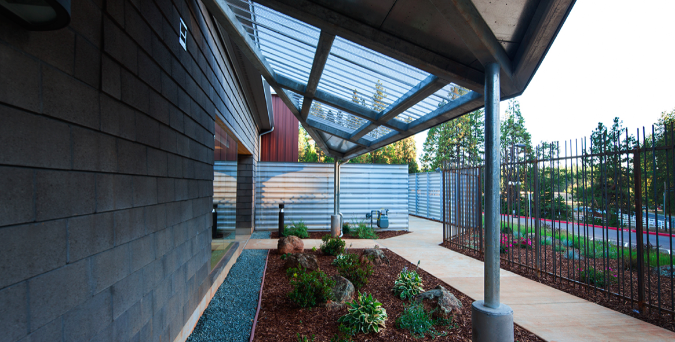
This is the end of the canopy that wraps around the building. You can see everything is galvanized. There’s no painting to be done on this.
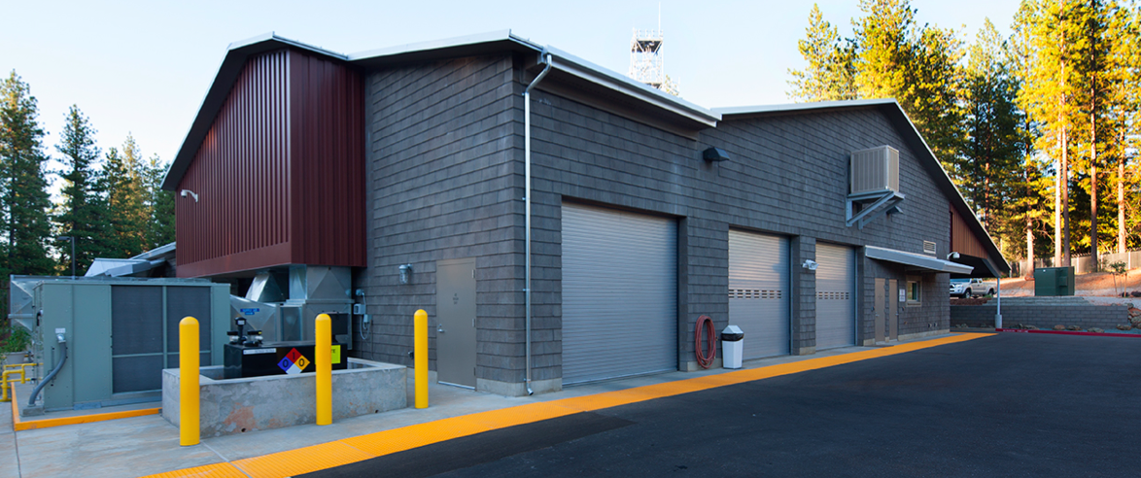
This is the warts-and-all side here. This is the service bay end of the building. You have a wash bay on the very left and a couple of auto service bays. Again, there are your ducts rising up into the facility. That’s blocked from view from the front side.
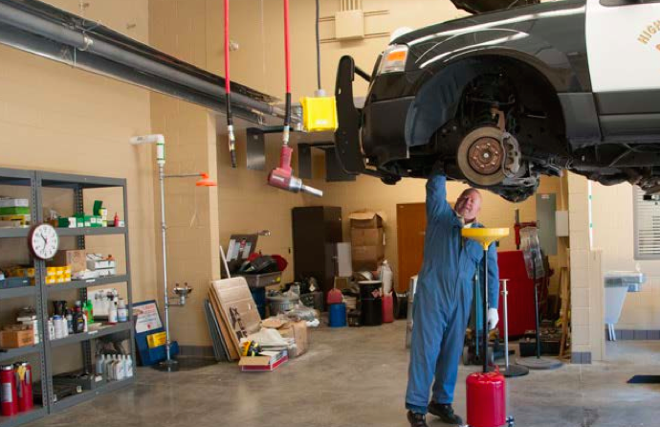
This is the world’s strongest man lifting a car with one hand! This is our auto service bay and one of Pat’s photos after construction, so I had to throw that one in.
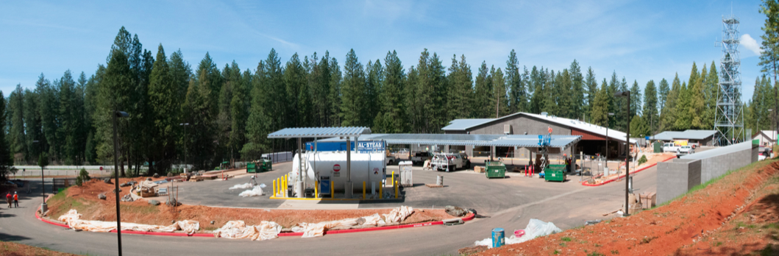
During construction: you can see the sandbags and plastic and the like in the foreground. You can see how much slope we were dealing with here on this site. You can see the fuel tank here.
Over here on this side, these were all mature trees that were protected during construction, and then wrapping all around behind, as well, and up behind the tower here. One of our goals was to protect as many of these trees as we can, because it’s just covered with mature trees.
One of the important things about protecting the trees is that in some of these views, you’ll notice, the trees are just about as tall as the tower. One of the ways to sell this tower in the local jurisdiction was that we were blending it in as best we could with the forestry around it.
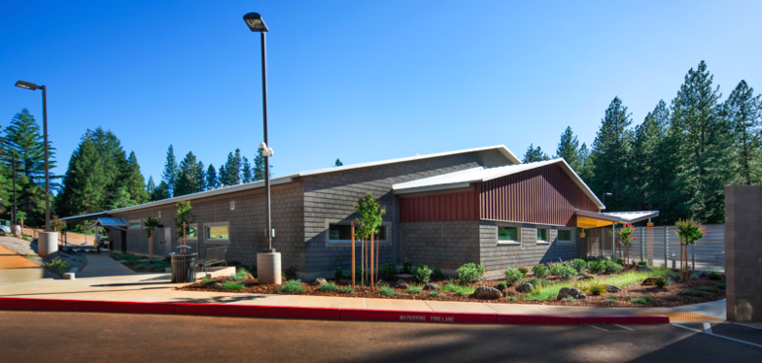
This is of the back side of the building from the staff entry side. The driveway is actually almost as high as the roof in this case. You’re descending down to the building from the back side where the staff parks. It’s definitely nestled into its hillside here.
That’s it. Those are them. We’ll take questions, if you have questions out there in the audience?
Participant: I have one question. You talked about the operating costs and lifecycle costs. Did you talk about what were some of the standards or requirements in the bridging document in terms of LEED sustainability?
Mike: All California State properties have to be LEED Silver. That’s a requirement. It becomes a contractual obligation, not a goal, when you go do this kind of system where it’s a Design-Build-Finance, so that’s a little different.
Erik: We have to deliver that in the March of 2014.
Mike: We’ve gone through the design process. We did well there on the point totals. We’re just summing up and about to submit on the construction side of it right now.
Pat: Allowable materials did come in the bridging documents, but as we mentioned, we made choices to go beyond that, because we found that some of the materials that were allowable were inconsistent with our goals for a 20-year ownership.
Mike: There are photovoltaic panels on this. One of the interesting aspects is that we made the decision not to put the photovoltaics on the roof because we didn’t want to have complication to the waterproofing on this building. The quantity that they required would easily fit on the vehicle canopy that we had for their official vehicles, so we went that route.
They wouldn’t accept substituting the decking for the photovoltaics, which is one possible approach. They wanted a watertight canopy, and so it’s an addition on top of the canopy.
In this particular case, they were mandating on the basis of a percentage of energy use. In subsequent ones, that has changed to just a straight square footage of panel.
Pat: It’s not even square footage of panel. It’s 100% coverage of the vehicle canopies. That seems to be an odd way to spec it. Yes, it’s going to maximize the area of your photovoltaics, but it’s incentivizing us to use the cheapest, crappiest, photovoltaics that we can put up there just to get enough square feet out of it.
Mike: I think one of the downfalls of this system currently is that other than LEED, there is really no incentive to energy savings, because all of the benefits accrue to the users of the facility, not to the owner of the facility.
Pat: Yes. The terms of this lease is it is a modified full service lease. We cover all expenses – taxes, insurance, maintenance, repair, janitorial, garbage – everything except for energy consumption. Natural gas and electricity are paid by the State. That’s why we lose that incentive to make it efficient for our own benefit, but we do maintain a motivation through LEED.
Mike: One of the interesting things, though, is that there are some side benefits to some of that type of energy-saving approach, like sky-lighting in the building. Getting daylight into that building was actually quite a benefit during construction as well as after, because we could walk through that facility while it was under construction with no temporary lighting and you would still be able to make your way around without any real problem. It was pretty amazing. We had a significant number of solar tubes in the facility.
It has other benefits. You have to look a little deeper than just what you are qualifying from a LEED standpoint.
Participant: One last question. Even though you said it was a pretty great relationship in the end, from the architect standpoint, what would be the biggest thing that you lost in the process, from a design standpoint?
Mike: You know, I don’t think we really did end up giving up a lot on the design side. We had a lot of fun with it on the design side, as I hope some of the photos indicate. I think that’s going to be dependent project to project.
In this case – I’ll use a term that was used by an agency talking to the police department in Vancouver, B.C. – there was a business case to be made for the canopy on the front of the building, not just from the shading of the windows – because you could go with a much simpler straight-line canopy for shading the windows or keeping the weather off people as they exit – but we had an entitlement risk which was not inconsiderable.
We were going before a reasonably – I wouldn’t say hostile, but probably not friendly – unfriendly, maybe, local government jurisdiction from the standpoint of looking at the aesthetics of the facility, so we had to be convincing on this. We couldn’t come in there with something half-baked. That was the reason for going that route.
Pat: I will say we are looking at additional projects in this vein in the CHP projects, and not every setting is as inspiring as this setting, and not every jurisdiction is going to have the same expectations. So between the jurisdiction issues and our need to compete, we really have to mind our Ps and Qs and keep our inspiration from getting in the way of cost competitiveness.
Mike: I think this drives us toward a revived modernism: the minimalist, good proportions, minimal materials, but good design. It won’t be as flashy, but it will be a nice place to be. We can’t lose track of the fact that people have to work in these buildings – and for a long time. We have to make sure that what we’re putting out there is first rate, even if it’s simple.
Erik: The team met with CHP, the user. We tried to integrate as much as we could. They probably got a little bit tired of us, because we wanted to integrate so much with them and make sure we’re delivering what they wanted. But at the end, when they’re occupying that building now, they’re just ecstatic. They love the building. They rave about it.
That’s a testimony to having the constant integration with them.
Pat: We hit the ball out of the park with this one. It’s how to be competitive on the next one that’s the challenge.
Mike: This was the first time that we’d ever done a project for CHP. I’ve done projects for more than 30 years for public safety, but never for CHP. Every client is a little different to the last, and we wanted to make sure we understood them and we understood what they were looking for and that they really understood where we were going with our design on all aspects.
We sat down with them weekly to go over each system individually and talk about what we were doing. We actually marked up their design program with “track changes” to make sure that every decision that was made was catalogued and submitted at each phase.
That helped us a lot, because once we got out into the field, you then don’t have an inspector of records saying, “Hey, you know it says right here in that design guideline that you’re going to do this,” and then suddenly somebody develops amnesia and you end up with a problem.
We were careful to bring them along through the process, because you don’t need that kind of risk during construction when you’re moving along at such a rapid clip.
Thank you.

