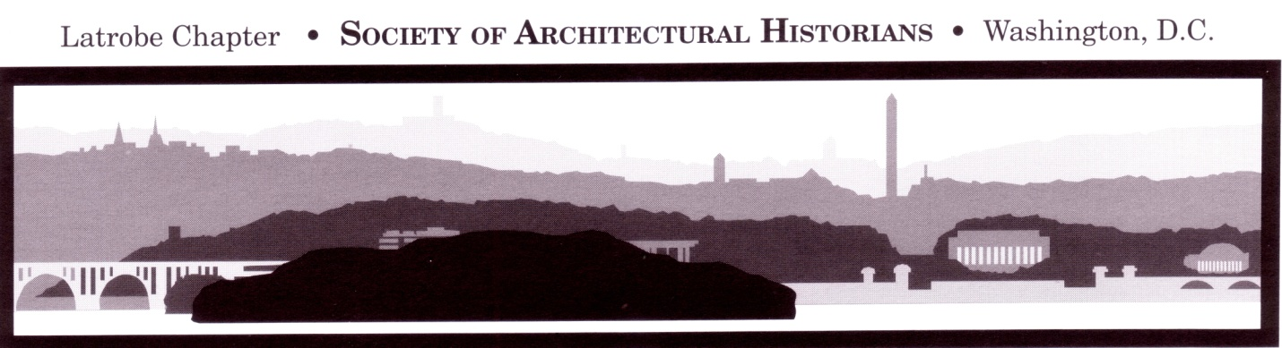

Latrobe Chapter
Of The Society Of Architectural Historians (SAH)
Graduate Student/Emerging Professional Annual Conference Fellowship, 2016

The Latrobe Chapter Annual Conference Fellowship helps a graduate student or emerging professional in architectural history, landscape history, urban studies, or historic preservation attend the Annual Conference of the Society of Architectural Historians, which in 2016 will be held in Pasadena, CA, April 6-9. Student applicants must be enrolled at a college or university, or affiliated with a research institution, in the metropolitan Washington, DC, area. Emerging professional applicants must be within five years of having received a terminal degree (M.A., M.S., Ph.D.) and must be working in the metropolitan Washington, DC, area. The fellowship award includes a stipend of $750 plus electronic membership in SAH for one year; and in addition SAH will waive the conference registration fee. Persons not presenting a paper at the Annual Conference are encouraged to apply.

The description of sessions of the 2016 SAH Annual Conference is available on the SAH website, www.sah.org. Reports of recent recipients of this award may be seen at the Latrobe Chapter SAH website, www.latrobechaptersah.org.

Applicants should submit a statement (not to exceed two pages, typed and double-spaced) explaining how their studies or professional work will be enhanced by attendance at the Annual Conference and indicating the source and amount of any other funding they might receive; a curriculum vitae; and the name, e-mail, and telephone number of their faculty advisor or principal professor (for graduate students) or other reference (for emerging professionals).

Questions may be sent to Patricia Waddy at pwaddy@syr.edu. Applications may be submitted by e-mail attachment to Patricia Waddy, pwaddy@syr.edu, no later than December 7, 2015.

