The Future of Specifications
Andy: Good afternoon. Welcome to the discussion on The Future of Specifications. BIM, BIM, BIM! BIM seems to be everywhere, but do you hear anybody talking about specifications? It’s just not a discussion that’s front and center. Will specifications always be written by a separate task towards the end of design, or can imagine specifications integrated within the BIM design environment?
The architectural engineering and construction industry is transitioning from paper to digital-based deliverables, and specifications are perfect for the inclusion in digital deliverables.
AIA Learning Objectives
Hello, I’m Andy Smith, architect and Solutions Executive for Bentley Systems, and a member of the AIA/TAP Advisory Group. Following today’s webinar, we hope that you’ll be able to lead a discussion within your firm to consider project workflow requirements to support specification automation and discuss the concepts of integrating specifications within the BIM Workflow.
Copyright Statement
We’d like to remind you that we have invited three industry leaders to present today. I have to remind everybody that these presentations are copyrighted and their contents cannot be used without permission from the speakers.
AIA/CES Compliance Statement
The “AIA Knowledge” is a registered provider with the American Institute of Architects Continuing Education Systems. Therefore, through your participation today, learning credits will be reported for AIA members. Also note that certificates of completion for both AIA members and non-AIA members are available upon request. You should also note that the AIA does not approve or endorse any products or services presented during this webinar.
AIA/CES Reporting Details
As noted, all attendees will be eligible to receive one learning unit for AIA continuing education, and at the end of today’s program, you will be e-mailed a form to apply for the continuing education credits.
Acknowledgements
This webinar, the BIM Awards Program, Building Connections, and other activities are funded by the sponsors of the AIA Technology in Architectural Practice Knowledge Community. Therefore, we would like to thank our sponsors ARCOM, Newforma, Graphisoft, and Bentley for their support.
Today’s Speakers
We’re fortunate to have three industry leaders presenting today. Let me introduce you to them:
Rob Dean is the president of Building Systems Design. He’s an expert in automated construction specifications and responsible for the creation of BSD SpecLink. He designed and managed the development of BSD LinkMan-E which provides interlock ability between BIM and BSD SpecLink.
Michael Brennan is president and co-founder of InterSpec. He pioneered the integration of building information models and specifications with e-SPECS technology. Prior to founding InterSpec, he developed a graphical information system, engineering software and hardware systems for the Science Applications International Corporation and the Department of Defense.
Mark Kalin is president of Kalin Associates. He's current co-chair of the CSI Sustainable Facilities Practice Group and past chair of the AIA Masterspec Review Committee and CSI National Technical Committee. He’s also past president of the Specification Consultants in Independent Practice.
Rob, let’s get started with our discussion.
Do Specifications Even have a Future?
Rob: The first question to answer is: do specifications even have a future? As Andy was indicating, things are changing in the industry, and BIM is, of course, one of the big changes that’s going on right now. Some people expect that construction specifications will go away altogether as BIM becomes the real modus operandi producing construction documents. A BIM (Building Information Model) in theory could contain all the information needed to construct a building, including lots of information about every product that goes into the structure.
There are a few little problems, however. For example, specifications really include more than product information. There are all kinds of administrative details, for example. Where do we talk about sample submittals? Where do we talk about quality control requirements associated with both the products and the installation of those products? Where do we deal with things that aren’t even shown in the building like temporary facilities and controls?
We also have an issue about legal documentation. After all, contract documents, as we call them – the drawings and specifications that are produced today – are legal documents that can be referred to subsequently, especially in a courtroom. How would we handle those if all of the data about a building was encapsulated in a BIM (Building Information Model) that could be changed at any time?
Specifications as legal documents will continue to be required. They could produce, let’s say, out of a BIM a snapshot, if you will, that would then be signed by everybody. But there are problems with that as well. Where is that information going to be retained? Where is it going to be formulated? How is going to be reported?
I will say that the future of specifications is inextricably tied up with the future of BIM, and as we move more into the BIM era, there will be change in how specifications are produced and updated.
What is BIM, anyway?
Let’s start with a quick definition of BIM. This is from the official National Building Information Model Standard by buildingSMART alliance which is part of NIBS, the National Institute of Building Sciences. That definition is “A digital representation of physical and functional characteristics of a facility… and a shared knowledge resource for information about a facility forming a reliable basis for decisions during its life-cycle; defined as existing from earliest conception to demolition.”
A basic underlying premise of BIM is that it is really a collaboration. Lots of different people at different phases of the project are going to be inserting, extracting, updating, and modifying information because every stakeholder has a different set of goals. The BIM is a shared digital representation founded on open standards for interoperability.
Notice that in this definition, there hasn’t been anything said about 3D Cad or 3D models or anything of the sort. It’s “a shared digital representation founded on open standards for interoperability.”
The facility life cycle starts off with programming, moves into design (including the production of contract documents), then into the building phase, and then of course operation of the building which is what we’re dealing with most of the time. One of the big advantages of BIM is supposed to be that the facility managers are going to have an opportunity to use this model throughout the operation of the building, leading to renovation and ultimately to decommissioning and demolition.
BIM is more than 3D modeling. How is it different?
It’s true that there are 2D and 3D CAD program out there today that store information about materials and products other than those properties that are needed to present the objects graphically. That is absolutely true. But, there are lots of properties that would be needed for a complete specification, and for that matter, for cost estimating and scheduling that are not relevant to graphic representation.
If we stuck them in a 3D CAD program, we would really start to affect the speed and operation of the software. I think those of you who are doing hospitals, for example, in BIM know how enormous those files are and how difficult it is to deal with them currently.
In Revit, for example, there are lots of door objects provided in the software, and they deal with things like height, width, thickness, and swing direction. Those properties are included, but they don’t include a lot of information that would be needed to prepare a detailed cost estimate or to produce detailed specifications.
For example, with the model objects that are provided with Revit, we don’t know whether the doors are wood or metal. That’s pretty basic. After all, wood doors and metal doors are specified in completely different sections and they have very different properties, and they certainly have very different costs.
The drawings, of course, do not include all elements that would be needed for specification, scheduling, and estimating. One quick example would be earthwork. Another example would be temporary facilities needed during construction. And, of course, programming, specification, and cost estimating tools don’t include any of the graphic information that would be needed.
So a BIM (Building Information Model) has lots of information of various types that really can be stored and manipulated in different places. There are two fundamentally different ideas about how this data should be stored for use during a facility’s lifecycle.
There’s a centralized data concept. This is kind of a traditional idea that the CAD program is going to contain everything needed about that building. There is another idea that distributed data is the way to go. This is, of course, one that I’m advocating – distributed data with linkage. This is kind of a traditional idea about how a BIM should work. Cost estimating information is fed into a database; specification information is fed into a database. And all of that information about a building – a project – is stored in one huge database, and the CAD system is envisioned as the way in which this data is manipulated, accessed, and reported. A little cumbersome, I think.
A better way, and the way I think we’re headed, is that the CAD application maintains graphic information and manipulates the graphic information. The spec application maintains the information needed to produce specifications. Cost estimating application includes and up-to-date database of cost information and manipulation of that information.
What we have in the middle is a standard taxonomy, a classification system for all of the information so that these various applications can talk to one another in both directions. So the Building Information Model is really a distribution of data that is managed by what I’m calling an interoperability manager.
How Can Linkage Be Achieved?
So how does the linkage occur? How do we achieve that linkage? When we talk about interoperability, CAD people talk about it in terms of disciplines. They talk about the architectural drawings being interoperable with the structural engineering drawings and with the mechanical drawings and with the electrical drawings.
When I’m talking about interoperability, I’m really talking about dissimilar applications talking to one another. Here’s what I believe. The applications need to be relational databases in order to talk to one another, and the relevant objects – projects, assemblies, spaces – need to be identified or tagged with unique identifiers.
GUIDS are globally unique IDs. These GUIDS, in turn, ultimately need to be linked to a central data repository, probably out on the web somewhere, that is based on a standardized set of properties. So we need relational databases to talk to one another, and we need – and this is really critical – something in the middle that I’m calling globally unique IDs organized so that we’re all talking about the same objects.
To achieve true interoperability, you’ve got to have relational databases because the detailed linkage required to be useful requires access to individual records. For example, in specifications, we can connect not only to individual paragraphs, but also to choices that are imbedded within those paragraphs.
We cannot really deal very comfortably with flat files such as those that you would get in a word processing system or in an Excel spreadsheet. You really need to be able to access information at a much more detailed level, and that’s why I think relational databases are essential.
Cost estimating is another example. Line items in a cost estimate have specific costs associated with them. A brick is not a brick. There are lots of different kinds of bricks. They are different sizes and shapes, but they’re also different compressive strengths, different weathering qualities, and so forth. We need to know through a globally unique ID and through use of these Globally Unique IDs in relational databases that we’re talking about the same object.
I mentioned the taxonomy earlier. What I’m really talking about is a master database of construction information. In that central database, every application that needs to talk to another application could map their data to that central database so that all applications would then be able to talk to one another. CSI has a number of standard formats including UniFormat, MasterFormat, and OmniClass, that could form the basis for such a globally unique ID taxonomy.
Is There Currently any Linkage?
There is. There are architects out there who are using products that are on the market currently to connect their BIM/3D CAD information with specifications and with cost estimates. As far as I know, there are only two commercial systems on the market at the moment that demonstrate a level of interoperability between BIM and specs, and that’s e-SPECS by InterSpec and BSD SpecLink-E and LinkMan-E by Building Systems Design.
What They Have in Common
They have a lot in common. For one thing, they both employ relational databases. They both employ a translator, or an interoperability manager as I called it, between BIM optics and spec text. e-SPECS uses an approach called mappings and a section checklist to bind BIM assembly codes to corresponding text in the specifications.
LinkMan uses a somewhat different approach – a master database of assemblies and products that are linked to BIM elements by unique names and to individual paragraphs in the specifications.
Another example of what they have in common is that they both provide keynotes to relate the BIM elements to corresponding specifications. And they take slightly different approaches to that.
How Are They Different?
There are lots of other things they have in common and there are lots of ways that they’re different. How are they different? I think it’s best explained by our owners [20:37 ?], and I am going to turn it over to Michael Brennan, who is the president of InterSpec. Michael, you should have the control.
Michael: Thank you, Rob. This is Michael Brennan from InterSpec, The Future of Specifications from Document Management to Information Management. As Andy mentioned at the top, everyone is talking about BIM, but it’s not just about integrating the specifications with the building models. Much of the “I” in BIM comes from the specifications. It’s really about how we better access and use the information that we integrate with the models and how we better manage the data that is mostly contained in specification documents at this point.
The future of specifications is really about moving from a document management process to an information management process so we can more efficiently access the data and specifications for all of the construction disciplines that need it.
There are many advances made in the preparation of specs as we have moved from a paper based process to a digital based process. By and large, the development over the years has been on better management of the spec documents, not necessarily on the management of the data contained in those documents. We’ve developed a number of good document indexing schemes like MasterFormat, UniFormat, and OmniClass, for referencing the information. We have a well-placed structured standard for the presentation of the specification information on section documents.
This is a tried and true system that has worked well for many years, but it is a system that was developed in an era when the drawings were paper based or printed CAD drawings when the reference to the specifications had to be by imitations or keynotes on the drawing. This is still the way the industry works for the most part today.
Building Information Modeling (which Rob went through in great detail explaining, which is great) which first started to gain traction a decade ago is transforming the design, construction, and operation process into an information driven one, spawning such advancements as automated engineering analysis, energy performance predictions, class detection, construction sequencing, etc.
It is now possible to better integrate the drawings and specifications, as we have direct digital access to the visual context as well as digital access to all of the components that make up the building, from the foundation to the roof pavers and all the building elements and systems in between. And it’s not just digital access to a symbol or a pattern or a text callout of those elements as we did with CAD. We now have detailed information about all of the building elements that you can use in the development and dissemination of the specifications. We need to take advantage of it.
Advancements have certainly been made in terms of integrating the specifications with the models. These are proving successful in better coordination and development of the specs from the model context, and better collaboration of the spec preparation process during design.
But the access of the specifications for use in estimating, bidding, purchasing, fabrication, construction, operations, etc., it is still by and large through a text based documents. We’re still using annotations and keynotes to reference the specs from the models. There are some initiatives on the way to standardize the spec information for direct data exchange among applications, like the Specifier’s Property Information Exchange that you’ll hear more about later.
There are other systems that are using direct application-to-application proprietary interfaces to accomplish this. But for the most part, the information is really locked up in a series of text based documents, and the industry users still get the required spec information from a project manual document.
This is where I see the opportunity for the long range future of specifications in better management of data that is contained in the specification documents so that the information can be provided to the users in the format and structure required – machine to machine where appropriate, from visual context in the model where available, and from documents built up from the data when needed.
How do we get there? The specification information has to be structured as portable data that can be accessed and formatted for a variety of applications and users requiring it. If we want to pass the specification information to other applications, it needs to be well structured so that both ends can interpret the data, and available for transport in the data structure, like XML [? 26:07], for instance.
Evolving standards like COBie and SPie will help this process, but until they are fully adopted, we are doing this with proprietary application programming interfaces. If we want to view this specification information, we should be able to access it from the model context in the form we want through various view templates. This is analogous to how some parametric BIM systems work today.
Plans, elevations, and section drawings are just different view of the BIM graphical data. The views of the specification would be similar: different views of the spec data depending on the requirements of the user that is accessing it. If the models are available to the user, provide a spec view from the model context. Make it visual.
The development of the specification should be an integral part of the development of the building designs. Drawings and specs have always been developed in parallel – or at least they should be – but now we have the ability to truly develop them together with a model context and access to the specification data which will facilitate the overall design process.
This does not mean putting all the extra information in the models themselves. Rob pointed this out earlier. We get asked this question all the time: “How much spec info should I put in the model?” The models are already large enough with the geometry data and more. The specification information should reside external to the models where it can be conveniently accessed by other applications and users.
We want to provide a reference to the specification from the model element and keep as much of the data external, but have the model context and access to the model data for the spec development. Specification data should be conveniently accessible to all of the construction disciplines that need it.
In the long term, we cannot continue to make downstream applications and get a copy of the data set to provide locally inside their firewalls. We would need to have the specification data available from shared online database servers with convenient secure access to all that need it. We increasingly have widely distributed project teams working on fast track projects all over the world where everyone needs access to the project information as soon as it is available.
For example, our services group recently worked on the specification for a health care project in California which was structured as an IPD project where the builders were located on the site in California; the designers were located in Arizona; the specifier [28:43 inaudible] on the East Coast; product consultants in California, Washington, and Texas; and the engineering team spread across a half a dozen or so other locations. Convenient online access to the information was absolutely critical, and this is becoming more common even on the smaller projects.
We did not have that level of integration on that project, but as an example, it would have been much easier and more expedient if we could have just provided the data access credentials and templates to the various users and applications that required the spec information that was developed and then been able to pass other information on for use in post-construction, facility management, and beyond.
Better access to the specification data will make the integration on the applications used by the various construction disciplines more accurate and less time consuming to maintain.
In addition, online model and information access to desktop machines in the construction trailers at job sites is fairly standard now, and the demand to have construction related information available to mobile devices is increasing. In terms of the need to view the information and specifications, this will further drive the need to have good contextual references to the models with information specific to the construction components of interest. Access to a 1,000-page specification manual on your smartphone to get some information about the concrete slab will just not cut it.
The following is one example of how the view of the data might look:
For the contractor that needs information about the concrete columns on the job site (shown in blue on the model), or perhaps the details about the slab-on-grade (again shown in blue on the model), they should be able to access the specification and technical data directly from the visual context as we’re showing here for the slab-on-grade only, as well as any other relevant information like installation details, product data sheets, or other information that is contained in the specification (or referenced on the specification) to the specific product, material, or element of interest.
This is certainly more efficient than lumping all similar elements together, as we show on the model. All the concrete in the building that we can see from this view (in blue) reference to a MasterFormat section – the Cast-in-Place section in this case – in parsing the desired information from the Cast-in-Place PDF document. It’s much more efficient if we can just focus specifically on the data for the element of interest we’re looking at, and we can only do that if we have better control of the information that’s currently contained in the documents.
These are just a couple of brief examples, but I think you can see that if we have better and more discreet access to the specification data, we can accomplish much more with it. The specification information is used to one degree or another by many industry disciplines, and providing better access to that information to the project team members in the form they need it, when they need it, and where they need it is the opportunity ahead.
BIM is certainly the catalyst that is transforming our industry, and the future of specifications is really about helping to fulfill the promise of BIM.
Thank you. I’m going to pass this over to Mark.
Mark: Thank you. In my role as a specification writer, I’ve often wanted to shake the BIM model and try and catch the spec information as it’s dropped out. Unfortunately, as hard as I shake, it doesn’t come through. Where is this going? We’ve got a limited number of spec writers. We’ve got people being trained on how to do designs and how to do BIM – maybe not exactly on what the specifier needs. If we start from the basics, the old joke is that I’ll tell you everything I know in twelve minutes, and I suppose I can actually do that.
What’s a Spec?
The designer calls and says, “I want to use a Mars ClimaPlus ceiling,” and there’s the texture of it and it has an NRC of .70. Maybe that’s where it contributes to LEED credits. So you turn to page two of the product literature and you realize there are three corner shapes; there are seven sizes; there are seven grids.
So until somebody makes that decision, it’s not really a spec, meaning that I know my role as a spec writer. It’s to defend the designer’s design intent, and also to not confuse the contractor’s estimator. They’re trying to big a job in a month. They look at it for a week; they estimate it in a morning. It really does have to be as clear as possible.
So we make all of these decisions and then, as a good spec writer, I’ll put that into a CSI three-part format spec – part 1, general; part 2, products; part 3, execution. Here are the exact same words as the previous page on the product literature, except I’ve added two more manufacturers. The first one was USG 86985. Now we’ve got an Armstrong 1912 and a CertainTeed 122BF, and that is hard-fought data.
Why do I need the other information? It usually has to do with the fire and sound performance, maybe the LEED criteria. The important thing is why the product was picked.
We take that exact same information – here’s our part 3 execution of this spec and there’s a paragraph that says, “Level the ceiling to within an 8th of an inch and ten feet in both directions.” Where’s that going to live in the model? How is that going to work?
We take this same information – remember that we were talking about the product literature, we were talking about the spec – and we put it into a BIM model and we find that it’s exactly the same words. Think of it as an outline spec perhaps. The basis of design can be there. You can have 15,000 lines in the model describing something. It’s not a problem to list equals. It’s not a problem to list performance.

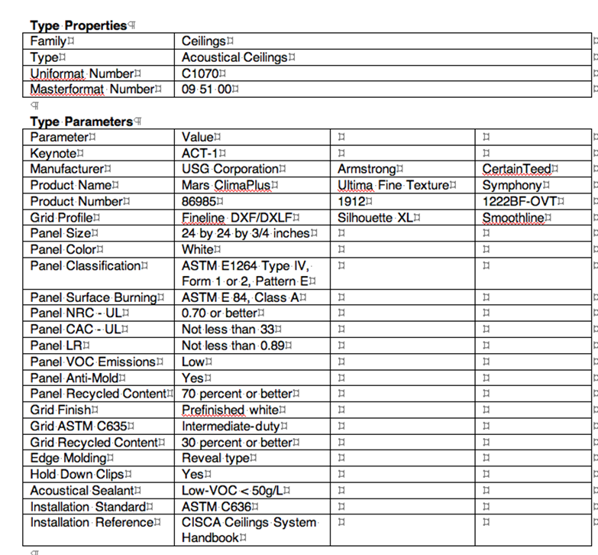
And right now most of us are in the situation in our offices where we don’t know that anyone is going to look at this information later, and no one’s paying us to put it in. So until that model changes, nothing more may change as far as the architect’s incentive to get more information in the model. But it is changing because there are owners who are paying architects to do this, and on and on it goes.
As we look downstream from where we are, we have to understand that old phrase, over 20 years, the cost of a building – 5% is the initial cost of the building and 95% is the salaries of the people who work there. So the architects do their best to look downstream because that building is going to come around and around again. There are 105 million buildings in this country. 50-60 million of them are more than 50 years old. We’re going to be really busy.
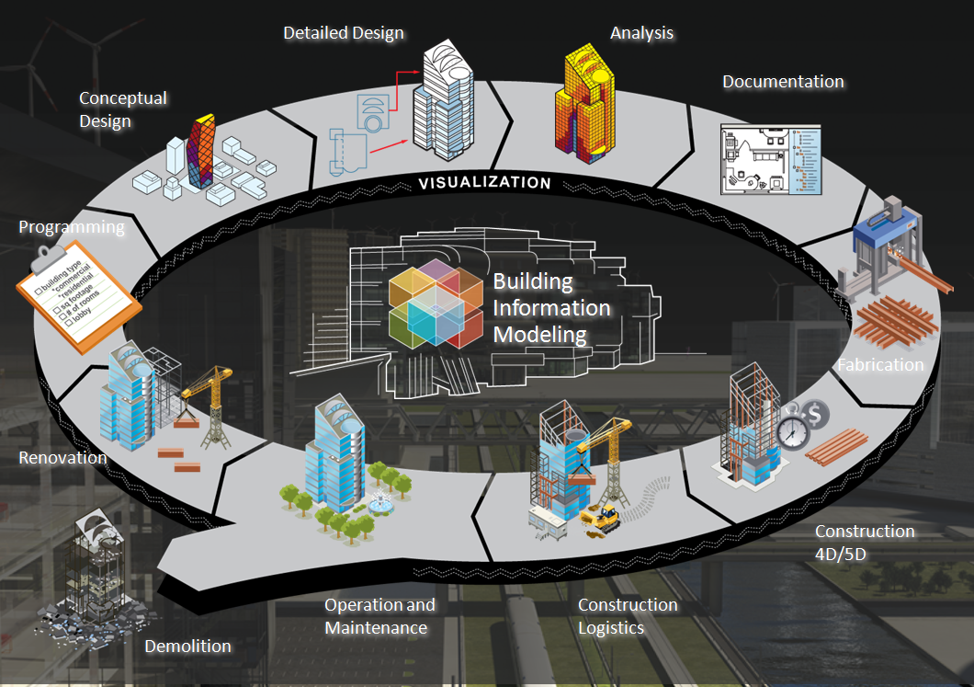
We start in design with schematic design and design development drawings. I get involved as a spec writer during bidding, as many of you do. You’re involved with design and cost estimate. Then finally, we go to build the document.
The AGC, I’m told, is that the number one trainer in BIM because the subcontractors get it. If you cannot have a Sawzall as your number one job site tool, you’re going to make more profit and the building’s going to open on time.
Finally, the people who have to run the buildings have developed a whole different priority. If you’re the government (GSA owns 9,000 buildings; the military owns 113,000 buildings) there is a huge incentive to make this work.
CSI and Its Formats
Why does it all work? It all works now because it works in paper. We’ve got UniFormat; we’ve got MasterFormat; we’ve got the national TED standard used by 4,000-5,000 firms; overlays of different types, whether it’s LEED or Green format; then there’s OmniClass which is 23 tables. So there is a structure, and there are committees from the AIA, CSI, Building Smart Alliance, and others that are really trying to just simply get a data dictionary set in place. It’s so critical so we can speak the same language.
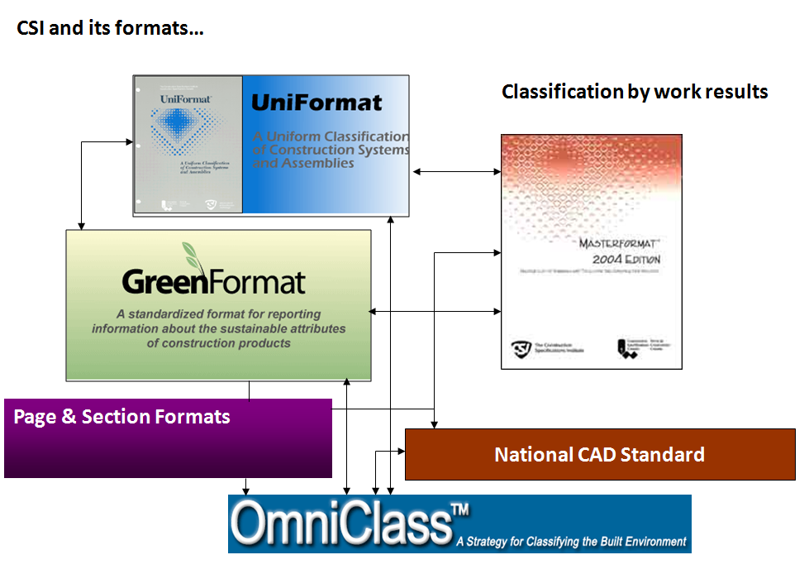
Information Formats and Standards
We’ve got our information formats. I fell in love with these as a spec writer. We know when to use UniFormat and MasterFormat. We know OmniClass. So BIM, at some level, is going to allow this all to happen in a less paper-heavy environment. As Michael said, before, you’ll be able to view things in any way that you way. For those of you who grew up with CSI, you recognize this slide where you’ve got a difficult project manual, drawings, addenda, and all the definitions. None of this is going to go away because our industry is slow to change.
Specifier’s Property Information Exchange (SPie)
But two things have happened. There’s the Specifier’s Property Information Exchange. It’s been supported by the U.S. Army Corps of Engineers, NASA, Overseas Building Operations, National Institute of Building Sciences, Spec Consultants in Independent Practice, Construction Specifications Institute. It’s trying to capture design phase decisions in the model, and it’s trying to catch product templates for the manufacturers as well as from the manufacturers.
Since 2007, there have been 300 property sets – specifier’s templates – on the NIBS website. They’ve evolved a little bit on time. (All of this I’m talking about is free and downloadable.) The manufacturers are so trying to connect with us, so trying to make sure that we use their products correctly that, as you go onto the sites like McGraw Hill, ARCAD, Reid [39:53 ?], and others, you see hundreds and hundreds of manufacturers with their information online. At this point it’s not like the movie “Avatar.” It’s like the TV show “The Simpsons.” We’re just trying to get enough data in there.
Construction Operations Building Information Exchange (COBie)
I don’t know if everybody has heard of COBie (Construction Operations Building Information Exchange), but this is really a driver. It was started by the U.S. Army Corps of Engineers and NASA almost ten years ago to deal with a lifecycle capture of information – what is it that’s going to be in the model that somebody else is going to look at?
It really is the U.S. standard right now for the exchange of information. There are 20 software products right now that work with COBie. Perhaps it’s just keeping track of the fan size and the pump size and the serial number, but these are the things that cost millions and millions of dollars in waste when we can’t understand what’s in our buildings and why they work.
Here’s an example. We took 490 sections of the Unified Facilities Guide Specifications and said, “What do we care about as a specifier? What are the specifier’s attributes?” This shows the COBie attributes. What’s the name on the product? What’s the basis of design manufacture? Where is it located? A system description. Perhaps something on sustainability.
As we go further, we see in the Unified Facilities Guide Spec that there’s a lot more information that’s there. In other words, if you go to the Steel Door and Frame section in the UFGS and you want to know if the glazing type is in the spec, and you went to UFGS paragraph 2.13, you’ll see that the choice are tempered and laminated.
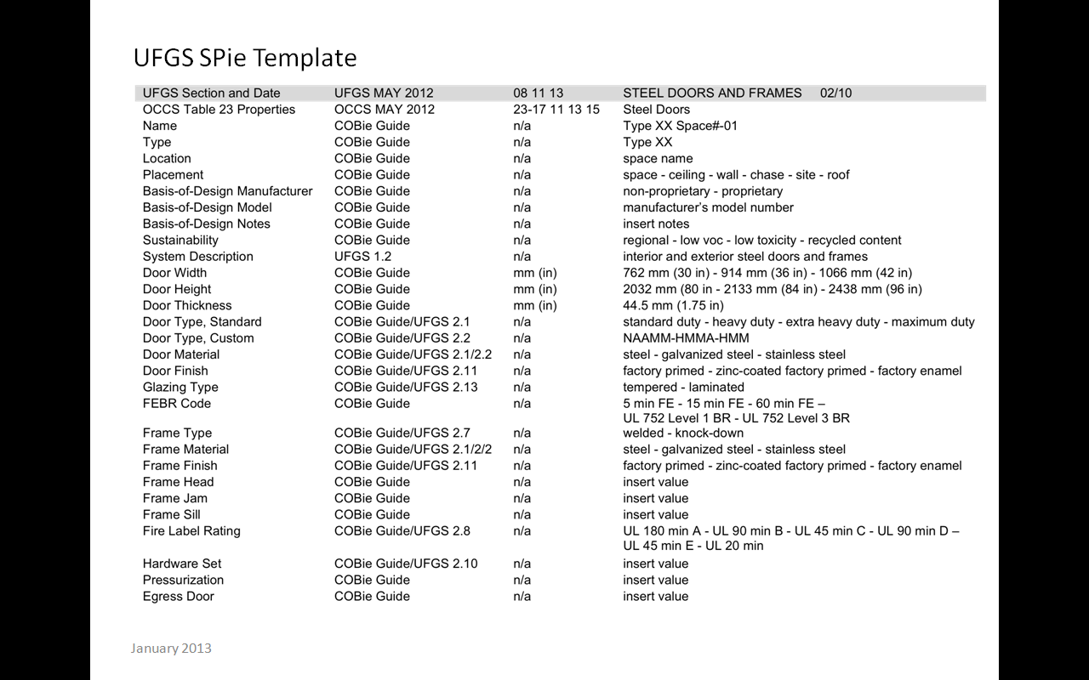
As a specifier, we know that there may be 50 choices on each one of these lines. But if we look at a fixed database of the UFGS spec which, altogether, is 21,512 pages, this is what’s in it now. To be fair, UFGS was never really designed for BIM. It’s been around for 40-50 years, starting out as the original specifications for each of the different industries – but it’s there. Whether you want the fire label rating or you want the 4th century bullet resistance code, these are the things that, right now, a specifier has to deal with, a designer has to deal with, to put that spec out to bid.
Here’s another basis. Right now, [42:44 inaudible], SEARLE [?], and buildingSMART alliance have populated three BIM models with attributes so that people can see what it is they want to do and not do. We’re a little bit in the wild west, but having those 300 original sections and now 500 more sections from UFGS, and with what Rob and Michael are doing with their systems, we’re getting there.
Here’s another UFGS SPie template for a commercial boiler. It starts out with a COBie guide, which are things that are really important to the location and the model, and also to the people who use the information that’s there. The boiler section is probably 100 pages long. How can you condense it one page? Well, you do because you can always refer back out to it.
The specifier’s role is really changing. Believe it or not, in the ‘20s the best thing to do was to print these books. That’s about all we could do. But now in that model, we can have our lumber cut. We can change the light level. We do our wastewater calculations. We can just get the owner a better building.
Now the information runs really deep and, at some level, gets terrifying because even with something as simple as the example we used before with acoustical mineral fiber ceilings, you’ve got, in Revit, a family and a type. You’ve got built-in keynotes – maybe they’re terrific; maybe your office as their own. There are probably five CSI MasterFormat numbers that represent ceiling. There are six UniFormat numbers that represent it.
With your cost code, by the time you get down to that two-by-four tile, you’ve got an 095123300830 number that kind of roles off the tongue, and you’ve got seven credits that this ceiling could contribute to if you’re dealing with LEED. The information could go phenomenally deep in orienting where you are what you’re trying to do.
Construction, Construction Management
So we’ve got a door, and each of those doors can have element properties in a model. You can define those. You can use the defaults. I know that the 300 manufacturers on ARCAD have links out from their models to their website. How do you get it out? You create a schedule.
This is just a picture of a Revit model. There’s a button called “Schedule.” You pull out the type of schedule you want, you build a database much like you do in Access. This is your home-grown BIM connection to data. If you put good information in, you’ll get good information out. If you don’t, of course, it’ll just be gibberish. But the structure is there; there’s nothing holding you back.
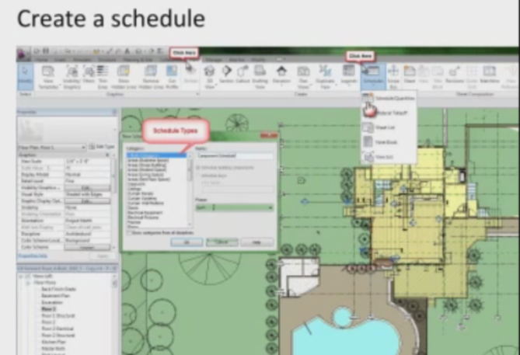
As a specifier, what I see now is that people are exporting schedules for markup so that I can get them. Whether they do this as a PDF or an Excel spreadsheet, I can then, as a specifier, give feedback to the design team to say, “I don’t have enough information to specify it –” maybe I do. But this is the information, ultimately, that the manufacturers are going to need to deal with.
There really aren’t enough specifiers right now, and according to the last issue of “Engineering News Record,” in 2014 there are not going to be enough architects or engineers either. We’re going to come to a time when the manufacturers and subcontractors are going to need to look into the model because it’s their money that’s really at stake in making sure their products work for our buildings.
There are places to start. There are places where you can go to look and see examples of this. You’ll have to decide for yourself what in your best interest for your own project.
Remember that 5 million people are moving to cities every month. Now maybe most of it is in the poorest countries in the world, but as architects and specifiers, we have to have a way to go faster because the people are already born. We need to share that water and air in buildings, and BIM, I think, is the only way that’s going to happen.
With that, I’d like to change back to Andy and continue on our discussion.
Andy: Thanks, Mark. Thanks to Rob, Michael, and Mark for taking the time to prepare today. Now we’d like to some questions. Our moderator is Mr. Michael Keene. Michael is the vice president of Engineering Specifications at ARCOM. He has 41 years’ experience in HVAC design, specification, and contract administration, and has worked nine years with the MasterSpec group at the American Institute of Architects.
Michael, what questions do we have?
Michael K: We have several questions, Andy. Of course we won’t be able to get to all of them, but there will be an opportunity to respond to those that we don’t get to.
How does bidding, especially government mandated competitive bidding, work into the BIM scenario?
Mark: The primary driver of data in BIM is the government. Part of the issue with property sets is that in order for an architect to leave schematic design, leave design development, leave construction documents phases of the project, they must enter data. Ultimately, when you draw a window, you probably have a basis of design window. You may or not include the name of that manufacturer in the government spec, depending on what you’re using. But, of course, your drawings can’t include 20 different windows. You have to make an assumption for just the flashing and pieces and parts.
The government has found that this will work very well for procurement, at the very least, with clash detection when things are loaded up into NAVIS. Now there’s co-checking software that will make sure you’ve got enough quarter length, and you’ll have your accessibility right and you can check whether there’s insulation in your exterior wall. So I think this feeds very well into federal procurement.
Michael K: Is the thought that these GUIDs that Rob was talking about would be registered by some organization, such that a brick type XXX, for example, would be registered by its manufacturer and receive a GUID specifically for that product – sort of like an ISDN number?
Rob: We wanted to have such a system in place before we started our software development for interoperability, but the standard does not exist at the moment. I think there are a couple of possibilities. You heard about the SPie approach that Mark has actually invented, I believe, and is working on.
There are, as he and I mentioned, a number of standards in place right now, including OmniClass, that could be expanded to form the basis for such a classification and ID system, but it does not exist at present. That’s one of the difficulties. That’s one thing that’s holding us back toward achieving real interoperability.
Michael B.: As I mentioned in my presentation briefly, until the standards are well formed and adopted, we and others are taking the route of doing proprietary interfaces. If we can interface to one application from our applications, or from one manufacturer to our applications, then we have to take what’s available to us today. If there’s not a well formed standard, then we’re doing that specifically with just application-to-application proprietary interfaces.
Now that puts more work on all of us because we have to sit and actually have an interface directly to that application, and when we migrate and have an adopted standard, I think that will help us all. But until then, we can have the manufacturer list his particular Revit object, for instance, if you want to use Revit as an example, and that can be interfaced through something like the UniFormat code or other things. That’s basically the way that it’s being handled today, at least on our end.
Mark: The buildingSmart alliance has 33 working groups with clever names like Spark-E [?], HVAC-E [?], and Wall-E [?] where groups who have a lot at stake – for example, with wall designations. It’s unbelievable that in the United States there’s no standard designation for walls, but there needs to be, as Michael said, if we’re going to move forward.
Michael K: If we’re talking about the “future”, why are we still expecting specifications as paragraphs of text? I understand that these paragraphs are automatically generated from a database; however, it should be presented differently as tabular [?] data with options and sub-options.
Michael B.: I’ll take the first crack at that. I absolutely agree 100%, and that’s sort of the gist of my presentation that we have to move from a document management process to an information management process so that we can, again, present the data in the form that it’s needed, whether visually or machine to machine. Or if you need to have a contract document attached to a legal contract, then it could be printed as it is today as a view into a database.
But I think that now that we have the model context and the ability to interface with infinite [?] models directly – not just the design models, but where the models are used downstream – we should be able to present very specific data to the user and not necessarily from a text document.
Mark: BIM cannot be a dumbing down. The hard-learned lessons of the construction industry, this magic handshake we have between 1,000 sheets of drawings and 2,000 sheets of paper produced by six or seven disciplines to produce a building that many trades will work on is a system that works regardless of your opinion of the efficiency of it.
To just go back to what Rob Dean said earlier about linking out to databases where you can keep that little piece of secret information about the difference between shop fabricated and factory fabricated as to whether or not your roof will look good – we can’t lose those things, so BIM needs to be handled in an intelligent way that adds to what we have so we can go faster because our population and our country require it.
Michael K: The drafters are typically not the people who make the decisions about materials and products. Won’t either the drafting process slow down while the decisions are being made or the accuracy of the specifications be jeopardized by incomplete information the model?
Mark: When the model is created, you’re often in schematic design. The people doing schematic design are often the most senior people and the most capable people in the firm. They make a lot of decisions about floor-to-floor height column spacing, preferred window, and preferred door, so that information can easily be there in drop-down menus for the Revit people. Some in the office here call themselves Reviteers.
Yes, they know the roof is 3 ½ or 7 inches thick, but they really need to know is if it’s a metal deck or a concrete deck. They aren’t being asked to learn that information, so the specifiers and the senior people in the firm need to use these tools to make it available to them because each person has to work to their strengths if this will work.
Michael K: How do you deal with product substitutions which seem to always be submitted by contractors and sub-contractors?
Mark: The same way you do now, and if somebody’s going to do an as-built model, then they would include the product actually included. I don’t think that changes a bit.
Rob: I agree with Mark. You handle it the same way you handle it now. Hopefully, BIM will allow us to handle it a little bit better, but one of the big issues that hasn’t been adequately addressed right now is the problem of propriety versus non-proprietary information in the model. Up to a certain point, up to bidding, we typically want non-proprietary for competitive bidding purposes. But in order for the model to be useful for facility managers after the project is built, we really need to know exactly what was installed. As-builts become more of a need, really, than up until now.
Mark: There are some design firms that are hoping to be the BIM architect of record for building so that they get all the subsequent remodeling. There are other firms who don’t see that as part of their practice. There are many contractors who would like to be the BIM architect of record. When you look at the big facilities programs, all of the Fortune 500 companies have asset management tools that are graphically based, so now we just need to tie them together and make that work.
Michael K: Do you see this eventually being integrated with business process modeling as a way to consider and assess how enterprise goals and logistics influence design and specification decisions?
Mark: That’s the dream, isn’t it? You stretch the model one more day [?] and you find out if your profit increased?
Michael B: I think if you have the discreet data available to you in a better form, then a lot of those options will become available. As it is now with the data more or less tied up in text documents, it’s more difficult to achieve that.
Michael K: Legal elements of sharing BIM information was mentioned but could be better addressed.
Mark: The Boston Society of Architects had a meeting with lawyers, architects, and BIM people. There’s a little PowerPoint that could be shared. The legal responsibilities are just where they are now because they’re based on case law and, of course, that case law was based on traditional methods of document production.
Andy: Michael, thanks for moderating the Q&A session. I’d like to remind all of our participants that, to ensure that you get your learning unit credit for today’s program, please make sure that you complete the Webinar Survey Report Form within the next five days.
Finally, thanks for participating. If you have a question about the TAP Knowledge community, please feel free to contact us at TAP@AIA.org. I hope everybody has a great day.

