**PDKC Project Spotlight**

**Houston Community College Sam Jacinto Building**

*For a more complete photo essay of the project, visit its* [*spotlight webpage*](http://network.aia.org/projectdelivery/ourlibrary/viewdocument?DocumentKey=a1deaa66-32dc-49d5-8914-045d54656a97&tab=librarydocuments&CommunityKey=f631dcdc-53a0-44fb-beb7-9dbba243fe10)*.*

**Background**

Originally constructed in 1914 and recently restored to its early twentieth century aesthetic, the HCC San Jacinto Building was listed on the National Register of Historic Places in January of 2013. The historic exterior had become almost unrecognizable with multiple colored coatings that obscured the detail of the cast stone. Original wooden sash windows and doors had been replaced with fixed aluminum frames in the 1970's, changing the appearance significantly. This work damaged the decorative copper panels and associated flashing contributing further to facade water infiltration.

Previous attempts at coating removal prior to the restoration project were unsuccessful in removing coatings and resulted in damage to portions of the building. The copper panels were damaged to the extent that replicated panels were required.

**Project Delivery Approach**

Skanska was added to the team as the CMAR - Construction Manager At Risk - early in design for the restoration / rehabilitation by BRW Architects with preservation consulting by Lord Eck Sargent.

**Teamwork delivers the solution**

The CMAR was able to bring on board a façade restoration subcontractor - Mid-Continental Restoration - under separate scope to explore the appropriate coating removal approach during design and perform test coating removal prior to developing the GMP – providing the owner with confidence the scope and budget could be aligned. Methods of removal were confirmed for each coating which provided clear understanding of the schedule and budget for this portion of the scope. This investigation would not have been possible without the CMAR delivery approach as the owner did not have the procurement process in place to commission the investigation in advance.

Sensitive restoration brings this resource back to life after years of deferred maintenance, inappropriate modifications and damage by the elements. The collaboration of the BRW team with Skanska supported by the CMAR Project Delivery approach developed the creative solutions needed to realize this buildings potential receiving the Good Brick award from Preservation Houston in 2015.

**See photos throughout the re-design process:**

***The “before” photo:***

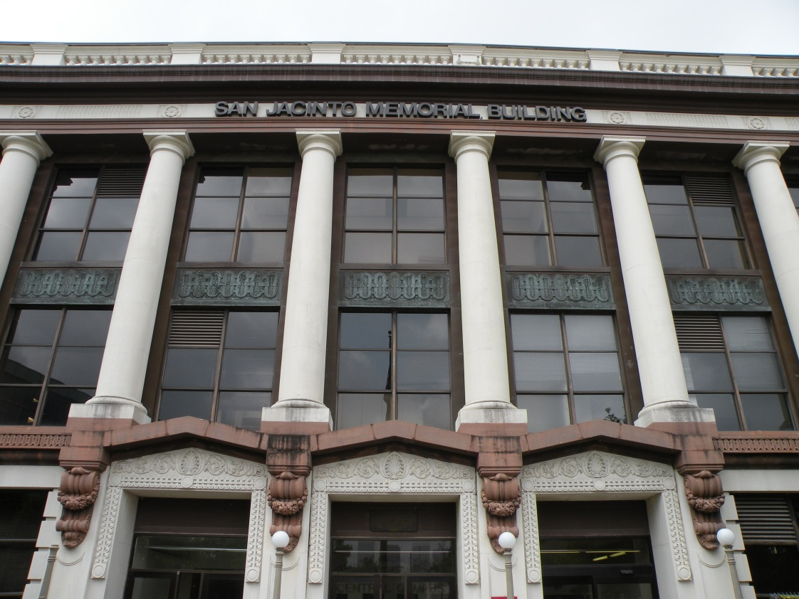

***During the re-construction process:***

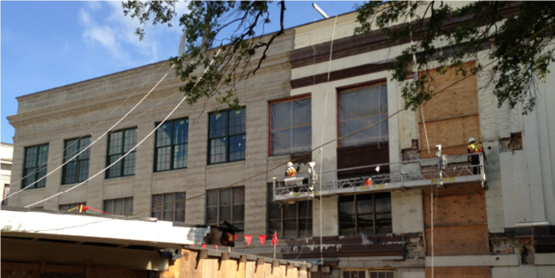

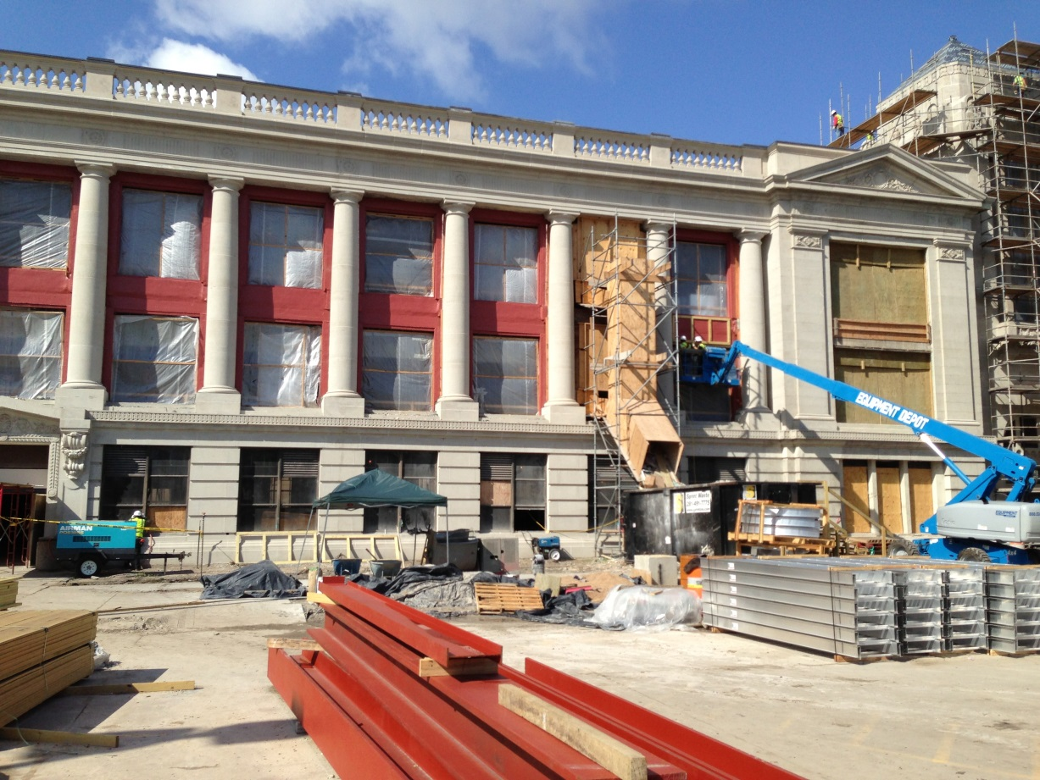

***The final result:***

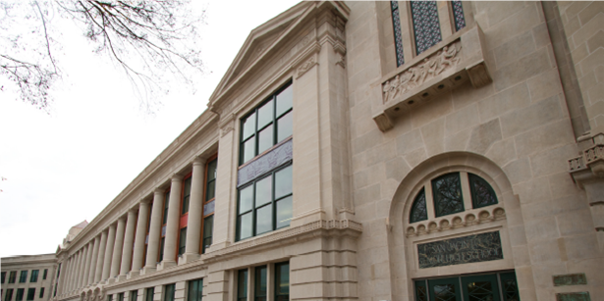

__________________________________

**Share your story!**

To submit for the Project Spotlight, please email [projectdelivery@aia.org](mailto:projectdelivery@aia.org).

Criteria: 200-800 words, sharing the use of an alternate project delivery approach that contributed to the success of the project. Please include 2-5 photos of the project.