Lean Collaborative Tools Applied to Public Funded Design Build Projects
Bill: Thanks for coming. My name is Bill Proctor. I’m with CGL Companies. I work in Sacramento, California. I’m real pleased to have you here. I think I’m going to talk about some things today that are going to be a little bit hard. They’re among my favorite things. Steve Carter said I was going to be talking to a cynical crowd. I’m okay with that.
My first experience in this business was also with a very cynical corrections market. It was in 1971, working for the Federal Bureau of Prisons, when we set about causing a tectonic shift in corrections and corrections facilities. Back then, penitentiaries were penitentiaries – a lot of tiered cellblocks, and so forth.
I was working for Norm Carlson, who was an enlightened director of the Bureau at the time. Norm wanted to change the way corrections was done, and he figured out pretty quickly that in order to do that, he needed a different kind of building to accommodate it.
What followed over the next ten years was work I was pretty proud of. We created podular design and what we called unit management – it later became direct supervision. We were proud of it.
It still wasn’t really taking hold in the ’70s, so we ended up creating the National Institute of Corrections, which became the vehicle that took it out to local and state jurisdictions. Through the ’80s and ’90s, we watched in horror as we saw what we had done become much larger and much more overcrowded, and watched the need grow.
I think we’re in the middle of another tectonic shift in corrections. After 30 years of massive building, we are starting to hear a politics that is not inclined to keep building at the same pace. The money has become a much larger issue, so we’re seeing changes in the way things are being approached.
I’m going to try to talk about five tools that I learned about when I managed the California Prison Health Care Receivership Program – tools that can be adapted into Design-Build and even, to some extent, into CM at-risk projects.
Before we get there, I’m going to talk about the hard part, which is cultural change – change in the way we organize and manage our projects. It is a hard thing to do. It’s easy to talk about. A lot of you are going to say, “Well, we already do that.” Probably not at the level I’m talking about. But I believe it’s as hard as it is essential.
I picked up a lot of this stuff from Lean Construction. The Lean Construction Institute was started by Greg Howell. Howell tells a great story. He was a graduate student at Stanford in the ’60s in civil engineering. He was working with his advisor, trying to come up with a methodology for doing a thesis project that would get a measure on the waste in construction. It’s a hard thing to do, but what he came up with was a pretty simple system of ones and zeros.
He found a sizeable hospital construction project and worked with the superintendent to work it out. Every construction job has an office trailer on the job site. It’s got a big table in the middle. The contractor has got a comprehensive schedule and a three-week look-ahead schedule. Every week, he sits down with the superintendents of all the subcontractors and tells them what they’re going to do in the following week. Everybody looks at each other, they shake their heads, they agree with what he said, and then they go off and do something different.
Greg asked the superintendent to just give his direction in increments that could be measured in the week. If a subcontractor finished what he promised to do during the week, he got a one. If he didn’t finish, he got a zero. If he started, but didn’t finish, he got a zero.
Greg says that at the end of that project, he was just blown away. 57% of what was promised got done. That means 43% of those promises didn’t get done. You have to ask yourself, “I wonder if those promises could result in work that actually got finished if it would be a measure of an efficiency on a project that would save money?”
You think about typical instruction projects. If you can cut 2%, 3%, 4%, or 5% out of the project… Even on our best day in design, if we could reduce cost by 10%, we’ve done a remarkable thing. It’s rare in these days. 43% waste, in an admittedly funny measure, is an extraordinary opportunity, if we can find a way to do it.
What if we could change our methodology in managing our projects so we can get that waste out of the projects and then reinvest those savings into better features and reduced cost? What if we could come up with a number of mature options for the project before we start making decisions in our traditional linear manner and avoid that continuous looping back for cost reduction, and change, and so forth?
I think about this as filling the space between the list makers and the dogmatics at the planning stage. At the program and planning stage, we meet with our clients on one end of the scale. We make a list of their requirements, develop bubble diagrams, create facilities, and so forth – I’m oversimplifying this – on one hand.
The dogmatics are those that come in and know the better answer, but prescribe it to a client. There is a lot of conversation, and so forth. But we very seldom drill into why the space is being configured in the way it’s done, particularly as the need changes.
What if we could change it? Think about a family that’s lived in a singlewide house trailer for those whole lives – a 12-foot wide house trailer. They win the lottery, and they get the chance to build their new dream house. They end up building a very long, narrow house, because it’s the only way they know how to live. We do that in corrections, as well. We continue to build that thing we know how to live in, and don’t really challenge the opportunities to change it.
What if we could design based on a detailed estimate, rather than continuing to cut scope in that continuous cycle again? I want to talk a little about a methodology for how we might be able to get to it.
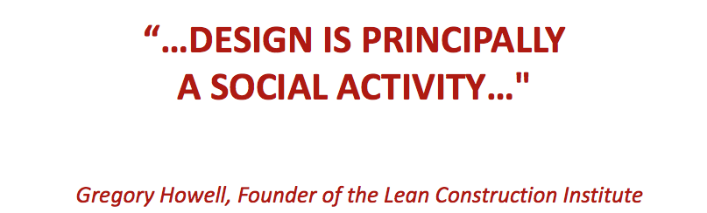
My pitch is at the bottom: design and construction is principally a social activity. It’s the working of the relationships and building trust and so forth that we feed into the way we make our decisions and run our projects.
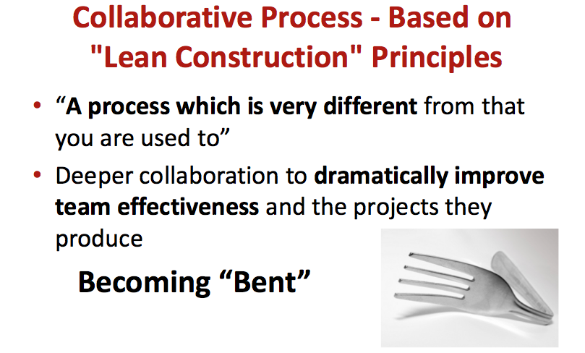
I’ve picked up a lot of this out of the Lean Construction, as I explained. It’s different from the way you’re used to doing projects, but it really gives us an opportunity to change the way we do things.
On the California Receivership Program, we call that change “getting bent.” If you think about that silverware holder at home that has the shapes of spoons, knives, and forks in it – after you’ve worked on a project using this methodology, what we have found is that people tend to be bent – they don’t fit back into that old traditional drawer anymore.
We believe that as we start adapting to these different ways of doing things, we sort of bend folks to the new way, and hopefully it has an opportunity to grow.
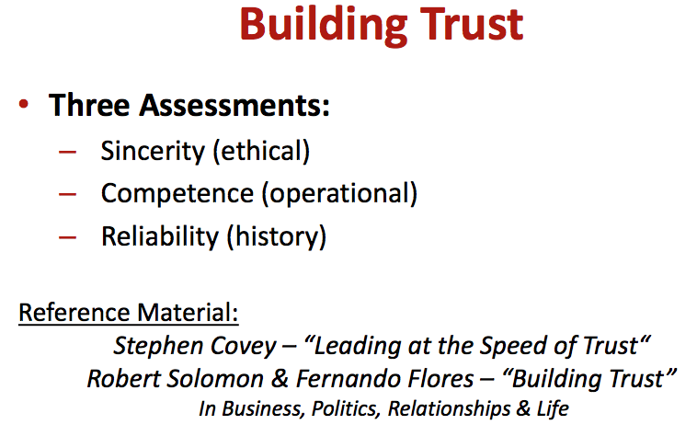
One of the most important things in this is building trust. This is one of the places where you’re going to say, “We all do that.” What I’m talking about is a pretty significantly different level of trust. We should be distrusted for our silence, or for our tacit agreement in things that we know aren’t a good idea, and for agreeing to do things that we know we aren’t going to be able to do. One of the things we do in this collaborative process is training on building trust.
It’s the sincerity, the making commitments that you intend to keep. If you can’t keep it, saying so. It’s a much harder kind of conversation. Everything I’m going to talk about here is based on an assumption and an understanding of competence. We need to pick teams who know how to design, manage the projects and construction, how to operate corrections, and so forth. We’re assuming a competence in the ability to work together and then bringing that competence to the table so it can be trusted.
Then we’re talking about reliability and being trustworthy throughout the entire project. It’s something we really need to pay attention to, because my experience has been that we talk of trust and work in relationships of trust when we really shouldn’t be trusted. We should be doing it a different way.
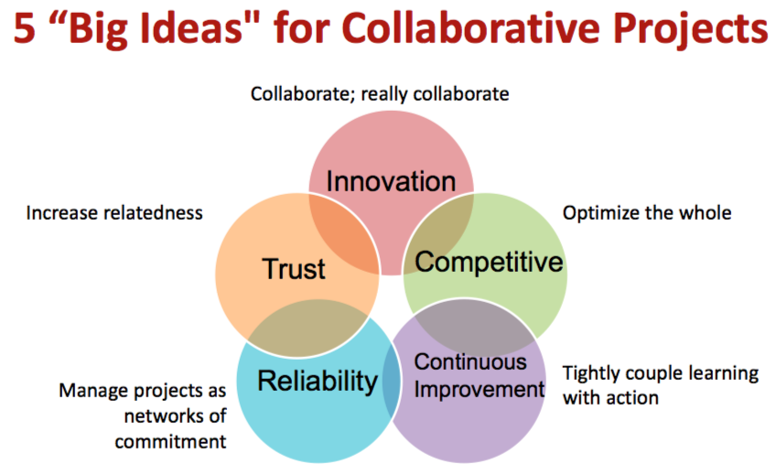
The Lean guys use this diagram a lot. It’s the five big ideas of the collaborative process. Innovation, for sure – an innovation that is only made possible by changing the way in which teams work together in order to enable a higher level of collaboration.
It’s competitive, but it’s competitive in a way that’s aimed really getting away from the sequential elements – silos, if you will – of the entire design and construction process where we’re all watching out for our own interest and are really collaborating, truly collaborating, in order to optimize the final product, the project.
We’re managing projects as a network of commitments, so that trustworthiness thing I was talking about really makes it possible to make commitments at a very detailed level that we can depend on and trust the work to happen across that network.
We aren’t born knowing how to do this. In fact, what I’m talking about is really making some fundamental changes in the way you think about doing your profession, the thing you’ve been doing for the whole time. It requires a commitment to a continuous level of learning new methodology for being able to accomplish the work.
We also know that one of the constraints in being able to make these projects work is in what we call the four essential elements here. We have to change the commercial terms of the contract, in a lot of cases, in order to enable this higher level of collaboration. In fact, right now we’re so constrained by public-funded agreements that it’s really difficult.
We’ve been talking a lot about Design-Build here, and every pitch I’ve heard on Design-Build talks about both its benefits and its limitations – the things that we can’t do. I’m beginning to think of Design-Build as the new Design-Bid-Build, until we can add this element of the methodology for how we work together to make it work.
We need to change the organization structure. If we have typical hierarchical organization structure – think owner, public agencies, really, a multi-headed owner, and then architect, with a whole list of sub-consultants, contractor with a whole list of subcontractors, each financially motivated to protect their own interest – then we have a structure that’s kind of designed to fail. Even when we take it to Design-Build, we’ve created a mechanism for better collaboration, but we really haven’t fixed those silos completely.
Then, we need to change the operating systems. That’s what I want to get to here. I have several suggestions for changes to the operating system that make it possible.
I was fortunate enough – unfortunate enough – to be the program director for the 10,000-bed California Prison Health Care Receivership Program. It was sort of my Frank Lloyd Wright mile-high building. It was this wonderful conceptual thing that we took very deep into the planning and then didn’t have to build. But we learned some extraordinary things there.
The program came together as a result of the determination that California was failing to provide minimum constitutional access to health care and mental health care. They needed 10,000 beds to get just up to the constitutional level.
They were killing half a dozen inmates a month in California prisons by just failing to provide access to health care. Cancer, brain tumors, heart failure, all kinds of things, happening to people who never saw a doctor and never had a chance. What we discovered was they didn’t have a place to provide adequate health care. It took them to the need to build these things very quickly.
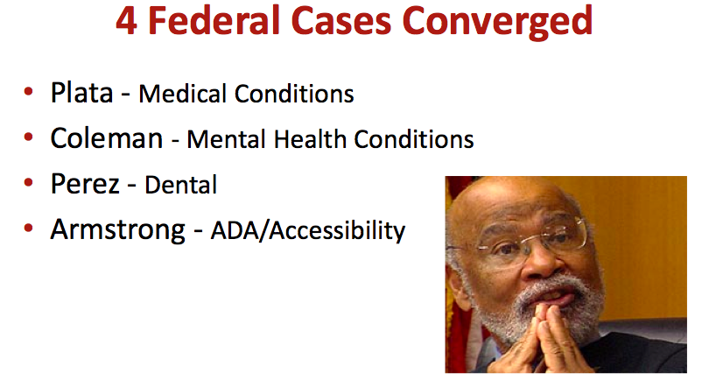
Essentially, we were given this extraordinary opportunity. There were four litigations – a medical conditions case, a mental health case, a dental, and an ADA case, all class-action lawsuits, where the state had been sued. They had lost, they had negotiated settlement agreements, and failed to comply. We were somewhere in the midst of about 16 years of appeals and trips to the Ninth Circuit and to the Supreme Court, and so forth.
It created an atmosphere where we had an opportunity to try things. We knew that it needed to go very fast. Did you ever do a mission statement on a project? You spend a day, and you negotiate, and it always comes out, “Better, faster, cheaper,” with some other superlatives to there?
I’ve always wanted to get it down to something much simpler. I used to joke about getting it down to one sentence, perhaps even one word. This one went very quickly to, “Go.” It was just, “Move as fast as you can.”
Our obligation was to build facilities that met but did not exceed a minimum constitutional standard. We didn’t even know what that meant – it’s not defined anywhere. What’s a minimum constitutional standard? Steve Carter and Bob Glass did some wonderful work on it.
The way I describe it is if you have this herd of horses that you want to confine in the smallest possible corral, they went back to 16 years of court orders and so forth in California and found enough fence posts in those orders to give us the shape of the corral and then started designing to fill those space between those posts. We felt like we were coming up with a defensible minimum constitutional standard.
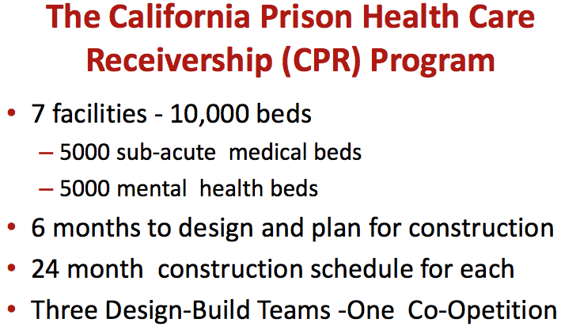
But we also had to go very fast. When I told the receiver that 10,000 beds was going to take six months or more to plan, and then 24 months or more for each of seven projects of 1,500 beds each – about 1,300,000 square feet each – it wasn’t fast enough. We ended up with a mission of just going as fast as humanly possible.
What that took us to pretty quickly was what we euphemistically called a “co-opetition.” We decided we would pick three design-build teams in a collaborative competition and have them come work together as a single team in a big room, to help us get from that minimum constitutional facility concept through site selections, through California CEQA, through and super fast-track design, to a project construction deliver method that could fit this timeframe, and for a long period of time, planning to operate the facilities on the notion that we couldn’t build something profoundly different and give it back to the same people who were not meeting minimum constitutional standards to begin with.
We wanted to create a culture of participants – in other words, a single team working together. When we selected the team, we selected from teams who were clearly qualified. We did it on criteria based on creativity, knowledge, openness, and a capacity for collaboration during this planning process.
We brought them together and said, “We’re not going to pick you on who provides lowest price or who provides fastest delivery, or whatever. We’re going to select the team to go out on the first project on the basis of your contribution to this collaborative team in helping us achieve those goals. These are going to be subjective judgments, but that’s how we’re going to get there.”
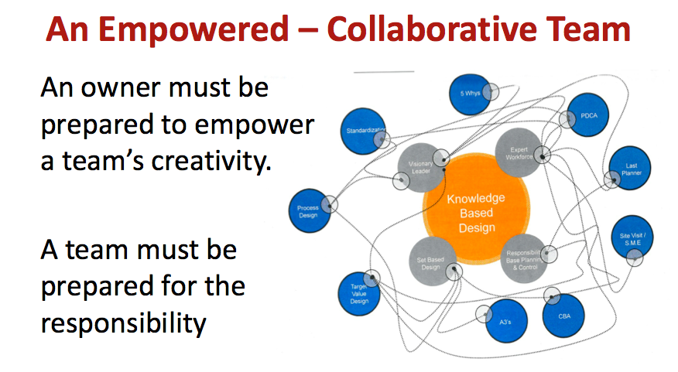
We brought this huge team together in a big room in Sacramento, and we started it with a two-week soft start. By that, we said, “We’re not going to spend time talking about the project yet. We’re going to talk about these tools from Lean Project Delivery. We’re going to teach you a new language, going to that trust thing, and the way of communicating. Then we’re going to work together to empower you to work as a collaborative team.”
This is way harder than the words would suggest, but we said, “As owner, we’re prepared to empower you to be a creative team. In return, you have to be prepared to take responsibility for that, and we’re looking for the measure of that responsibility to be the way in which you collaborate.”
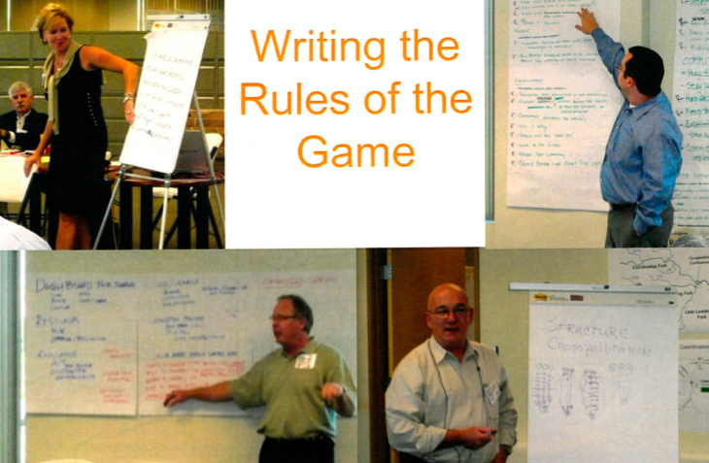
During that two-week period, we also said about writing the rules of the game, about how we’re going to do the work and how we were move it forward. The teams included Hensel Phelps with HOK and HKS Architects, a Clark/McCarthy team with HDR and HGA, and then a DPR team with Stantec design partnership – and forgive me if you’re in the room, I’m forgetting two others.
There was some horsepower in that team. As we were giving them the Lean instruction, we were also giving them the opportunity to help us write rules for how the project was going to run.
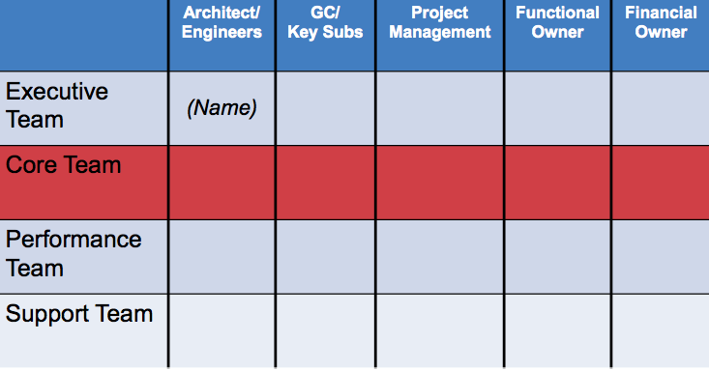
The structure that we came up with was really important, also. Each of those firms had somebody who was a part of the executive team – these would be very senior managers, the top decision-makers. Our deal with them was that we wanted to make sure they understood what we were doing in order for them to empower that core team.
The core team was the lead people onsite who were empowered to manage the work of the organization. They worked as a team, so there was a single lead team made up of representatives from all the key firms. Then we had performance teams and support teams – the job captain level and then other folks.
Our whole goal was to push as much power and authority down into those teams as we could, in a structure where they were able to work together and bring back recommendations. The concept was that those people responsible for hands-on doing the work are far and away the best experts for being able to give us feedback on how to do that work.
So we wanted to empower them in a structure where they could go off, be creative, and come back within the context of this fierce schedule, on a project that had no definition, for a client who was deeply embattled. We were really pleased with the way it worked.
One of the first things we did was start with what we call conditions of satisfaction – what is it that we’re trying to accomplish? The conditions of satisfaction are basically defining the promise of the team. A promise is not complete unless it’s been written down.
We wrote it as a network of commitments and so forth. It was written by the stakeholders, and we wrote it so it described what we wanted that team to do, in terms that were measurable – measurable in the way so that if we were doing things that didn’t address that condition of satisfaction, we would ask ourselves the question, “Why are doing that? Isn’t it waste?” and we were just continuously knocking those things out.
As this team got larger, it was doing this massive task. We were also constantly focusing it back to the conditions of satisfaction. We summarized them and put it up on the wall. They were always visible.
The real goal was delivering project value, eliminating waste, managing a remarkable constant state of change, and then constantly moving towards improving our product and continuing to make sure the team understood – this was really a hard one – that they really did have the power to be innovative. We were encouraging it.
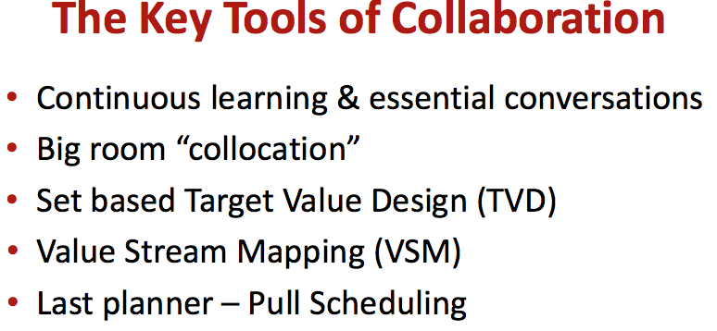
These are the tools I’m going to try to get to if I don’t talk too much – the continuous learning and essential conversations, as we call it. We put everybody in the project through this training. We were busy, as you can imagine. I got about halfway through it and thought, “Ah, I have to go back. I didn’t realize how important this was.” I put myself on the short bus and went back and started over. What we were doing was talking about the ways of making those promises and putting some hard structure into building trust.
I’m going to talk a little about the big room collocation, target value design, value stream mapping, and last planner, if I can get to it.
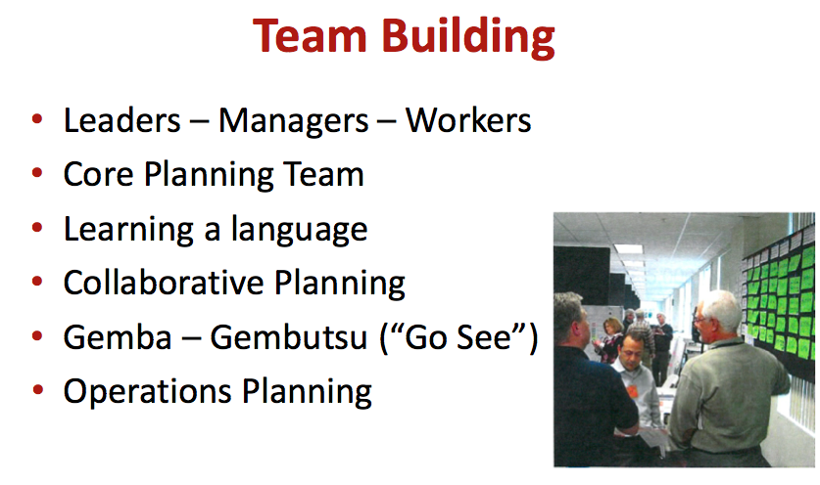
Team building: I think we talked about this. One key thing in here was the Japanese gemba gembutsu, “go see.” When we’re talking about new things and when you’re trying to change a cultural mindset on a specific way of fixing the problem, you have to really crack that hard.
We all come into this with 10, 20, or 30 years of experience. We know the answer. We just have to convince everyone else to go along with our answer. What we were doing was constantly going to see the way others were doing things – not necessarily buildings projects, even. A lot of manufacturing concepts came into what we were doing.
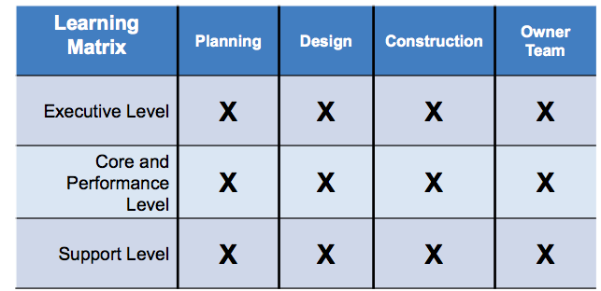
The levels of learning is sort of parallel to the organization chart I showed you. We were managing training at the executive level. Even the bosses at Hensel Phelps and Clark/McCarthy, HOK, and everybody committed to and recognized the importance of learning a different way, so that they simply knew what they were empowering down.
You can imagine coming into a big room of 250 people, with each of you working with your most fierce competitor, caused some angst in the heart of these bosses. We had to help them understand why it was in their best interest. Let me tell you, across the board, they got it and they empowered down.
We were giving everybody skills training that took away from remarkably busy daily schedules, but people really understood the value of learning, and they were applying it to what we were doing. If we spent two or three hours a week on training, we were getting it back in productivity.
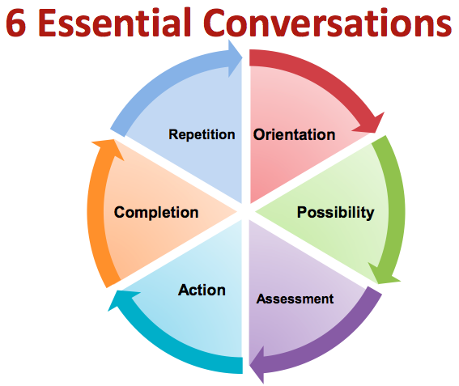
The six essential conversations – I’m not going to be able to go deep in this – really deal with specific ways of talking about things, from orientation – how we work together – to conversations of possibility. It’s absolutely essential if you’re going to change things. You have to open your mind up to being willing and able to consider other alternatives, other possibilities, for how that problem may get solved.
Conversations of assessment: we tend to have opinions that are deeply rooted and are so rigid that they kill the possibility of change. Conversations of action: we’ve decided what we’re going to do, what we’re going to do about it, how we’re going to do it, and come into agreement. Conversations of completion: that’s making the decisions and being able to determine when something is done.
Repetition is important. We were building these first things here, so that our model was replicable, both in terms of process and in output. In prison and jail work, more than any building I’ve ever been associated with, that repetition is extremely rich an opportunity for carving waste out of projects.
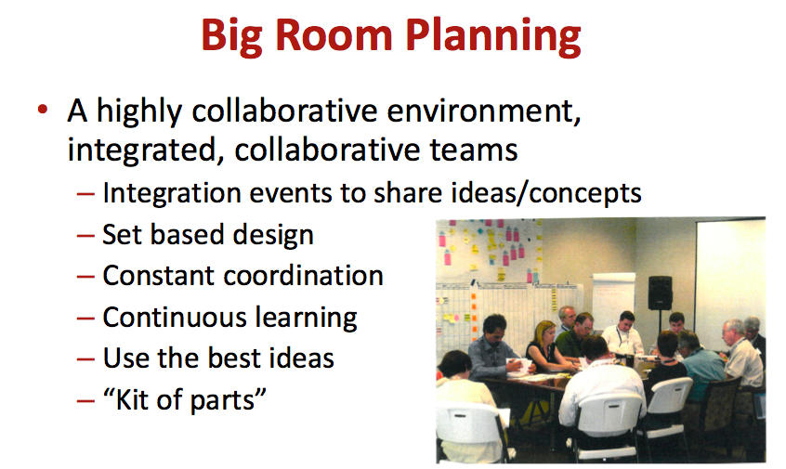
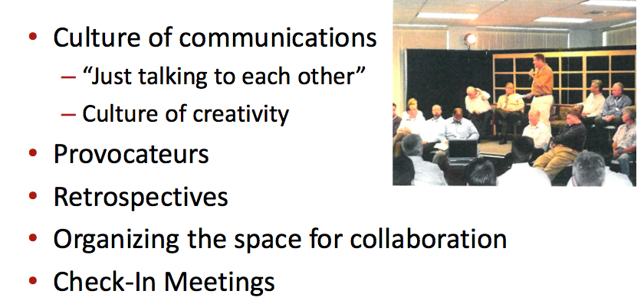
The big room planning was a highly collaborative environment. I call this thing “making projects fun again.” Those who were successful in this environment, I think to a person, they would tell you it was among the most fun they’ve ever had on a project. It was hard driving, but you had authority. You had the ability to drive change, and you were working in this thing that was working.
What we did learn is some people can’t do it. They just simply could not make the adjustment to this way of working. We had to identify and get them out of the project as quickly as we could. What I learned was, when people would come in, I would say, “I know this person is not going to make it,” and more often than not, I was just wrong about that. Some of the hardest contractors I had ever worked with just got it and became leaders in doing it. Some of the architects were able to make the transition.
Bill Valentine at HOK: during our intensive work sessions, I walked by sessions sometimes, and I would see this guy in there in a t-shirt, khakis, loafers, and no socks, facilitating a work session. It was Bill. He was sneaking in and facilitating work. He just wanted to see how it was working.
The big room was fundamental, because it got everybody in one place. I used to call the process there “lightning across the network,” because we were working on all elements of all of those seven things I listed, all at the same time. The face-to-face collaboration was essential in being able to make it work.
We brought in a class that we called provocateurs. A lot of you probably saw Craig Unger yesterday. Craig was one of our provocateurs. The provocateur’s job was to mix it up, to just keep bringing in creative ideas. They, of course, got a kick out of it, because they could come in and put some really wild things on the table that they believed in. We had a mechanism that was able to hear it, absorb it, and take it into the program.
David Chambers from the Sutter Health system, one of the most innovative people I’ve ever worked with in design and construction, was a provocateur. He came in and brought some ideas that really changed everything we were doing.
Michael Rona, the former CEO of Virginia Mason University Hospital in Seattle, came in and brought us value stream mapping, which I’ll talk about in a minute, which is the old Toyota process of taking an activity – putting a bucket seat in a Camry – and breaking it down into each increment of work, putting a timeline on each of those increments, and figuring out which ones were waste and knocking them out, finding a better way to do it. They took putting a bucket seat in from ten minutes down to 75 seconds or something.
We can do that, in both the way work happens and the facilities we plan if we can break the bond of either that list maker or that dogmatic planner. If we’re willing to drill into how work happens, then that’s where the very large savings in these facilities can come.
I think our best opportunity for this tectonic shift I was talking about earlier lives in our ability to use something like value stream mapping to challenge the way work is done in these facilities, and perhaps even challenge who the population is in the facilities and other methods of managing work.
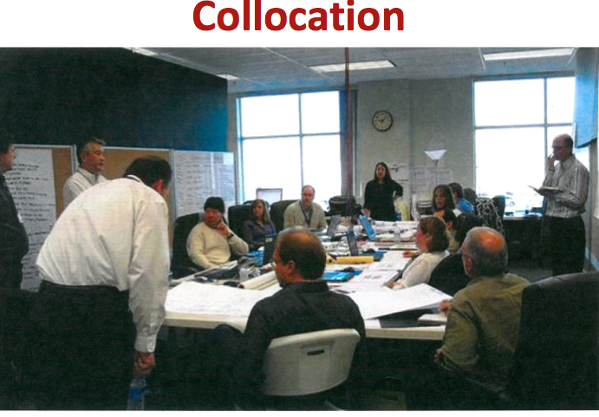
This process, this thing – you can imagine 200 or 250 people working in one room – had a rhythm to it. You could hear it, and you could also hear it start to whine, sometimes. You could tell it was losing its momentum.
Sometimes, it would just happen in smaller groups. They would get stuck around a bad idea and couldn’t figure out how to get out. But having them together so we could see them at one time also made it possible for us to recognize when they were getting stuck.
We would say, “Let’s stop and do a retrospective.” It could be on a team working on a mechanical system, or it could be the whole group. This happened two or three times, where we would just call a stop, and we would spend two or three hours – in one case, en entire day – talking about what wasn’t working.
The beauty of that was because we had done this essential conversation thing, we got some feedback that was just blistering, sometimes. But we were also prepared, because of the essential conversation, to listen, and we heard it. We sat there and we figured out what was the right thing for us to do to make an adjustment so this could work. The next morning, it’s back online, humming again, and we could see it go.
These things have a value that’s very difficult to measure and had a profound effect on the projects.
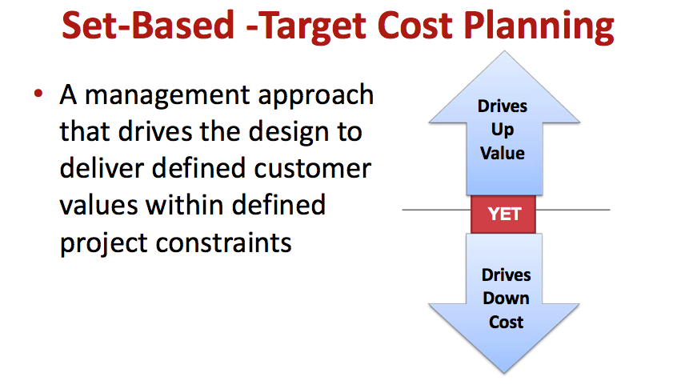
One of our best tools is what we call set-based-target cost planning. It’s just a management approach that defines customer value in a very specific kind of way. In that condition of satisfaction, we’re understanding what it is that’s important to the client.
We’ve worked that out. We’re driving things that aren’t a part of that condition of satisfaction out of the project, and you can see things just get more efficient. We were making the facilities far simpler, we were making them smaller, we were making them more staff-efficient, and we were saving a lot of money and we’re making better facilities.
We were discovering that if we’re thoughtful about how we simplify things, we’re also making them more flexible for the future, we’re making them more adaptable, and we were able to drive the cost down in a profound way.
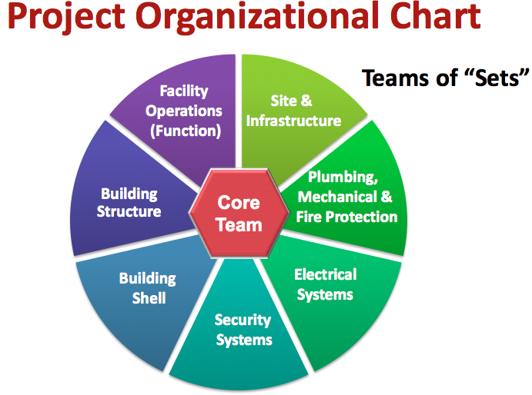
From our original model for that program, we were at $7.5 billion. Over a six-week period and a process I’m going to show you here – I’m not going to be able to tell you a lot of detail about it, but I’ll try to explain it – we were able to drive that down to $6 billion – in about six weeks. That’s not a small thing.
The organization chart: I talked earlier about not wanting to do hierarchical organization charts. This is pretty much the way we thought about our organization for that big team.
That core team we talked about had the authority to manage and run the work. They spent a lot of time collaborating. We were watching over them, guiding, facilitating, clearing a path, and so forth – not directing. They knew what to do, because it was in our conditions of satisfaction. We were watching to make sure they were staying on track. We would nudge them when they weren’t.
We organized the work in teams of sets. In other words, design folks, operations folks, and construction folks for site and infrastructure, each of the buildings systems here, and had them working as collaborative teams to develop multiple alternatives for how to address their piece of the work.
Target value: think about, in a traditional project delivery, how we create a budget. Essentially, it’s taking what we’ve learned on other things, adding some contingency to it – so god forbid, we don’t run over budget – and creating the number that we use as the basis for moving forward, and then our entire process is backing into that budget.
With target value, during that early stage of the project, we take that same budget and we look at it and make an assessment, as a team, of where we think the waste might live in that and what we might be able to get out of it, and then set a target value.
I’m seeing target values being in the 80% range, sometimes even less, of that traditional budget. It’s the budget to cover exactly the same things, but it’s the teams making a commitment to find ways to eliminate waste without sacrificing the quality of the building. We drive the quality up as we drive the cost down.
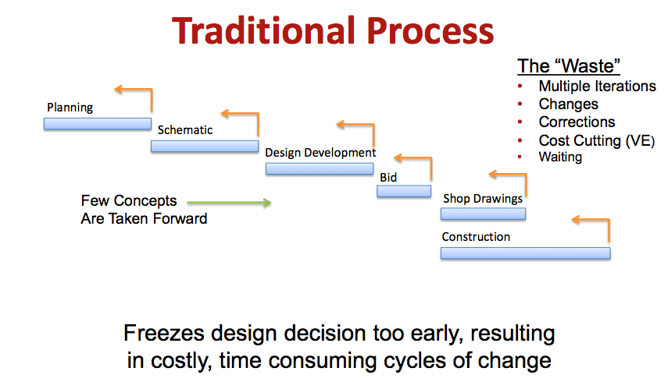
I’m not going to hammer the traditional process. You know that it’s sequential and that in each of the steps along the way, we have to circle back and adjust for cost or adjust for functional things we didn’t get quite right, and so forth
That continuous cycle – multiple iterations, changes, corrections, the value engineering, and all of that – is cost. It’s usually very significant cost, if we were able to truly get a measure on it. If we could avoid having to do that sequential process, I wonder if we could save any money.
What we do is we just freeze the design too early. I have a structural engineer friend who tells the story about working on a courthouse project where they were working with a well-known, star architect.
They got selected, and in their first team meeting, after they kicked off that project, the architect had everybody together and said, “I want to thank you. You did a great job in the interview. Let’s get started. We’re going to get floor plans. Structural engineer, we need a structural grid.”
My guy gets tears in his eyes when he hears that, and he thinks, “Do you have any idea how many alternatives and how many alternatives for cost savings you’re eliminating by locking us down so early on a system that has so many possibilities for cost savings after we understand the building better?”
If you think about it, different versions of that run through almost every decision that we make in a sequential process. We lock down function very early without having gone through that value stream mapping thing and lose the opportunity to really take out unnecessary square footage.
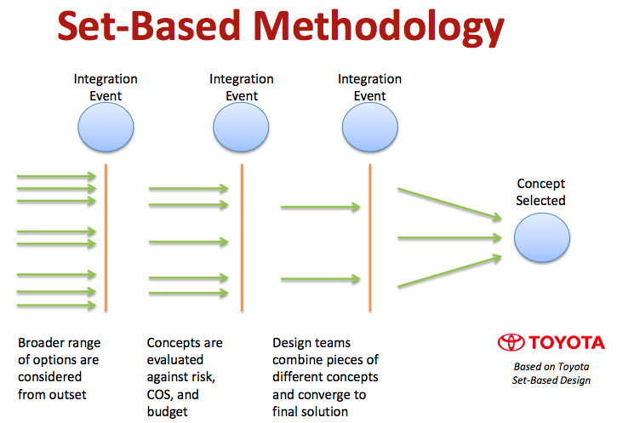
With a set-based methodology, we stack it differently. We consider a broader range of options from the outset in those set-based teams. We send those teams off to look at multiple alternatives for how to address their piece of the work.
Then through a rigorous and pretty sophisticated integration process within that target value budget of 80% of the original cost, we’re looking for ways to wring waste out of the project in order to maintain or improve the quality of the project by mixing and matching these various alternatives. I’ll explain how the sets work in a minute, but what it does is allow these set teams to negotiate and work back and forth.
Think about the space above ceiling in a courthouse. It is often driven by that structural system, and it’s really limiting the alternatives for mechanical systems. What if we could consider a range of alternatives for both, and make a decision after we’ve done that? We divide up that target budget among those sets so that they’ve each got an appropriate piece of that target value we set.
It sets about with a negotiation of developing alternatives, evaluating the quality of those alternatives, and then folding them together through these integration events to create an entirely different approach to the design.
The regular weekly meetings – more often, because we were moving so fast – are where the set teams come together and they report out on their work. Guess who runs those meetings? The chief estimator. Now, it’s not your mother’s estimator. This is not the traditional estimator. We were training people to be facilitators and giving them a responsibility for not only the cost – not just driving cost down – but also being responsible for the quality of the design.
We were dealing with cost in this way, so we were looking for those alternatives that were driving the waste cost out, and taking best advantage of the funds for buying value for the project. This took us all the way back, regularly, to our conditions of satisfaction. “Is this thing we’re fighting for really fundamental to what we originally agreed we were going after?”
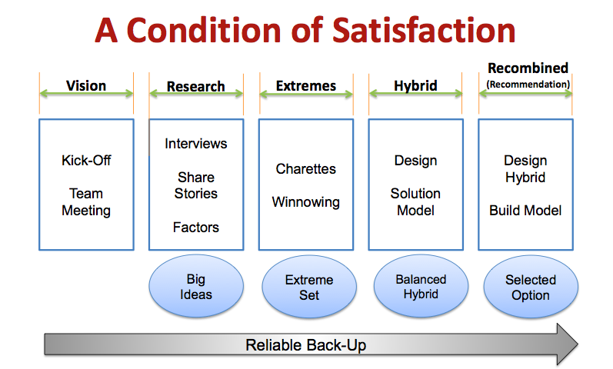
The way the process flowed was from the beginning, that vision and kickoff, that learning, soft start that we did, and getting the teams organized, up through the research, which was not just your traditional design things, but meetings, sharing stories, and defining factors that were really going to drive the decision making.
Extreme sets: what set-based allows us to do is really reach way out there for some things that can make profound change that you just can’t get to in a sequential process. It allowed us to put some pretty remarkable alternatives on the table.
There is a $1 billion facility sitting in Stockton today that looks remarkably like one we developed for this program that was only made possible because it was an extreme set that after we got it defined, it started making sense.
When we first saw that set, I went and pulled up aerial photographs of Dachau and was able to show… But as we worked our way through how that set could work, it started really making sense and it’s an existing project today.
Going to the design and solutions model we called a balanced hybrid: that’s selecting from the best from the alternatives that fit our cost model, then locking it down.
We also created a set and carried it forward that we called our reliable backup. So if the extremes took us into a ditch somewhere further down the road that we couldn’t see, we had a place to come back to. We were refining the reliable backup as we went along, but we were taking advantage of the opportunity to see the extremes.
Think about prisons and think about the possibilities that have evolved over 30 years. I believe I was the architect for the first total pre-cast prison built in the United States in 1971. We were pretty proud of it. We did all our integration of all the electrical, plumbing, security, electronics, doors, and frames, hand drawn shop cards with precast manufacturer. We did a lot of it in advance in a collaborative way like this.
If you think about the advancements that we’ve made, but think about the possibilities that open up if we’ve got all the possibilities on the table in a collaborative set-based approach like we were talking about. Then you add BIM to the model, and we start thinking about the potential for really going to a “kit of parts” off-site built component.
I have a friend, a mechanical contractor, doing a lot of health care work. Think about the war that breaks out the moment space above ceilings in a hospital become available, with all of the subcontractors who sequentially try to get into that space, and they basically screw the last guy.
He was the sheet metal mechanical contractor, and he was usually the one on the end of that chain of screwing. What he offered was, “Please don’t do that. I will provide the BIM. Let’s design everything that goes above that ceiling in BIM. Come to my shop. I’ll give you a table, a channel frame. We’ll fabricate these things and build them in my shop with everything – sprinkler pipes, everything – in this channel frame. I’ll drive it to the site, jack it into place, and you connect it up on both ends.” A remarkable opportunity, and I wonder if it saved any money?
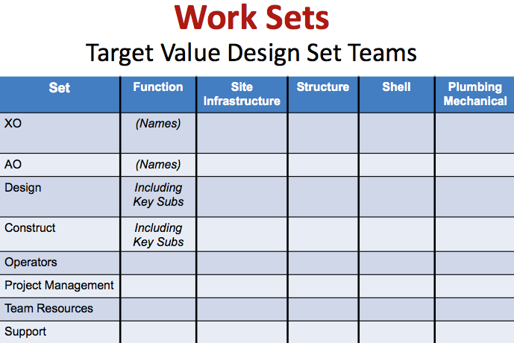
The set teams were organized like this. Each set had an XO – an executive officer – and an AO – an administrative person who was responsible. We could’ve been more creative with names. Those two were responsible for managing the activities of the teams and making sure they showed up in the right place and they were getting their homework assignments done. Then each team was made up of representatives from the whole network of players in the project.
This was extremely important. It worked extremely well. This big room space was broken up. We tore all the cubicles out, went down to Home Depot, bought a truckload of eight-foot folding tables and some rolling partitions with tack board on one side and whiteboard on the other, so you could instantly rearrange the space for these meetings.
There would be any number of meetings going on concurrently. They would be like a flock of birds. Every once in a while, you’d see a team jump up and run to the wall where we had the schedule pinned up or budget stuff. There would be a conversation, and you would see someone run off and bring somebody back from another team. They would have a conversation, and then they would go back to their workplace. I would know that some very significant problem just got solved.
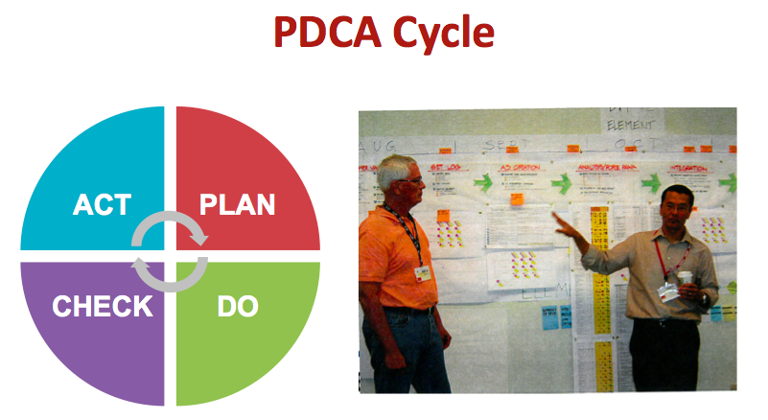
I’m not going to spend a lot of time on this. This is the Toyota “plan, do, check, act.” If you think about it in the context of those sets and the continuous cycle of developing and improving the work, this is also how Toyota got from being a little tin-can cars to being Lexus and the good Toyotas. They are continuously focused on improvement.
One of the training things we did is on some very hard methodology for making sure that we actually do this and don’t just pay lip service to it.
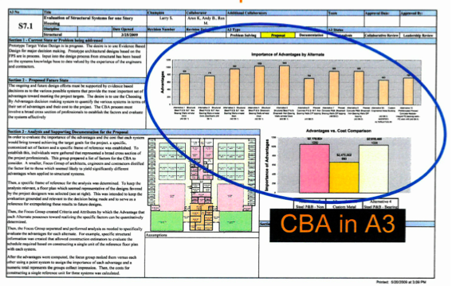
A3, as you know, is really just an 11x17 sheet of paper. It’s set up in a specific format. It’s not a document; it’s a process. It has the documentation of the process, and it’s iterative. These things are just going through a continuous cycle. Essentially, it’s a way of describing and thinking about these alternatives in a group environment and generally roll up to a relative number in the lower right-hand corner, so we could take them to those weekly cost meetings. These were the currency of the negotiation of fitting alternatives together.
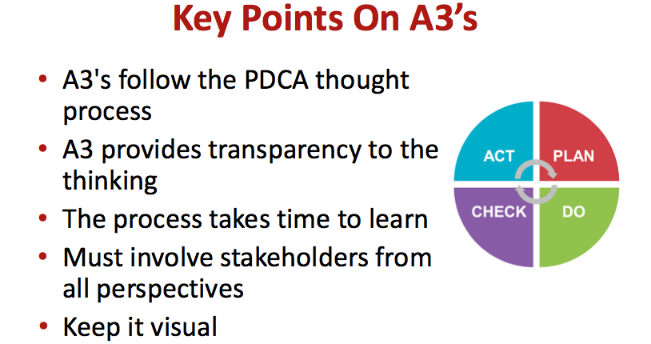
Key points on A3s – I think I’ve covered most of that.
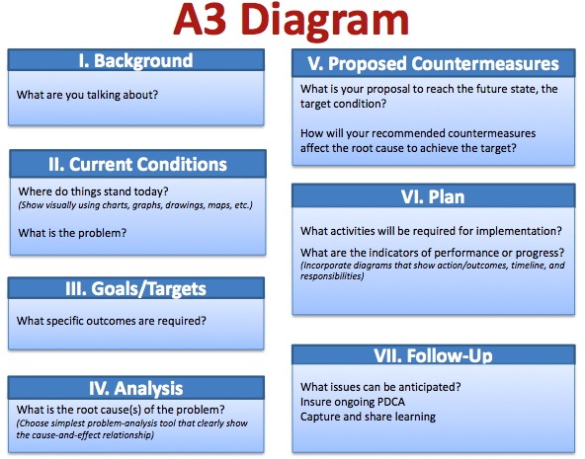
This is a typical starting place. It’s got the background, it’s got the current condition – often it would just describe the issue we were dealing with. It would set goals and targets as specific as that target value budget we were talking about. It does a similar thing on what we want these systems to accomplish.
This is where we described where the waste would disappear and the value would come in – discussed in detail, written in a few words. There’s space for analysis, and it’s eventually following to a recommendation or a plan and a track for follow up – how do we make sure this actually gets carried out?
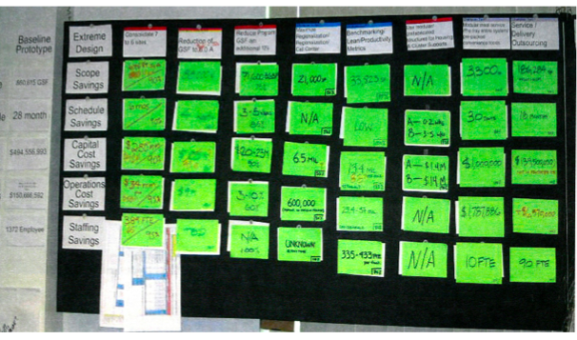
We used absolute, latest, cutting-edge technology to manage the information here – nothing like having a bunch of people in a windowless office with a laptop computer making things up and not communicating.
By this hand-drawn visual display, we changed the nature of the communication of these project teams. It was visual – it was right there. We would have these daily check-in meetings, where we’re standing at the wall. Nothing shortens a meeting like making everybody stand up, and most of our meetings were standing. It would be checking in on the information and talking about what’s displayed there, and then going back in and developing the details to support it.
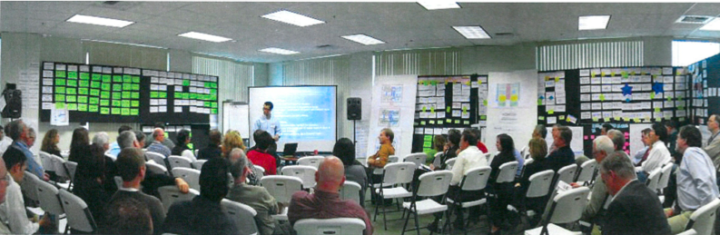
We would have major integration meetings. They look something like this, with a facilitator really taking us in. This is Stan Chu from HGA taking us through the analysis of those extreme alternatives, where that $1.5 billion came out.
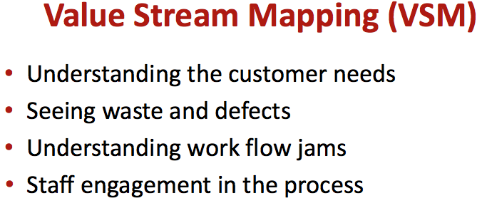
The value stream mapping is the issue of understanding the customer’s needs. This goes all the way back to those conditions of satisfaction and the conversations with the client that happen following that. It’s very powerful when the senior level client is working with you on setting the conditions of satisfaction and then sending you off to work two or three tiers down in the organization for the actual details of the planning function.
This gives you a mechanism for managing the decision-making process down there. It’s going this way, rather than this way. It gives us the mechanism for managing the decision-making.
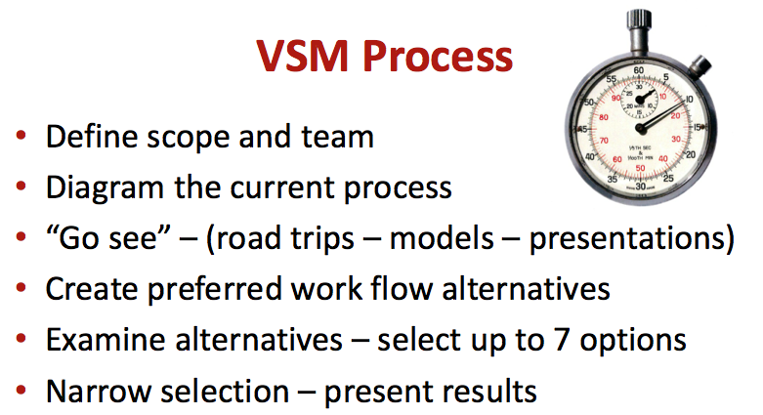
Value stream mapping: when you map the process, the activity, or whatever, it gives you the opportunity – you have to be smart about it – to identify the places where the waste lives in a way that you can eliminate it. You can’t just have this activity and a wasteful thing, and this activity, and butt them together. There will be something missing.
The value stream mapping is a way of being able to see that and then think about how to change those activities, plug something else in, rearrange the order, or whatever, so that you can get at eliminating that waste.
It helps us understand where workflow jams occur. How many of you sub-consultants have ever been waiting for floor plans or waiting for documentation or something? This can be used on managing a design process or a planning process of pouring a concrete slab, for purposes of thinking through how the work is going to get done.
It’s done by the people who are responsible for doing the work. This is not the bosses figuring this out and then directing. It’s the people who do the work figuring it out.
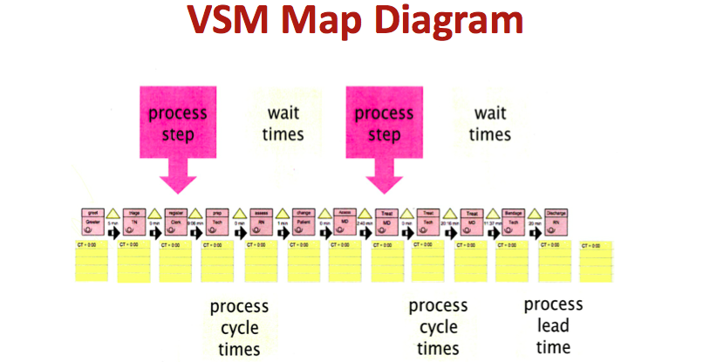
A value stream map documentation looks something like this. It ends up being a lot of hand drawn stuff on butcher paper or white paper. Sticky notes are a very good way to do it. The best way to do it is not put it on a computer. Let it be a collaborative thing.
The greatest limitation of our space – that big room for the receiver’s program – was a limitation of wall space. We had to bring in artificial walls so we had places to pin things up, because one of the fundamentals of the collaboration was visual information and being able to have a team stand and talk about it, the ability to move things around, to add things, or whatever. It’s hugely valuable.
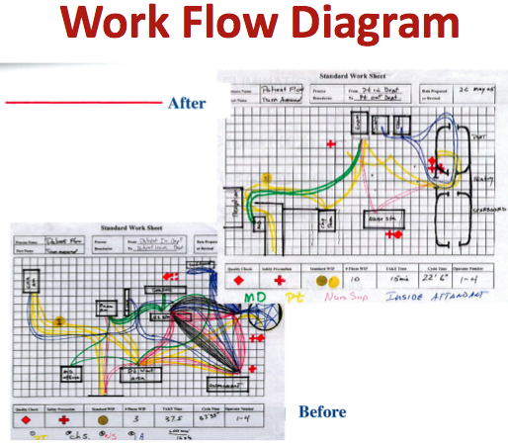
We did a lot of work flow diagrams. Think about a million square foot health care facility and the function of distributing pills, where you have 10,000 sick people. We took the standard CDC process – Steve, forgive me for this, I’m going to make up numbers – but through value stream mapping and looking at alternatives for how pill delivery could be done, it took us to more centralization and less decentralization.
Decentralized pill distribution has somebody taking pills out to the housing units with a correctional officer going with them, so you have two people going. The more you can pull it into a centralized place, the fewer people it took to do it. I think we went from something like 35 people to nine, and from some extraordinary square footage to a much smaller space to be able to accomplish it.
It was done with some diagrams like this, talking to the people who had to distribute the pills, and empowering them to give us some guidance so that we could take it back up through our recommendation process as a set in a context of its budget implications for not doing it this way. The collaborative process gave us a lot of power in how to do this.
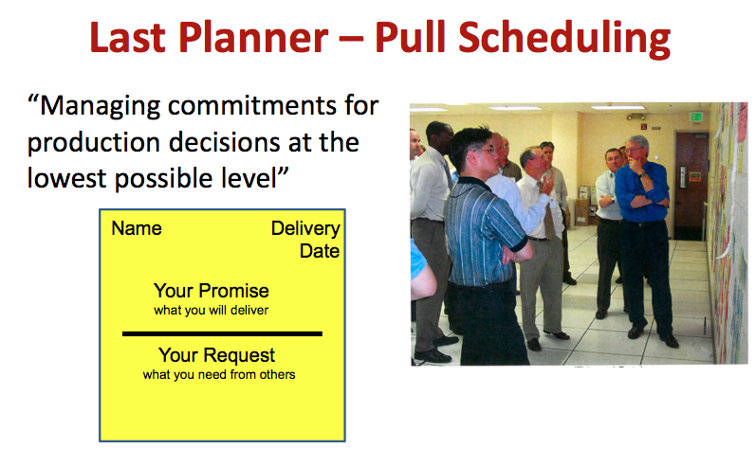
I’m running out of time, and I want to touch on this quickly. This may be the most important.
Last planner/pull scheduling is different way of approaching scheduling. What I’ve done for 30 years and what a lot of you probably do is sit down, look at the work that needs to be done. You do some kind of broad master schedule, you break it down into milestones, and then you break it down into details. It’s prescriptive. You may or may not have had any significant input from the people who actually have to do the work. There is a better way.
With pull scheduling, we’re taking it to the people who actually do the work, and we’re developing it as a promise and commitment for how the work is done. Do you see these guys here? That’s the pull schedule – that’s the way it works. They have sticky notes on the wall.
In pull scheduling, the last planner is starting with the last activity to accomplish a goal and making a request for what you need and getting promises from those people who precede you in performing that work, to make ready for you to be able to do your task. We’re just pulling it, all the way down the long.
Think about pouring a concrete slab. The superintendent at the weekly meeting tells the concrete guy, “I need that 20,000 square foot slab over in section D8 poured by Friday.” The concrete guy shakes his head, he looks over at the plumber, thinks about all the sewer laterals that goes in there, and says, “Shit, I’m going to pour on Thursday and maybe Tuesday of next week and sometime in the week after that. I’m not going to have to meet my commitment to pour that slab by Friday, because it’s not going to be my fault.”
In pull scheduling – this really is significant – everybody who touches that slab gets together. I have a film of some of the roughest looking concrete finishes you’ve ever seen, with a tack board and a little roof over it. They’re standing in their rubber boots, safety vests, hardhats, covered in mud and concrete, doing a pull schedule, because it was important to them once they figured it out.
The concrete guy says what he needs, and he works backwards through the form guys, the layout guy, then the rebar guy, the electrician, and back through the plumber, then the wire mesh guy, and so forth. They make deals and commitments. The concrete guy may pay the plumber to put on an extra crew to get all those laterals run in time to be able to pour his slab on schedule.
But two things happen: one, the guys who are responsible for doing the work make the commitments to each other to have it happen. They’re the only people in the world who can get that slab poured by Friday. But second – and more important – they’re building relationships of trust and horse-trading and so forth. Money may change hands, but they’re empowered to make those kinds of deals.
But that slab is not the only thing they’re going to do together on the job. By teaching this pull scheduling and empowering these teams to do this, we’re also creating a network where if that slab gets poured by Friday, I wonder if everybody involved in it doesn’t make more money than they would if it took three weeks. It affects the whole job, and it’s applicable to every activity on the job.
Hold onto your chair: exactly the same thing is possible in design. Do you ever spend time waiting for somebody? Do you ever get a directive to have something done by Friday, where you have no control over it and no obligation to get it done within that time constraint?
Even better, it goes back into planning, into the very earliest planning stages of the project, where we can pull a schedule and negotiate how work is going to do. In planning, probably the most valuable thing is within a limited period of time, we can make an efficiency that allows us to go much deeper within that same timeframe into the activities that are fundamental to what that project is going to be.
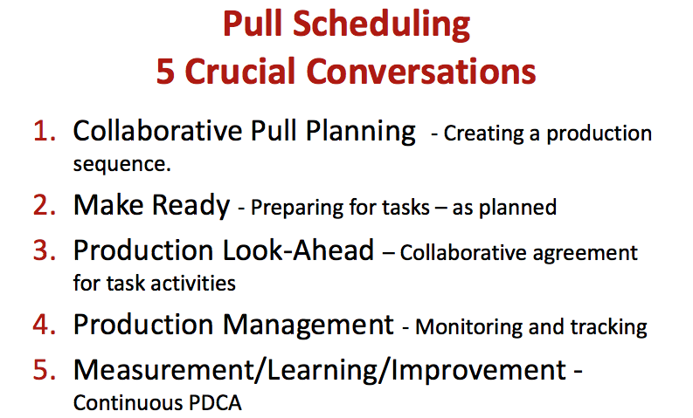
The five crucial conversations in pull scheduling are creating the production sequence, that’s what I was telling you about those concrete guys; making ready, that’s making promises; then going and doing what you promised in order to make ready and have that work occur in the way you promised.
The trick here is we’re doing this in small enough increments that you’re not making promises that you’ll forget or that are dependent on too many things that you don’t have control over. We’re breaking it down into increments where the promise really can be meaningful and you either keep it or you don’t.
Then production look-ahead is a collaborative agreement about how the tasks are going to be carried out. There is production management – monitoring and tracking – to make sure that things are moving. We still do primavera scheduling, but it’s usually tracking the promises that have been made, rather than prescribing how the work is going to be done.
The trick about pull scheduling – and I love this – pull scheduling will do one thing: it will deliver some terrible, bad news early. But what it’s doing is telling you things: “That may have seemed like a good idea when you made up that prescriptive milestone, but you can’t get there from here.”
The good news is that bad news early is a good thing. Bad news provides good information, if you know why you can’t get it done – and the earlier you get it, the more valuable it is.
I didn’t leave much time for questions, but I’ll be happy to answer questions if you have any.
Participant: I hate to do this but, this is a great process and all that – but it didn’t happen.
Bill: It didn’t happen on that project.
Participant: So it’s not proven out.
Bill: No, it didn’t happen on that project for me, but it is proven. It’s being done extensively in the health care work. What I would recommend – write this down – go to the Lean Construction Institute website, LCI. They have a wealth of information.
This thing you’re going to do at the end here to see what kind of products that can come out of these meetings that might be valuable: LCI, for these conferences, films every one of these presentations. They post them on their site. I have I think 400 documents that they’ve referenced that I’ve pulled out, and a lot of it is case study stuff of things that’s happening.
Michael Rona in Virginia Mason University Hospital didn’t build anything. He just had a budget he couldn’t afford in a hospital that wasn’t working very well and was getting worse. He started doing the value stream mapping within his existing operation – I’m making up numbers here but he cut his operating costs over four years by something like 20% at a time when inflation took it up 25%. That one is pretty well known.
A lot of the stuff I described here comes out of the auto industry and manufacturing. Remember Craig Unger’s thing yesterday, where he showed how productivity in the United States has gone up over the last 50 years, and in project design and construction, it’s gone down? That difference is largely the result of doing these kinds of things in manufacturing.
If you think about making a car, you start with nothing on an assembly line. The assembly line moves along, and you just add pieces to it until a car comes off on the other end. What Greg Howell figured out is that a construction project – and my pitch would be a design and a planning project– is very similar, where the place for the car stays fixed, and the work moves past it.
What I’m proposing here is that we use the same techniques that are being used in other industries and apply them to planning, design, construction, in ways that are well documented and are being used very successfully. To a large extent, the health care industry, and particularly in industrial building, are being used very successfully – very mature project planning, design, and delivery mechanisms.
I’m not making this up. All I’m doing is suggesting that we need to get in gear and apply it to one of the best building opportunities for doing this I know. We have projects that have a very high replication. They are buildings that really lend themselves to “kit of parts” kinds of opportunities for offsite fabrication and even advanced fabrication onsite.
We have design processes where we can pull information from many places. We unfortunately just pull it without the thought. I’m suggesting adding the thought, so that as we replicate things, we replicate them for a specific purpose.
Back to that tectonic shift, we are not going to be allowed to continue building prisons, jails, and courthouses in the way we’ve done them for the last 30 years, because the secret is out: we can’t afford it anymore. We have to find a way to bring efficiency to these projects.
For all of you, I would suggest that efficiency at the level I’m talking about here is an extraordinarily competitive advantage. If you can promise a client the kinds of savings that live in the waste that we’re identifying here in this, you put yourself in a different position in your markets.
Participant: It seems like an unusual aspect of the example you’re showing here is the whole “co-opetition” aspect. You could very easily use all of these Lean Design and Construction applications with a selected team. You didn’t need to have a co-opetition conglomeration of three different entities put together to use all of these principles.
The state might have been better served by selecting a team on a qualification base, getting their one team, then applying all of these principles. Rather than have 250 people go through when you could have had 80 people go through.
Bill: Thank you for that. That’s actually a really important question. We did the three teams because of the volume of work. We were concerned if we were doing seven of these things at over a million square feet each, the industry in California didn’t have the capacity to do them.
We grabbed three teams on the notion that we were going to put them out on three separate projects, and rather than us having to be in three places, running three concurrent projects at the same time, we just brought them to us.
I agree with you – it could be a single team. It works on a small scale. I’ve seen this done successfully on $20 million projects. It doesn’t have to be that huge scale. What CPR did was give us an opportunity to really wring it out. The urgency, the threat of federal court orders, and the power of the receivership gave us the opportunity to try all these things and see what worked and what didn’t work.
We learned a lot of things that don’t work. I haven’t told you about those. It doesn’t serve my best interest for this purpose. It didn’t have to be a co-opetition. Co-opetition was driven by the volume of work, and we centralized it in order to be able to deal… We needed three teams and we wanted one process.
I think I’m between you and happy hour. Thank you for coming. I really appreciate it.

