ReFAB PreFAB: The Practice and Science of Prefabrication at the Cutting Edge
Steve: Today’s AIA Housing Knowledge Community presentation, ReFAB PreFAB – The Practice and Science of Prefabrication at the Cutting Edge. This is the second in the 2013 series of webinars on researches in the residential sector. My name is Steve Schreiber and I’m the moderator.
If you’ve missed the series, please visit the Housing Knowledge Community library on AIA KnowledgeNet to view the recordings and download the handouts, the questions, and the answers.
Today’s presentation is copyright 2013 The American Institute of Architects.
AIA Knowledge is a Registered Provider with the AIA Continuing Education System. Today’s presentation is worth one Health, Safety and Welfare continuing education hour for licensed architects and one elective Supplemental Experience hour for interns enrolled in the IDP.
Although prefabrication is not new to the practice of architecture, its full potential –residential design and construction – has yet to be realized. The time for architects to take a lead in realizing this potential is now. New concepts and technologies in prefabrication are creating exciting new architecture and opening the opportunity for architects to influence a larger segment of the construction industry. Not only will prefabrication expand architects' influence, it will also help revitalize residential neighborhoods, influence sustainable design, and provide lower-cost home-ownership alternatives.
In an effort to realize this ambition, Andrew Daley, Jason Fleming, and Peter Muessig (all are recent graduates of the M. Arch. program at Rice) set out to design and build a prefab consolidated kitchen/bath/mechanical “core” tailored specifically for the renovation of existing houses. Having just installed their first working prototype, these three will present their project as a case study of the opportunities and challenges inherent to prefabrication.
Among other outcomes, attendees will be able to recognize the potential of prefabrication residential architecture, understand the potential of sustainable design, computer modeling and the factory process, new architectural avenues based on mass production, recognize the limitations of prefabrication, and develop strategies that permit design flexibility.
On behalf of the three designers, Peter Muessig will be doing today’s presentation.
Welcome, Peter.
Peter: Hello. What I’d like to share with you today is our experiences so far – the history of the project, our experience building the prototype – and bring us up to where we stand with the project and where we’re looking at it going forward.
As Steven mentioned, this is a prefabricated room. What we see as an advantage here is that we’re pairing a technical system with an opportunistic design and carrying it through with a social vision. As we continue to advance this project, we’re hoping to find ways continue to move architecture away from construction processes and more towards processes of manufacturing to help advance this project further.
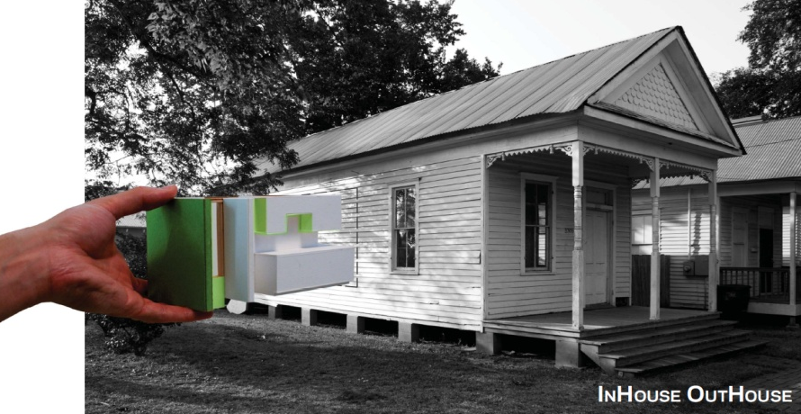
This initiated as a project at the Rice School of Architecture, initially in a studio. That was about a year and a half ago, and since then we have been developing this project on our own. A lot of the initial design and research was carried out in a studio setting, and since then we’ve been raising funding and actually developing the design of the prototype and then executing it.
History
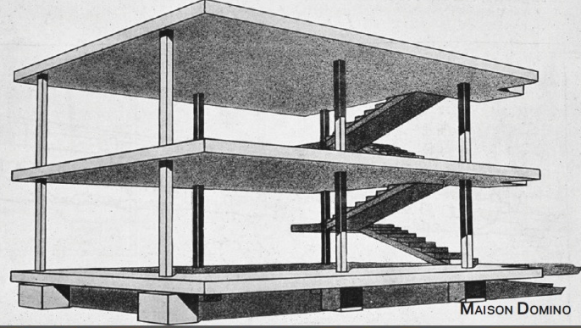
In the studio we had the luxury of time to carry out fairly extensive precedent research, and we focused primarily on modernist examples. One of the purest forms that we found was that of the Maison Domino. In its purest sense, it's a skeleton that’s just waiting to be filled in with architectural assemblies. One can almost think about this as a car skeleton in a car plant somewhere. It’s been assembled and then from various other manufacturing locations, parts are brought to site. And rather than everything being fabricated component by component full assemblies are installed. In an example like this, we could imagine an OutHouse and various other formations of architectural program and systems being installed into this ready-waiting skeleton.
From the post-war era, Lustron steel homes stood out as an example to us. They had a clear goal in the market they were trying to reach. They were especially trying to reach out to returning war veterans and provide both an affordable and durable house. These could be brought in by truck and readily assembled in the field as a series of fold out panels. They're called steel homes and they were made primarily out of steel panels.
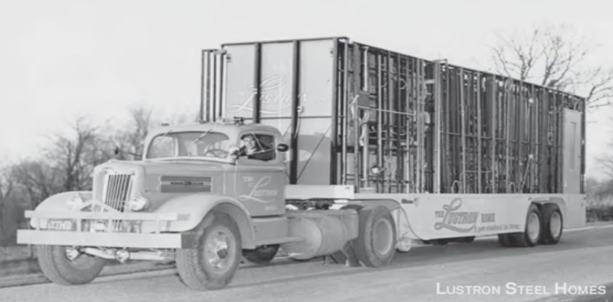
The real selling point was that, once assembled, these were very durable houses and would require very little maintenance in the long term. They were selling the American Dream of the easy lifestyle. They were also producing very affordable homes. They were selling their initial models at $9,500 which, in today’s value, would be about a $99,000 house.
There were a few models with various designs and features and, in the end, probably one of the greatest lessons we’ve learned from them is that they didn’t last more than five years, as they had trouble with their distribution and actually delivering these units. Both marketing and the costs and ability to deliver a prefab project really come into play.
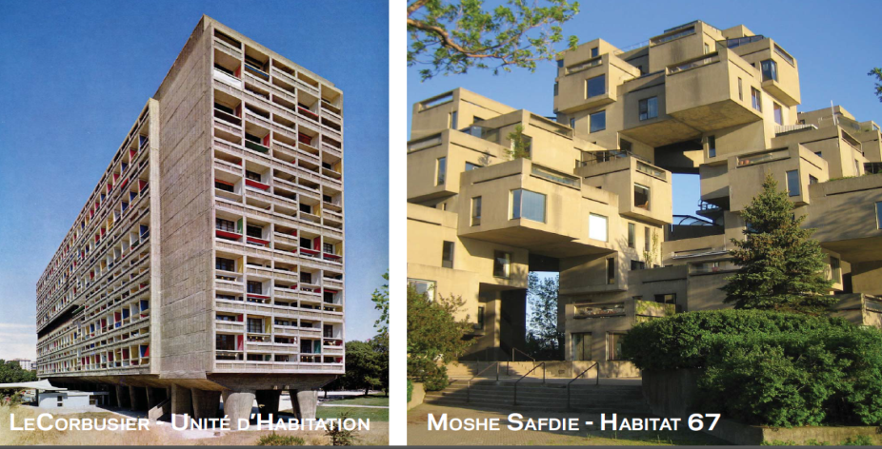
Some of the more interesting examples we’ve found from the ‘50s and ‘60s were at the larger scale. Both were driven by visions of large communal living. Both of the habitats demonstrate what can be accomplished with off-site prefabrication. I think one of the biggest shortcomings that we found in these is that they were entirely focused on speeding on-site construction, but were very idiosyncratic in their design so were not reproduced. While the initial construction of each of these might have been sped up by the off-site construction, they didn’t really see any financial gains, which is something we’re seeking in our project.
These are some contemporary examples, and each of these had something very valuable to offer in terms of their own independent case studies. I’ll just move through them quickly as we’d like to get to our project. There are also a lot of things to learn in their shortcomings.
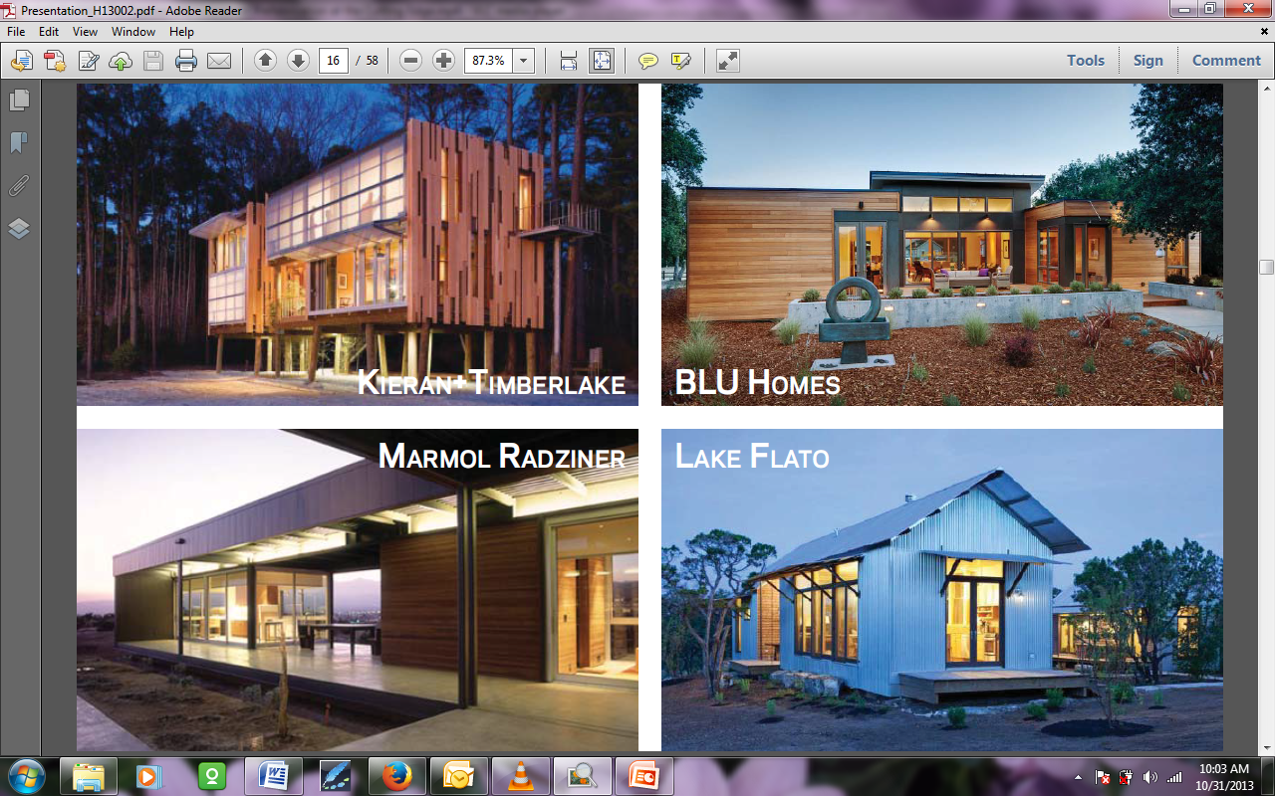
BLU Homes has a fairly innovative delivery system with hinged wall panels that can be delivered without any wide-load issues. It almost comes as a flat pack unit, almost IKEA style. A lot of the others explore different types of assembling connections and integrated systems.
At the moment it seems like you have the choice of either a double wide trailer at the low end or a high-end version. Even the most affordable one, the Lake Flato, is really a luxury item. All of these serve either sub-suburban rural situations or serve as vacation homes in very pristine landscapes and really don’t have much of a viable potential as an urban infill project.
You can see, especially from the Marmol Radziner project, its design is gorgeous and it has a wonderful layout. But it’s both sprawling and its views are panoramic, which really don’t address the urban nature of a project like ours is trying to take on.
At the smaller scale of things is the modular building component. This is a way of thinking and this gets down into thinking through process design and manufacturing issues. In the best case scenario such as SIPS panels, it tries starting to integrate multiple systems into a single, deliverable unit so that you’re delivering both a structural system and an insulation system to site.
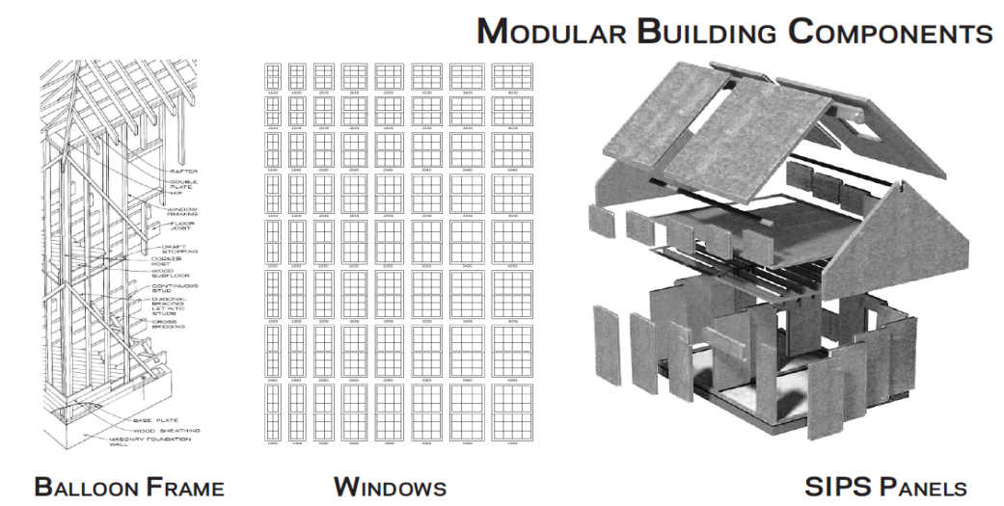
Some of the other examples that we saw are entire floor plates that can be designed and constructed off-site where the systems run through them. There are a number of projects throughout the world, but especially in China, that we looked at a little bit where 40 story high-rises were being assembled in a matter of weeks as each floor plate was delivered to site and stacked on top of each other.
I think we’ve found the sweet spot for us, and relatively unresearched a scale of project to be that of the room. This is where the technical issues of the components start to meet the programmatic issues of space and architecture, and this is where we found our greatest potential to lie in terms of having an effect on the prefabricated worlds.
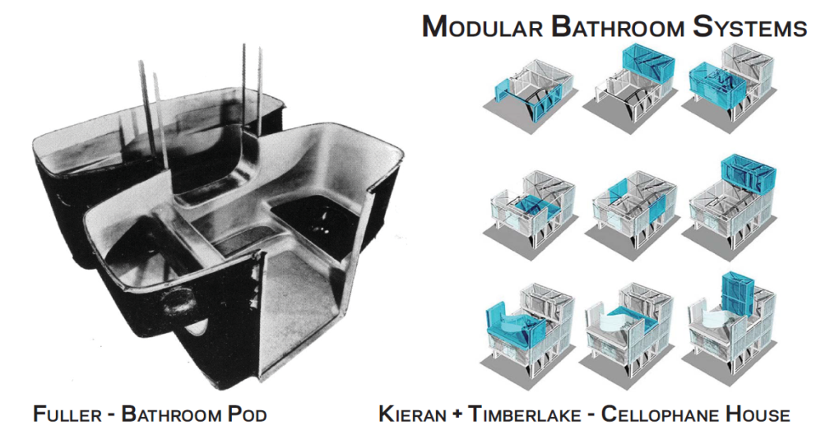
The Fuller bathroom and the Kieran and Timberlake Cellophane house, I would say, were fairly successful technologically in terms of issues of lightweight and durable construction, but they start to fall short on aesthetic and domestic appeal. They both have these very industrial feels to them and are very idiosyncratic as well. I feel that even non-architects, but especially non-architects, would think twice about introducing units such as these into their households.
Project
I’d like to talk a little bit about our project now. Our prefabricated unit focused on the scale of the room and wrapping several programs around the main building systems at play. As we started out in our studio, we identified three core goals that we wanted to focus on throughout the course of the project. These were that this had to be a prefabricated unit.
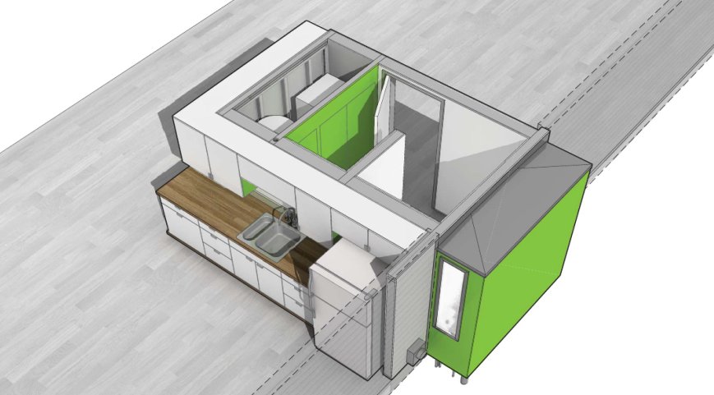
The second was that we had a series of design standards that we wanted to maintain. We asked ourselves, “Is this something that we would want to live in? Are these finishes that we would want in our homes?”
The last was that this had to work for existing construction.
So the prefab nature of this comes from years of research being carried out by the Rice Building Workshop, which is the studio we started this in. It’s a design build studio. They’ve always explored ideas of the consolidated core, which takes all of the more technical and advanced construction systems in a house – electrical, plumbing, mechanical – and tries to consolidate those into a single area to focus both their coordination and the time spent on construction to one area of the house. This is frequently paired with the kitchen and bathroom and the mechanical space and the areas where the skilled trades mostly involved.
We were challenged with taking this consolidated core and moving its construction off-site. We essentially started with the design of the systems themselves – identifying which we wanted to include and how to actually coordinate and orchestrate this. One interesting thing about a space this size is bringing these systems primarily into just a single wall. We were really able to closely coordinate how they interact with each other and avoid each other. At the end of the day, we need to bring all the services in through one point and waste back out through that same point.
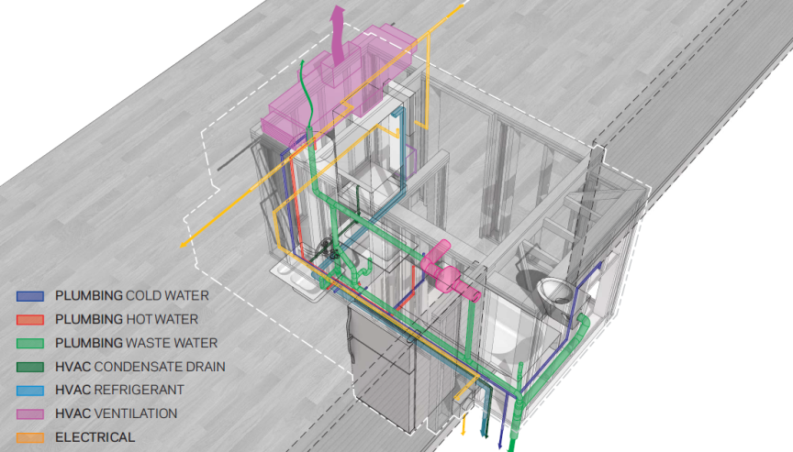
To get all these systems wrapped around each other, we relied heavily on very precise computer modeling. I’ll go through the construction techniques we used a little bit later on. But in the end, we were able to provide systems in this deliverable room that can drive about a 1,400 square foot house, and the only limitations placed on that are from the HVAC system. Anything larger than that and you start to need more than a single condenser or air handler.
Also, you start to get into programmatic issues. Houses larger than that are typically going to have more than one bathroom to serve all the occupants.
In the future, we can see there being multiple units being delivered to a single house; but for the initial design exercise and the prototype, we focused on a smaller home. The eventual house the prototype was inserted in was about 800 square feet.
We’re looking to deliver plumbing, HVAC, electrical, and a full data system. One of the analogies we used was that this is a heart transplant in a way. We’re delivering an entire circulatory system for a house in this 95 square foot space. The guts are the systems that take the major coordination, and after that there’s a lot of flexibility in what we actually wrap this in.
This leads to our second point which is the level of design that we’re trying to achieve with the surface and appliances. The rooms we decided to include in this were the bathroom and kitchen. To some degree these were quite obvious choices, and those were the ones that were pursued in past examples that we had seen.
Aside from the systems themselves being the most trade-intensive parts of the house, the bathroom and the kitchen would follow as the most cost- driven rooms. They require the most labor and the most expensive appliances, materials, and assemblies that go into them.
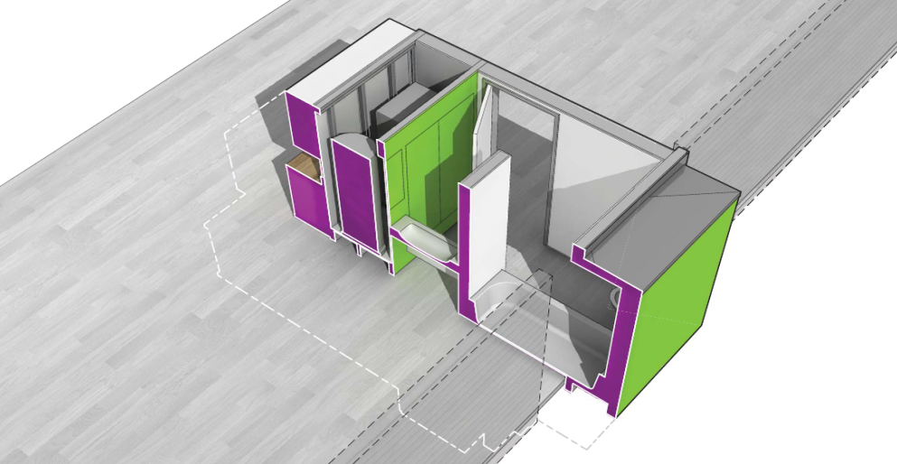
This unit was about 95 square feet, and the plan was one of the initial designs that we worked on. The one that we insert in the prototype is slightly different, but on the inside of the system we have a full bathroom and a kitchen. The bathroom has a stand-in shower and tub combo, a wall-hung toilet with an in-wall carrier, a sink and vanity, and a mechanical closet – and then the outside is wrapped.
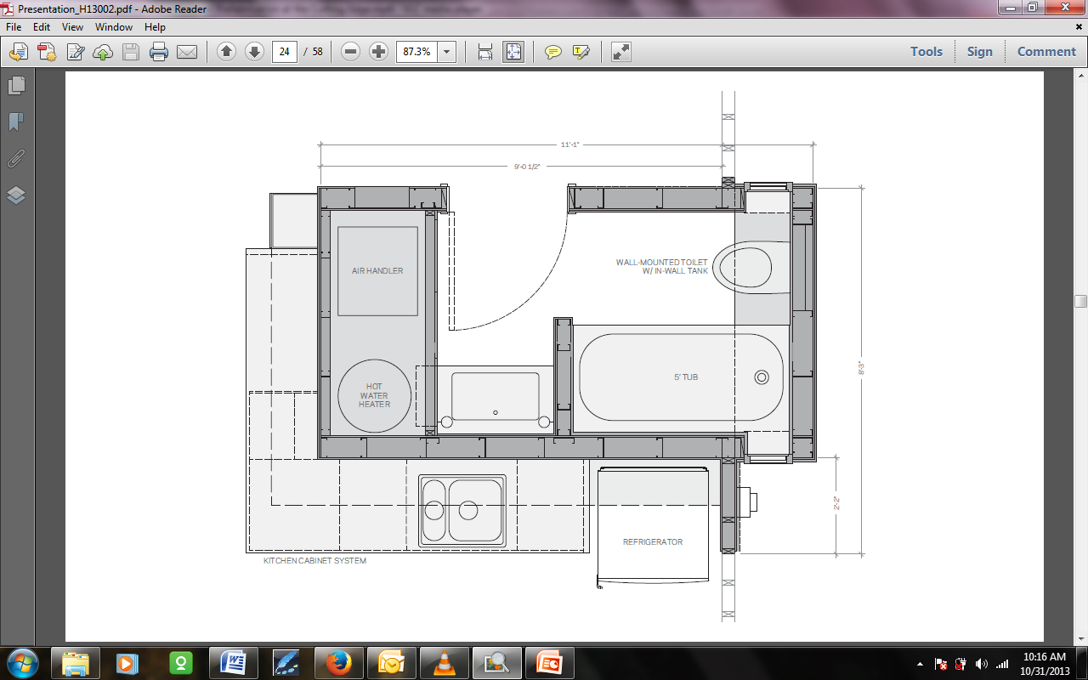
The kitchen that we ended up including in the actual prototype also had an oven and a range, and we moved the refrigerator around the corner into another space. It’s only serving a road-house, so the layout was a little unique and maybe not ideal for a larger house.
One of the things we also debated on and finally came to terms with, is that we, in the future, want to handle all the appliances with major electrical and plumbing needs. We can rely on the rest of the house to provide something like a kitchen island that can accommodate more storage within the kitchen and even move the refrigerator off of this. We had to deliver that separately anyway, and we want to focus on the appliances and fixtures that can come attached with this.
When we get to the finishes themselves, there’s a high degree of customization and flexibility afforded in this. In our prototype we specked all Bosch appliances, but that’s because we had very generous donations from the appliance company, Bosch. They donated all of them free of charge. One of the greatest opportunities in effecting the cost of this prefabricated unit is in the finishes and fixtures, so we could go with much more builder grade appliances and bring the cost down by several thousands of dollars.
But in the end, there is a certain level of design that we are trying to maintain, and some of that is as much in the layout and detailing as it is in material finishes. Any of the savings that we can find in the factory were looking for ways that we can return back into the system itself in creative design solutions.
The fact that we’re CNC milling a lot of the structure allows us to really customize every surface, as well as the size of it. We can really get into details of the wall sandwich and any bump-outs for shelving or ducting or door rails that we need. By the time this is completed in the factory and ready for shipping, all the finishes on the prefab unit are ready to be used. We look at this as a window system which is delivered to site. It's pretty much ready to be plugged into the wall. There’s some additional on-site work that I’ll describe later, but when it arrives on truck all the finishes are already installed and it just a little bit of trim work to have it ready for habitation.
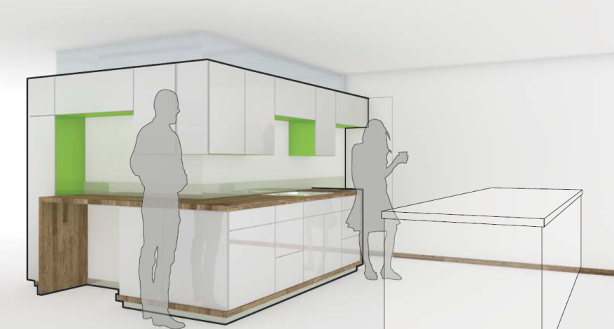
The last goal we set for ourselves was that we wanted this to work for existing housing stock. I think this is where we found most of the innovation in the design of this project. All of the examples that we showed earlier focus on new construction. While this could easily work in a setting for new construction – whether it be single family residences or with some minor design changes for condo units or multi-unit housing – we challenged ourselves to find a way that we could use this in existing housing stock.
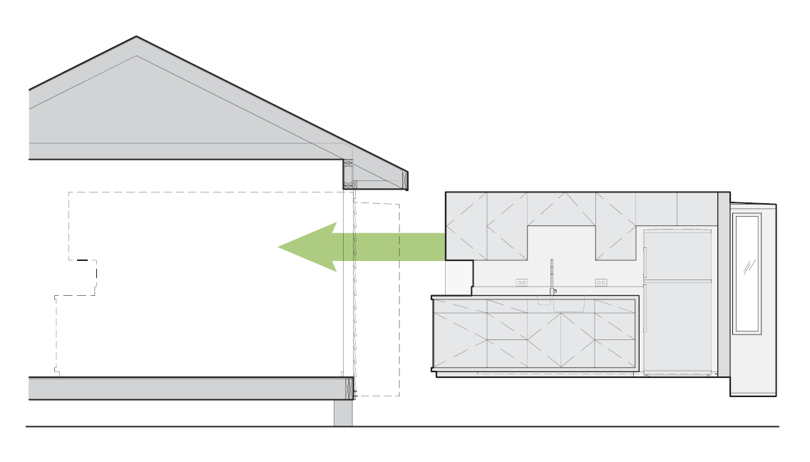
Some of the issues and limitations that came up when we began looking at this are, first and foremost, the height of the eaves. There are so many variables in existing structures that at some point you need to come up with a baseline or an average that you’re designing for. So we developed an average height that we needed to bring this unit down under so it could fit under the eaves. And with this, there is also the issue of dealing with existing structural systems and how our unit can be self supportive.
The prefabricated unit, the OutHouse, is internally structured and does not have a floor or a ceiling. This initially presented some design challenges that took quite a bit of time to work through, but I think it opened up a lot of possibilities in terms of what we’re using the walls for and the types of scenarios this could be used in. We’ve overcome a lot of the height issues because of this.
Probably the last major challenge, brought to us by existing conditions, was the delivery system itself. In a case of new construction, this could arrive before anything else. You would build the foundation and the OutHouse could be brought along and hooked up, and the rest of the house essentially goes around it.
But in existing conditions, lots of times you’re going to find lots side by side, so how do you get this on to the sites between existing houses and inserted into the side of the house? How do you cut a hole in the side of the house? This is where the project really tried to simplify that process and, in doing so, to accommodate existing usage. I think it also made the design stronger for new construction possibilities as well.
The only protrusion, or the only sign of this from the side of the house, is this bump-out. We first pushed against this, then embraced it, then pushed against it again. In the end it really became a design element, and I would admit that we haven’t reached the full potential of what this could do. But it accommodates a window and, on the inside of the bathroom, the real reason for its existence is a technical one. We have the P-trap for the tub and with no floor to this unit, it had to go somewhere, so this bump-out both accommodates natural light on the interior of the bathroom and the P-trap for the tub. Also, all of the city hook-ups would actually drop from this bump-out, so it consolidates all of your hook-ups to a single location.
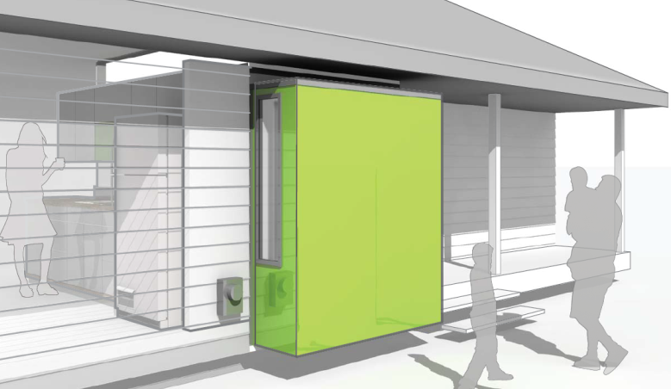
The design process wasn’t a linear one. I’ve been talking about it as such, but we would work on an idea for a little while and then move back around to see if it met up with some of our goals. We ran into a lot of road blocks, especially when switching from this being to a paper proposal in studio to one we were seriously pursuing and talking with consultants about.
In trying to detail for actual construction, we ran into a lot of physical, technical, real world issues. We would solve one of those and all of a sudden it would start to feel like we were just a construction project and we would cycle it back through some of our standards and desires for what we were trying to achieve with this project. It’s a continuous cycle, even up until now, as the prototype is wrapping up.
Vision
One of the things that really drove this was this vision that we had for it. What really set this project apart from just a technical exercise and made it something architectural was what we were trying to achieve with this at a larger scale, and that was one of urban renewal. Rice is located in Houston, Texas, and, as with a lot of major cities, there is a large amount of existing housing stock – a lot of it going through its second or even third cycle, depending on the age of the city.
We are currently, at least in Houston, really [28:21 inaudible]. Houston is an outward expanding city. The suburbs are where most new construction exists. We’re trying to offer an alternative, in an affordable way, to renew the existing urban housing stock in the urban core, and to find a way to do so that would keep it affordable. Most of the new construction in Houston’s urban core these days is in the form of luxury townhomes, so a lot of the existing neighborhoods are undergoing wild transformations.
The slide that I have here is actually of the neighborhood directly around the Menil, the museum here in Houston designed by Renzo Piano. The foundation owns all of the bungalows around it and rents them out mostly as residences with some small offices. The bungalows are all from the early portion of the century and are in major need of repair. Once scenario we looked at was what if we could preserve these bungalows by inserting OutHouses into them and both readying them for another century of habitation and adding a new design element to the Menil district with these badges on the outside.
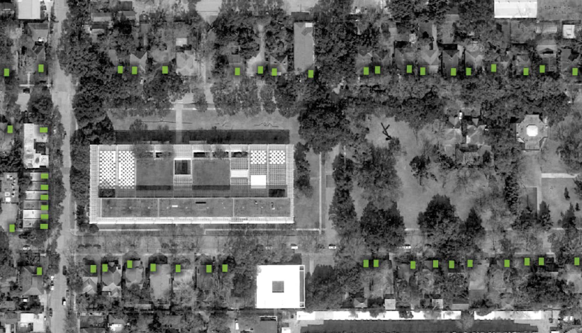
This is not the Menil neighborhood, but it is representative of a lot of the streetscapes you see around urban Houston, and we really see these as a badge of honor, in a way. There are ways that we could clad these or conceal the bump-out more, but I think the architects – and us – wanted to make some sort of statement that really speaks to the owner's desire to preserve what was there and work towards a sustainable community.
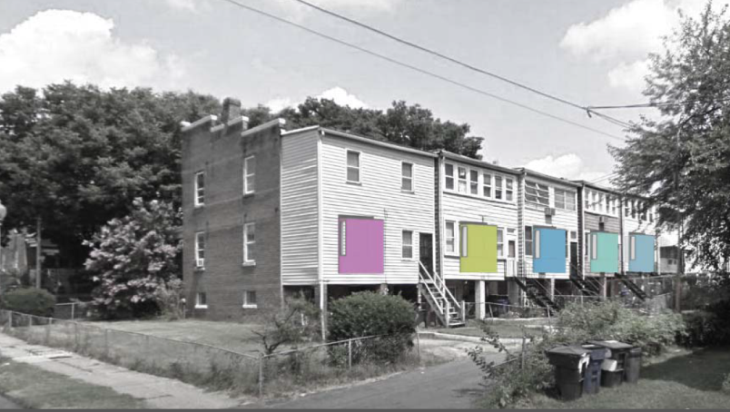
By sustainable, we’re not talking necessarily about solar and a reuse of natural materials, but more of sustaining the infrastructure and the community and the existing urban fabric that’s there. We’ve always seen it like this: an OutHouse in one house is an anomaly, but an OutHouse in all the houses in a neighborhood really begins to speak to changing sentiments towards how we inhabit our urban neighborhoods.
The prototype is located in Houston’s Third Ward which is not as dense by some city standards, but in Houston, this is one of the denser neighborhoods. We found a row house there that is the location of the first prototype that we built.
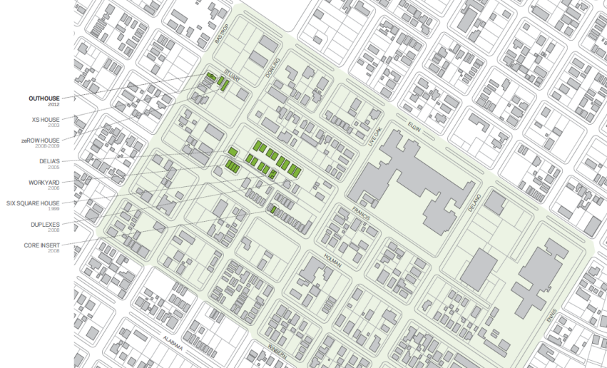
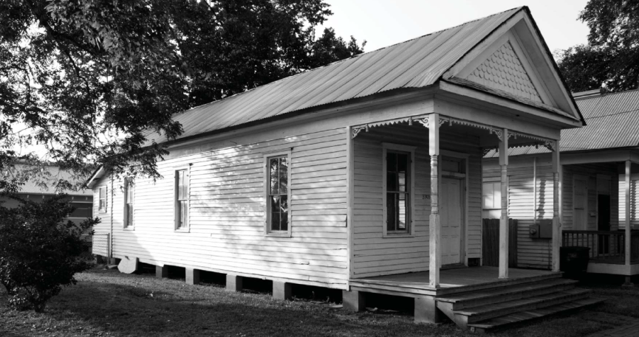
Existing Construction Condition
The existing construction model in our minds is one that can be summarized by that of Habitat for Humanity where the majority of the house can be built with unskilled labor and volunteers in the instance of Habitat for Humanity.
This is really fast and straight forward; whereas the mechanical systems – plumbing, electrical, and HVAC – require skilled laborers and professionals to install. This is both time intensive and material intensive, and these really become the factors that drive the cost and schedule of any construction project.
Parallel Timelines
We proposed a new scenario with parallel timelines of on-site preparation and factory assembly. These are not one-for-one linear, chronological models. As we found, the house prep takes about half a day; whereas the factory sequence takes about 80 hours. We will give those numbers a little toward the end.
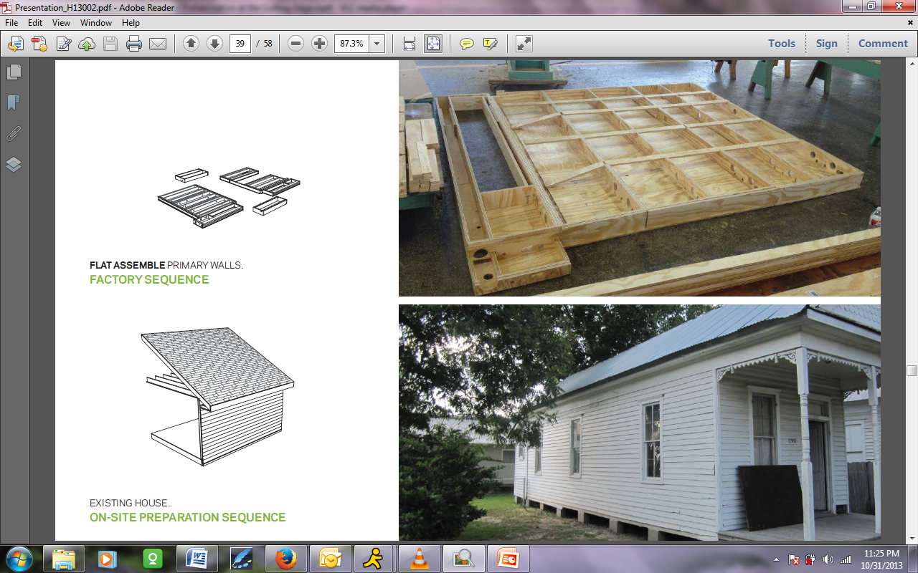
The bottom of our house is sitting there waiting for us. Up in the factory we begin with a structural wall built out of CNC milled plywood. We designed the model in Rhino, and we’re able to test all the systems that have to fit in it, and we’re able to mill out all the pieces individually. We were able to work it at a local cabinet maker and had full access to their CNC mills, so we were able to test files and make adjustments as went to finesse the tolerances.
But in the end, the time that is spent setting up these files and milling it are made up for in the assembly of the wall. The plywood base that you see resting on the floor has a series of data cut into it that allowed the rest of the slats to fall right into place which are in turn all notched. Assembly can be accomplished with two laborers, and of all these walls of this prefabbed unit, it's just a matter of a day.
Once the individual walls are assembled, there are erected on the delivery frame which is, at the moment, this steel structure made up of channels and I-beams that is used primarily as the delivery system and for on-site installation. While this assembly is occurring, the house can begin to be prepped on-site – other renovation, local demolition to where the insertion will take place, as well as the renovation of the rest of the house.
What’s required in the existing condition to insert an OutHouse is the removal and salvaging of the exterior cladding, as well as beginning to open up the hole that the OutHouse will be inserted into. This hole is really nothing more than a large frame that you would create for something like a French door or a large bay window.
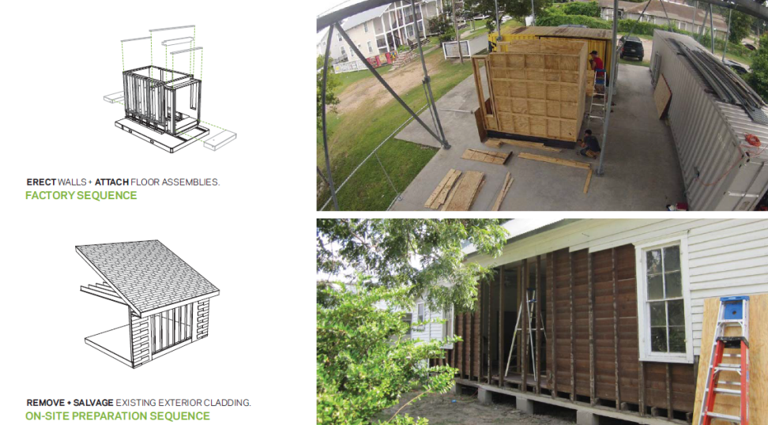
After removing some of the existing framing, we inserted a standard APB that you can get at any lumber yard and some additional jack and king studs, and also reinforce some of the framing in the floor directly underneath where the OutHouse would sit.
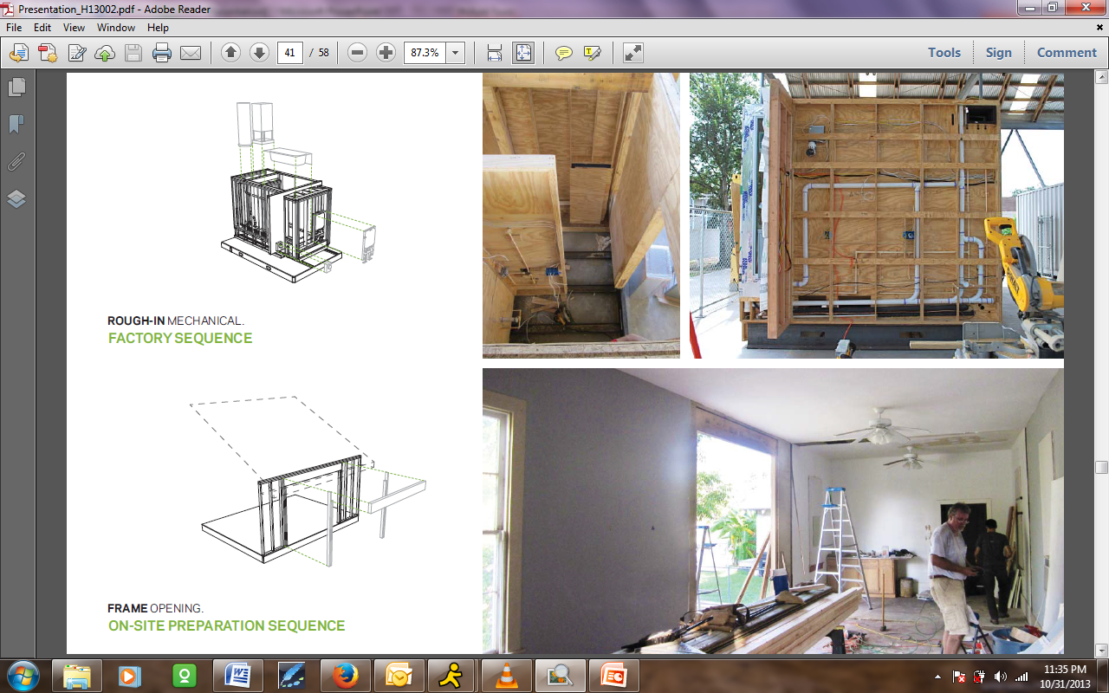
Meanwhile in the factory, after the walls go up we begin to insert the fixtures and appliances and apply the final finishes and cabinetry. Again, this is working towards an assembly that's entirely finished off-site. All the cabinets are hung. Drywall is mudded and painted. All the interior connections are made for the plumbing and electrical work, and it is ready for hookup on-site.
On-site preparation begins for the delivery system. We have designed a much more high tech system, but the one we used for the prototype consisted of a series of railroad ties that were stacked on top of each other to help level the delivery area for where the trailer would be set on top of. The other preparation work involved the installation of these two tracks also inserted into the house.
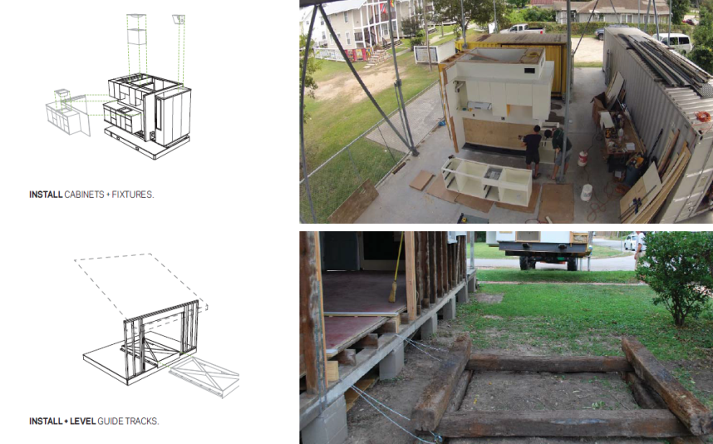
The idea here is that it is much easier to level two plywood tracks than it would be to try to level a several ton unit in place. So with a little bit of easy work up front, we save ourselves much harder labor in the end. The cables are actually anchored to the underside of the house so when the unit is delivered, it will actually be cranked in through the side of the house.
When the unit is finished, it is loaded onto a flatbed truck in the case of the prototype. In future models, we’ve already started developing plans for how we can put this inside of a container truck for better safety and delivery to site. We’re able to pick this up with a forklift and load it on the flatbed truck. This whole assembly was constructed about two blocks away from the row house that it was inserted in. There's a work yard in that neighborhood which has a sheltered work pad that we were able to build all this on and then transport it over to the site when it was ready.
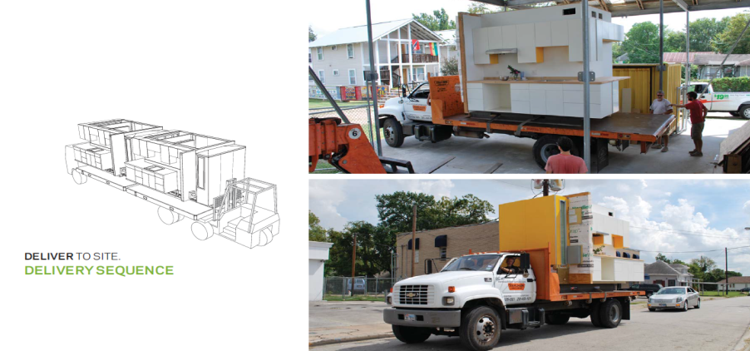
At the site, the truck pulls up and a forklift is able to connect with the tray and carry the OutHouse into its final position. So it's able to navigate the space between houses and deliver it to those railroad ties, at which point the final leveling takes place so that the OutHouse would be able to slide directly onto the existing floor structure.
Those chains that you see at the toilet bowl are hooked up to the cables of the wenches. Jason and myself crawled under the house with a couple of hand wenches and cranked this whole thing in over the course of an hour.
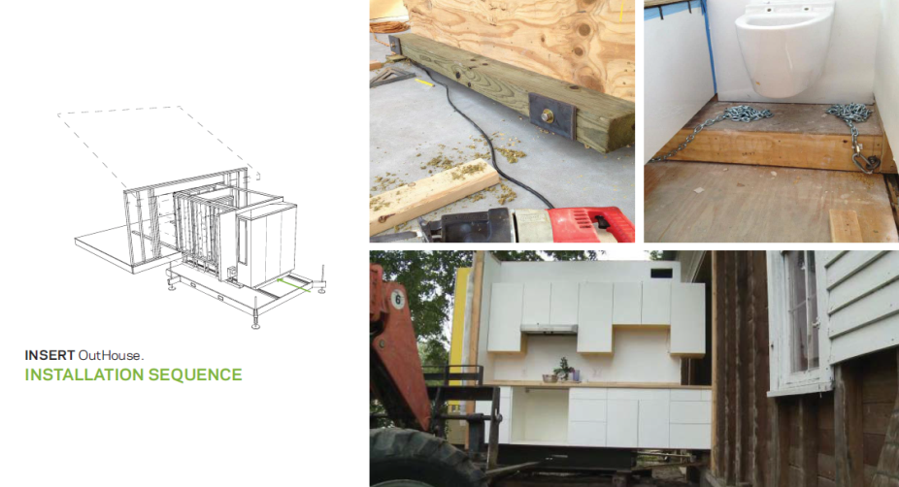
You can see the prototype in its final position. The total time it took from when we lifted it up at the work yard to when it was cranked all the way in was only three hours. That was our prototype sequence, so we figuring a lot of things out on the fly and making adjustments to the leveling system and the track system. Once we have this a little better orchestrated, you can see the amount of time savings can take place on-site.
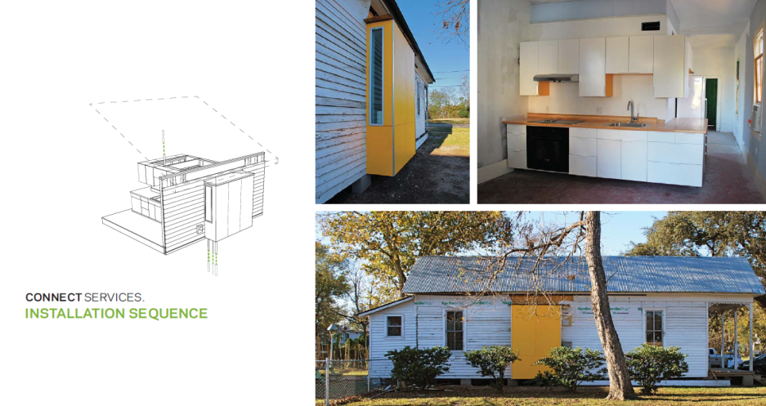
The only thing that’s left to do once insertion is completed is that the existing cladding system can be patched back in and there is some drywall finishing left for the inside.
One thing that we didn’t take into account was that the wing wall in the prototype is an area we need to look into redesigning. We found out with this that the walls of these row houses in any existing condition are not necessarily plumb, so in trying to get the vertical wall of the row house and the vertical wing wall to align, we had some major issues that required a lot of [39:59 inaudible] out and creative dry walling.
You can see how it sits in its almost finished state there. We're about a week away of trying out some of the last items and having the electricity hooked up and having everything completed.
Challenges of Prefabrication
In general, some of the issues we run into with prefabrication are with transportation. Whereas building space on-site is the cheap parts; transporting space from a factory is extremely expensive. Anytime you get up over a dimension of 8'6” wide, you get into Wide Load scenarios which exponentially increases the cost of transportation. Not only of transportation, but of delivery as soon as a crane is involved. As we have learned through some of our pricing exercises, the type of site crane you would need to move any type of housing structure is rented out at about $20,000, so that's a pretty big line item to consider when you are talking about prefabricated housing and architecture.
We also looked through a number of different installation scenarios. This one on the top left is what you find with a typical row house neighborhood with narrow lots. Over on the right hand side of the page is a scenario that we came up with if you were to be designing new houses for the installation of OutHouses. These grayed out blocks represent the forklift and the OutHouse being moved. We discovered that we probably need about twelve feet of clear space between houses to make a successful insertion. We were doing a bunch of mapping studies of Houston and we estimate that about 75% of Houston’s housing stock contains enough clearance for this.
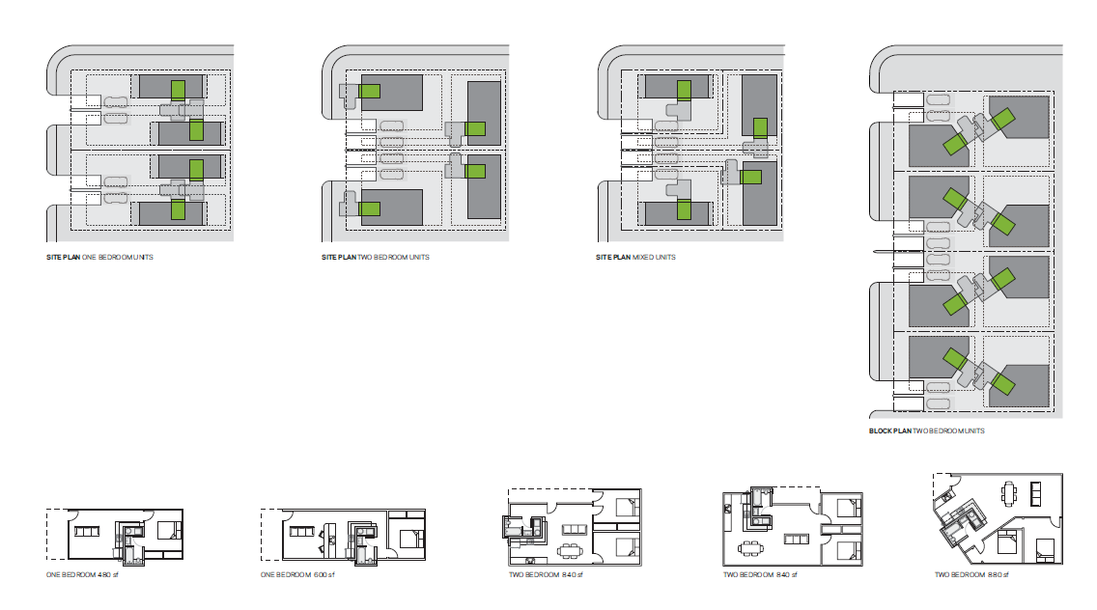
One of the other issues of off-site construction is that if we were to take this to a scale where we were producing, fabricating, and manufacturing them ourselves, there a lot of costs involved, both in setting up a factory and maintaining it. We would also suddenly be employing full time workers as opposed to hiring out contractors and sub-contractors. So there are a lot of other costs at play as soon as you take over the responsibility of manufacturing all of this yourself off-site.
Case Study
As for some of the numbers that we put together through our case study, what we found at the end of the day is that labor savings plus material savings minus factory overhead has to be greater than the cost of transportation in order to make this a viable project. The way we reached this estimate was that we worked with a couple of local builders to have them provide their own personal estimates for the site-built analog cost of what our proposal is – so essentially giving them plans of the space that we built and getting them to price out the material and labor that would be involved in traditional construction methods.
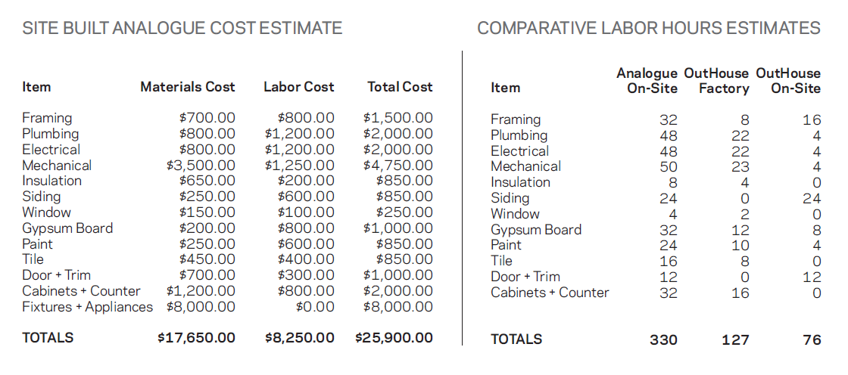
I think the important numbers to note here are those in the right-hand column, which begin to compare the labor estimates. The material estimates on the left-hand side are very similar, but on the right-hand side we end up with an analog site-built model taking 330 hours versus the OutHouse which is 127 in-factory and 76 on-site, which brings us up to just over 200. That's a labor savings of over 100 hours.
As we begin to compare these in terms of time, some of the important numbers are that the analog model would take a little over four weeks where the OutHouse takes just under a full week of on-site labor. This affects the homeowner and the flow of the construction schedule the most. If it's a simple renovation project, the homeowner can be back in their house much sooner. In terms of replicating a construction process, you can imagine building a multi-unit structure from the ground up using OutHouses. Multiply that by however many units you have and you can begin to see where the time savings lies.
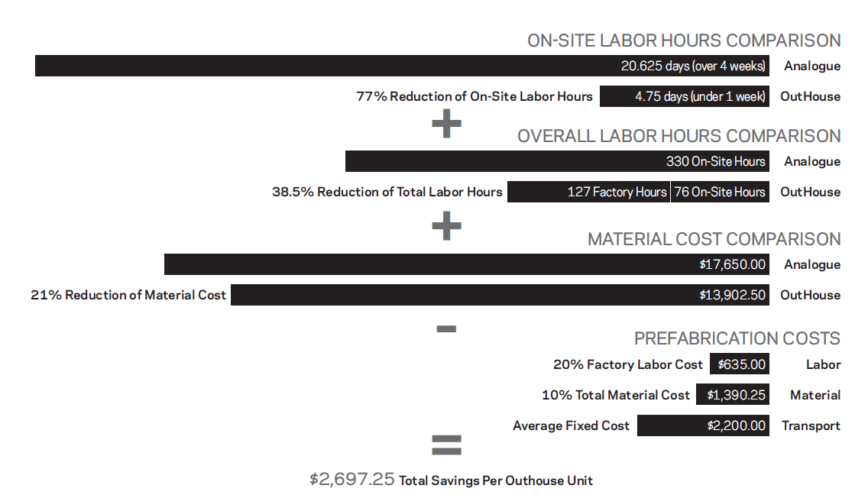
Even in terms of the material comparison, as we begin to manufacture these in a controlled setting, we predict that we can see a savings of up to 21% of material costs. This lies both in waste and in the ability to buy bulk. If we’re producing 10 or 15 of these a month, there could real value in the wholesale cost we would be able to get for the individual components for fabrication. As we begin to standardize the work and labor and come up with more processes that are designed and developed, there will be a greater efficiency in use of materials as well.
Conclusions
In conclusion, in building the prototype, we’ve learned about a number of shortcomings in our initial design and have worked those out through the construction of this and have a number of goals for the future models of these.
What really excited us most about this project and has kept us working on this well past graduation has been the vision that we have for the OutHouse's effect on urban communities. While that might not be a model that would be viable for a startup business, it’s a vision that we would like to maintain as we begin to market and sale OutHouses – that their initial intent was always for preserving urban communities and finding ways that we could continue to do projects in those areas.
The last is that the scale of this project, I think, really is the most achievable way to execute prefabricated architecture at a mass production, affordable scale that allows us to both exhaustively design the structure and the content of what we are providing, and to do this at an affordable and feasible cost.
I would like to end it there and take any questions.
Steve: Thank you so much Peter that was great. A bunch of questions came in during the presentation, and some of them are comments meant for you and your co-principal investigators, so I might pass on some of those. There are various themes that come through in the questions and I am going to try to bundle these together.
There are a lot of questions about the water heater. What happens if the water heater fails and needs to be replaced?
Peter: I can answer that two ways. First of all, in future models we plan to use a tankless hot water heater. This was more or less a challenge to ourselves to design a space that could accommodate a standard 40 gallon hot water heater since those are the most affordable units on the market. In the future, we would like to move to tank less, but this was just a personal challenge that we set for ourselves.
The mechanical room can actually be accessed from inside of the bathroom. The wall between the mechanical room and the bathroom is actually a removable panel which can be taken off. It's not the sort of thing you want to do every day, but in the event of the hot water heater failing, it would only take a matter of minutes to disassemble and drain the hot water heater to lighten the load and to remove it. We have actually had to take it in and out several times as we have adjusted the mechanical space and wired it, so we know it can be done quite easily.
Steve: Excellent. So there a number of questions about the plumbing on the exterior wall – particularly concerns about colder climates. Have you addressed the potential for freezing plumbing on the interior wall under the water closet and the tub in northern climates?
Peter: We know that’s a challenge. All three of us are from the northeast. In a way, we got to almost cheat a little bit by designing this and building the first prototype down in Houston where freezing is really not an issue. We know this is a design challenge that we're going to have to overcome if we want to be able to market this as a unit that can be used across the country.
I think it is one of those things that you can’t design for everything at once, and I believe personally that, as these come to market, we’ll probably have several variations of the same model – one designed for colder climates and one for areas like the sunbelt. I think we're just going to have to find a way to extend the base of that in a way that we can use to insulate the pipes.
That brings up another issue with this being raised. Most of the houses of the Houston area and Texas are built on these raised foundations. The floor level is sitting fairly high above the adjacent grade, so it is very easy to insert this and have access to the plumbing and electrical connections. As we look at scenarios and other locations, in a way it's initially probably going to be a case by case basis where we actually develop a market and get some orders from and, over time, hopefully, it would be a matter of you selecting the region you are in and getting the options for the appropriate OutHouse model that you would be considering.
Steve: Thank you. Is under cabinet lighting anticipated? Would the entire module be UL rated as a single appliance?
Peter: Yes, and the UL question is kind of complicated. There is under cabinet lighting. At the moment we have LED lighting everywhere. There is under cabinet LED lighting and there is also LED lighting mounted on the top of the wall facing upwards in the space between the top of the wall and the actual ceiling of the house. In the prototype, we installed a translucent polygal panel, so the whole space above the insertion lights up.
We also had LED donated. That was donated to us by Hafele on their new Loox line. It’s definitely more expensive than the incandescent lighting, but again, I think this is where we find cost savings in other areas. We would upgrade other systems such as the LED lighting to make this doable.
And, yes, an appliance is a good comparison. We see the OutHouse as a single assembly. We’ll have to consider getting testing and approval by them, but similar to the way an RV is constructed and sold, each one is not getting inspected by a local municipality. The factories have received certificates after providing evidence of their design standards. Those standards get inspected and approved and are occasionally checked for compliance, but then the factory itself is allowed to release each individual unit to the market saying that it meets these standards. I think that is one of the jumps from thinking about this as architecture to thinking about this as a manufacturing process.
Steve: Did you consider handicap accessibility implications in the size of the unit?
Peter: Our initial design actually met all ADA code. I'm sorry, but I cannot remember off hand if the prototype actually met it in the end. It was like within a half inch or an inch and we were debating whether to try to accommodate that or not because the row house itself is up a flight of stairs and will never have a ramp attached. So in this specific scenario, ADA accessibility seemed like a moot point. But the initial design did accommodate it, and while we do have a tub and not a roll-in shower, I think issues of not having a floor in this...
We had to make sacrifices in some places. That is something we would like to revisit again at a later date in a future design to see if there are other ways we can accommodate ADA accessibility.
Steve: This question is about your cost comparisons. Where does overheard and profit fit into the bar chart?
Peter: We didn’t include that in the slide show, but it’s something that we worked out for a case study that we did. We’re in the process of developing our business plan, and it has been quite a jump from taking off our architect hats and starting to think through this as a business person and as a process designer.
I don’t have those numbers in front of me at the moment, so I can’t give them to you. I don’t know if there's a handout later that we could give out and insert our projections into. If people are interested in seeing those, we would be happy to share them. But the total numbers of our estimated overhead are factored into overall saving of $2,700. That’s estimating over the course of a five year projection. In five years, as we are up to speed and producing at volume, those are taking into account $2,700. Sorry if that wasn’t clear.
Steve: We'll send you the whole list of questions and you can answer at your will. Then we'll post your answers and we can include attachments like that as part of the package that will go up on the Housing Knowledge Community.
Peter: I would like to add that I don’t know if it has been formatted or if it's up there yet, but we have produced a full case study and business plan that were delivered to the AIA as part of a research grant that we worked on for them. That's something that I believe is going to be accessible on the Housing Knowledge website.
Steve: Excellent. How was the existing bathroom and kitchen handled? Was the OutHouse located in the same place in the floor plan?
Peter: This, again, is a little bit of a situation where we got to cheat a little bit. The row house we were given was 14 feet wide by – I forget exactly how long – 40 feet long? There were a couple of existing partitions, but there almost was no kitchen or bathroom so to speak. There was a toilet in an addition off the back and sort of a slop sink in the main space, so the structure really was inhabitable.
That was one of the beauties of seeing this fully inserted. It took a house that was not really fit for living and actually created a space where most people who have visited so far have found it to be much more agreeable than the apartments they live in.
We demoed the existing partitions of the row house to open it up as one large space, and then the OutHouse was inserted roughly in the center of the length of it and acted as a partition from front and back. This is eventually going to be used as artist in resident housing by a not-for-profit group in the area. It's not going to be for a family. It is probably going to be for one or two individuals who are pursuing artistic work, using the back space as a private bedroom space and the front as a living and work space. That's how this will be used in the future.
Steve: Thank you so much. This concludes this AIA Continuing Education System webinar.
We really appreciate your feedback. Even if you don't need the continuing education credit please take a moment to complete the survey. Thank you so much, Peter, and thank you to your two co-conspirators. This has been great.
Peter: I'll pass it along to them. Thank you for joining us today.
Steve: Take care, everyone. Bye-bye.

